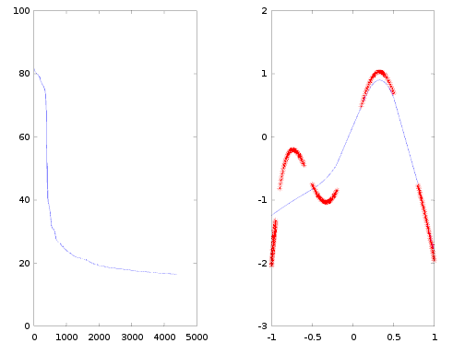

Eta adaptativo y chosen ones. Training ordenado .
15' quedó ya en 20.

clear; clf
trainingAmount = 200;
middleAmount = 15;
maxIt = 10000000;
calcAllFreq = trainingAmount;
ETol = 0.005;
gName = 'sigmodea';
[training, expected] = generateTrainingTPfunctionChosenOnes(trainingAmount);
training = [training, expected];

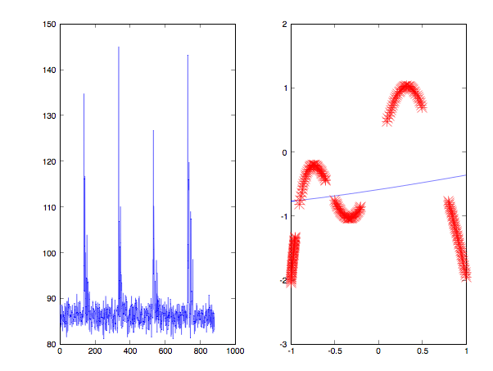

Eta adaptativo y chosen ones. Training se desordena en cada epoca.

clear; clf
trainingAmount = 200;
middleAmount = 15;
maxIt = 10000000;
calcAllFreq = trainingAmount;
ETol = 0.005;
gName = 'sigmodea';
[training, expected] = generateTrainingTPfunctionChosenOnes(trainingAmount);
training = [training, expected];

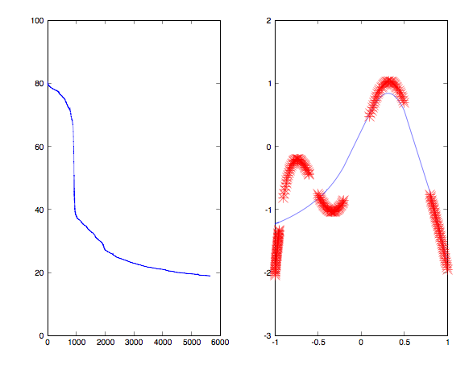

Eta adaptativo y chosen ones. Training se desordena una sola vez.

clear; clf
trainingAmount = 200;
middleAmount = 15;
maxIt = 10000000;
calcAllFreq = trainingAmount;
ETol = 0.005;
gName = 'sigmodea';
[training, expected] = generateTrainingTPfunctionChosenOnes(trainingAmount);
training = [training, expected];

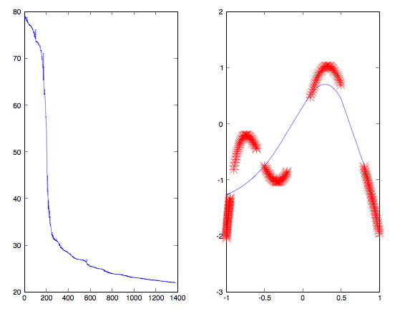

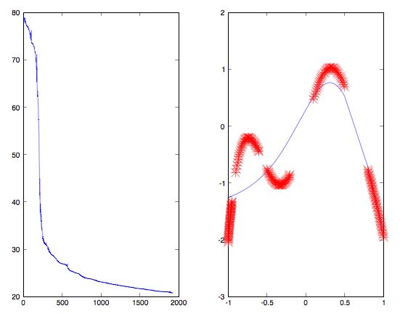

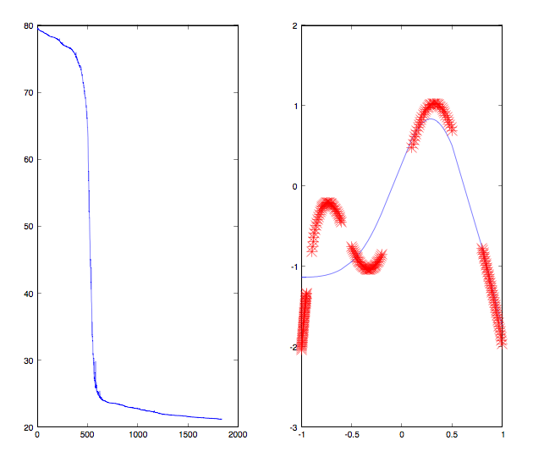

Eta adaptativo y chosen ones. Training se desordena una sola vez. Con control de saturacion con delta = 0.001 y rand()/10

clear; clf
trainingAmount = 200;
middleAmount = 15;
maxIt = 10000000;
calcAllFreq = trainingAmount;
ETol = 0.005;
gName = 'sigmodea';
[training, expected] = generateTrainingTPfunctionChosenOnes(trainingAmount);
training = [training, expected];

EXPONENCIAL
TEST 2 CAPAS OCULTAS CON CONTROL DE SATURACION
ETOL = 0.25
CONTROL SATURACION =0.001(NO SE SATURO)
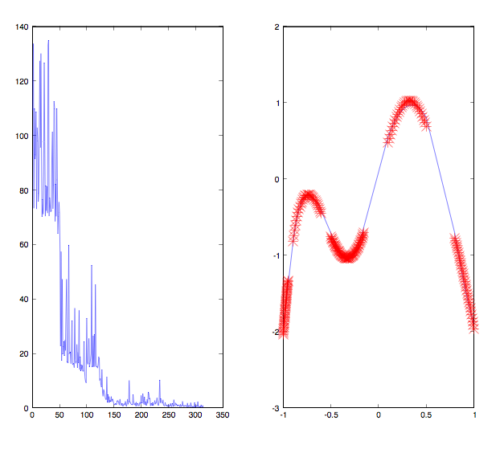

idem pero control saturacion 0.01(no satura)
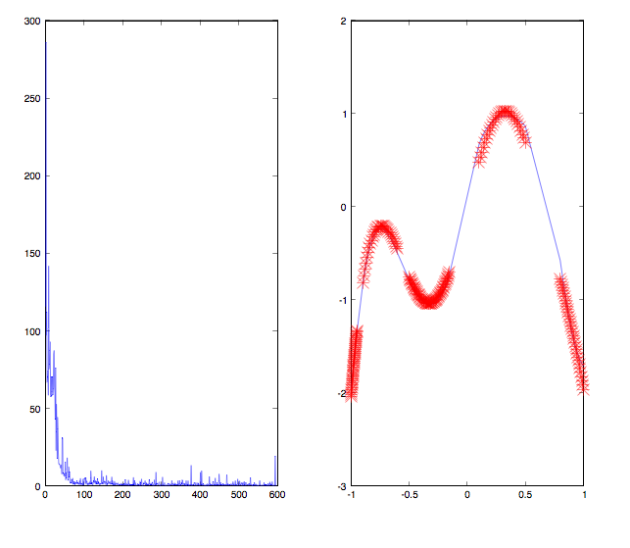

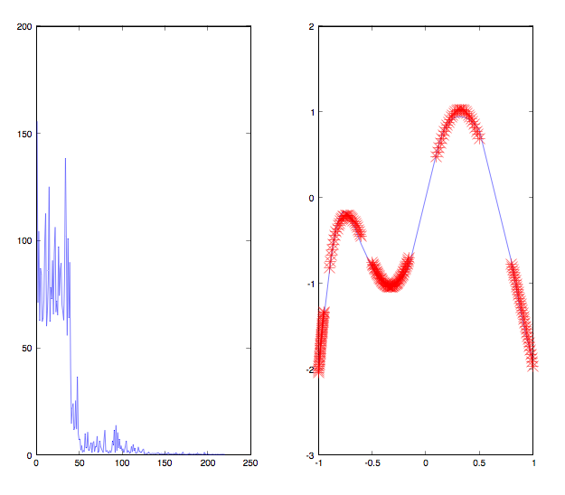
exponencial, multilayered2, etol 02.5

idem

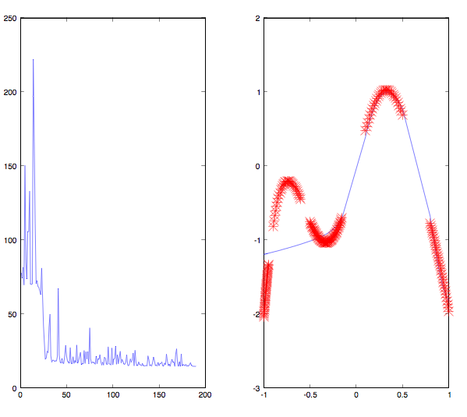

momentum exponencial: con etol 0.25

