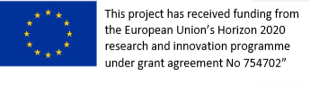
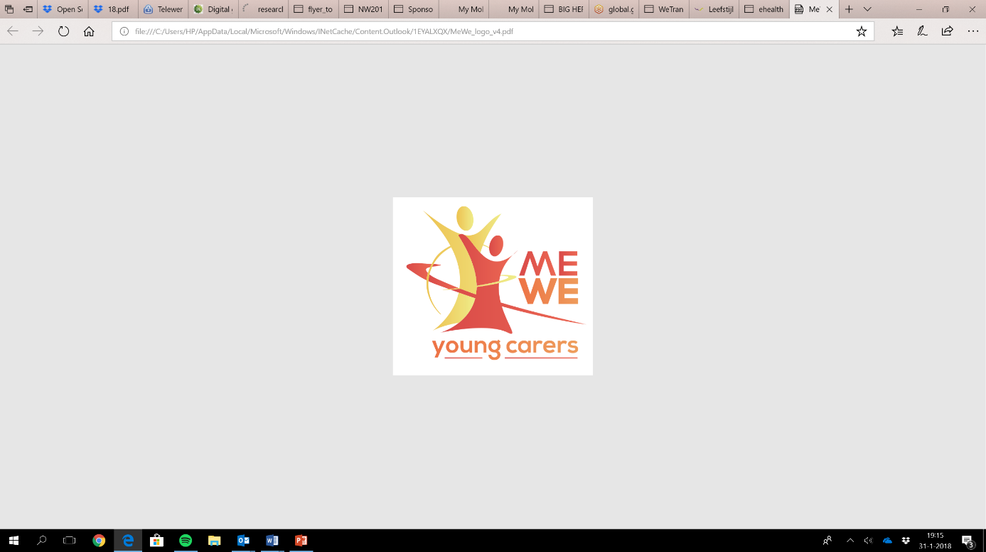
ME-WE Delphi Study
Summary Template first round v0.1

Instruction: in this document you will provide a summary on the available data of the first round of interviews per code (themes/topics). You can use your notes, transcripts (if available) and/or recorded interviews to provide this preliminary overview. We need this input to develop the interview guide for the second round, including a summary that will be shared with the experts before the second round. Please share the main findings in approximately 5 lines per topic and after that 5-10 lines per subtopic.
Date: 28/05/2018
Country: Italy
Based on number of Experts: 10
Codes of the experts: IT_1-IT_10 (Round_1)

- Visibility and awareness raising

Main findings (5 lines):
In Italy there is a lack of visibility and awareness on AYCs at all levels (local, regional, national) which is accompanied by a lack of systematic studies and official statistical survey. One respondent said that they carried on a survey in her school finding that 2% of students were AYCs (IT_6), and another one told about the program for supporting oncological patients in Sant’Orsola Hospital (Bologna) that is able to reach also AYCs (IT_3). Apart from these specific cases, the visibility of AYCs is due to the experience of the teachers or medical professionals.

  - Local level
Non applicable

  - Regional level
Non applicable

  - National level
Non applicable

1.4 Additional
Non applicable

- Strategies, interventions and programs to support (A)YC

Main findings (5 lines):
Except for the interventions carried out by ANS in the area of Carpi, which are mentioned by three respondents (IT_9, IT_7, IT_10) and one support action in a school (IT_6) in the same geographical area, no other activities specifically dedicated to AYCs have been described. On the other hand, participants were able to identify other actions – currently targeting other groups – which could be applied /transferred to AYCs: an ICT app to share information about health and social services (IT_1, IT_2), peer-support (IT_10, IT_2, IT_3), workshops in schools (IT_10, IT_3), reflecting teams (IT_9, IT_3), support to children of parents with mental illnesses (IT_8), programmes to prevent earlier educational system drop outs (IT_6), alternative school programs (IT_2), assistance support (IT_3, IT_2, IT_4) and more generally the application of a whole family approach (IT_8, IT_10, IT_2, IT_3, IT_4). This intervention should be designed starting from a co-participation methodology (IT_2)
2.1 Strategies, interventions and programs
Laws and regulation:
In order to fix the lack of a specific regulation at all level (national, regional and local), some respondents mention the possibility of passing a law on informal carers as an opportunity to support young carers as well (IT_10, IT_8, IT_1), however one of them also underlines the risk of a “cash for care” approach, aiming to support informal carers simply by providing economic support. One expert considers the local authority as the main actor able to provide adequate interventions for AYCs for its proximity with local needs, and suggests the creation of a national authority responsible for the evaluation and the exchange of the local practices (IT_1). Another one suggests to deliver national Guidelines in order to have a common framework for identifying AYCs and planning tailored interventions (IT_3).
Education:
A lot of inputs relate to the role of schools and teachers in supporting AYCs. In terms of dedicated intervention it was mentioned: awareness rising activities targeting teachers and students (IT_6, IT_3), a tailor-made educational plan for AYCs in schools (IT_6, IT_1, IT_2), setting up a group of teachers specifically dedicated to support AYCs in school (IT_6), cooperation between schools and other services in order to promote integrated actions (IT_3).

Welfare:

2.2 Goals , strengths and weaknesses
Laws and regulation:
- Goals:

An expert mentioned an approach (not specifically for carers but transferable to them) that includes school-tutors (psycho-educational professionals that are the contact point for academic and personal problems of students); time to talk to families, dedicated staff member to take care of social issues of the students and, whenever necessary, to cooperate and make referrals to other services, use of peer-education. (IT_7).
Welfare:
Experts emphasize development of long term programs based on a whole-family approach, which would have a positive impact on AYCs as well (IT_10, IT_8, IT_1, IT_3, IT_4). Moreover they suggest an integration of the different services involved in order to go over segmented actions (IT_3).Respondents also mention interventions aimed to share emotions and relieve the psychological burden (IT_10, IT_8).
Education:
- Goals: dropout prevention – identification
Evidences that works (IT_6), improvement in school attainments (IT_6), awareness rising towards teachers and students, community based practicies (IT_2), interventions using communication channels common among youngest (e. g. Facebook, Instagram) (IT_2), integration of actors (IT_3), family based approach (IT_3, IT_4) (+);
interest of school professionals still low (IT_6, IT_3, IT_5), interventions are currently focused on high schools while to be more effective and preventive they should start in middle-school (IT_6) (-).

Welfare:
Risk of labelling (IT_10) – lack of time for professionals to focus on the whole household instead of on the patient (IT_9, IT_10) – resistances from professionals to change their usual approach (IT_8), not-sufficient integrated health and social services (IT_5), absence of multi-disciplinary interventions (e.g. in educational, social, health realm) (IT_5), absence of family based approach (IT_3, IT_5) (-)

Prevention and care for children with a psychiatric / addicted parent (KOPP/KVO)
Support a positive and healthy development, break the intergenerational exchange, providing information, psycho-education, self-recognition (IT_8)

- Goals: improvements on the whole family, not only on the AYC (IT_8, IT_5) (+)
Relaxing activities / supportive groups
- Goals: sharing emotion and experiences with people in similar situation, helping them to release from the household (moving on and living their own lives while keeping an affective bond with their families) (IT_10, IT_3) (+)

Individual support
- Goals: assistance support (IT_1,IT_3), voluntary peer support program (IT_3) (+)
Courses
- Goals:

Training for professionals
- Goals: Training for teachers in order to improve the AYCs awareness (IT_2, IT_3), training for medical and health professionals, in order to promote an adequate communication with AYCs (IT_2) (+)
Informal respite care
- Goals:

2.3 Coping strategies
2.4 Additional
- Future needs to support the well-being and health situation of (A)YCs
Main findings (5 lines):
There is consensus among respondents on the need of information and training for all professionals and policy makers (IT_1, IT_2); in particular, training for teachers to promote the awareness of AYCs, training for health professionals to spread adequate communication strategy for a correct dialogue with AYCs, statistical studies useful for policy makers to quantify the AYCs (IT_1, IT_2, IT_3). Moreover, experts emphasize the need for families to be taken into account in a systemic way and to be listened to (IT_3, IT_4) in long term programs providing integrated actions (education, health, social activities and support)
3.1 Future needs to support well-being / health situation
Long term and multi-actors programs, based on appropriate tools for AYCs age, such as an ICT app (IT_2), aimed to listen AYCs needs and promote their self-awareness. Moreover these programs must be able to consider the whole family in order to improve families well being, not only AYCs individual well being (IT_3), and to include: different school programs able to reach the AYCs educational needs (IT_2, IT_3), assistance support in order to improve the AYCs free time and get them free to spend it in hobbies and sports (IT_2, IT_3, IT_5), support group with others AYCs.
3.2 AYC needs
Multi-actors programs should be implemented to improve the professionals’ attention towards the AYCs and their capability of listening their needs in different life realms (e.g. educational, emotional, relational, healthy dimensions) and to rise their self-awareness (IT_3). Moreover, AYCs have a specific need for adequate information (IT_1, IT_2), contact with fellow AYCs to reduce the sense of loneliness and isolation (IT_3), resilience training and space for their own needs (IT_2, IT_3).
3.3 Professional and family needs
Information and training for teachers in order to improve awareness about the conditions and the problems of AYCs also their specific needs (IT_1, IT_2, IT_3, IT_6, IT_8, IT_9, IT_7, IT_10). Moreover, for families: assistance support (IT_3, IT_2), professional support to understand the problems of the AYCs, interventions to support families difficulties in a systemic way, providing a place to share experiences and to reflect on themselves (IT_6, IT_9, IT_7, IT_10, IT_3, IT_4). There is the need of additional studies and survey to quantify the AYCs in Italy.
3.5 Working concepts to reach (A)YCs
One expert suggests to reach the AYCs by the way of cared for people once they access the health and social services. Social workers should ask which is the caring network in order to identify the presence of a AYC (IT_2).

3.6 Responsibility
In terms of responsibility, it is mentioned at national and regional level that of the Ministries of Education, Welfare and Health (IT_8, IT_6, IT_1). Schools and the Regional School Offices are mentioned (IT_7, IT_6, IT_1, IT,2, IT_3) together with all public and private community based services that, for different reasons, have the chance to work with families (IT_10, IT_9, IT_6, IT_1). A respondent says that it should be a collective responsibility of all members of the community (IT_10) while another stresses the importance of a case-manager profile (IT_7). Local authority, for its knowledge of the local needs, is the main actor responsible to plan and realize the AYCs programs support (IT_1).

3.8 Funding
The program should be financed largely by public funds with the collaboration of the private and no- profit sector (IT_1, IT_2, IT_3). Opportunities for funding are identified in funding for schools to prevent drop-out, the National Operational Programme for Education (European Funds through the ESF), resources that schools dedicate to the training of teachers. (IT_6). One respondent also mentions the fact that currently the funding available for health and social care is mostly dedicated to older persons and their carers while there is not much left for other target groups. (IT_9).

3.9 Additional

