
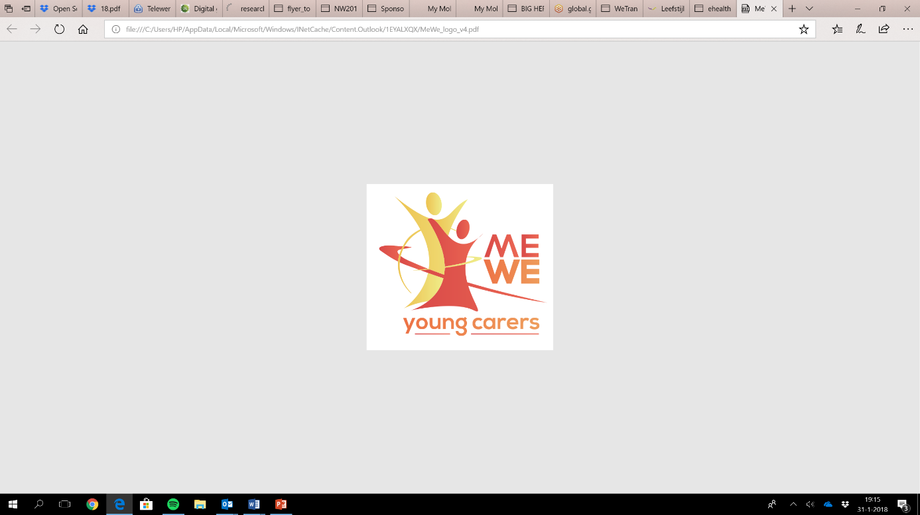
ME-WE Delphi Study
Summary Template first round v0.1

Instruction: in this document you will provide a summary on the available data of the first round of interviews per code (themes/topics). You can use your notes, transcripts (if available) and/or recorded interviews to provide this preliminary overview. We need this input to develop the interview guide for the second round, including a summary that will be shared with the experts before the second round. Please share the main findings in approximately 5 lines per topic and after that 5-10 lines per subtopic.
Date: 22-05-2018
Country: The Netherlands
Based on number of Experts: 9
Codes of the experts: P1-P9

- Visibility and awareness raising

Main findings (5 lines):
YCs in the Netherlands are not very visible in the Netherlands. YCs don’t always recognize themselves as a young carers and frequently prefer not to draw attention to them (P5_NL,P9_NL). Nowadays their visibility is slowly increasing (P9_NL). Welfare organizations developed programs to identify and support YCs and make their social environment aware of the challenges YCs encounter. The visibility and awareness raisings of AYCs differs per region. Municipalities struggle with their policy. Most municipalities see to have policy for informal care, but not specific for young carers.
  - Local level
In the Netherlands young care is a theme belonging to the law social support (Wmo) (P5_NL). Welfare organizations are responsible and operate to raise the visibility and awareness for AYCs. They mostly search for cooperation with schools to identify YCs. Experts think schools play an important role in the identification of YCs. Also local newspapers start to have more attention for this subject, for example by attention for events for young carers. Mostly this is suggested by welfare organizations to raise more awareness. On a local level only a few municipalities have specific policies for informal care by young carers and mainly focus on adult informal carers.
  - Regional level
On a regional level next to welfare organizations also public health service organizations (GGD) and youth healthcare (CJG) try to raise the visibility and awareness of YCs. The GGD uses monitors as a tool for contact with youth. The survey doesn’t contain a standard question for AYCs yet (P6_NL). Experts address young carers as a group that falls between two laws (Wmo/Jeugdwet) (D8_NL). Help and support often focus primarily on the person with a diagnose instead of the social environment (D9_NL).
  - National level
On a national level there is relative little awareness for YCs (P6_NL), it’s getting better (P5_NL) for example by addressing young carers as a group of informal carers with specific needs for support by our former minister of public health. Also experts address a little increase of visibility of young care as a subject in programs on national television (P6_NL, P7_NL). Also on a national level there was a conference last April to connect education, youth healthcare, municipalities & health- and welfare organizations on the subject of young carers (P4_NL).
  - Additional
Experts emphasize development of an integral approach by welfare-, healthcare-, educational- and (local) government organizations when it comes to the visibility, awareness and support of YCs (P1_NL, P4_NL, P5_NL). Also experts address that different organizations use different definition of young carers, which not favors the visibility and awareness raising of AYCs (P2_NL, P3_NL, P4_NL). When it comes to visibility young carers don’t always recognize themselves as YCs and don’t want to draw too much attention on them (P9_NL).

- Strategies, interventions and programs to support (A)YC

Main findings (5 lines):
Experts discussed different strategies, interventions and programs for the support of youth with a parent or sibling with a diagnosed disability / illness. They differ from individual to group support and there’s also a variety seen in the regularity, duration and demonstration of the effectiveness.
2.1 Strategies, interventions and programs
Laws and regulation: From a policy perspective the ministry of healthcare tries to encourage municipalities to develop specific policy and support for YCs by scheduling this subject. Also for example the organization of a conference / expert meeting might contribute to more awareness for this group of informal carers. Also one expert stated the UN convention on the rights of the childs including the right on information and the right on giving your opinion as important to take in account when it comes to (A)YCs. National authorities should respect this convention (P9_NL).
Education: different plays are developed for schools to make young people aware of informal care and contributes to the identification of young carers (P6_NL, P7_NL, P8_NL). Also in higher education there is a module about informal care with specific space for experiences of young carers (P2_NL).
Welfare: different programs for young carers varying from leisure activities, resilience training, supportive groups, individual support and courses (psycho-education and other information provision about disabilities / illnesses). Also there is an offer in family support for the families of young carers and trainings for professionals in awareness raising and support of young carers.

2.2 Goals , strengths and weaknesses
Laws and regulation:
- Goals: The development of policy specific for young carers as a specific and unique group of informal carers (+): Powerful places to schedule young carers as a group (P1_NL), Regulation can be helpful in addressing authorities (P9_NL). (-): No direct contact with YCs (P1_NL).
Education:
- Goals: To recognize oneself as young carer, the identification and support of YCs, making YCs visible for classmates, normalizing YCs, daring to ask questions, starting dialogues about the subject (P2_NL, P8_NL). (+): Creating a climate in which youngsters discuss this theme / existing care structures at school are made accessible (-): Schools are flooded with requests for attention of divergent subjects (P2_NL, P8_NL)
Welfare:
Prevention and care for children with a psychiatric / addicted parent (KOPP/KVO)
- Goals: Information provision, recognition, support (prevention and care for children of a parent with a psychiatric disorder or an addiction) (+): Effectiveness is demonstrated (P6_NL)
Relaxing activities / supportive groups
- Goals: Mostly focusing on relaxation and also exchanging experiences (+): Low threshold, contact with fellow YCs, being able to think about something else (-) The impact is difficult to measure (P5_NL)

Individual support
- Goals: Customized support by a buddy with similar experiences (+) Customized, relative long term (-) YC and buddy sometime have the same pitfalls, the period is finite (P5_NL)

Courses
- Goals: Providing YCs information about disability / illness (P5_NL, P8_NL) (+) Learning about diagnosis, contact with fellow YCs (-) Duration in relative short and information drops away (P5_NL, P8_NL)

Training for professionals
- Goals: Making professionals aware of young carers and ways to identify and support them (+) Mostly a lot of recognition by professionals, developing an analytic view on families (-) Professionals already need to have attention for divergent subjects (P8_NL)

Informal respite care
- Goals: Support for parents of YCs (+) exclusive attention for parents, closes the gap between formal and informal care, duration is relative long (8 months), working on goals (-) The support raises ethical question about how far informal care reaches (P8_NL)

2.3 Coping strategies
Young carers (18+) may ignore their role as informal carer, they often are able to balance between different interests, they work efficient and hardly try to draw attention on themselves (P3_NL). Other coping strategies of YCs are finding ways to relax / destraction like hobbies (P5_NL, P6_NL, P_9). Also they often feel very responsible, experience home as a confronting and restless place and tend to efface themselves (P5_NL, P9_NL). Overall they often are powerful / resilient persons (P2_NL). They often write their experiences down in a diary (P9_NL)
2.4 Additional
A lot of interventions are focusing on YCs, less interventions are focusing on the parents of the children who are responsible for their care until the kid is 18 years old. Some expert advocate for support for both YC as the parent. There often is a degree of reluctance and embarrassment (P6_NL, P8_NL). Also it’s important for the whole system (professionals, YCs, parents, social network) to know how to recognize risks and when to come in action (P8_NL). Furthermore experts stress the importance of developing interventions and programs in co-creation with YCs. To ‘talk with’ young carers instead of ‘talk about’ them (P3_NL, P7_NL, P9_NL).

- Future needs to support the well-being and health situation of (A)YCs

Main findings (5 lines):
Young carers should be seen as a specific group of informal carers (P4_NL, P9_NL). The basis for YC support is ‘eye and ear’, giving attention to them, ask how they are doing and let them know where/who to go when they need help or support (P5_NL, P9_NL). At the moment we focus on YCs ‘own-strenght’ of informal carers even before we acknowledged them. Also YCs should not be too much problematized but at the same time not disguised (P3_NL, P6_NL). There is a special need to further improve the identification of YCs. The expert state an integral approach is needed to develop.
3.1 Future needs to support well-being / health situation
In educational settings experts strive for a regulation that acknowledges and support YCs. Similar to existing regulations for top sport students (P2_NL). Also reducing the stigma around YCs and normalizing young carers. Also the way of approach YCs is very important (P9_NL).
3.2 AYC needs
YCs like to feel acknowledged as informal carers (P2_NL, P6_NL), besides they like to be addressed by their strengths like their resilience and self-dissolving ability (P9_NL). An educational setting that match their needs instead of giving them dispensation. (P2_NL). At the same time YCs like not to be seen only as a ‘young hero’, but wishes support for sadness, frustrations and coping (P6_NL). YCs have a specific need for adequate information, contact with fellow YCs, resilience training and space for their own needs (P5_NL). They like to be addresses on human and equal way as everyone else and have their own direction when it comes to support. They just need to know where they can go in case they feel the need to (P9_NL).
3.3 Professional and family needs
Professionals need to be more aware of young carers as a target group in order to improve the identification of YCs. For example by asking a parents if they have children. Families have a hard time facing their realities, they search for appropriate support for their children. Often parents need support to deal with their feelings of guilt and shame.
3.5 Working concepts to reach (A)YCs
Identification of YCs could improve by starting to recognize these kids at the place (healthcare) where care takes place. Welfare organization play a key-role in the organization of events where YCs can meet fellow young carers and where they can get help and support. Also it is very helpful to let YCs participate in the development of policy and support for young carers. YCs themselves can articulate their needs the best (P4_NL, P7_NL). Let them you are there even by just ringing bell-doors, shows low threshold (P9_NL).
3.6 Responsibility
There is a shared responsibility in the identification and support of YCs. Next to schools, healthcare is by the experts seen as domain with specific responsibility for identification of YCs. They should be standard ask their patients if they have children (P6_NL). Ideally every professional (or volunteer) who meets children for their profession is aware of the young carers and able to identify them. There is a special responsibility in schools where kids spent a lot of time.
3.8 Funding
At the moment municipalities provide funding for local welfare organizations to give support to informal carers. Creating a specific offer for young carers is needed. Also help and support could be organized more efficient if welfare-organizations work together more often. Current financial flows are not always helpful in creating an integral approach (P5_NL).
3.9 Additional
There is a shift needed towards an integral approach of young carers which means different organizations (education, local government, welfare- and healthcare) work together, hereby local government act as a director (P1_NL, P4_NL). Additional there is a need for the improvement of interaction between formal and informal care in the identification and support of young carers. Also there is need for the exchange of information on the topic to learn from each other

