
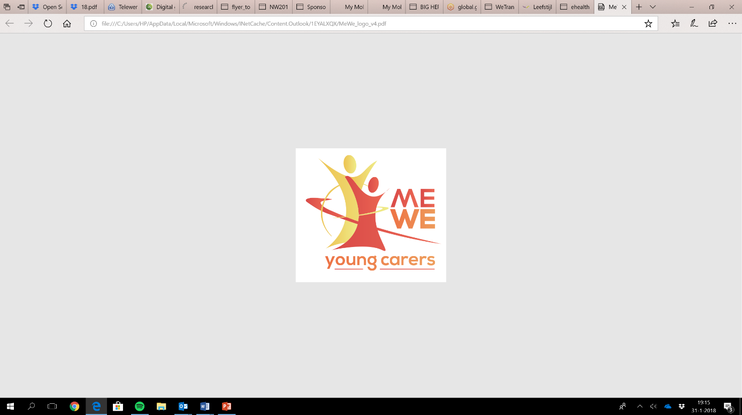
ME-WE Delphi Study
Summary Template first round v0.1

Instruction: in this document you will provide a summary on the available data of the first round of interviews per code (themes/topics). You can use your notes, transcripts (if available) and/or recorded interviews to provide this preliminary overview. We need this input to develop the interview guide for the second round, including a summary that will be shared with the experts before the second round. Please share the main findings in approximately 5 lines per topic and after that 5-10 lines per subtopic.
Date: 25-05-2018
Country: Sweden
Based on number of Experts: 10
Codes of the experts: P1-P10

- Visibility and awareness raising
Main findings (5 lines):
The concept of “YCs” is unknown for most Swedish citizens. The term “children as next of kin” has been used during the latest decade, but when it comes to the issue of YCs, the experts perceive the visibility and awareness as low or even very low, at local as well as at regional and national levels (P1-P10). The Swedish welfare systems are supposed to take full responsibility for care. Thus, no children should have to assume a caring role. The common Swedish view is that childhood should be free from such burdens (P1/P2/P4/P6/P9/P10). These assumptions make YCs invisible (P1/P2/P4/P6/P9/10).
1.1 Local level
Social workers and health care staff do not usually involve children and adolescents when planning care for parents or siblings. They often find it difficult to talk to the children, when the parents have problems, and Swedish confidentiality laws cause uncertainty about how much they are allowed to talk to the children/adolescents about the family situation. There are examples where staff have been forbidden to talk to clients’/patients’ children about the childrens situation and their needs (P1). It is likely that school staff notice that some children take a great responsibility at home, but it is not certain that the staff realize what this means for the individual child (P10).
1.2 Regional level
At a regional level, the term “children as next of kin” is often used but, in recent years, some regions have included the issues of YCs in their education for health care staff (P8). The awareness is generally low, but in some regions, it has increased slightly in recent years.
1.3 National level
Neither (A)YCs, nor children as next of kin, are mentioned in Swedish legislation. “You are not considered as a next of kin until you are eighteen years old” (P9). The life situation of (A)YCs has not been on the agenda until 2015, when the Swedish National Board of Health and Welfare was instructed to raise the issue. Since then, an initial survey has been carried out, to find out to what extent 15-year-olds are taking on a caring responsibility. “The aim was to raise the issue of YCs on the agenda but unfortunately, the study did not receive much attention” (P1). The awareness is still low, but has increased slightly in recent years.

- Strategies, interventions and programs to support (A)YC
Main findings (5 lines):
Experts discussed various strategies and programmes to support children whose parent or sibling needs interpretation assistance, or has disabilities, illnesses, mental health problems, or addiction. They also mentioned support strategies for children who have lost a parent or sibling.
2.1 Strategies, interventions and programs
Laws and regulations:
According to the Swedish Health Care Act 2010, health care staff who care for patients (who are parents) with addiction, disabilities or severe illness, or when a parent dies, have the responsibility to take into account the children’s needs for information, advice and support. Children have the right to receive information about their parents’ illness and/or changed behaviour. This is not so clearly formulated for social workers.
In addition, Swedish legislation gives people with disabilities or severe illnesses the right to receive help and support in their daily life. This may to some extent be facilitating for YCs.
Education:
Individual information
Business cards with informative links.
Beardslees family intervention – when a parent suffers from mental health problems or addiction.
Welfare:
Supportive groups for children/adolescents whose parents have disabilities, or suffer from mental health problems or addiction, or for children who have been exposed to family violence.
Supportive groups for families in grief.
Supportive groups for families when a parent suffers from cancer.
Summer camps for children/adolescents whose parents suffer from mental health problems or addiction
“Children’s agents/representative” who represent the children of parents, who have severe illnesses, suffer from mental health problems, addiction, or other difficult problems.
Practical support for parents in their parenting role.
Training for professionals: Social care staff, health care staff, ambulance staff, police officers, children’s agents/representative.
Voluntary help and support phone lines
  - Goals, strengths and weaknesses
Laws and regulation:
- Current legislation, giving people with disabilities or severe illnesses the right to receive help and support in their daily life.
Goals: Making it possible for people with disabilities and severe illnesses to live their lives as independent as possible (meaning that children and adolescents do not have to take care of their parents). (+): May, to some extent facilitate life for YCs, since they are not alone in taking care of the parent. (-): It is very inflexible and does not meet the childrens’/adolescents’ needs. “A decision on help and support only includes the needs of the individual who is disabled/ill… If the children of the same family have needs that go beyond the parent’s ability, it is still not included in the decision to give children support”(P1).
Education:
- Individual information
Goals: To increase the child's knowledge of their parents' illness, mental illness or substance abuse. To relieve the children from feelings of guilt and shame, and to make them better prepared to continue to live in this life situation. (+): The children get more knowledge and may be relieved from guilt and shame (-): The children still have the same responsibility burden, and there may be a risk that this kind of effort will suppress the child’s ability to desperately cry for help (P10).
- Business cards with informative links.
Goals: To give children and adolescents opportunities to apply for knowledge (P6).
- Beardslees family intervention – when a parent suffers from mental health problems or addiction. To visit the family and meet the children in their home (P6/P7).
Goals: To get some knowledge about the children’s situation, to discuss the family situation together with parents and children, and to get the parents aware of the children’s situation.
Welfare:
- Supportive groups for children/adolescents whose parents have disabilities, or suffer from mental health problems or addiction, or for children who have been exposed to family violence.
Goals: Giving opportunities for children/adolescents to talk about their situation, to meet and get support from other children/adolescents who are in a similar situation, and to get support from professionals. (+): The children/adolescents get information about the disability/illness/addiction. They realize that they are not alone in being in such a situation. They get the opportunity to talk about their experiences (P2/P4/P7). They are being seen and listened to. (-): Many children/adolescents expect that once they have told their story, they will get more concrete and practical help. But those support groups just offer support in the form of information and dialogues (P2/P4/P7), and (A)YCs may be disappointed since they have told that “they were living in a difficult situation, taking a great responsibility at home, but nothing more happened, and of course there were some disappointments, since nothing more happened” (P2). There are no resources to provide concrete and practical help. “I could only get the help they had in their package, and I needed other things” (P7).
- Supportive groups for families in grief. “You meet and eat dinner. Then we divide the group into a children’s group, a youth group and a parent group, working with themes, using creative materials, while talking about death and associated reactions” (P6).
- Supportive groups for families when a parent suffers from cancer. The children and the healthy parent meet other families in a similar situation, for enjoyable and relaxing activities over a weekend (P6).
Goals: to give the children opportunities to relax together with the healthy parent, and to meet and play with other children who are in a similar situation. (+): To relax and play with the healthy parent and with other children. To have the opportunity to talk about the cancer without having to think about how this affects the sick parent. (-): The sick parent is not allowed to participate. Some parents find it difficult to accept that they cannot attend when their children are having a fun weekend (P6).
- Summer camps (e.g. with the organization Maskrosbarn- Dandelion Children Association). (+): To get away from responsibility, to relax and play with other children/adolescents who are in a similar situation. (-): Difficulties to leave the family, or to leave a parent alone at home. Unless the parent/family gets help and support, the YC is unable to join the camp (P7).
- Child groups and parent groups in parallel.
Goals: Support for the children. Support for the parents. Raising parents’ awareness of children’s situations (P3).
- Individual support: “Children’s agents/representative” who represent the children of parents, who have severe illnesses, suffer from mental health problems, or addiction (P5/P6).
Goals: Every child who has a parent with severe illness, mental health problem, or addiction, should have an adult who represents her/him and expresss her/his interests and needs.
- Practical support for parents in their parenting role. A new parental support model, for parents with neuropsychiatric disabilities. Together with the parents, you investigate what parental skills they need to practice, and how you can help them to manage their parenting role. For example, parents may receive text messages to remind them that it is time to send the children to school or nursery school, or someone visits the family in the morning and helps to get the children to school or nursery school (P10).
Goals: To provide parents with support at the level and to the extent they need to achieve a working everyday life for the whole family. (+): Parent support at low costs.
- Training for professionals:
Regional meetings for “childrens’ agents/representatives”, with education and opportunities for exchange of experiences (P6). Brochures about talking with children to severely ill parents (P6).
Goals: To improve the skills of the “children’s agents/representatives”
For all ambulance staff and police officers: a checklist to be used in connection with unexpected deaths outside hospitals. According to the checklist, which is placed in all ambulances and police cars in the county, ambulance staff and/or police officers should offer families the opportunity to be contacted by their health care centre within 72 hours, to check how the children are doing, and then to maintain contact for one year (P6).
Goals: To discover family needs for support, as early as possible.

Information and education for social care staff and health care staff, about the issue of (A)YCs (P5/P8).
Goals: Increased knowledge among staff.
- Voluntary help and supportive phone lines
Goals: To support people in various vulnerable situations (+): You get someone to talk to (-): There are often queues for these phone lines, and the majority of calls are not answered. There is no coordination between the different phone lines (P7).
2.3 Coping strategies
- By taking care of their parents, children/adolescents may gain some control over the situation, “gaining control and feeling that you are not completely powerless, is also a way to… to feel better” (P2).
- Important to strengthen the (A)YCs in their coping strategies by confirming that they are doing a great job, in order to move forward and discuss how we can reach a reasonable level of caring tasks (P2).
- Future needs to support the well-being and health situation of (A)YCs
Main findings (5 lines):
Experts identified a number of future needs. They discussed the need of: increased knowledge and acceptance of the phenomenon (A)YCs; reducing the stigma; family support; collaboration across professional boundaries; digital chatrooms and other digital communication forms for (A)YCs.
3.1 Future needs to support well-being / health situation
- To identify fragile families at an early stage, and giving the family the support they need before the situation has become burdensome for the children (P7/P10).
- Dissemination of knowledge about the issue of (A)YCs (P1-10).
- To make (A)YCs visible (P1-10).
- We need to accept that (A)YCs exist and that “this is not only a bad thing” (P2).
- To reduce the stigma (P2).
- All adults who meet children/adolescents in their profession, need to be better at identifying (A)YCs – professionals in schools and nursery schools have a major responsibility (P1-10).
- The school social worker should be a natural part in all children’s everyday life, from nursery school and throughout school time (P10).
- Collaboration between health care, specialized care, prisons, social care services, schools and voluntary organizations – in identifying and supporting (A)YCs (P1/P2/P3/P5/P6/P9/P10).
- Education for professionals about issues of (A)YCs, and how to handle various situations (P1-10).
- Legislation measures dealing with parents’ rights versus children’s rights (P10).
- Adopting a family perspective – to consider the family as a whole, include the children’s needs when estimating parents’ need for support (P1), and support the parents in their parenting role (P4/P5/P10).
- To introduce Beardslees’ family intervention in somatic care as well as in psychiatric care (P6/P7). To make the parents aware of the roles their children take at home (P3)
- Not only identify (A)YCs and listen to their stories, but also ask them about their needs (P5) and offer more concrete, practical help and support (P1/P4). “We should not support (A)YCs in being (A)YCs, but we should consider how the society can relieve them of this… this caring responsibility, their caring burden” (P1).
- Digital group meetings for (A)YCs, makes it possible to communicate with other (A)YCs across a larger geographical area (P7).
- A digital chat room, where the (A)YCs can get support from each other and/or from a professional adult can be perceived as less frightening than to make a call to make an appointment with a professional (P7).
- A national coordination of information as well as help and support efforts, easy to find on the Internet, with addresses and links to social services, health care, help and support phone lines, chat rooms, forums, volunteer organizations, etc. (P7).
3.2 AYC needs
- Every (A)YC has unique needs
- Notice that you are not alone
- Connecting with fellow (A)YCs
- Someone who listen to their story
- To be relieved from responsibility
3.3 Family needs
- Every family has unique needs
- Parents need to get support in their parenting role, and support in structuring everyday life in the family (both for parents and for children).
3.4 Professional needs
- Education about YCs
- Short information films, where (A)YCs talk about their situation as a (A)YC, could be used in education for health care staff (P8).
- Education and guidelines to ask, “Do you have any children?”
- Education and guidelines for supplementary questions about the children’s situation.
- Education and guidelines how to include the children’s needs in the caring plan for the parent (or sibling).
3.5 Working concepts to reach (A)YCs
It is possible to reach (A)YCs through social and health care. When adults seek for care, help, or support, their “children’s situation and needs should be investigated” (P1). It is also possible to reach (A)YCs through school and nursery school (P1-P10). In addition, we can reach (A)YCs through their leisure activities and social media (P5/P7).
3.6 Responsibility
The experts consider that everyone who meets children and adolescents in their profession, has the responsibility to identify (A)YCs and their needs, and they emphasize schools’ responsibilities to pay attention to children’s home situation and needs (P1-10), since “all children from six or seven years are in school five days a week” (P3).

3.8 Funding
- Funding needs to be coordinated at a national level.
- Municipalities, as well as county councils need to collaborate with each other as well as with voluntary organizations, to ensure that the money is sufficient to meet (A)YCs’ needs.
- Digital solutions may be a cost-effective way to provide help and support for (A)YCs.
- Promoting young people’s mental health and wellbeing means saving money in the long run.

Rosita Brolin, Elizabeth Hanson, LNU, Sweden 28.5.2018.

