Model Validation Report
Generated on: 2025-12-16 08:40:33 CST
Validated by: TanML UI (Refit-only)
Model File: (refit in UI)
Task: Classification
Table of Contents
1. Model Metadata 3
2. Performance Metrics 3
a. Classification Metrics 3
b. Classification Visuals 3
b.1. ROC Curve 3
b.2. Precision–Recall Curve 3
b.3. Cumulative Gain / Lift 4
b.4. Calibration (Reliability) Curve 4
b.5. Confusion Matrix (image) 4
b.6. Confusion Matrix (Classification) 4
b.7. Decile Lift Table 4
b.8. KS Curve (Kolmogorov–Smirnov) 4
3. Data Quality (Cleaned Data) 4
4. Raw Data Validation 5
5. Correlation Analysis 5
a. Top High-Correlation Feature Pairs (|r| ≥ Threshold) 5
b. Correlation Heatmap 5
6. Variance Inflation Factor (VIF) Check 5
7. Exploratory Data Analysis (EDA) 5
8. Benchmark (Logistic Regression Baseline) 6
a. Logistic Regression Results 6
b. Logistic Regression Coefficients 6
c. Baseline Metrics 6
9. Stress Testing Results 6
10. Input Cluster Coverage Check 6
a. Cluster Summary Table 6
b. Cluster Distribution Plot 6
11. Rule Engine Check 6
12. Model Contents Summary 7
a. Model Class: {{ModelMetaCheck.model_class}} 7
b. Module: {{ModelMetaCheck.module}} 7
c. Hyperparameters: 7
d. Attributes: 7
13. Explainability 7
a. SHAP Summary Plot 7
b. Top Features by Mean |SHAP| (Bar) 7
c. Top SHAP Features 7

Model Metadata
Model Type: LogisticRegression
Feature Count: 5
Feature Names: feature_0, feature_1, feature_2, feature_3, feature_4
Training Rows: 1400
Target Balance: 0: 705, 1: 695

Performance Metrics

Classification Metrics
AUC-ROC: 0.96
KS: 0.80
F1: 0.88
PR AUC: 0.96
Gini: 0.92
Precision: 0.90
Recall: 0.87
Accuracy: 0.89
Brier Score: 0.08

Classification Visuals

ROC Curve
Shows the trade-off between True Positive Rate (sensitivity) and False Positive Rate (1 – specificity) across thresholds. The closer the curve is to the top-left corner, the better the model’s discrimination ability.
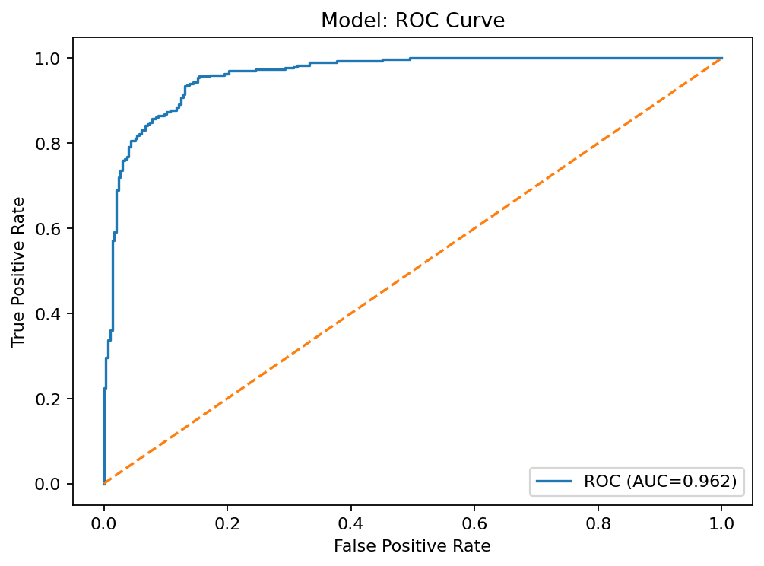

Precision–Recall Curve
Plots precision vs recall at different thresholds. Particularly useful when the positive class is rare, since it focuses on the model’s ability to find positives without producing too many false alarms.
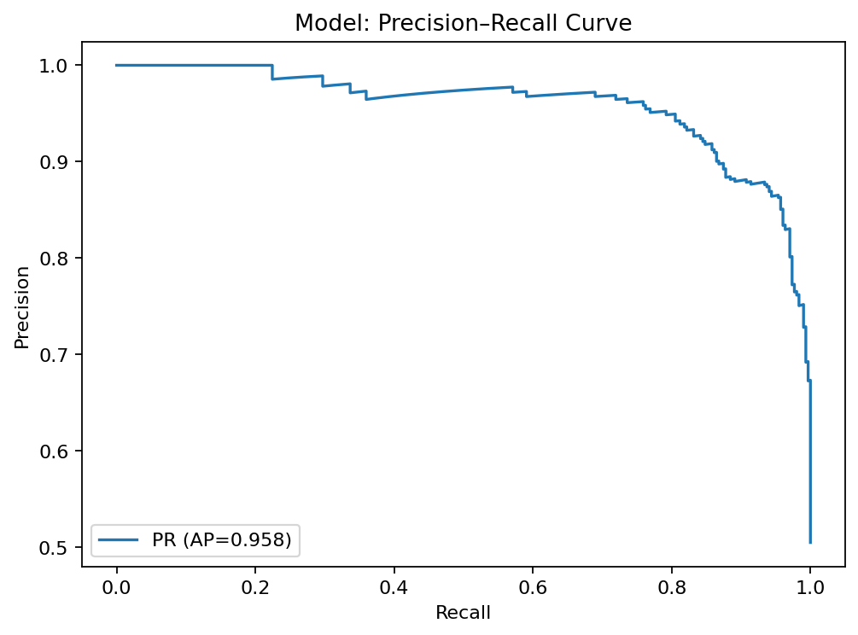

Cumulative Gain / Lift
Compares model targeting to random selection. A model with good lift quickly captures a high proportion of true positives in the top deciles, showing value for prioritization strategies.
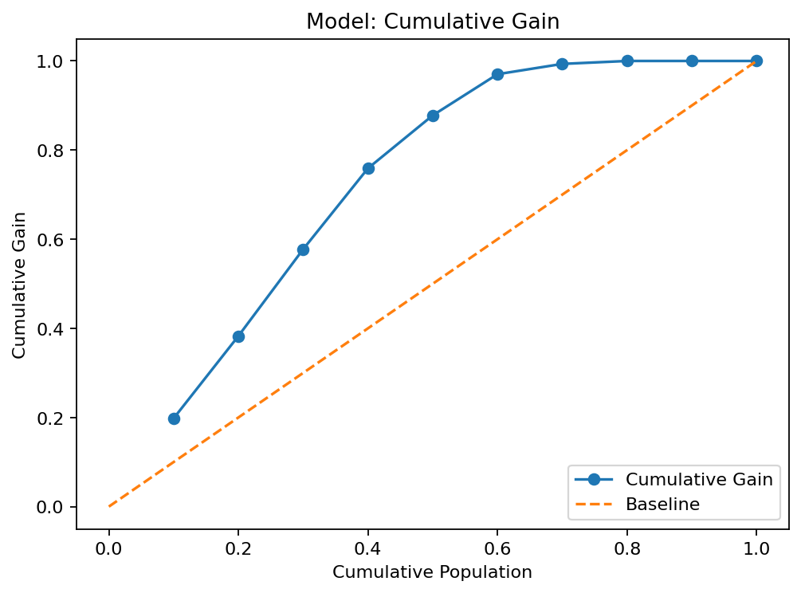

Calibration (Reliability) Curve
Plots predicted probability vs observed probability. A perfectly calibrated model will follow the diagonal; deviations indicate over- or under-confidence in predicted probabilities.
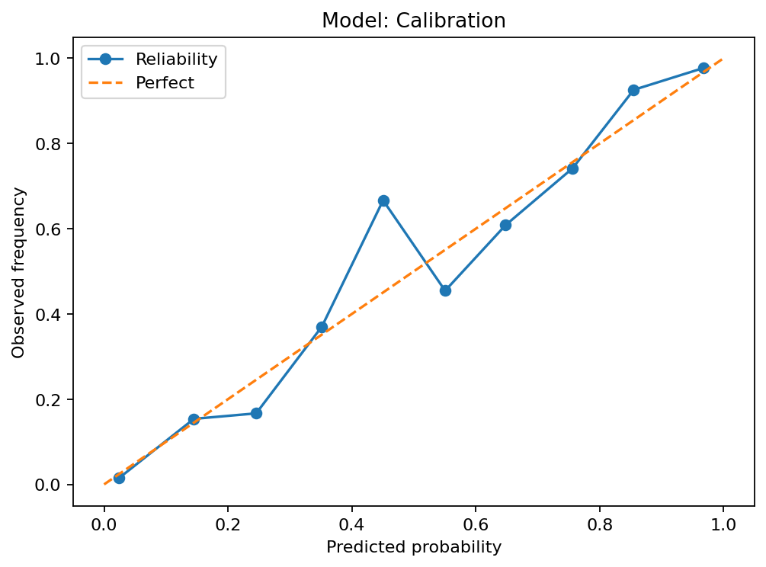

Confusion Matrix (image)
Visual heatmap of predicted vs actual classes. Helps identify where the model is making the most errors.
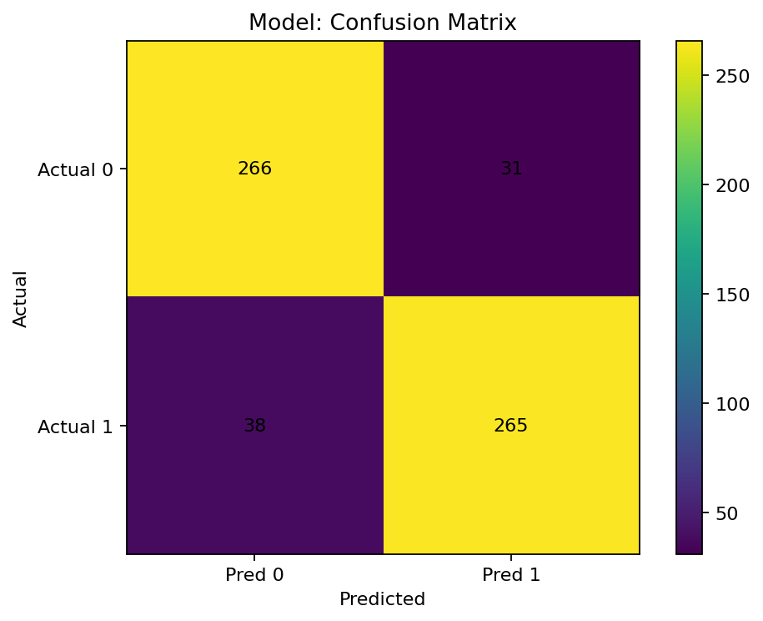

Confusion Matrix (Classification)
 | Pred 0 | Pred 1
Actual 0 | 266 | 31
Actual 1 | 38 | 265

Decile Lift Table
Decile | Total | Events | Avg  score | Event  rate | Lift | Cum.  events | Cum.  total | Cum.  capturerate | Cum.  population | Cum.  gain
1 | 60 | 60 | 1.0 | 1.0 | 1.98 | 60 | 60 | 0.2 | 0.1 | 0.2
2 | 60 | 56 | 0.98 | 0.93 | 1.85 | 116 | 120 | 0.38 | 0.2 | 0.38
3 | 60 | 59 | 0.93 | 0.98 | 1.95 | 175 | 180 | 0.58 | 0.3 | 0.58
4 | 60 | 55 | 0.84 | 0.92 | 1.82 | 230 | 240 | 0.76 | 0.4 | 0.76
5 | 60 | 36 | 0.65 | 0.6 | 1.19 | 266 | 300 | 0.88 | 0.5 | 0.88
6 | 60 | 28 | 0.36 | 0.47 | 0.92 | 294 | 360 | 0.97 | 0.6 | 0.97
7 | 60 | 7 | 0.14 | 0.12 | 0.23 | 301 | 420 | 0.99 | 0.7 | 0.99
8 | 60 | 2 | 0.04 | 0.03 | 0.07 | 303 | 480 | 1.0 | 0.8 | 1.0
9 | 60 | 0 | 0.01 | 0.0 | 0.0 | 303 | 540 | 1.0 | 0.9 | 1.0
10 | 60 | 0 | 0.0 | 0.0 | 0.0 | 303 | 600 | 1.0 | 1.0 | 1.0

KS Curve (Kolmogorov–Smirnov)
Measures maximum separation between the cumulative distribution of positives and negatives. Higher KS indicates better class separation.
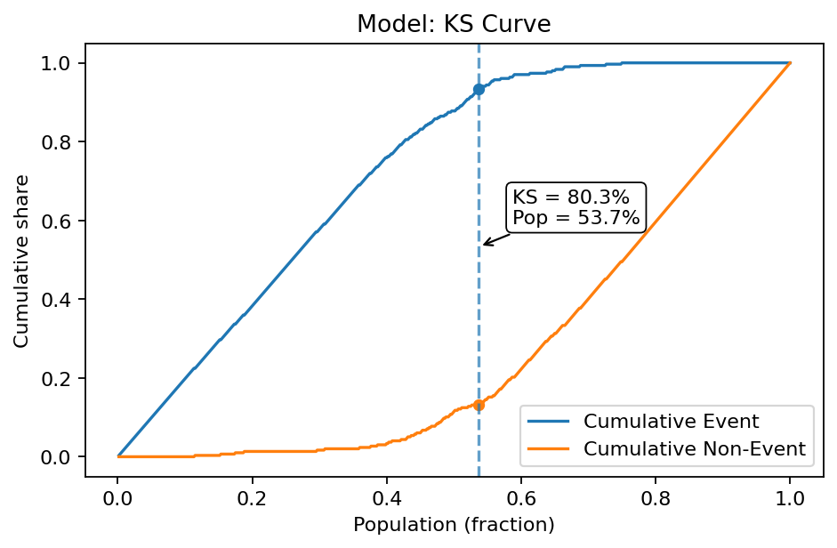

Data Quality (Cleaned Data)
Missing (Train): 0.00%
Missing (Test): 0.00%
Columns With Missing (Train): None detected
Columns With Missing (Test): None detected
Constant Columns: None detected

Raw Data Validation
Total Rows: Dataset not provided
Total Columns: Dataset not provided
Average Missing: Dataset not provided
Columns With Missing: Dataset not provided
Duplicate Rows: Dataset not provided
Constant Columns: Dataset not provided

Correlation Analysis

Top High-Correlation Feature Pairs (|r| ≥ Threshold)
feature_i | feature_j | corr | n_used | pct_missing_i | pct_missing_j
feature_1 | feature_3 | -0.9869 | 1400 | 0.00 | 0.00
Note: Displayed only if high-correlation pairs exist; otherwise, none are generated.

Correlation Heatmap
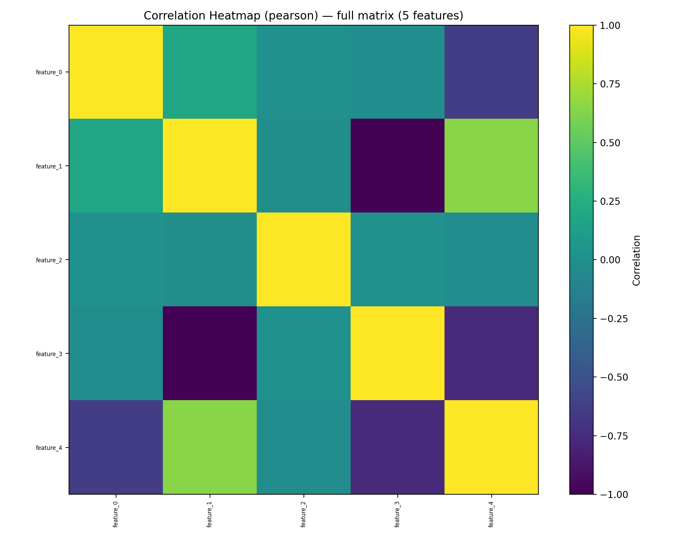
Method: pearson, Threshold: 0.80,
Features plotted: 5 of 5,
High-corr pairs ≥ threshold: 1 (of 10)
Full CSV: .ui_runs/31e5cdae/artifacts/correlation/correlation_top_pairs.csv
Pearson Correlation CSV: .ui_runs/31e5cdae/artifacts/correlation/pearson_corr.csv
Spearman Correlation CSV: .ui_runs/31e5cdae/artifacts/correlation/spearman_corr.csv

Variance Inflation Factor (VIF) Check
Feature | VIF
Intercept | 3.47
feature_0 | inf
feature_1 | inf
feature_2 | 1.0
feature_3 | inf
feature_4 | inf
default_flag | 2.48

Exploratory Data Analysis (EDA)
Summary Stats CSV: reports/eda/summary_stats.csv
Missing Values CSV: reports/eda/missing_values.csv
Distribution Plots
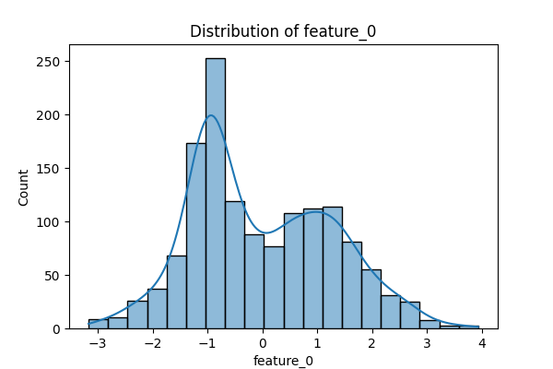 | 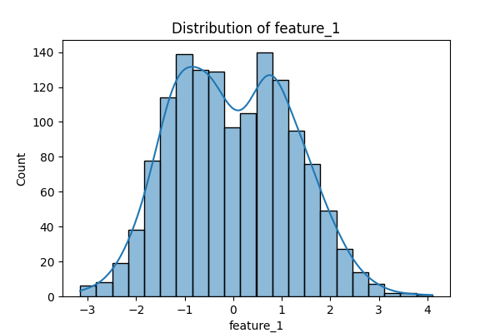 | 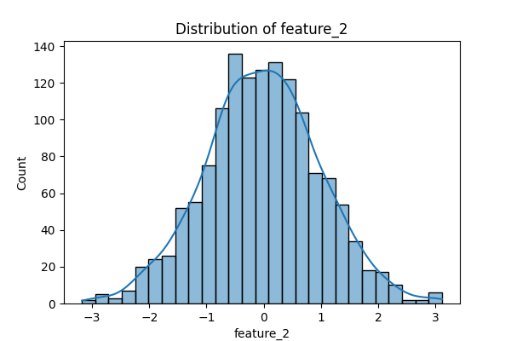
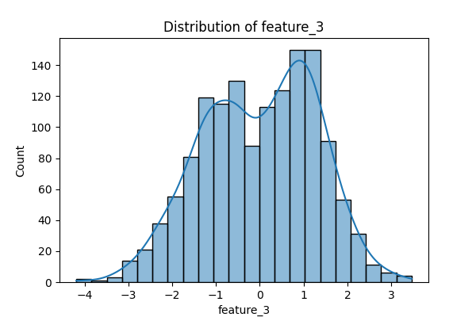 | 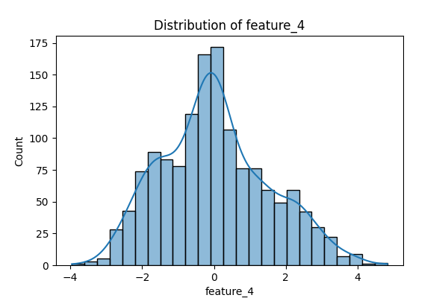 | 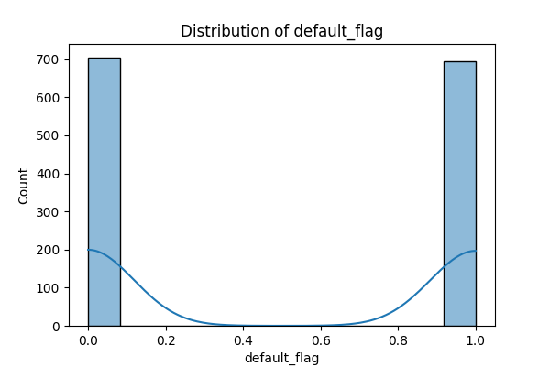

Benchmark (Logistic Regression Baseline)

Logistic Regression Results
Results: Logit
==================================================================
Model: Logit Method: MLE
Dependent Variable: default_flag Pseudo R-squared: 0.636
Date: 2025-12-16 08:40 AIC: 718.3056
No. Observations: 1400 BIC: 749.7709
Df Model: 5 Log-Likelihood: -353.15
Df Residuals: 1394 LL-Null: -970.37
Converged: 1.0000 LLR p-value: 1.0207e-264
No. Iterations: 35.0000 Scale: 1.0000
-------------------------------------------------------------------
Coef. Std.Err. z P>|z| [0.025 0.975]
-------------------------------------------------------------------
const -0.2631 0.1008 -2.6103 0.0090 -0.4606 -0.0655
feature_0 -2.0880 1.9500 -1.0707 0.2843 -5.9099 1.7340
feature_1 -27.4396 5.5140 -4.9764 0.0000 -38.2468 -16.6324
feature_2 0.0558 0.1000 0.5587 0.5764 -0.1401 0.2518
feature_3 -30.9545 6.5676 -4.7132 0.0000 -43.8269 -18.0822
feature_4 -10.2957 3.1494 -3.2691 0.0011 -16.4685 -4.1230
==================================================================

Logistic Regression Coefficients
feature | coef | std err | z | P>|z| | ci_low | ci_high
const | -0.2631 | 0.1008 | -2.6103 | 0.009 | -0.4606 | -0.0655
feature_0 | -2.088 | 1.95 | -1.0707 | 0.2843 | -5.9099 | 1.734
feature_1 | -27.4396 | 5.514 | -4.9764 | 0.0 | -38.2468 | -16.6324
feature_2 | 0.0558 | 0.1 | 0.5587 | 0.5764 | -0.1401 | 0.2518
feature_3 | -30.9545 | 6.5676 | -4.7132 | 0.0 | -43.8269 | -18.0822
feature_4 | -10.2957 | 3.1494 | -3.2691 | 0.0011 | -16.4685 | -4.123

Baseline Metrics
metric | value
ROC-AUC | 0.9600
KS | 0.8100
F1 | 0.8900
PR AUC | 0.9600
Gini | 0.9300
Precision | 0.8900
Recall | 0.8900
Accuracy | 0.8900
Brier Score | 0.0700
* Calculated on the same dataset that was used to train and evaluate the primary model.

Stress Testing Results
feature | perturbation | accuracy | auc | delta_accuracy | delta_auc
feature_0 | +1.0% | 0.89 | 0.96 | 0.0 | 0.0
feature_0 | -1.0% | 0.89 | 0.96 | 0.0 | 0.0
feature_1 | +1.0% | 0.89 | 0.96 | 0.0 | 0.0
feature_1 | -1.0% | 0.89 | 0.96 | 0.0 | -0.0
feature_2 | +1.0% | 0.89 | 0.96 | 0.0 | 0.0
feature_2 | -1.0% | 0.89 | 0.96 | 0.0 | 0.0
feature_3 | +1.0% | 0.89 | 0.96 | 0.0 | 0.0
feature_3 | -1.0% | 0.89 | 0.96 | 0.0 | 0.0
feature_4 | +1.0% | 0.89 | 0.96 | 0.0 | 0.0
feature_4 | -1.0% | 0.89 | 0.96 | 0.0 | -0.0

Input Cluster Coverage Check
A K-Means clustering algorithm was applied to the cleaned dataset to evaluate input space coverage. This analysis highlights the distribution of samples across different clusters, assisting in the identification of any imbalance or concentration that could affect model behavior.
Input cluster distribution (saved to CSV): reports/clusters/cluster_distribution.csv

Cluster Summary Table
Cluster | Count | Percent
None | 238 | 17.0
1 | 302 | 21.57
2 | 338 | 24.14
3 | 243 | 17.36
4 | 279 | 19.93

Cluster Distribution Plot
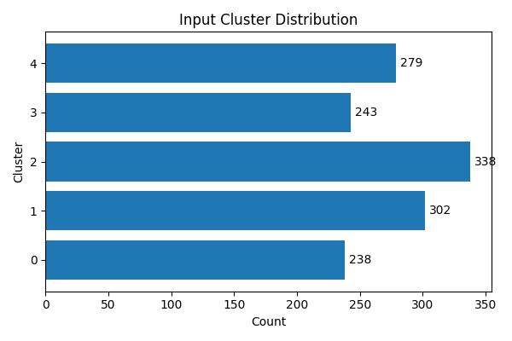

Rule Engine Check
Overall Pass: ✅ Yes
Rule Details: No rule results were generated for this run.

Model Contents Summary

Model Class: LogisticRegression

Module: sklearn.linear_model._logistic

Hyperparameters:
- C: 1.0
- class_weight: None
- dual: False
- fit_intercept: True
- intercept_scaling: 1
- l1_ratio: 0.0
- max_iter: 1000
- n_jobs: None
- penalty: l2
- random_state: 42
- solver: lbfgs
- tol: 0.0001
- verbose: 0
- warm_start: False

Attributes:
- penalty: l2
- C: 1.0
- l1_ratio: 0.0
- dual: False
- tol: 0.0001
- fit_intercept: True
- intercept_scaling: 1
- class_weight: None
- random_state: 42
- solver: lbfgs
- max_iter: 1000
- verbose: 0
- warm_start: False
- n_jobs: None
- feature_names_in_: ['feature_0' 'feature_1' 'feature_2' 'feature_3' 'feature_4']
- n_features_in_: 5
- classes_: [0 1]
- n_iter_: [8]
- coef_: [[-0.33602782 -1.16223001 0.07507529 1.19796925 -0.81568622]]
- intercept_: [-0.22935689]

Explainability

SHAP Summary Plot
SHAP (SHapley Additive exPlanations) is used to explain the impact of each input feature on the model's predictions. The SHAP summary plot below shows the magnitude and direction of influence of the top features across a sample of predictions. Features at the top have the highest average impact. Red indicates higher feature values, and blue indicates lower values. This plot helps identify which features the model relies on most and whether they align with domain knowledge. Only a subset of the test data is used for SHAP due to performance considerations.

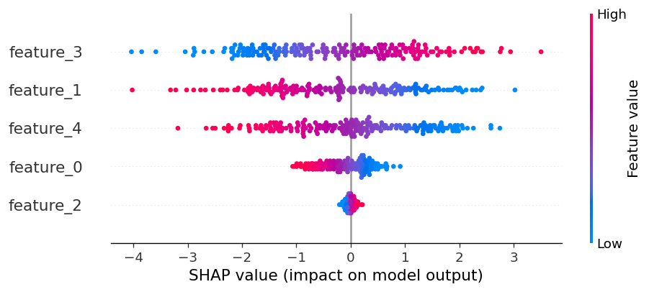

Top Features by Mean |SHAP| (Bar)
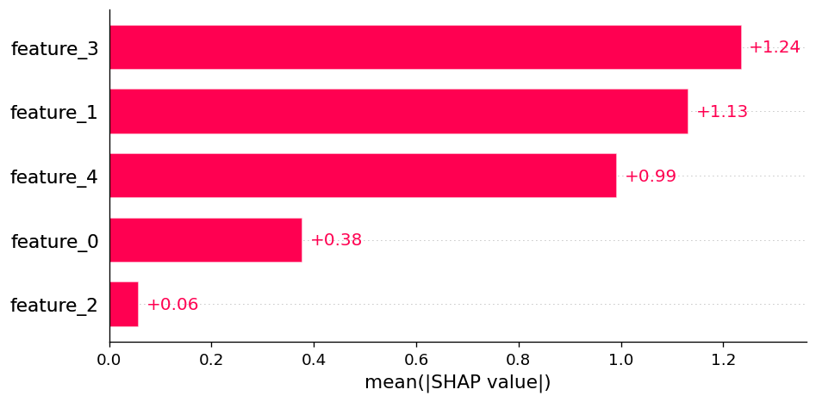

Top SHAP Features
feature | mean_abs_shap
feature_3 | 1.2359643574328956
feature_1 | 1.1323530877684211
feature_4 | 0.9922503492409729
feature_0 | 0.3783337270997057
feature_2 | 0.05821241462420427

