Model Validation Report
Generated on: 2025-12-17 19:01 UTC
Validated by: TanML
Model File: RandomForestRegressor.pkl
Task: Regression
Table of Contents
1. Model Metadata 3
2. Performance Metrics 3
a. Regression Metric 3
b. Regression Visuals 3
b.1. Predicted vs Actual 3
b.2. Residuals vs Predicted 3
b.3. Residual Distribution 4
b.4. Residuals (Q–Q Plot) 4
b.5. Absolute Error (Box Plot) 4
b.6. Absolute Error (Violin Plot) 4
3. Data Quality (Cleaned Data) 4
4. Raw Data Validation 4
5. Correlation Analysis 5
a. Top High-Correlation Feature Pairs (|r| ≥ Threshold) 5
b. Correlation Heatmap 5
6. Variance Inflation Factor (VIF) Check 5
7. Exploratory Data Analysis (EDA) 5
8. Linear Regression Results (Full OLS Summary) 5
a. OLS Regression Results 5
b. OLS Coefficients (Regression) 6
9. Stress Testing Results 6
10. Input Cluster Coverage Check 6
a. Cluster Summary Table 6
b. Cluster Distribution Plot 6
11. Rule Engine Check 6
12. Model Contents Summary 6
a. Model Class: {{ModelMetaCheck.model_class}} 6
b. Module: {{ModelMetaCheck.module}} 6
c. Hyperparameters: 6
d. Attributes: 6
13. Explainability 6
a. SHAP Summary Plot 6
b. Top Features by Mean |SHAP| (Bar) 7
c. Top SHAP Features 7

Model Metadata
Model Type: RandomForestRegressor
Feature Count: 10
Feature Names: feature_0, feature_1, feature_2, feature_3, feature_4, feature_5, feature_6, feature_7, feature_8, feature_9
Training Rows: 400
Target Balance: Mean: 2.40, Range: -413.57 to 352.14, Std: 146.22

Performance Metrics
2a. Cross-Validation Performance Summary (Robust)
Metric | Mean | Std Dev | P05 | P50 | P95
RMSE | 0.5000 | 0.1000 | 0.4000 | 0.5000 | 0.6000
MAE | 0.4000 | 0.0500 | 0.3500 | 0.4000 | 0.4500
Median AE | 0.4000 | 0.0500 | 0.3500 | 0.4000 | 0.4500
R2 Score | 0.9000 | 0.0200 | 0.8800 | 0.9000 | 0.9200

Regression Metric
RMSE: 70.75
MAE: 54.15
R²: 0.75
Adjusted R²: 0.72
Median AE: 40.48
MAPE/SMAPE: 169.41% (MAPE)
Metric Notes: None

Regression Visuals
Visual diagnostics complement the numerical metrics by showing how predictions compare to actuals and whether residuals follow expected patterns.

Predicted vs Actual
Shows how closely model predictions align with true target values. Points near the diagonal line indicate good predictive accuracy.
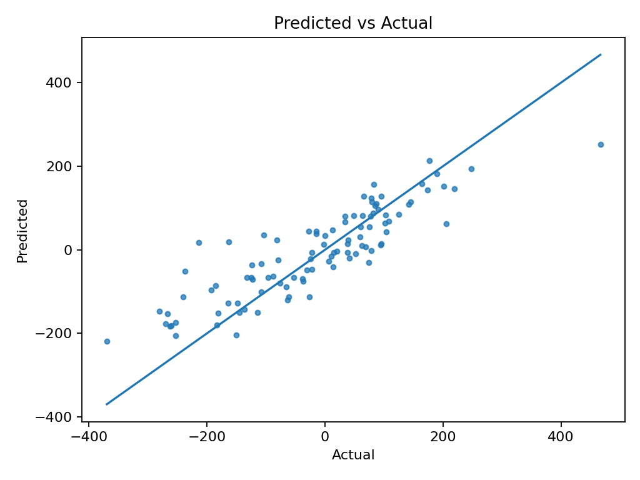

Residuals vs Predicted
Plots errors against predicted values. Random scatter around zero suggests well-specified model; visible patterns indicate potential bias.
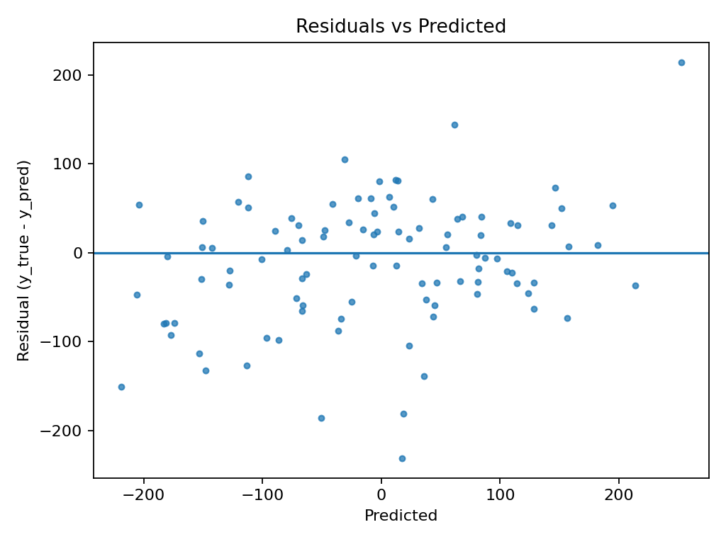

Residual Distribution
Histogram of residuals. A symmetric, bell-shaped distribution suggests errors are centered and approximately normal.
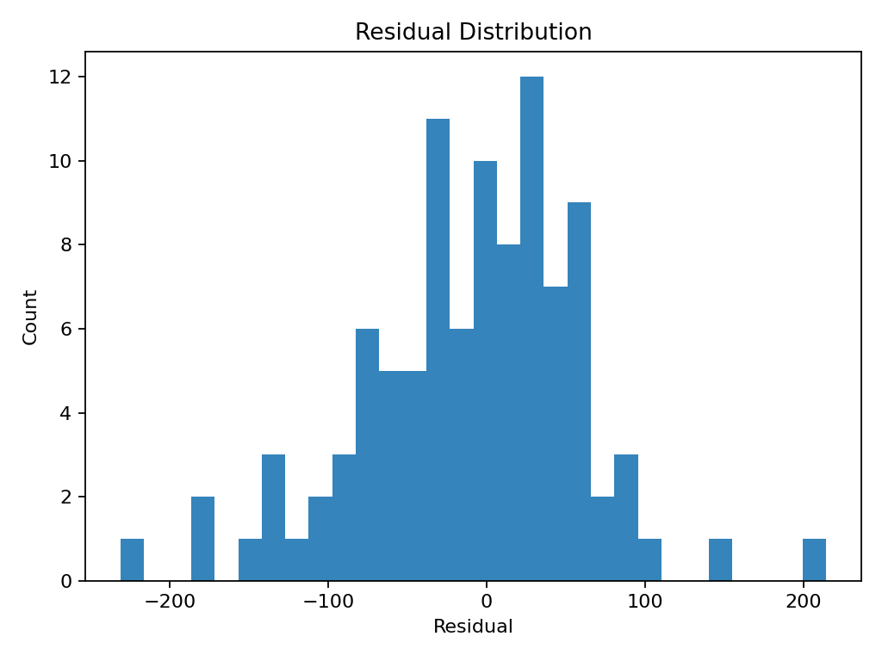

Residuals (Q–Q Plot)
Compares residual quantiles to a normal distribution. Close alignment with the diagonal line supports the assumption of normal errors.
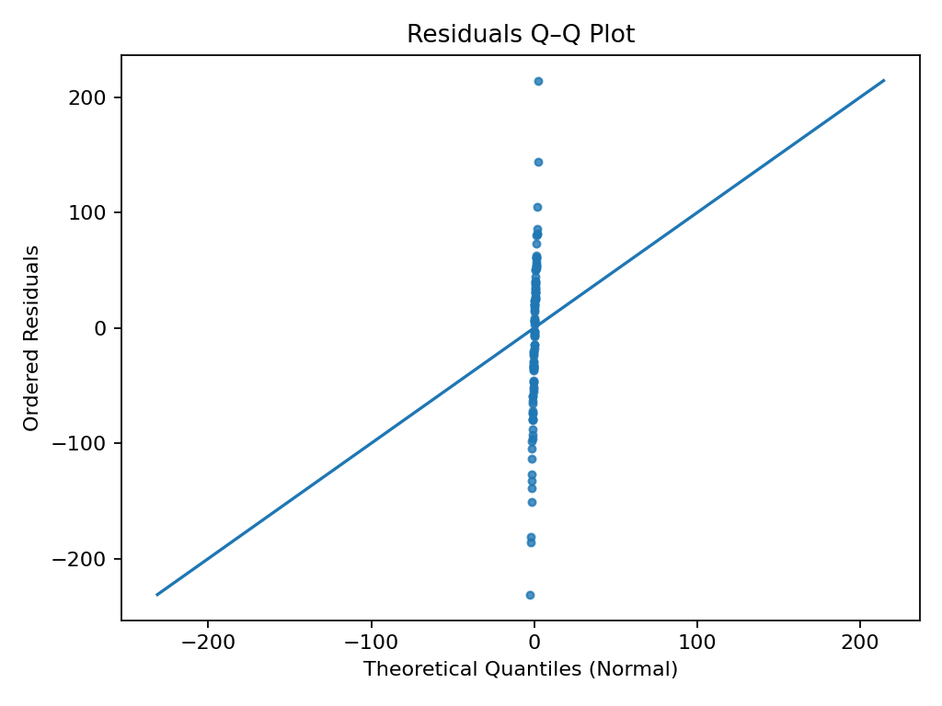

Absolute Error (Box Plot)
Boxplot of absolute errors. Shows the spread and presence of outliers in model error magnitudes.
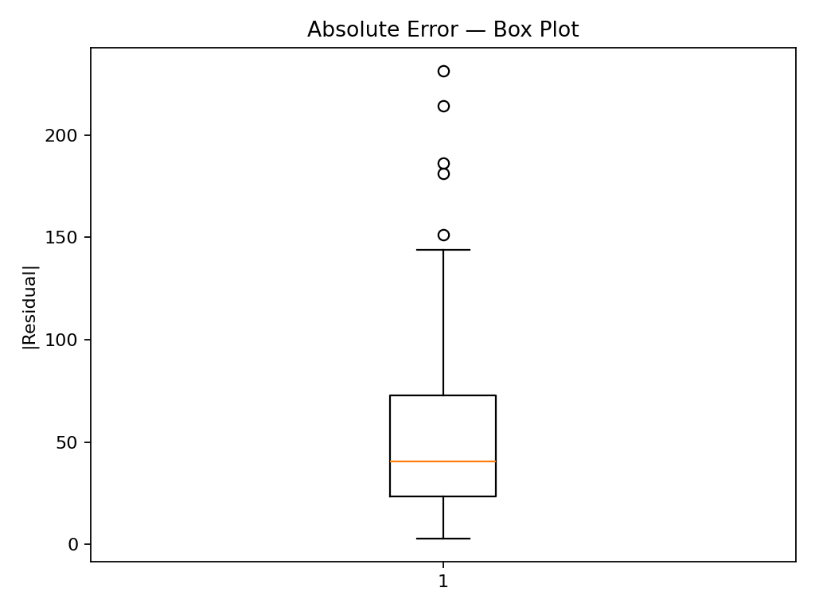

Absolute Error (Violin Plot)
Violin plot of absolute errors. Combines distribution shape with summary statistics to highlight variability and asymmetry in error magnitudes.
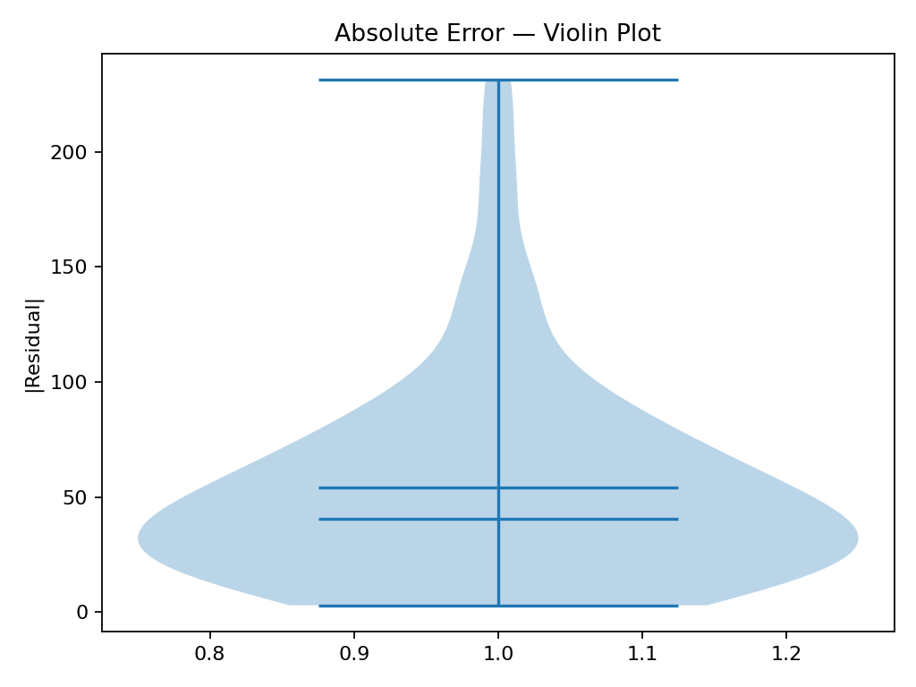

Data Quality (Cleaned Data)
Missing (Train): nan%
Missing (Test): nan%
Columns With Missing (Train): None detected
Columns With Missing (Test): None detected
Constant Columns: None detected

Raw Data Validation
Total Rows: Dataset not provided
Total Columns: Dataset not provided
Average Missing: Dataset not provided
Columns With Missing: Dataset not provided
Duplicate Rows: Dataset not provided
Constant Columns: Dataset not provided

Correlation Analysis

Top High-Correlation Feature Pairs (|r| ≥ Threshold)
Note: Displayed only if high-correlation pairs exist; otherwise, none are generated.

Correlation Heatmap
(image not available)
Method: , Threshold: —,
Features plotted: — of 0,
High-corr pairs ≥ threshold: — (of —)
Full CSV:
Pearson Correlation CSV:
Spearman Correlation CSV:
Notes:
- ⚠️ Not enough numeric features for correlation.

Variance Inflation Factor (VIF) Check
_No VIF results were generated for this run._

Exploratory Data Analysis (EDA)
Summary Stats CSV: N/A
Missing Values CSV: N/A
Distribution Plots
(no plots available)

Linear Regression Results (Full OLS Summary)

OLS Regression Results
OLS Regression Results
==============================================================================
Dep. Variable: target R-squared: 1.000
Model: OLS Adj. R-squared: 1.000
Method: Least Squares F-statistic: 3.633e+06
Date: Wed, 17 Dec 2025 Prob (F-statistic): 0.00
Time: 13:01:57 Log-Likelihood: -272.21
No. Observations: 400 AIC: 566.4
Df Residuals: 389 BIC: 610.3
Df Model: 10
Covariance Type: nonrobust
==============================================================================
coef std err t P>|t| [0.025 0.975]
------------------------------------------------------------------------------
const -0.0154 0.024 -0.630 0.529 -0.064 0.033
feature_0 41.7780 0.026 1607.595 0.000 41.727 41.829
feature_1 65.0551 0.025 2585.912 0.000 65.006 65.105
feature_2 18.9850 0.023 819.948 0.000 18.939 19.031
feature_3 46.1078 0.024 1895.968 0.000 46.060 46.156
feature_4 24.7120 0.024 1013.190 0.000 24.664 24.760
feature_5 16.8079 0.025 672.061 0.000 16.759 16.857
feature_6 82.4685 0.024 3486.350 0.000 82.422 82.515
feature_7 64.5115 0.023 2753.683 0.000 64.465 64.558
feature_8 7.3226 0.026 281.470 0.000 7.271 7.374
feature_9 28.6353 0.025 1127.718 0.000 28.585 28.685
==============================================================================
Omnibus: 4.531 Durbin-Watson: 1.903
Prob(Omnibus): 0.104 Jarque-Bera (JB): 4.273
Skew: 0.232 Prob(JB): 0.118
Kurtosis: 3.203 Cond. No. 1.33
==============================================================================
Notes:
[1] Standard Errors assume that the covariance matrix of the errors is correctly specified.

OLS Coefficients (Regression)
feature | coef | std err | t | P>|t| | ci_low | ci_high
const | -0.0154 | 0.0245 | -0.6299 | 0.5292 | -0.0635 | 0.0327
feature_0 | 41.778 | 0.026 | 1607.5954 | 0.0 | 41.7269 | 41.8291
feature_1 | 65.0551 | 0.0252 | 2585.9124 | 0.0 | 65.0056 | 65.1045
feature_2 | 18.985 | 0.0232 | 819.948 | 0.0 | 18.9395 | 19.0305
feature_3 | 46.1078 | 0.0243 | 1895.9682 | 0.0 | 46.06 | 46.1556
feature_4 | 24.712 | 0.0244 | 1013.1901 | 0.0 | 24.6641 | 24.76
feature_5 | 16.8079 | 0.025 | 672.0614 | 0.0 | 16.7587 | 16.857
feature_6 | 82.4685 | 0.0237 | 3486.3504 | 0.0 | 82.422 | 82.515
feature_7 | 64.5115 | 0.0234 | 2753.6825 | 0.0 | 64.4654 | 64.5575
feature_8 | 7.3226 | 0.026 | 281.4699 | 0.0 | 7.2715 | 7.3738
feature_9 | 28.6353 | 0.0254 | 1127.7179 | 0.0 | 28.5853 | 28.6852

Stress Testing Results
feature | perturbation | rmse | r2 | delta_rmse | delta_r2
feature_0 | +1.0% | 71.07 | 0.74 | 0.32 | -0.0
feature_0 | -1.0% | 70.75 | 0.75 | 0.0 | 0.0
feature_1 | +1.0% | 70.82 | 0.75 | 0.07 | -0.0
feature_1 | -1.0% | 70.75 | 0.75 | 0.0 | -0.0
feature_2 | +1.0% | 70.75 | 0.75 | 0.0 | 0.0
feature_2 | -1.0% | 70.75 | 0.75 | 0.0 | 0.0
feature_3 | +1.0% | 70.78 | 0.75 | 0.03 | -0.0
feature_3 | -1.0% | 70.75 | 0.75 | 0.0 | 0.0
feature_4 | +1.0% | 70.84 | 0.75 | 0.09 | -0.0
feature_4 | -1.0% | 70.75 | 0.75 | 0.0 | 0.0
feature_5 | +1.0% | 70.75 | 0.75 | 0.0 | 0.0
feature_5 | -1.0% | 70.75 | 0.75 | 0.0 | 0.0
feature_6 | +1.0% | 70.75 | 0.75 | 0.0 | 0.0
feature_6 | -1.0% | 70.75 | 0.75 | 0.0 | -0.0
feature_7 | +1.0% | 70.83 | 0.75 | 0.09 | -0.0
feature_7 | -1.0% | 70.78 | 0.75 | 0.04 | -0.0
feature_8 | +1.0% | 70.75 | 0.75 | 0.0 | 0.0
feature_8 | -1.0% | 70.75 | 0.75 | 0.0 | 0.0
feature_9 | +1.0% | 70.75 | 0.75 | 0.0 | 0.0
feature_9 | -1.0% | 70.75 | 0.75 | 0.0 | 0.0

Input Cluster Coverage Check
A K-Means clustering algorithm was applied to the cleaned dataset to evaluate input space coverage. This analysis highlights the distribution of samples across different clusters, assisting in the identification of any imbalance or concentration that could affect model behavior.
Input cluster distribution (saved to CSV):—

Cluster Summary Table
_No cluster summary was generated for this run._

Cluster Distribution Plot
(image not available)

Rule Engine Check
Overall Pass: ✅ Yes
Rule Details: No rule results were generated for this run.

Model Contents Summary

Model Class: RandomForestRegressor

Module: sklearn.ensemble._forest

Hyperparameters:
- bootstrap: True
- ccp_alpha: 0.0
- criterion: squared_error
- max_depth: None
- max_features: 1.0
- max_leaf_nodes: None
- max_samples: None
- min_impurity_decrease: 0.0
- min_samples_leaf: 1
- min_samples_split: 2
- min_weight_fraction_leaf: 0.0
- monotonic_cst: None
- n_estimators: 10
- n_jobs: None
- oob_score: False
- random_state: 42
- verbose: 0
- warm_start: False

Attributes:
- estimator: DecisionTreeRegressor()
- n_estimators: 10
- estimator_params: ('criterion', 'max_depth', 'min_samples_split', 'min_samples_leaf', 'min_weight_fraction_leaf', 'max_features', 'max_leaf_nodes', 'min_impurity_decrease', 'random_state', 'ccp_alpha', 'monotonic_cst')
- bootstrap: True
- oob_score: False
- n_jobs: None
- random_state: 42
- verbose: 0
- warm_start: False
- class_weight: None
- max_samples: None
- criterion: squared_error
- max_depth: None
- min_samples_split: 2
- min_samples_leaf: 1
- min_weight_fraction_leaf: 0.0
- max_features: 1.0
- max_leaf_nodes: None
- min_impurity_decrease: 0.0
- ccp_alpha: 0.0
- monotonic_cst: None
- feature_names_in_: ['feature_0' 'feature_1' 'feature_2' 'feature_3' 'feature_4' 'feature_5'
'feature_6' 'feature_7' 'feature_8' 'feature_9']
- n_features_in_: 10
- n_outputs_: 1
- estimator_: DecisionTreeRegressor()
- estimators_: [DecisionTreeRegressor(max_features=1.0, random_state=1608637542), DecisionTreeRegressor(max_features=1.0, random_state=1273642419), DecisionTreeRegressor(max_features=1.0, random_state=1935803228), DecisionTreeRegressor(max_features=1.0, random_state=787846414), DecisionTreeRegressor(max_features=1.0, random_state=996406378), DecisionTreeRegressor(max_features=1.0, random_state=1201263687), DecisionTreeRegressor(max_features=1.0, random_state=423734972), DecisionTreeRegressor(max_features=1.0, random_state=415968276), DecisionTreeRegressor(max_features=1.0, random_state=670094950), DecisionTreeRegressor(max_features=1.0, random_state=1914837113)]

Explainability

SHAP Summary Plot
SHAP (SHapley Additive exPlanations) is used to explain the impact of each input feature on the model's predictions. The SHAP summary plot below shows the magnitude and direction of influence of the top features across a sample of predictions. Features at the top have the highest average impact. Red indicates higher feature values, and blue indicates lower values. This plot helps identify which features the model relies on most and whether they align with domain knowledge. Only a subset of the test data is used for SHAP due to performance considerations.

(image not available)

Top Features by Mean |SHAP| (Bar)
(image not available)

Top SHAP Features

