Model Validation Report
Generated on: 2025-12-17 17:40 UTC
Validated by: TanML
Model File: RandomForestClassifier.pkl
Task: Classification
Table of Contents
1. Model Metadata 3
2. Performance Metrics 3
a. Classification Metrics 3
b. Classification Visuals 3
b.1. ROC Curve 3
b.2. Precision–Recall Curve 3
b.3. Cumulative Gain / Lift 4
b.4. Calibration (Reliability) Curve 4
b.5. Confusion Matrix (image) 4
b.6. Confusion Matrix (Classification) 4
b.7. Decile Lift Table 4
b.8. KS Curve (Kolmogorov–Smirnov) 4
3. Data Quality (Cleaned Data) 4
4. Raw Data Validation 5
5. Correlation Analysis 5
a. Top High-Correlation Feature Pairs (|r| ≥ Threshold) 5
b. Correlation Heatmap 5
6. Variance Inflation Factor (VIF) Check 5
7. Exploratory Data Analysis (EDA) 5
8. Benchmark (Logistic Regression Baseline) 6
a. Logistic Regression Results 6
b. Logistic Regression Coefficients 6
c. Baseline Metrics 6
9. Stress Testing Results 6
10. Input Cluster Coverage Check 6
a. Cluster Summary Table 6
b. Cluster Distribution Plot 6
11. Rule Engine Check 6
12. Model Contents Summary 7
a. Model Class: {{ModelMetaCheck.model_class}} 7
b. Module: {{ModelMetaCheck.module}} 7
c. Hyperparameters: 7
d. Attributes: 7
13. Explainability 7
a. SHAP Summary Plot 7
b. Top Features by Mean |SHAP| (Bar) 7
c. Top SHAP Features 7

Model Metadata
Model Type: RandomForestClassifier
Feature Count: 30
Feature Names: mean radius, mean texture, mean perimeter, mean area, mean smoothness, mean compactness, mean concavity, mean concave points, mean symmetry, mean fractal dimension, radius error, texture error, perimeter error, area error, smoothness error, compactness error, concavity error, concave points error, symmetry error, fractal dimension error, worst radius, worst texture, worst perimeter, worst area, worst smoothness, worst compactness, worst concavity, worst concave points, worst symmetry, worst fractal dimension
Training Rows: 455
Target Balance: 0: 170, 1: 285

Performance Metrics

Section 2a — CV Performance Summary
Metric | Mean | Std | P05 | P50 | P95
AUC-ROC | 0.9855 | 0.0112 | 0.9646 | 0.9879 | 0.9989
PR AUC | 0.9859 | 0.0126 | 0.9607 | 0.9899 | 0.9989
KS | 0.9296 | 0.0338 | 0.8779 | 0.9355 | 0.9801
Log Loss | 0.3117 | 0.2684 | 0.0809 | 0.1573 | 0.8648
Brier Score | 0.0372 | 0.0115 | 0.0211 | 0.0355 | 0.0540
Gini | 0.9710 | 0.0225 | 0.9292 | 0.9757 | 0.9977

Threshold-based Metrics (Policy: Default (0.5) | Thresh: 0.5000)
Metric | Mean | Std | P05 | P50 | P95
F1 | 0.9633 | 0.0160 | 0.9385 | 0.9655 | 0.9825
Precision | 0.9687 | 0.0217 | 0.9322 | 0.9815 | 0.9966
Recall | 0.9586 | 0.0252 | 0.9158 | 0.9649 | 0.9825
Accuracy | 0.9543 | 0.0198 | 0.9231 | 0.9560 | 0.9780
Bal. Acc. | 0.9528 | 0.0214 | 0.9214 | 0.9502 | 0.9813

Classification Metrics
AUC-ROC: 0.99 ± 0.01
KS: 0.89
F1: 0.96 ± 0.02
PR AUC: 0.99
Gini: 0.98
Precision: 0.97 ± 0.02
Recall: 0.96 ± 0.03
Accuracy: 0.95 ± 0.02
Brier Score: 0.04

Classification Visuals

ROC Curve
Shows the trade-off between True Positive Rate (sensitivity) and False Positive Rate (1 – specificity) across thresholds. The closer the curve is to the top-left corner, the better the model’s discrimination ability.
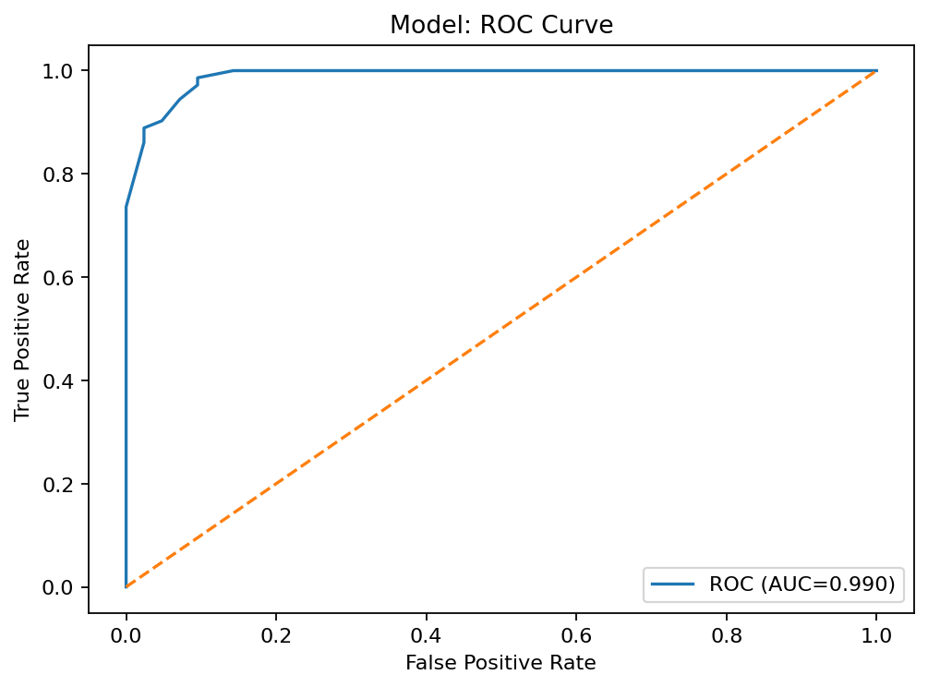

Precision–Recall Curve
Plots precision vs recall at different thresholds. Particularly useful when the positive class is rare, since it focuses on the model’s ability to find positives without producing too many false alarms.
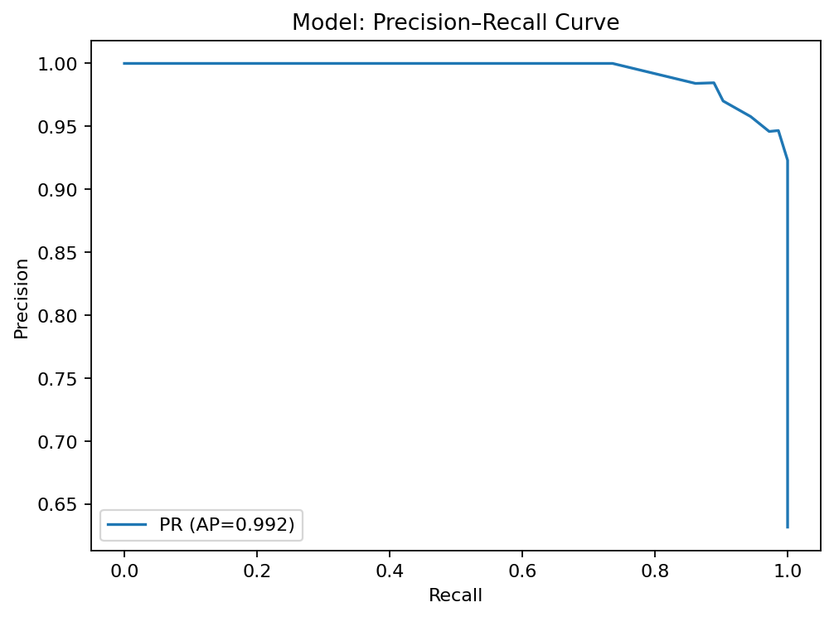

Cumulative Gain / Lift
Compares model targeting to random selection. A model with good lift quickly captures a high proportion of true positives in the top deciles, showing value for prioritization strategies.
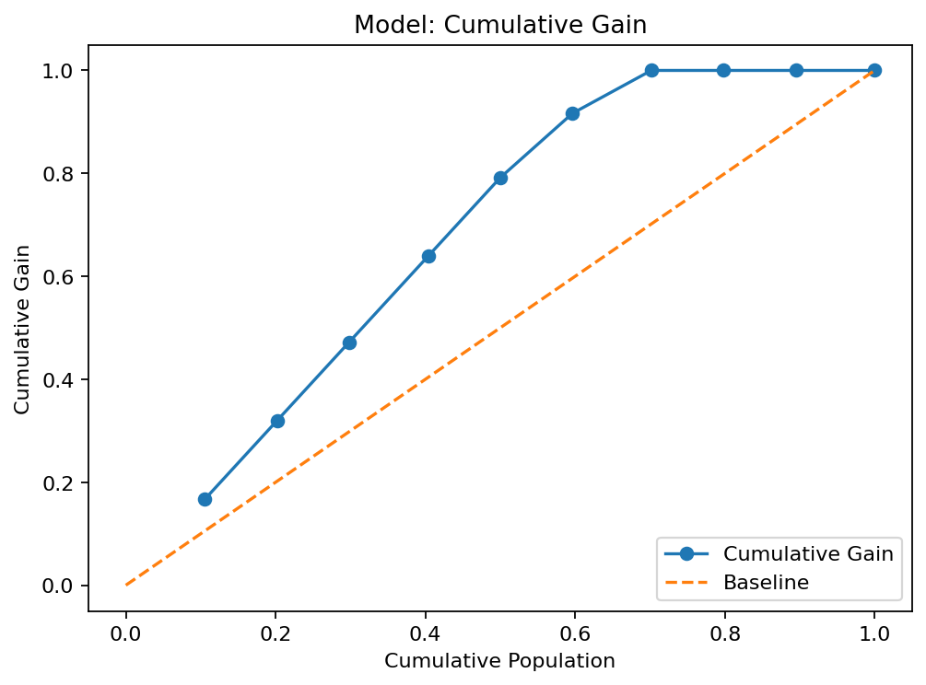

Calibration (Reliability) Curve
Plots predicted probability vs observed probability. A perfectly calibrated model will follow the diagonal; deviations indicate over- or under-confidence in predicted probabilities.
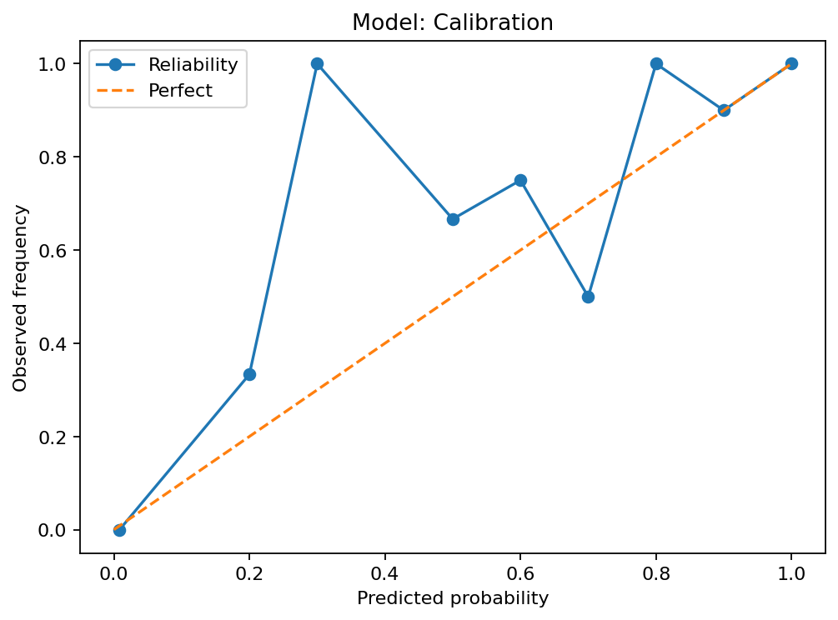

Confusion Matrix (image)
Visual heatmap of predicted vs actual classes. Helps identify where the model is making the most errors.
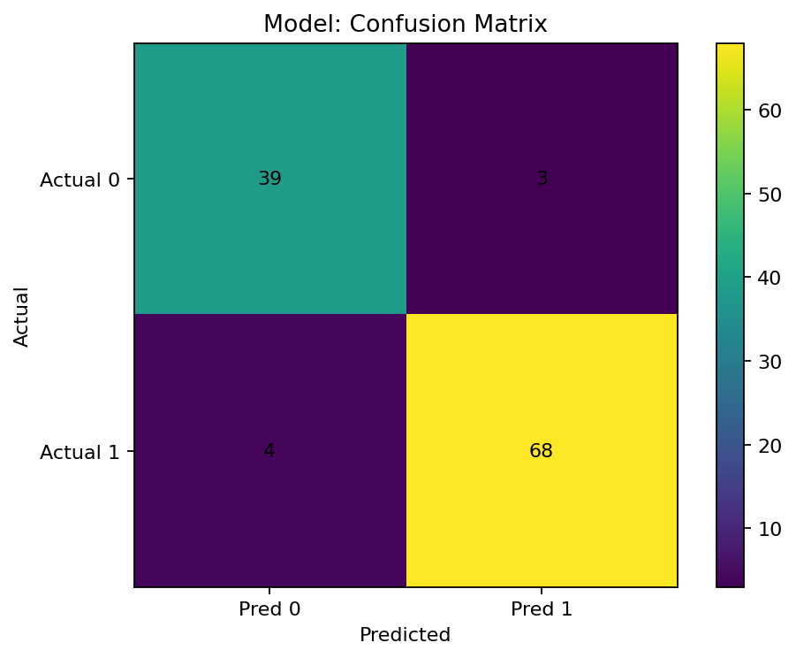

Confusion Matrix (Classification)
 | Pred 0 | Pred 1
Actual 0 | 39 | 3
Actual 1 | 4 | 68

Decile Lift Table
Decile | Total | Events | Avg  score | Event  rate | Lift | Cum.  events | Cum.  total | Cum.  capturerate | Cum.  population | Cum.  gain
1 | 12 | 12 | 1.0 | 1.0 | 1.58 | 12 | 12 | 0.17 | 0.11 | 0.17
2 | 11 | 11 | 1.0 | 1.0 | 1.58 | 23 | 23 | 0.32 | 0.2 | 0.32
3 | 11 | 11 | 1.0 | 1.0 | 1.58 | 34 | 34 | 0.47 | 0.3 | 0.47
4 | 12 | 12 | 1.0 | 1.0 | 1.58 | 46 | 46 | 0.64 | 0.4 | 0.64
5 | 11 | 11 | 0.96 | 1.0 | 1.58 | 57 | 57 | 0.79 | 0.5 | 0.79
6 | 11 | 9 | 0.82 | 0.82 | 1.3 | 66 | 68 | 0.92 | 0.6 | 0.92
7 | 12 | 6 | 0.37 | 0.5 | 0.79 | 72 | 80 | 1.0 | 0.7 | 1.0
8 | 11 | 0 | 0.01 | 0.0 | 0.0 | 72 | 91 | 1.0 | 0.8 | 1.0
9 | 11 | 0 | 0.0 | 0.0 | 0.0 | 72 | 102 | 1.0 | 0.89 | 1.0
10 | 12 | 0 | 0.0 | 0.0 | 0.0 | 72 | 114 | 1.0 | 1.0 | 1.0

KS Curve (Kolmogorov–Smirnov)
Measures maximum separation between the cumulative distribution of positives and negatives. Higher KS indicates better class separation.
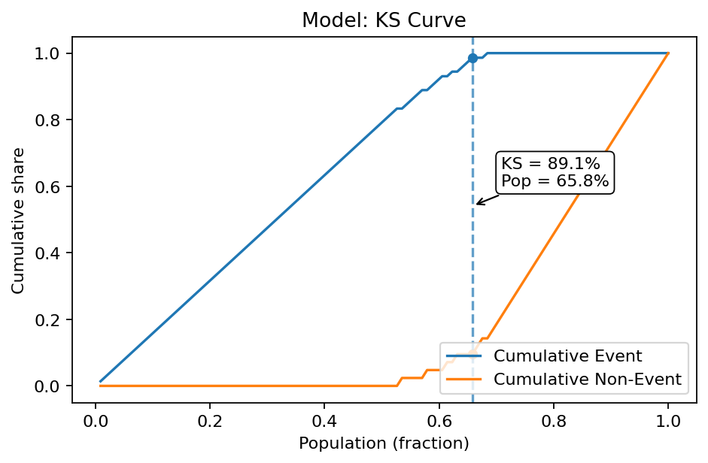

Data Quality (Cleaned Data)
Missing (Train): 0.00%
Missing (Test): 0.00%
Columns With Missing (Train): None detected
Columns With Missing (Test): None detected
Constant Columns: None detected

Raw Data Validation
Total Rows: Dataset not provided
Total Columns: Dataset not provided
Average Missing: Dataset not provided
Columns With Missing: Dataset not provided
Duplicate Rows: Dataset not provided
Constant Columns: Dataset not provided

Correlation Analysis

Top High-Correlation Feature Pairs (|r| ≥ Threshold)
feature_i | feature_j | corr | n_used | pct_missing_i | pct_missing_j
mean radius | mean perimeter | 0.9979 | 569 | 0.00 | 0.00
worst radius | worst perimeter | 0.9937 | 569 | 0.00 | 0.00
mean radius | mean area | 0.9874 | 569 | 0.00 | 0.00
mean perimeter | mean area | 0.9865 | 569 | 0.00 | 0.00
worst radius | worst area | 0.9840 | 569 | 0.00 | 0.00
worst perimeter | worst area | 0.9776 | 569 | 0.00 | 0.00
radius error | perimeter error | 0.9728 | 569 | 0.00 | 0.00
mean perimeter | worst perimeter | 0.9704 | 569 | 0.00 | 0.00
mean radius | worst radius | 0.9695 | 569 | 0.00 | 0.00
mean perimeter | worst radius | 0.9695 | 569 | 0.00 | 0.00
mean radius | worst perimeter | 0.9651 | 569 | 0.00 | 0.00
mean area | worst radius | 0.9627 | 569 | 0.00 | 0.00
mean area | worst area | 0.9592 | 569 | 0.00 | 0.00
mean area | worst perimeter | 0.9591 | 569 | 0.00 | 0.00
radius error | area error | 0.9518 | 569 | 0.00 | 0.00
mean perimeter | worst area | 0.9415 | 569 | 0.00 | 0.00
mean radius | worst area | 0.9411 | 569 | 0.00 | 0.00
perimeter error | area error | 0.9377 | 569 | 0.00 | 0.00
mean concavity | mean concave points | 0.9214 | 569 | 0.00 | 0.00
mean texture | worst texture | 0.9120 | 569 | 0.00 | 0.00
mean concave points | worst concave points | 0.9102 | 569 | 0.00 | 0.00
worst compactness | worst concavity | 0.8923 | 569 | 0.00 | 0.00
mean concavity | worst concavity | 0.8841 | 569 | 0.00 | 0.00
mean compactness | mean concavity | 0.8831 | 569 | 0.00 | 0.00
mean compactness | worst compactness | 0.8658 | 569 | 0.00 | 0.00
mean concavity | worst concave points | 0.8613 | 569 | 0.00 | 0.00
mean concave points | worst perimeter | 0.8559 | 569 | 0.00 | 0.00
worst concavity | worst concave points | 0.8554 | 569 | 0.00 | 0.00
mean perimeter | mean concave points | 0.8510 | 569 | 0.00 | 0.00
mean compactness | mean concave points | 0.8311 | 569 | 0.00 | 0.00
mean concave points | worst radius | 0.8303 | 569 | 0.00 | 0.00
mean area | mean concave points | 0.8233 | 569 | 0.00 | 0.00
mean radius | mean concave points | 0.8225 | 569 | 0.00 | 0.00
worst perimeter | worst concave points | 0.8163 | 569 | 0.00 | 0.00
mean compactness | worst concavity | 0.8163 | 569 | 0.00 | 0.00
mean compactness | worst concave points | 0.8156 | 569 | 0.00 | 0.00
area error | worst area | 0.8114 | 569 | 0.00 | 0.00
worst compactness | worst fractal dimension | 0.8105 | 569 | 0.00 | 0.00
mean concave points | worst area | 0.8096 | 569 | 0.00 | 0.00
mean smoothness | worst smoothness | 0.8053 | 569 | 0.00 | 0.00
compactness error | fractal dimension error | 0.8033 | 569 | 0.00 | 0.00
compactness error | concavity error | 0.8013 | 569 | 0.00 | 0.00
worst compactness | worst concave points | 0.8011 | 569 | 0.00 | 0.00
mean area | area error | 0.8001 | 569 | 0.00 | 0.00
Note: Displayed only if high-correlation pairs exist; otherwise, none are generated.

Correlation Heatmap
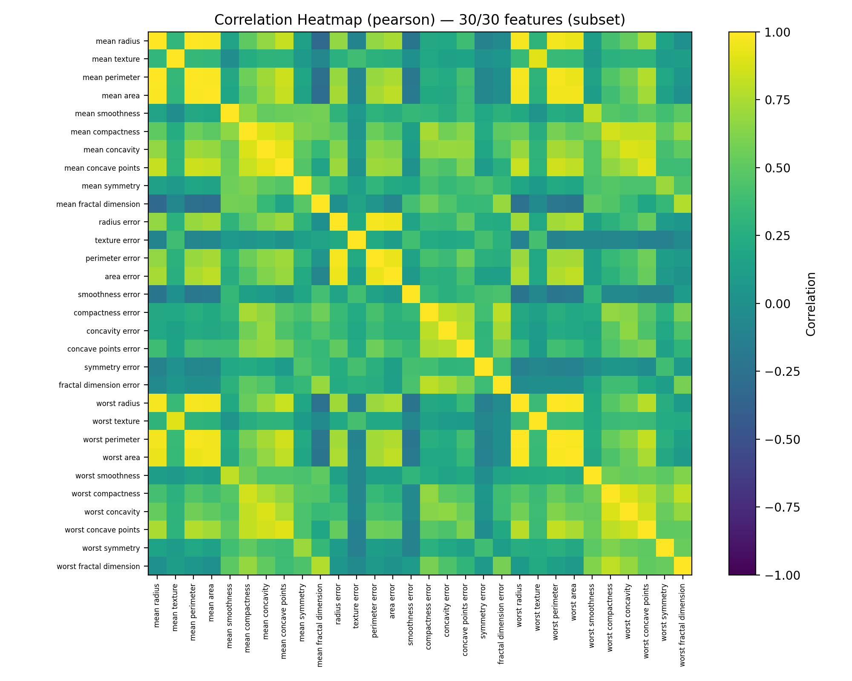
Method: pearson, Threshold: 0.80,
Features plotted: 30 of 30,
High-corr pairs ≥ threshold: 44 (of 435)
Full CSV: reports/correlation/correlation_top_pairs.csv
Pearson Correlation CSV: reports/correlation/pearson_corr.csv
Spearman Correlation CSV: reports/correlation/spearman_corr.csv
Notes:
- Heatmap shows a subset (30/30); see CSV for full list of pairs.

Variance Inflation Factor (VIF) Check
Feature | VIF
Intercept | 2041.28
mean radius | 3817.26
mean texture | 11.89
mean perimeter | 3792.7
mean area | 348.12
mean smoothness | 8.19
mean compactness | 51.45
mean concavity | 71.0
mean concave points | 60.17
mean symmetry | 4.22
mean fractal dimension | 15.76
radius error | 75.74
texture error | 4.21
perimeter error | 70.4
area error | 41.2
smoothness error | 4.07
compactness error | 15.37
concavity error | 15.91
concave points error | 11.6
symmetry error | 5.18
fractal dimension error | 9.72
worst radius | 815.95
worst texture | 18.61
worst perimeter | 405.15
worst area | 343.49
worst smoothness | 10.93
worst compactness | 36.98
worst concavity | 32.09
worst concave points | 36.78
worst symmetry | 9.54
worst fractal dimension | 18.98
target | 4.43

Exploratory Data Analysis (EDA)
Summary Stats CSV: reports/eda/summary_stats.csv
Missing Values CSV: reports/eda/missing_values.csv
Distribution Plots
(no plots available)

Benchmark (Logistic Regression Baseline)

Logistic Regression Results
Results: Logit
===================================================================
Model: Logit Method: MLE
Dependent Variable: target Pseudo R-squared: 1.000
Date: 2025-12-17 11:40 AIC: 62.0139
No. Observations: 455 BIC: 189.7431
Df Model: 30 Log-Likelihood: -0.0069560
Df Residuals: 424 LL-Null: -300.69
Converged: 1.0000 LLR p-value: 1.5442e-107
No. Iterations: 103.0000 Scale: 1.0000
-------------------------------------------------------------------
Coef. Std.Err. z P>|z| [0.025 0.975]
-------------------------------------------------------------------
const 131.7860 nan nan nan nan nan
mean radius -787.4431 nan nan nan nan nan
mean texture 1141.8020 nan nan nan nan nan
mean perimeter 266.2276 nan nan nan nan nan
mean area 380.6973 nan nan nan nan nan
mean smoothness -678.4479 nan nan nan nan nan
mean compactness -3767.3660 nan nan nan nan nan
mean concavity 114.7993 nan nan nan nan nan
mean concave points 1848.3683 nan nan nan nan nan
mean symmetry 271.6765 nan nan nan nan nan
mean fractal dimension 1961.0734 nan nan nan nan nan
radius error 576.1461 nan nan nan nan nan
texture error 327.5654 nan nan nan nan nan
perimeter error -1076.8084 nan nan nan nan nan
area error 2164.5990 nan nan nan nan nan
smoothness error -961.6350 nan nan nan nan nan
compactness error -2503.2140 nan nan nan nan nan
concavity error 1696.8486 nan nan nan nan nan
concave points error 1282.7776 nan nan nan nan nan
symmetry error -407.2186 nan nan nan nan nan
fractal dimension error -84.4260 nan nan nan nan nan
worst radius -500.0955 nan nan nan nan nan
worst texture -211.4773 nan nan nan nan nan
worst perimeter 1620.4626 nan nan nan nan nan
worst area 1635.8827 nan nan nan nan nan
worst smoothness 1359.3308 nan nan nan nan nan
worst compactness 3960.2308 nan nan nan nan nan
worst concavity -1054.1612 nan nan nan nan nan
worst concave points 43.8743 nan nan nan nan nan
worst symmetry 314.3169 nan nan nan nan nan
worst fractal dimension -1613.6838 nan nan nan nan nan
===================================================================

Logistic Regression Coefficients
feature | coef | std err | z | P>|z| | ci_low | ci_high
const | 131.786 | nan | nan | nan | nan | nan
mean radius | -787.4431 | nan | nan | nan | nan | nan
mean texture | 1141.802 | nan | nan | nan | nan | nan
mean perimeter | 266.2276 | nan | nan | nan | nan | nan
mean area | 380.6973 | nan | nan | nan | nan | nan
mean smoothness | -678.4479 | nan | nan | nan | nan | nan
mean compactness | -3767.366 | nan | nan | nan | nan | nan
mean concavity | 114.7993 | nan | nan | nan | nan | nan
mean concave points | 1848.3683 | nan | nan | nan | nan | nan
mean symmetry | 271.6765 | nan | nan | nan | nan | nan
mean fractal dimension | 1961.0734 | nan | nan | nan | nan | nan
radius error | 576.1461 | nan | nan | nan | nan | nan
texture error | 327.5654 | nan | nan | nan | nan | nan
perimeter error | -1076.8084 | nan | nan | nan | nan | nan
area error | 2164.599 | nan | nan | nan | nan | nan
smoothness error | -961.635 | nan | nan | nan | nan | nan
compactness error | -2503.214 | nan | nan | nan | nan | nan
concavity error | 1696.8486 | nan | nan | nan | nan | nan
concave points error | 1282.7776 | nan | nan | nan | nan | nan
symmetry error | -407.2186 | nan | nan | nan | nan | nan
fractal dimension error | -84.426 | nan | nan | nan | nan | nan
worst radius | -500.0955 | nan | nan | nan | nan | nan
worst texture | -211.4773 | nan | nan | nan | nan | nan
worst perimeter | 1620.4626 | nan | nan | nan | nan | nan
worst area | 1635.8827 | nan | nan | nan | nan | nan
worst smoothness | 1359.3308 | nan | nan | nan | nan | nan
worst compactness | 3960.2308 | nan | nan | nan | nan | nan
worst concavity | -1054.1612 | nan | nan | nan | nan | nan
worst concave points | 43.8743 | nan | nan | nan | nan | nan
worst symmetry | 314.3169 | nan | nan | nan | nan | nan
worst fractal dimension | -1613.6838 | nan | nan | nan | nan | nan

Baseline Metrics
metric | value
ROC-AUC | 0.9300
KS | 0.8400
F1 | 0.8900
PR AUC | 0.8200
Gini | 0.8500
Precision | 0.8500
Recall | 0.9300
Accuracy | 0.9100
Brier Score | 0.0900
* Calculated on the same dataset that was used to train and evaluate the primary model.

Stress Testing Results
feature | perturbation | accuracy | auc | delta_accuracy | delta_auc
mean radius | +1.0% | 0.95 | 0.99 | 0.0 | 0.0
mean radius | -1.0% | 0.95 | 0.99 | 0.0 | 0.0
mean texture | +1.0% | 0.95 | 0.99 | 0.0 | 0.0
mean texture | -1.0% | 0.95 | 0.99 | 0.0 | 0.0
mean perimeter | +1.0% | 0.95 | 0.99 | 0.0 | -0.0
mean perimeter | -1.0% | 0.95 | 0.99 | 0.0 | 0.0
mean area | +1.0% | 0.95 | 0.99 | 0.0 | 0.0
mean area | -1.0% | 0.95 | 0.99 | 0.0 | 0.0
mean smoothness | +1.0% | 0.95 | 0.99 | 0.0 | 0.0
mean smoothness | -1.0% | 0.95 | 0.99 | 0.0 | 0.0
mean compactness | +1.0% | 0.95 | 0.99 | 0.0 | 0.0
mean compactness | -1.0% | 0.95 | 0.99 | 0.0 | 0.0
mean concavity | +1.0% | 0.95 | 0.99 | 0.0 | 0.0
mean concavity | -1.0% | 0.95 | 0.99 | 0.0 | 0.0
mean concave points | +1.0% | 0.95 | 0.99 | 0.0 | 0.0
mean concave points | -1.0% | 0.95 | 0.99 | 0.0 | 0.0
mean symmetry | +1.0% | 0.95 | 0.99 | 0.0 | 0.0
mean symmetry | -1.0% | 0.95 | 0.99 | 0.0 | 0.0
mean fractal dimension | +1.0% | 0.95 | 0.99 | 0.0 | 0.0
mean fractal dimension | -1.0% | 0.95 | 0.99 | 0.0 | 0.0
radius error | +1.0% | 0.95 | 0.99 | 0.0 | 0.0
radius error | -1.0% | 0.95 | 0.99 | 0.0 | 0.0
texture error | +1.0% | 0.95 | 0.99 | 0.0 | 0.0
texture error | -1.0% | 0.95 | 0.99 | 0.0 | 0.0
perimeter error | +1.0% | 0.95 | 0.99 | 0.0 | 0.0
perimeter error | -1.0% | 0.95 | 0.99 | 0.0 | 0.0
area error | +1.0% | 0.95 | 0.99 | 0.0 | 0.0
area error | -1.0% | 0.95 | 0.99 | 0.0 | 0.0
smoothness error | +1.0% | 0.95 | 0.99 | 0.0 | 0.0
smoothness error | -1.0% | 0.95 | 0.99 | 0.0 | 0.0
compactness error | +1.0% | 0.95 | 0.99 | 0.0 | 0.0
compactness error | -1.0% | 0.95 | 0.99 | 0.0 | 0.0
concavity error | +1.0% | 0.95 | 0.99 | 0.0 | 0.0
concavity error | -1.0% | 0.95 | 0.99 | 0.0 | 0.0
concave points error | +1.0% | 0.95 | 0.99 | 0.0 | 0.0
concave points error | -1.0% | 0.95 | 0.99 | 0.0 | 0.0
symmetry error | +1.0% | 0.95 | 0.99 | 0.0 | 0.0
symmetry error | -1.0% | 0.95 | 0.99 | 0.0 | 0.0
fractal dimension error | +1.0% | 0.95 | 0.99 | 0.0 | 0.0
fractal dimension error | -1.0% | 0.95 | 0.99 | 0.0 | 0.0
worst radius | +1.0% | 0.95 | 0.99 | 0.0 | -0.0
worst radius | -1.0% | 0.95 | 0.99 | 0.0 | 0.0
worst texture | +1.0% | 0.95 | 0.99 | 0.0 | 0.0
worst texture | -1.0% | 0.95 | 0.99 | 0.0 | 0.0
worst perimeter | +1.0% | 0.95 | 0.99 | 0.0 | -0.0
worst perimeter | -1.0% | 0.95 | 0.99 | 0.0 | 0.0
worst area | +1.0% | 0.95 | 0.99 | 0.0 | 0.0
worst area | -1.0% | 0.95 | 0.99 | 0.0 | 0.0
worst smoothness | +1.0% | 0.95 | 0.99 | 0.0 | 0.0
worst smoothness | -1.0% | 0.95 | 0.99 | 0.0 | 0.0
worst compactness | +1.0% | 0.95 | 0.99 | 0.0 | 0.0
worst compactness | -1.0% | 0.95 | 0.99 | 0.0 | 0.0
worst concavity | +1.0% | 0.95 | 0.99 | 0.0 | 0.0
worst concavity | -1.0% | 0.95 | 0.99 | 0.0 | 0.0
worst concave points | +1.0% | 0.95 | 0.99 | 0.0 | 0.0
worst concave points | -1.0% | 0.95 | 0.99 | 0.0 | 0.0
worst symmetry | +1.0% | 0.95 | 0.99 | 0.0 | 0.0
worst symmetry | -1.0% | 0.95 | 0.99 | 0.0 | 0.0
worst fractal dimension | +1.0% | 0.95 | 0.99 | 0.0 | 0.0
worst fractal dimension | -1.0% | 0.95 | 0.99 | 0.0 | 0.0

Input Cluster Coverage Check
A K-Means clustering algorithm was applied to the cleaned dataset to evaluate input space coverage. This analysis highlights the distribution of samples across different clusters, assisting in the identification of any imbalance or concentration that could affect model behavior.
Input cluster distribution (saved to CSV): —

Cluster Summary Table
_No cluster summary was generated for this run._

Cluster Distribution Plot
(image not available)

Rule Engine Check
Overall Pass: ✅ Yes
Rule Details: No rule results were generated for this run.

Model Contents Summary

Model Class: RandomForestClassifier

Module: sklearn.ensemble._forest

Hyperparameters:
- bootstrap: True
- ccp_alpha: 0.0
- class_weight: None
- criterion: gini
- max_depth: 16
- max_features: sqrt
- max_leaf_nodes: None
- max_samples: None
- min_impurity_decrease: 0.0
- min_samples_leaf: 1
- min_samples_split: 2
- min_weight_fraction_leaf: 0.0
- monotonic_cst: None
- n_estimators: 10
- n_jobs: -1
- oob_score: False
- random_state: 42
- verbose: 0
- warm_start: False

Attributes:
- estimator: DecisionTreeClassifier()
- n_estimators: 10
- estimator_params: ('criterion', 'max_depth', 'min_samples_split', 'min_samples_leaf', 'min_weight_fraction_leaf', 'max_features', 'max_leaf_nodes', 'min_impurity_decrease', 'random_state', 'ccp_alpha', 'monotonic_cst')
- bootstrap: True
- oob_score: False
- n_jobs: -1
- random_state: 42
- verbose: 0
- warm_start: False
- class_weight: None
- max_samples: None
- criterion: gini
- max_depth: 16
- min_samples_split: 2
- min_samples_leaf: 1
- min_weight_fraction_leaf: 0.0
- max_features: sqrt
- max_leaf_nodes: None
- min_impurity_decrease: 0.0
- monotonic_cst: None
- ccp_alpha: 0.0
- feature_names_in_: ['mean radius' 'mean texture' 'mean perimeter' 'mean area'
'mean smoothness' 'mean compactness' 'mean concavity'
'mean concave points' 'mean symmetry' 'mean fractal dimension'
'radius error' 'texture error' 'perimeter error' 'area error'
'smoothness error' 'compactness error' 'concavity error'
'concave points error' 'symmetry error' 'fractal dimension error'
'worst radius' 'worst texture' 'worst perimeter' 'worst area'
'worst smoothness' 'worst compactness' 'worst concavity'
'worst concave points' 'worst symmetry' 'worst fractal dimension']
- n_features_in_: 30
- n_outputs_: 1
- classes_: [0 1]
- n_classes_: 2
- estimator_: DecisionTreeClassifier()
- estimators_: [DecisionTreeClassifier(max_depth=16, max_features='sqrt',
random_state=1608637542), DecisionTreeClassifier(max_depth=16, max_features='sqrt',
random_state=1273642419), DecisionTreeClassifier(max_depth=16, max_features='sqrt',
random_state=1935803228), DecisionTreeClassifier(max_depth=16, max_features='sqrt',
random_state=787846414), DecisionTreeClassifier(max_depth=16, max_features='sqrt',
random_state=996406378), DecisionTreeClassifier(max_depth=16, max_features='sqrt',
random_state=1201263687), DecisionTreeClassifier(max_depth=16, max_features='sqrt',
random_state=423734972), DecisionTreeClassifier(max_depth=16, max_features='sqrt',
random_state=415968276), DecisionTreeClassifier(max_depth=16, max_features='sqrt',
random_state=670094950), DecisionTreeClassifier(max_depth=16, max_features='sqrt',
random_state=1914837113)]

Explainability

SHAP Summary Plot
SHAP (SHapley Additive exPlanations) is used to explain the impact of each input feature on the model's predictions. The SHAP summary plot below shows the magnitude and direction of influence of the top features across a sample of predictions. Features at the top have the highest average impact. Red indicates higher feature values, and blue indicates lower values. This plot helps identify which features the model relies on most and whether they align with domain knowledge. Only a subset of the test data is used for SHAP due to performance considerations.

(image not available)

Top Features by Mean |SHAP| (Bar)
(image not available)

Top SHAP Features

