Topics in Intelligent Systems Engineering: VLSI Design

Intelligent Systems Engineering, ENGR-E 399/599

Spring 2025
Full Term Course | INFO, CS, and ISE Majors Welcome

Lecture 3 Credit Hours

Course Start Date 🚨
This course begins the week of January 13, 2025

Course Description
VLSI Design introduces students to fabrication and layout techniques for designing large-scale integrated circuits (ICs) and systems. Students will use industry-standard tools for designing and fabricating ICs in nanometer-scale technology nodes. Specific topics include MOSFET and FinFET theory, CMOS logic, standard fabrication processes, layout design rules, and all the factors required for a practical circuit design. Analog and digital design techniques for creating static and dynamic logic structures, interconnect analysis, chip layout, simulation, and testing will be explored.
Course Pre-Requisites: ENGR-E 311
Course Co-Requisites: None

Location and Time
ENGR-E 399 13739 / ENGR-E 599 13738
Tuesday / Thursday 12:45 pm-2:00 pm
IF Room 4111

Instructor Information
Instructor: Dr. Daniel Loveless
https://www.linkedin.com/in/daniel-loveless

Email: dlovele@iu.edu
Including the course and section number in your email subject line will help me to respond to your inquiry with the correct information.

Office Hours and Location: TR, 9:00am-11:00am (IF 4138 or Zoom)

Zoom Office: https://iu.zoom.us/j/82563823486?pwd=bn3zbYzFdWl8PBHqiOE4kR9zAywNBh.1
Meeting ID: 825 6382 3486
Password: 647407
Required Texts and Supplies
CMOS Circuit Design, Layout, and Simulation, John Wiley & Sons, July 2019. ISBN 9781119481515 (Errata)
- https://www.amazon.com/CMOS-Circuit-Simulation-Microelectronic-Systems/dp/1119481511
- https://www.bkstr.com/indianastore/course-materials-results?shopBy=course&divisionDisplayName=&departmentDisplayName=ENGR-E&courseDisplayName=599&sectionDisplayName=13738&programId=5130&termId=100086336

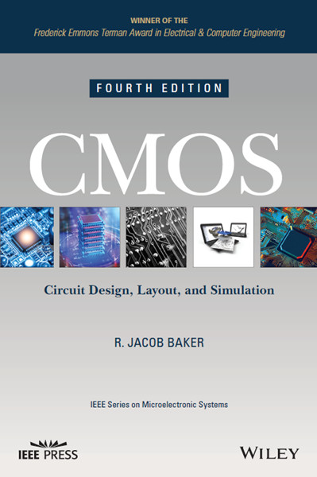

Additional Online Resources for Textbook
https://cmosedu.com/
Technology Information
VLSI Design will utilize the Cadence Design electronic design automation (EDA) tool suite. The Cadence EDA is a high-quality, industry-standard tool heavily used to design and simulate integrated circuits. We will be using the Cadence Design System for circuit schematic design (Virtuoso), simulation (Spectre), circuit layout (Virtuoso), and verification (Pegasus). Information about Cadence can be found here: https://www.cadence.com/en_US/home/tools/custom-ic-analog-rf-design/layout-design/virtuoso-layout-suite.html

Cadence is installed on the burrow-rhel server at IU. You will be given accounts on this Red Hat Linux system and can access it via the classroom (IF 4111) or remotely through IU’s VPN. More information will be provided in week 1 of class.

All course material will be published to https://github.com/tdloveless/iu-vlsi

Note that Canvas will only be used to publish grades.

Important Dates
1/13/2025 Classes Begin
1/16/2025 Waitlist Requests Expire
1/19/2025 100% Refund Deadline & Last day to drop a course without a ‘W’
1/20/2025 MLK Day (No Class)
1/26/2025 75% Refund Deadline
2/2/2025 50% Refund Deadline
2/9/2025 25% Refund Deadline
2/10/2025 Pass/Fail Option Deadline
2/23/2025 Verification of Class Attendance & Early Evaluation Grades Due
3/13/2025 Midterm Exam
3/16/2025 Withdrawal with a ‘W’
3/16-3/23/2025 Spring Break (No Class)
5/3/2025 Last Day of Classes/Final Quiz
5/3/2025 Complete Withdrawal Deadline
5/6/2025 Final Project Due
5/13/2025 Final Grades Deadline

Tentative Schedule
Week | Topic | Select Assignments  (See Canvas for complete list)
1 | Introduction & Course overview  Getting Started with Cadence  Circuits & Layout Part 1 | Pre-Experience Reflection
2 | Circuits & Layout Part 2  Tutorial: Layout of a NAND Gate | Lab 1
3 | CMOS Transistor Theory  SPICE Simulation  Non-Ideal Transistor Theory Part 1 | HW 1
4 | Non-Ideal Transistor Theory Part 2  DC & Transient Response | Lab 2
5 | Tutorial: Gate Optimization  Logical Effort Part 1 | HW 2
6 | Logical Effort Part 2  Power Part 1 | Lab 3
7 | Tutorial: Analog Device Layout  Power Part 2 | HW 3
8 | Scaling  Sequential Design | Midterm Reflection  Lab Corrections
9 | Clocking | Midterm Exam
10 | Verilog  Synthesis and Place and Route Adders, | HW 4
11 | Datapath Functional Units  Simple Processor Example | Lab 4
12 | Memory | HW 5
13 | Challenges & Pitfalls | Project Work
14 | Design for Test & Verification  Packaging, I/O & Power Distribution | Project Work
16 | Project Discussions | Project  Final Quiz  Final Reflection
Learning Assessment & Grading
Course Student Learning Outcomes: ENGR-E 399/599 students will be able to (1) design a system, component, or process to meet desired needs, (2) identify, formulate, and solve engineering problems, (3) an ability to communicate effectively, (4) recognize the need for, and an ability to engage in life-long learning, and (5) use the techniques, skills, and modern engineering tools necessary for engineering practice.

Course Assessments and Requirements:
Journal/Lab Notebook: All students are required to maintain a journal/lab notebook. The journal should include (1) a pre-experience reflection, (2) weekly logs of status (to be used for project briefings) and well as any technical information and design work that should be logged, (3) weekly reflection, and (4) a post-experience reflection.
- Pre-experience reflection activities include identification of a problem/challenge, assessment of skills required to solve problem/challenge, reflection of current skillsets, proposal of possible path/direction for acquiring new skills appropriate for solving problem.
- Weekly status updates should include a bullet list of activities related to the design project, highlights of any important finding or progress, details of any challenges and proposed solutions if possible, and any details relevant to other teams.
- Critical reflection activities include assessment of outcomes following proposed solutions, analysis of alternative solutions to problem and challenge of current solution, reflection of progress towards development of new skills.
- Post-experience reflection activities include assessment of design, reflection of development of new skills, reflection of skillsets before and after classroom experience, analysis of path/direction chosen for development of skills appropriate for solving problem.

Design Project: There will be a teams-based design project due on the 5/6/2025. The project will involve a design, simulation, and layout of an integrated circuit ready for fabrication in the SkyWater 130 nm process. You will be required to brief the design progress and outcomes 4 times throughout the semester:
- Preliminary Design Review, 4/17/25: description of integrated circuit (IC) and purpose, formal inspection of the high-level architecture of IC, simulation results, plan for completion
- Critical Design Review, 4/24/25: description of integrated circuit (IC) and purpose, analysis of the stability of design expected to meet performance requirements, 90% of layout should be completed, confirming design is on-track for meeting deadline
- Tapeout Readiness Review, 5/1/25: description of integrated circuit (IC) and purpose, final designs with evidence of manufacturability readiness, including results from design-rule checks and evidence, results from verification of layout compared to schematic design
- Final Project Presentation, 5/6/25: on-campus Microelectronics Design and Research Symposium hosted by the Reliable Electronics and Systems Laboratory.

Graduate Student Credit: To obtain graduate credit for this course you must (1) lead a design team and (2) submit a review article (IEEE format) on a topic of your choosing in VLSI. The review article must be submitted before April 10, 2025.

Course Grading:

Course Grading Policy (399):
Lab Notebook | 10%
Assignments | 20%
Attendance | 10%
Design project | 30%
Midterm exam | 20%
Final quiz | 10%
Total | 100%

Course Grading Policy (599):
Lab Notebook | 10%
Assignments | 20%
Review Article | 15%
Design project | 30%
Midterm exam | 15%
Final quiz | 10%
Total | 100%

Grading Scale: Grades will be assigned on the basis of your performance relative to others and will not necessarily be consistent with 100% > A > 90%, 90% > B > 80%, etc., of the total possible course points. Every student must make at least 50% of the total points earned by the top student in class in order to receive a "D" or better by the end of the semester.
The Luddy School of Informatics, Computing, and Engineering follows the official grading system of Indiana University. For more information see the Informatics Bulletin Grading Policies

Instructor Grading and Feedback Response Time: 1 week

Grade Review: If you have questions about the grade you earned you should contact the instructional team in person. Please be aware that a grade review may result in the grade you earned staying the same, increasing, or decreasing.

Incomplete Grade: In accordance with IU policy ACA-66, an “I” will “be assigned to a student who, in the judgment of the instructor, has performed at a satisfactory level during a majority of the course but has not completed all the required work by the end of the term due to hardship or other good cause that the instructor deems would make it unjust to penalize that student for not completing the required work on time.”

Late Policy: Canvas displays several types that are important for you to understand.
Due Date: this is the ideal date by which you submit your assignment.
Until Date: this date means the assignment is closed and you can no longer submit your work to be graded.
Available From: Some assignments may not be available until a specified date.
Policies & Resources

Academic Honesty
Doing your own work is absolutely essential. You must cite sources of any information, quotations, or ideas which are not your own. If you are unsure, ask me or the super helpful librarians at your nearest library. Let me be very clear. You cannot cut and paste text from the internet into assignments and pass it off as your own. You cannot turn in work that someone else has created or that you have bought or downloaded.
This syllabus, nor course, reviews the entire university policy on academic honesty; it is the responsibility of the student to be cognizant of and adhere to all requirements in the code.
Familiarize yourself with and follow University Policy.
Code of Student Rights, Responsibilities, & Conduct: Indiana University (iu.edu)
I will respond to acts of academic misconduct according to university policy concerning plagiarism; sanctions for plagiarism can include a grade of F for the assignment in question and/or for the course and must include a report to the Dean of Students Office.

Attendance: Regular attendance and engagement in class is required for students to accomplish the learning outcomes designed in the course successfully. No student should come to class if they have tested positive for COVID-19, have been asked to isolate, or are not feeling well. Attendance will be taken formally and is included in the Participation category. Your attendance may be reduced if you arrive late, leave early, or are not engaged with the class. All students will have three discretionary absences for lectures — this adjustment will be made at the end of the semester before the final grade calculation.

If you miss class, you should:
- Catch up on missed material
- Still complete assignments on time
If you miss class, you may:
- Complete extra credit opportunities

If you are absent, you are responsible for finding out what content was covered during class and learning it on your own by checking the syllabus, accessing materials on Canvas, and getting in touch with classmates who were present. In-class assignments may be completed if you are absent from class.

You are responsible for submitting assignments on time, regardless of whether they are present on the day of class. Start homework assignments early; late assignments will be penalized according to the course late policy.

Bias-based incident reports: These reports can be made by students, faculty and staff. Any act of discrimination or harassment based on race, ethnicity, religious affiliation, gender, gender identity, sexual orientation or disability can be reported through any of the following options:
1) Email biasincident@indiana.edu or incident@indiana.edu
2) Call the Dean of Students Office at (812) 855-8188 or
3) Use the IU mobile App https://mobile.iu.edu
(Reports can be made anonymously)

Childcare: If you have care responsibilities for a child and your childcare needs come into conflict with the course schedule, please don't feel as though you have to miss class. I understand that sometimes childcare plans fall through. If this happens, you are welcome to bring a child with you. I ask that you bring materials to keep them busy (e.g., books, headphones, and screens) and remain mindful of your classmates. If you have questions about this, feel free to contact me. We'll make it work.

Crisis Line Information:
- 24/7 Crisis line: 812-855-5711, option 1
  - Also offering telehealth services, to schedule, call 812-855-7688.
- 24/7 Trevor Project Crisis Line (LGBTQ support), call 1–866-488-7386, text ‘start’ to 678-678, or chat online, thetrevorproject.org
- 24/7 Crisis Line – 1-800-832-5442
  - Also offering intakes, therapy and such via telehealth. Call 812-339-1691 to schedule.
- IU CAPS 812-855-5711
- Centerstone Crisis Line - (800) 832-5442
- National Text Crisis Line 24/7 – 741-741
- Go to the nearest ER or call 911

Email Etiquette: Please give me at least 2 days to reply to your emails, and I will do the same for you. I do not respond to emails on Saturday or Sunday. Please put the course number in the subject line and remember to sign your email with your name. I expect the language and structure of your emails to be professional. This includes punctuation, salutations/signature, etc.


Classroom Conduct
“Be excellent to each other. Look out for your classmates. Be self-aware. Make sure you are allowing other people space to speak. Be intellectually generous to each other. We are here to learn together. For our discussion to be open and engaged, everyone needs to know that they will be heard by a respectful audience. When you encounter disagreement and confusion, work through it together in a cooperative and respectful fashion.”
(©Jacob Boss).

Accommodations
I desire to make this a genuinely welcoming instructional climate and an equal learning opportunity for everyone. Your success is important to me. To that end, please notify me immediately if you have a need I can address. I can be reached at dlovele@iu.edu
If you have a documented disability (learning or otherwise), and you need a reasonable accommodation made for you in this course, please consult with me immediately at the beginning of the course so we can design a solution that will help you be successful in this class. To request an accommodation, you must establish your eligibility by working with the Office of Student Life.

Service animals at IU
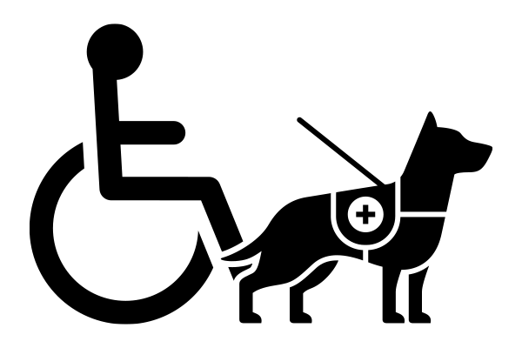
I welcome service animals in the classroom. Students with emotional support animals should contact the Office of Disability Services for Students (DSS) for guidance.
What’s the difference between a service animal and an emotional support animal?
If the service animal’s presence provides comfort, it is not a service animal under the ADA. However, if the animal is trained to perform a task related to a person’s disability, it is a service animal under the ADA. For more information see IU Service Animals on Campus or ADA Frequently Asked Questions about Service Animals

Office of Disability Services for Students:
Phone: (812) 855-7578
Website: https://go.iu.edu/409q
Note that services are confidential, may take time to put into place, and are not retroactive. Please get in touch with the campus office as soon as possible to ensure the proper accommodations are available.



Land Acknowledgement
I acknowledge and honor the Indigenous communities native to this region and recognize that Indiana University Bloomington is built on Indigenous homelands and resources. I recongnize the Myaamiaki, Lënape, Bodwéwadmik, and Saawanwa people as past, present, and future caretakers of this land.

Credé, Marcus, Sylvia G. Roch, and Urszula M. Kieszczynka. "Class attendance in college: A meta-analytic review of the relationship of class attendance with grades and student characteristics." Review of Educational Research 80, no. 2 (2010): 272-295.

