VLSI Design Course

LAB 2
XOR Gate Design, Simulation, and Layout
Issue 1.2

- Introduction
You will design, simulate, and lay out three transistor-level implementations of a 2-input XOR gate. You will compare implementations for functionality, propagation delay, switching energy, static/leakage current, and layout area. Finally, you will complete DRC/LVS verification.
Reading Material: Review course notes/text on:
• Static CMOS complex gates.
• Transmission-gate and pass-transistor logic; threshold-drop and level restoration.
• Standard-cell layout conventions (rails, pin planning, diffusion sharing, folding).
• DRC/LVS workflow for sky130 in Cadence.
- Learning Objectives
At the end of this lab, you should be able to:
- Implement three XOR topologies and explain tradeoffs (robustness, delay, energy, area).
- Create a reusable testbench to verify functionality and measure delay/energy/static current.
- Produce three 12-track standard-cell layouts with correct rails/pins and good routability.

- Technology and Cell Framework
This lab uses the open-source SkyWater sky130 CMOS process and a fixed 12-track standard-cell architecture. All XOR cells must be layout-compatible with the IU standard-cell library used in this course.
Reference library (required): https://github.com/tdloveless/iu-vlsi/tree/main/IC_CAD/cadence/iu_stdcell_2025

Required constraints:
- PDK: SkyWater sky130 (Cadence PDK used in the course environment).
- Cell height: fixed 12-track (must exactly match the IU stdcell templates).
- Power rails: continuous horizontal VDD (top) and VSS (bottom) aligned to the library grid.
- Pin conventions: match metal layers/widths/access used in the IU stdcells (A, B inputs; Y output).
- Well/substrate taps: use the same tap strategy as the reference cells; do not invent new tap spacing.
- Verification: pass sky130 DRC and LVS; generate extracted views (PEX) and run post-layout simulations.

- XOR Implementations (Choose 3)
Implement three (your choice) of the following XOR styles (or instructor-approved equivalents). All implementations must satisfy the 12‑track standard‑cell constraints and be evaluated using the same testbench and load conditions.

XOR #1 — Static CMOS (Required)
- Complementary pull-up/pull-down network. PMOS and NMOS transistors should be sized to match a unit-sized inverter (inv1 cell). You may use inverters to generate A’ and B’.

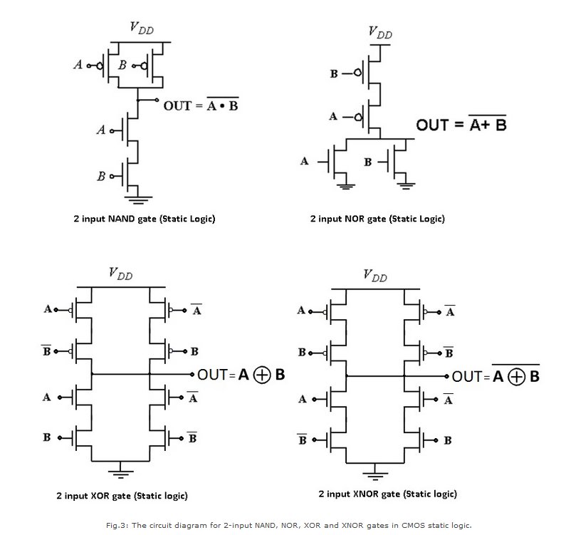
Why this cell?
- Gold-standard for robustness and noise margin
- Baseline for comparing delay, energy, and area

XOR #2 — Transmission-Gate XOR
- XOR implemented as a 2:1 mux using transmission gates
- Requires inverters to generate complements
- NMOS+PMOS pairs must be symmetrically laid out

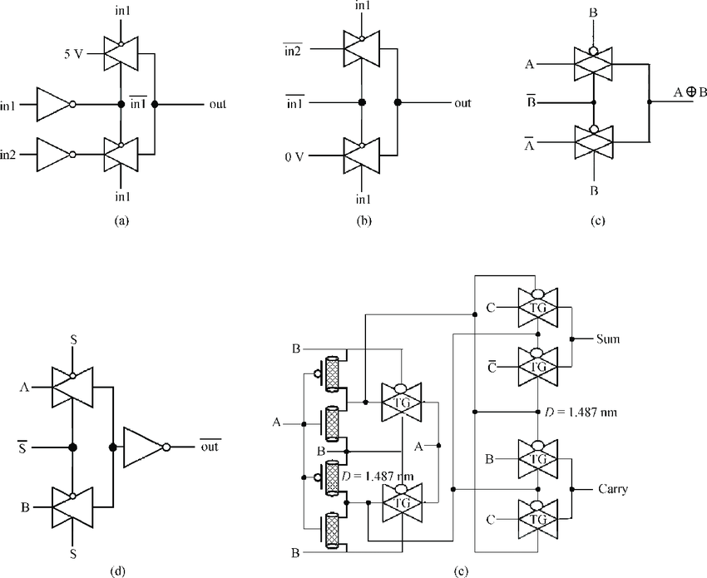
Why this cell?
- Excellent balance of energy–delay–area
- Maps very naturally to standard-cell layout

XOR #3 — NAND-Based XOR
- XOR constructed exclusively from NAND gates
- Typically implemented as a small NAND network
- Uses the NAND as a universal gate
- NAND gates may be instantiated from the IU stdcell NAND
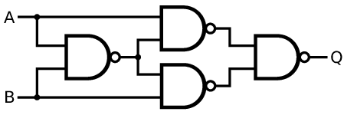
Why this cell?
- Logic-level thinking + layout reuse
- NAND is usually the best-optimized cell in a library

XOR #4 — AOI-Based XOR
- XOR implemented using AOI / OAI-style logic factoring
- Example: rewrite XOR into sum-of-products form that maps to AOI (Y=(AB+CD)’)
- You may use existing gates within our standard cell library to construct an AOI cell first, or build a custom AOI gate at the transistor level
Why this cell?
- Brings logic factoring + complex gates into play
- Very realistic for industrial cell libraries

XOR #5 — Your choice
- You may choose an XOR strategy that is not listed above!

- Layout
When laying out each XOR cell, pay particular attention to:
- Diffusion sharing vs pin accessibility
  - Over-sharing diffusion can break pin access in a fixed-track cell
- Internal node capacitance
  - XORs have multiple high-activity internal nodes; placement matters
- Transmission-gate symmetry
  - Asymmetry will show up as delay skew
- Output drive
  - The output Y pin must not degrade excessively
Students are expected to compare the three XOR layouts visually and explain how topology influenced routability and performance.
- Test Bench
Implement the test bench using the method outlined in: https://github.com/tdloveless/iu-vlsi/blob/main/HW/tb_xor_starter.md

- Grading Checklist / What to Turn In

☐ All three XOR cells exist: schematic, symbol, layout, extracted (PEX)

☐ All three layouts are exact 12-track height and align with IU stdcell rails/grid

☐ Pins exactly: A B Y VDD VSS, and pin access matches library conventions

☐ DRC clean for each XOR layout

☐ LVS clean for each XOR (schematic ↔ layout match)

☐ Stimulus exercises all input states + transitions; waveform proof included

☐ Worst-case t_{dlh}/_{tdhl} reported (schematic) for each XOR

☐ Energy/toggle reported (schematic)

☐ Static/leakage reported for all 4 DC states (00/01/10/11)

☐ Cell width + area reported (width × fixed height) with brief routability discussion

☐ Final comparison summary + conclusions included

