**Java Servlet Practical Lab Sheet**

Lab Task 2: Get User Input from Form and Display &

Lab Task 3: Get Multiple Inputs, Perform Calculation, and Display Result

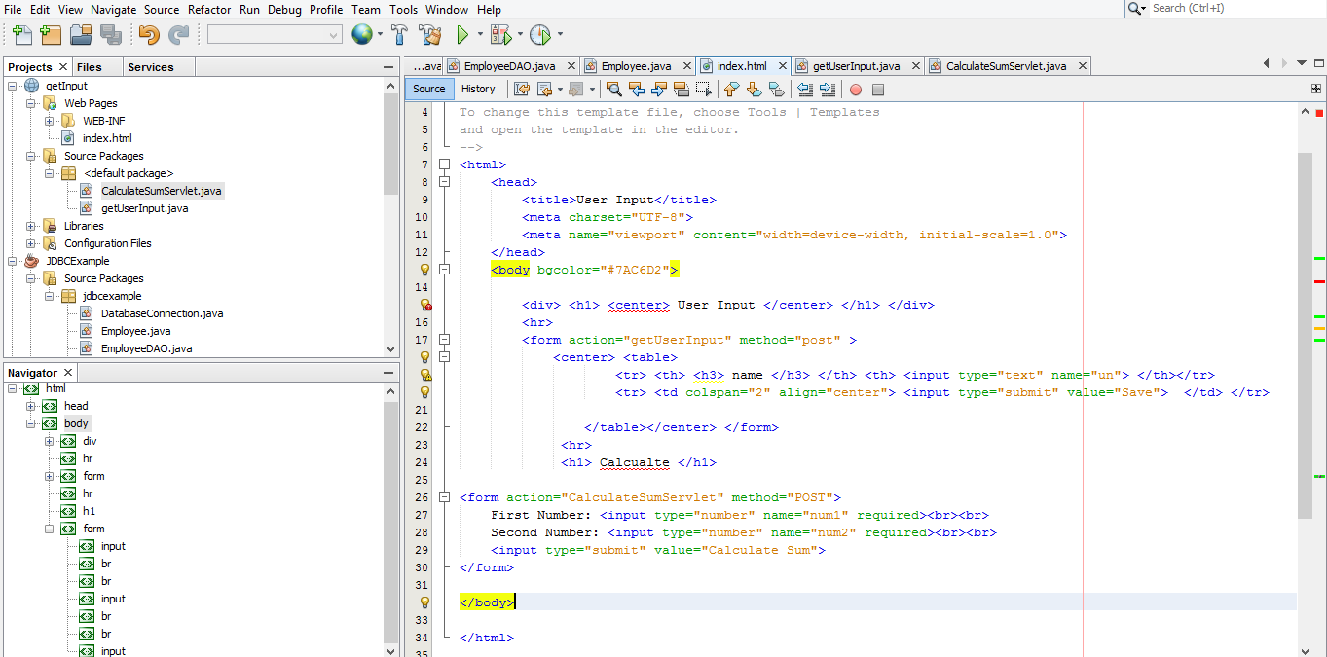index.html & calculate.html

Servlet Code (GetUserInputServlet.java)

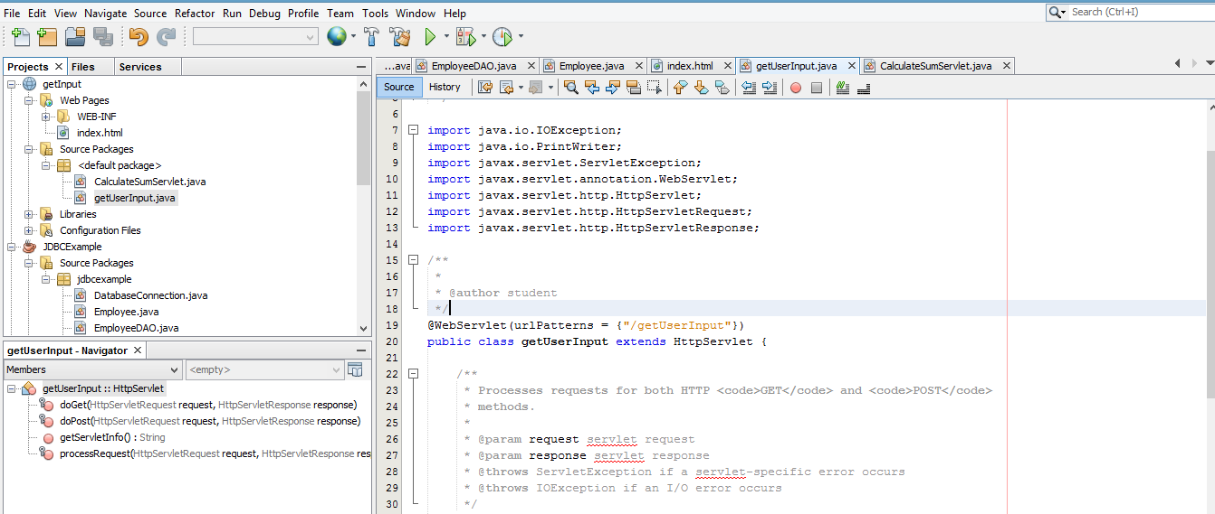

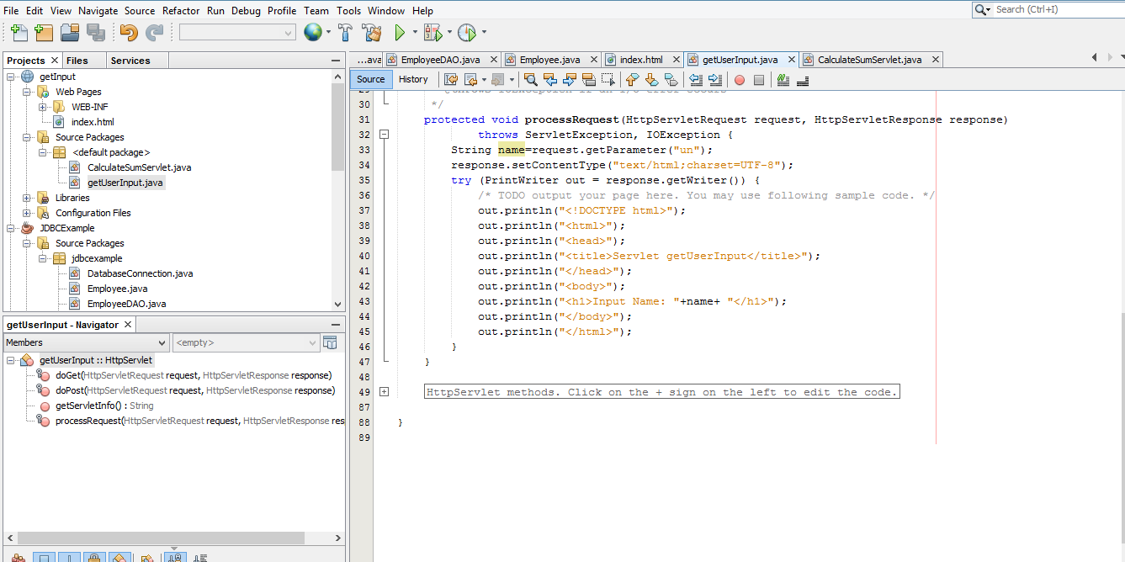

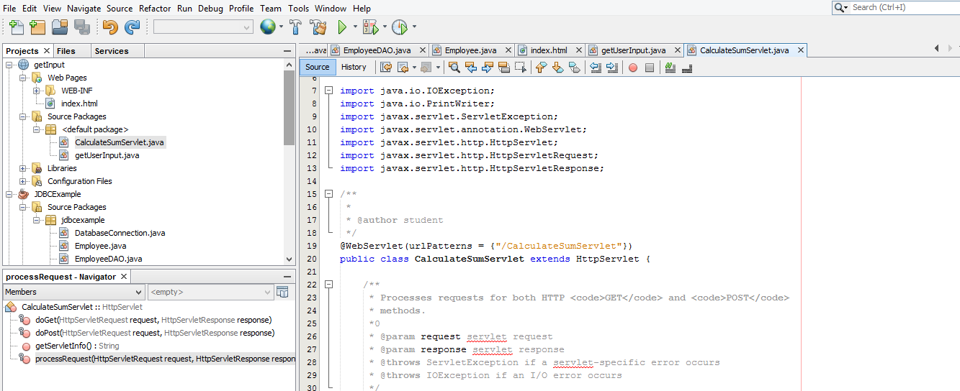Servlet Code (CalculateSumServlet.java)

