TITLE : ECO TOURISM AGENCY
STUDENT NAME: Arimiyau Abubakar
STUDENT ID : 24158615
DATE : 02/24/26

1. SELECTION AND DOCUMENTATION

Ecotourism is a growing field that promotes the sustainable travel while protecting the environment and supporting local and tribal communities. Unlike other tourism, it focuses on cultural preservation , eco-friendly practices and disciplined visitor management. An eco-tourism agency actually serves as effective bridge between the travelers and destinations such as forests, wildlife reserves and cultural heritage sites,thereby offering cost efficient packages that balance enjoyment with sustainability.
Designing a system for such an agency requires more effort compared to the simple booking management. Customers should be registered with their personal details and preferences, while the agents manage reservations and provide guidance. Suppliers - including guides, eco-lodges and transport providers, need to be integrated so their services can form part of flexible packages. Attractions must be cataloged with information like location, type, and visitor limits. The system also needs to handle the payments, cancellations, and modifications, ensuring security and reliability.
Beyond the technical value, ecotourism has got global significance. It contributes to sustainable development goals, climate action, and local livelihoods. By creating a database for an eco-tourism agency, the project demonstrates not only technical skills , but also how information systems can support responsible and sustainable travel.

Requirements Gathering

To design the database for an eco-tourism agency, requirements were gathered through research on ecotourism practices, review of existing travel agency systems, and analysis of user expectations from online surveys and case studies. Around 5 eco tourism companies were researched and existing online surveys were thoroughly analyzed in order to build the database. Hypothetical interviews with stakeholders—such as agency managers, tour guides, and eco-conscious travelers—were also considered to simulate real-world data and convert the same into database tables.
Finally below entities were identified as the essential part of the proposed system:
- Customers: Individuals who book eco-friendly trips
- Agents: Employees who manage bookings and assist customers
- Suppliers: Service providers such as local guides, eco-lodges and transport companies
- Attractions: Destinations like wildlife reserves, forests, and cultural heritage sites
- Packages: Bundled offerings combining the attractions and supplier services
- Bookings and Payments: Financial transactions ensuring secure reservations and reviewing the history

Requirement Determination Process

1. Identifying core entities – From the research, it was clear that customers, bookings, and packages formed the backbone of the system.
2. Adding supporting entities – Suppliers and attractions were included to reflect real-world diversity of services.
3. Defining attributes – Attributes such as customer details, attraction location, package duration, and payment status were added based on system functionality.
4. Establishing relationships – Many-to-many and one-to-many relationships were identified, such as packages consisting of multiple attractions and customers making multiple bookings.
5. Validating requirements – The draft schema was compared with online eco-tourism agency models to confirm completeness and practicality.
The documented requirements formed the foundation for the Chen and UML ER diagrams. These diagrams ensured that the system design accurately represented the agency’s operations while allowing scalability for real-world implementation.

2. ER DIAGRAMS

In this section, the list of entities and attributes for an eco-tourism agency database is identified. After analyzing several existing tourism companies, the following entities and attributes were derived. This design satisfies the needs of a real-world eco-tourism agency. A sample dataset was generated with realistic values.
Entities and Attributes:
- Customer: CustomerID (PK), Name, Email (unique), Phone, Nationality
- Agent: AgentID (PK), Name, Email
- Supplier: SupplierID (PK), Name, Type, Contact
- Attraction: AttractionID (PK), Name, Location, Type, Capacity
- Tour_Package: PackageID (PK), Title, Description, Duration_days, BasePrice
- Package_Attraction: (PackageID, AttractionID, SequenceOrder)
- Booking: BookingID (PK), BookingDate, StartDate, EndDate, Status, TotalAmount, CustomerID, AgentID,PakcageID
- Booking_Item: BookingItemID (PK), BookingID, ItemType, ItemRefID, Quantity, Price
- Payment: PaymentID (PK), BookingID, PaymentDate, Amount, Method, Status
- Room: RoomID (PK), SupplierID, RoomType, Price
Key Relationships:
- One-to-many between Customer–Booking, Agent–Booking, Booking–Payment
- Many-to-many between Tour_Package–Attraction via Package_Attraction
- One-to-many between Supplier–Room, Supplier–Attraction

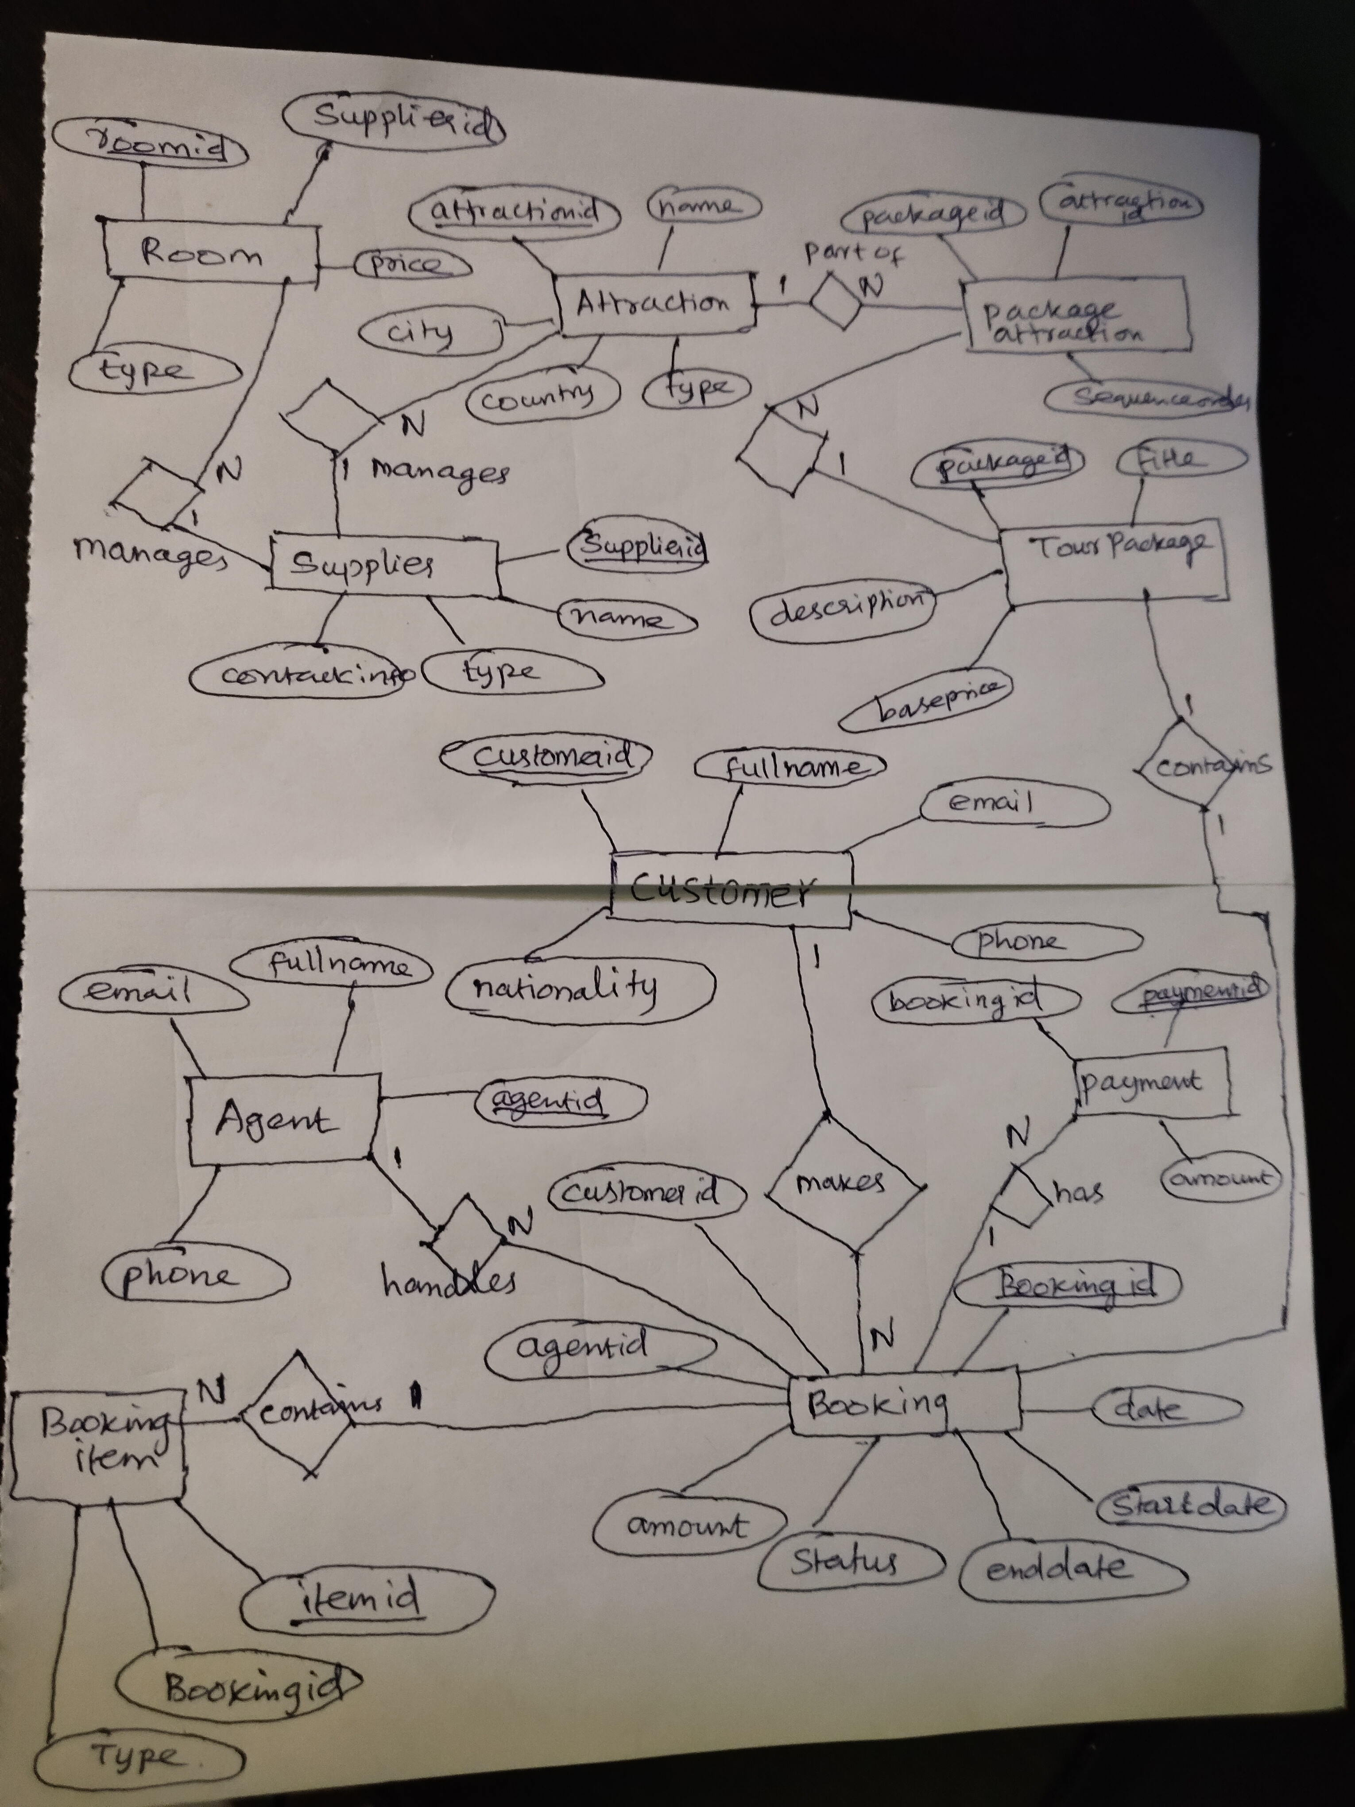
Chen Style ER Diagram for eco-tourism
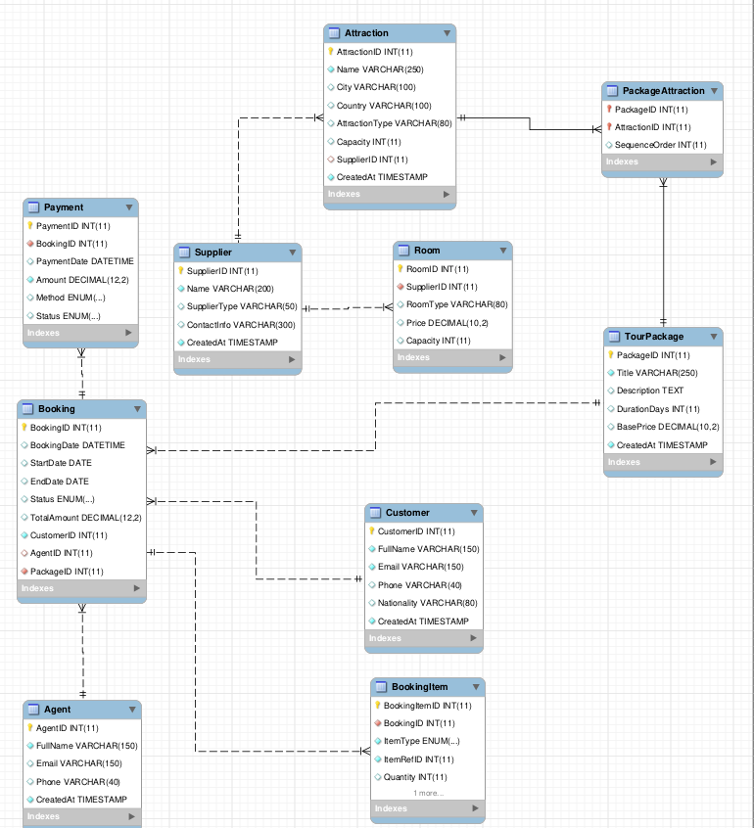

UML Style ER Diagram generated from mysql workbench

3. DATABASE AND SQL SCRIPTS

In this section , we will see in detail about the database schema for the eco tourism. Below section shows the complete sql script used to create the database, use it , create tables with all constraints like foreign key and primary key, insert statements and finally the select statements to manipulate it.
DROP DATABASE IF EXISTS eco_tourism;
CREATE DATABASE eco_tourism;
USE eco_tourism;

-- CUSTOMER
CREATE TABLE Customer (
CustomerID INT AUTO_INCREMENT PRIMARY KEY,
FullName VARCHAR(150) NOT NULL,
Email VARCHAR(150) NOT NULL UNIQUE,
Phone VARCHAR(40),
Nationality VARCHAR(80),
CreatedAt TIMESTAMP DEFAULT CURRENT_TIMESTAMP
) ENGINE=InnoDB;

-- AGENT
CREATE TABLE Agent (
AgentID INT AUTO_INCREMENT PRIMARY KEY,
FullName VARCHAR(150) NOT NULL,
Email VARCHAR(150) UNIQUE,
Phone VARCHAR(40),
CreatedAt TIMESTAMP DEFAULT CURRENT_TIMESTAMP
) ENGINE=InnoDB;

-- SUPPLIER
CREATE TABLE Supplier (
SupplierID INT AUTO_INCREMENT PRIMARY KEY,
Name VARCHAR(200) NOT NULL,
SupplierType VARCHAR(50), -- e.g., 'hotel','guide','transport'
ContactInfo VARCHAR(300),
CreatedAt TIMESTAMP DEFAULT CURRENT_TIMESTAMP
) ENGINE=InnoDB;

-- ATTRACTION
CREATE TABLE Attraction (
AttractionID INT AUTO_INCREMENT PRIMARY KEY,
Name VARCHAR(250) NOT NULL,
City VARCHAR(100),
Country VARCHAR(100),
AttractionType VARCHAR(80),
Capacity INT DEFAULT NULL,
SupplierID INT DEFAULT NULL,
CreatedAt TIMESTAMP DEFAULT CURRENT_TIMESTAMP,
FOREIGN KEY (SupplierID) REFERENCES Supplier(SupplierID) ON DELETE SET NULL
) ENGINE=InnoDB;

-- TOUR_PACKAGE
CREATE TABLE TourPackage (
PackageID INT AUTO_INCREMENT PRIMARY KEY,
Title VARCHAR(250) NOT NULL,
Description TEXT,
DurationDays INT,
BasePrice DECIMAL(10,2),
CreatedAt TIMESTAMP DEFAULT CURRENT_TIMESTAMP
) ENGINE=InnoDB;

-- PACKAGE_ATTRACTION (associative)
CREATE TABLE PackageAttraction (
PackageID INT NOT NULL,
AttractionID INT NOT NULL,
SequenceOrder INT DEFAULT 1,
PRIMARY KEY (PackageID, AttractionID),
FOREIGN KEY (PackageID) REFERENCES TourPackage(PackageID) ON DELETE CASCADE,
FOREIGN KEY (AttractionID) REFERENCES Attraction(AttractionID) ON DELETE CASCADE
) ENGINE=InnoDB;

-- ROOM
CREATE TABLE Room (
RoomID INT AUTO_INCREMENT PRIMARY KEY,
SupplierID INT NOT NULL,
RoomType VARCHAR(80),
Price DECIMAL(10,2),
Capacity INT DEFAULT 2,
FOREIGN KEY (SupplierID) REFERENCES Supplier(SupplierID) ON DELETE CASCADE
) ENGINE=InnoDB;

-- BOOKING
CREATE TABLE Booking (
BookingID INT AUTO_INCREMENT PRIMARY KEY,
BookingDate DATETIME DEFAULT CURRENT_TIMESTAMP,
StartDate DATE,
EndDate DATE,
Status ENUM('BOOKED','CONFIRMED','CANCELLED','COMPLETED') DEFAULT 'BOOKED',
TotalAmount DECIMAL(12,2) DEFAULT 0,
CustomerID INT NOT NULL,
AgentID INT DEFAULT NULL,
PackageID INT NOT NULL,
FOREIGN KEY (CustomerID) REFERENCES Customer(CustomerID) ON DELETE RESTRICT,

FOREIGN KEY (PackageID) REFERENCES PackageAttraction(PackageID) ON DELETE RESTRICT,
FOREIGN KEY (AgentID) REFERENCES Agent(AgentID) ON DELETE SET NULL
) ENGINE=InnoDB;

-- BOOKING_ITEM (polymorphic item reference)
CREATE TABLE BookingItem (
BookingItemID INT AUTO_INCREMENT PRIMARY KEY,
BookingID INT NOT NULL,
ItemType ENUM('PACKAGE','ATTRACTION','ROOM') NOT NULL,
ItemRefID INT NOT NULL,
Quantity INT DEFAULT 1,
Price DECIMAL(10,2) NOT NULL,
FOREIGN KEY (BookingID) REFERENCES Booking(BookingID) ON DELETE CASCADE
) ENGINE=InnoDB;

-- PAYMENT
CREATE TABLE Payment (
PaymentID INT AUTO_INCREMENT PRIMARY KEY,
BookingID INT NOT NULL,
PaymentDate DATETIME DEFAULT CURRENT_TIMESTAMP,
Amount DECIMAL(12,2) NOT NULL,
Method ENUM('CARD','CASH','ONLINE') DEFAULT 'ONLINE',
Status ENUM('PENDING','COMPLETED','FAILED') DEFAULT 'COMPLETED',
FOREIGN KEY (BookingID) REFERENCES Booking(BookingID) ON DELETE CASCADE
) ENGINE=InnoDB;

-- Indexes for performance
CREATE INDEX idx_booking_customer ON Booking(CustomerID);
CREATE INDEX idx_attraction_city ON Attraction(City);
CREATE INDEX idx_package_price ON TourPackage(BasePrice);

-- CUSTOMER
INSERT INTO Customer (FullName, Email, Phone, Nationality) VALUES
('Alice Patel','alice@example.com','+91-9876543210','India'),
('John Smith','john@example.com','+44-7700-900000','UK'),
('Maria Lopez','maria@example.com','+34-600123456','Spain'),
('David Chen','davidc@example.com','+86-13500001111','China'),
('Fatima Khan','fatima@example.com','+971-500000123','UAE');

-- AGENT
INSERT INTO Agent (FullName, Email, Phone) VALUES
('Meera Rao','meera.agent@example.com','+91-9000000001'),
('Ravi Kumar','ravi.agent@example.com','+91-9888888888'),
('Sophia Brown','sophia.agent@example.com','+44-7711111111'),
('Carlos Fernandez','carlos.agent@example.com','+34-611111111'),
('Li Wei','liwei.agent@example.com','+86-13999999999');

-- SUPPLIER
INSERT INTO Supplier (Name, SupplierType, ContactInfo) VALUES
('GreenTrail Lodges','hotel','info@greentrail.example'),
('WildWalk Guides','guide','contact@wildwalk.example'),
('EcoStay Resorts','hotel','contact@ecostay.example'),
('NatureWay Transport','transport','support@natureway.example'),
('BlueBay Guides','guide','help@bluebayguides.example');

-- ATTRACTION
INSERT INTO Attraction (Name, City, Country, AttractionType, Capacity, SupplierID) VALUES
('Riverbank Nature Reserve','Coorg','India','Forest',50,2),
('Blue Lagoon Marine Sanctuary','Andaman','India','Marine',30,NULL),
('Desert Oasis Camp','Dubai','UAE','Desert',100,3),
('Rainforest Expedition','Goa','India','Jungle',40,2),
('Sierra Mountain Trek','Granada','Spain','Mountain',25,5);

-- TOUR_PACKAGE
INSERT INTO TourPackage (Title, Description, DurationDays, BasePrice) VALUES
('Coorg Wildlife Weekend','Weekend trip to Coorg reserve',3,350.00),
('Andaman Marine Eco Tour','3-day marine conservation focused tour',4,650.00),
('Dubai Desert Safari','Eco-friendly desert camping and stargazing',2,500.00),
('Goa Rainforest Adventure','Exploring tropical rainforest ecosystems',5,700.00),
('Spain Sierra Trek','Mountain trekking with local guides',6,1200.00);

-- PACKAGE_ATTRACTION
INSERT INTO PackageAttraction (PackageID, AttractionID, SequenceOrder) VALUES
(1,1,1),
(2,2,1),
(3,3,1),
(4,4,1),
(5,5,1);

-- ROOM
INSERT INTO Room (SupplierID, RoomType, Price, Capacity) VALUES
(1,'Deluxe Cottage',120.00,2),
(1,'Family Suite',200.00,4),
(3,'Eco Villa',180.00,3),
(3,'Standard Room',90.00,2),
(1,'Tent Stay',50.00,2);

-- BOOKING
INSERT INTO Booking (StartDate, EndDate, Status, TotalAmount, CustomerID, AgentID, PackageID) VALUES
('2025-10-10','2025-10-12','BOOKED',350.00,1,1,1),
('2025-11-05','2025-11-09','CONFIRMED',650.00,2,2,2),
('2025-12-01','2025-12-03','BOOKED',500.00,3,3,3),
('2026-01-15','2026-01-20','CANCELLED',700.00,4,4,4),
('2026-02-10','2026-02-16','BOOKED',1200.00,5,5,5);

-- BOOKING_ITEM
INSERT INTO BookingItem (BookingID, ItemType, ItemRefID, Quantity, Price) VALUES
(1,'PACKAGE',1,1,350.00),
(2,'PACKAGE',2,1,650.00),
(3,'PACKAGE',3,1,500.00),
(4,'PACKAGE',4,1,700.00),
(5,'PACKAGE',5,1,1200.00);

-- PAYMENT
INSERT INTO Payment (BookingID, Amount, Method, Status) VALUES
(1,350.00,'CARD','COMPLETED'),
(2,650.00,'ONLINE','COMPLETED'),
(3,500.00,'CASH','PENDING'),
(4,700.00,'CARD','FAILED'),
(5,1200.00,'ONLINE','COMPLETED');

-- CUSTOMER
SELECT * FROM Customer;

-- AGENT
SELECT * FROM Agent;

-- SUPPLIER
SELECT * FROM Supplier;

-- ATTRACTION
SELECT * FROM Attraction;

-- TOUR_PACKAGE
SELECT * FROM TourPackage;

-- PACKAGE_ATTRACTION
SELECT * FROM PackageAttraction;

-- ROOM
SELECT * FROM Room;

-- BOOKING
SELECT * FROM Booking;

-- BOOKING_ITEM
SELECT * FROM BookingItem;

-- PAYMENT
SELECT * FROM Payment;

4. REFERENCES

[1] Honey, M., & Gilpin, R. (2009). Tourism in the developing world: Promoting peace and reducing poverty. United States Institute of Peace.
[2] United Nations World Tourism Organization (UNWTO). (2023). Sustainable development of tourism. https://www.unwto.org/sustainable-development
[3] World Travel & Tourism Council. (2022). Environmental sustainability in tourism. https://wttc.org
[4] Elmasri, R., & Navathe, S. B. (2016). Fundamentals of database systems (7th ed.). Pearson.

