Lake Kivu CTD database manual
Tomy Doda
08 July 2026
Table of Contents
1. Installation 3
2. Usage 3
2.1. Explore the repository structure 3
2.2. Visualize the existing database 3
2.3. Adding new profile to the database 3
2.3.1. Recommended data format 3
2.3.2. Downloading lake level data from satellites 3
3. Steps performed by the scripts 5
3.1. Choices for database creation 5
3.2. General parameters and files selection 5
3.3. Define manual corrections 5
3.4. Load metadata 5
3.5. Load gas data 5
3.6. Create list of unprocessed files 5
3.7. Process Kivuwatt files from L0 to L1 5
3.7.1. Read the L0 file 5
3.7.2. Create a CTD object 5
3.7.3. Extract the profile data and include metadata 5
3.7.4. Extract the water level data 5
3.7.5. Apply quality control 5
3.7.6. Export to L1: to add 5
3.8. Process REMA files from L0 to L1 5
3.8.1. Create CTD object 6
3.8.2. Read the L0 file 6
3.8.3. Extract the water level data 6
3.8.4. Add metadata 6
3.8.5. If several profiles, split the data 6
3.8.6. If needed, apply manual corrections 6
3.8.7. Extract the profile data 6
3.8.8. Apply quality control 6
3.8.9. Export to L1: to add 6
3.9. Process data from L1 to L2A and L2B 6
3.9.1. Derive relevant quantities 6
3.9.2. Apply quality control 6
3.9.3. Export to L2A 6
3.9.4. Apply mask 6
3.9.5. Interpolate the data to a constant depth grid 6
3.9.6. Export to L2B nc file 6
3.10. Process data from L2B to L3 6
3.10.1. Select L2B files 6
3.10.2. Import existing L3 data 6
3.10.3. Read the L2B file (CTD object) 6
3.10.4. Remove data from selected periods 6
3.10.5. Include the L2B data into existing L3 data 6
3.10.6. Export to L3 nc files (Kivuwatt + REMA) 6
3.10.7. Create a combined L3 nc file 6
4. Future changes 7

Installation
As in README file, with screenshots

Usage
As in README file, with screenshots

Explore the repository structure

Figure: diagram of the structure
netcdf files: could be open with Panoply or with python (provide script).
https://www.giss.nasa.gov/tools/panoply/download/

Objectives of the different scripts

Visualize the existing database

Adding new profile to the database

Recommended data format

Downloading lake level data from satellites

The lake level data is available at https://land.copernicus.eu/en/products/water-bodies/water-level-lakes-near-real-time-v2.0#general_info. The best way to download it is to use the Copernicus Browser (https://browser.dataspace.copernicus.eu) as follows:
- If not already done, create a free account here to access the Copernicus Browser.
- Log in to your account here.
- Zoom in on Lake Kivu. You can also select the lake by adding a point of interest with the marker tool:
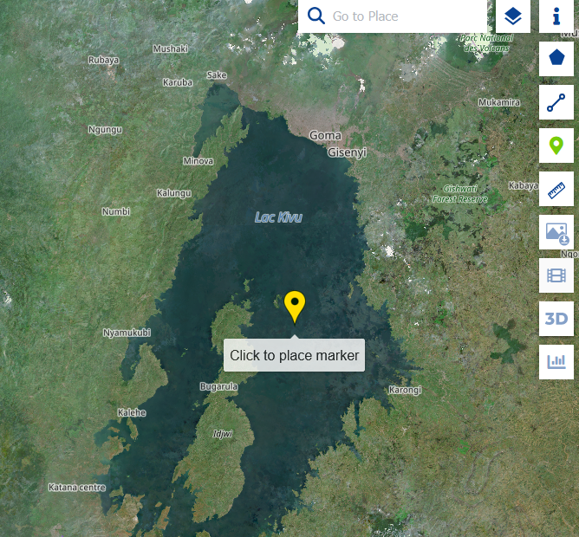

- Go to the Search Menu and select “CLMS Bio-geophysical Parameters” > “Water Bodies” > “River and Lake Water Level” > “Lake Water Level NRT (vector), Daily, (1992–present), V2”

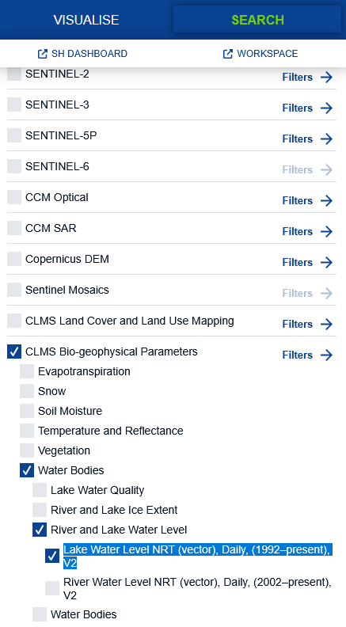
- Drag the menu down, select the period of interest and click on “Search”. The first date must be before 1995 to see the data file.
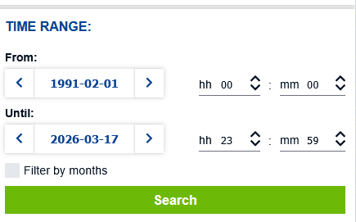
- Click on the download button at the bottom right corner of the file window to download the .json file:
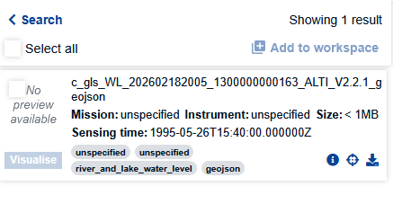

Steps performed by the scripts
Figure: diagram of the script steps

This section describes the steps performed by the scripts that produce the processed data (Levels 1-3) from the raw data (Level 0).

Choices for database creation

General parameters and files selection

Define manual corrections

Load metadata

Load gas data

Create list of unprocessed files

Process Kivuwatt files from L0 to L1
The following steps are performed for each L0 data file.

Read the L0 file
Detects number of profiles. The next steps are repeated for each profile.

Create a CTD object

Extract the profile data and include metadata

Extract the water level data

Apply quality control

Export to L1: to add

Process REMA files from L0 to L1
The following steps are performed for each L0 data file.

Create CTD object

Read the L0 file

Extract the water level data

Add metadata

If several profiles, split the data

If needed, apply manual corrections

Extract the profile data

Apply quality control

Export to L1: to add

Process data from L1 to L2A and L2B
The following steps are performed for each CTD object (L1 data).

Derive relevant quantities

Salinity

Density

Depth

Other quantities

Apply quality control

Export to L2A

Apply mask

Interpolate the data to a constant depth grid
Function profile_to_timeseries_grid:
- The variables specified in the argument “vars_nointerp” are not interpolated.
- The other variables are interpolated along the fixed depth vector ctd.grid[“depth_interp”] which is defined by ctd.fixed_depths_ref in the initialization of the ctd class. The current depth vector ranges from 0 to 400 m with a 0.2 m depth interval.

Export to L2B nc file

Process data from L2B to L3

Select L2B files

Import existing L3 data
Save in a dictionary.
The following 3 steps are repeated for each L2B file.

Read the L2B file (CTD object)

Remove data from selected periods

Include the L2B data into existing L3 data

Export to L3 nc files (Kivuwatt + REMA)

Create a combined L3 nc file

Future changes

