
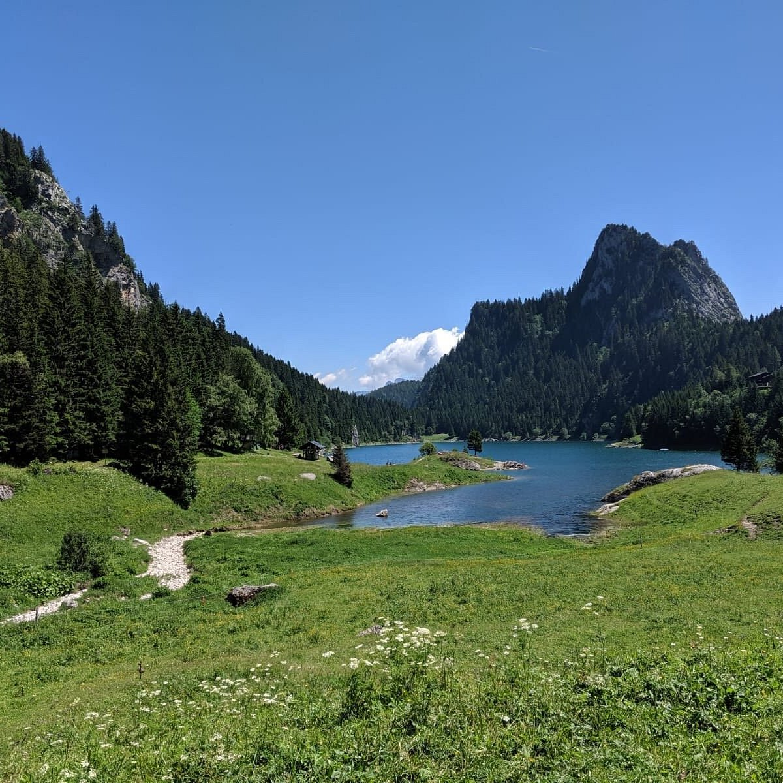
Lake Taney Monitoring – Operational Management Report
2024 Campaign

Introduction
- General context
1.1 Geographical context
Lake Tanay is a natural mountain lake located at an altitude of 1,409 meters in the municipality of Vouvry in Valais (Figure 1). The overdeepening that forms the lake was shaped by glacial erosion in the Tanay valley. [1] The lake is fed by a small stream but has no outflow. However, there is an overflow on the eastern side of the lake, and some of the water seeps away and feeds the springs in the Tové valley. [1] The water level of the lake is also artificially regulated by a water catchment at the bottom of the lake. This water catchment is used for hydroelectric purposes and is shut down in the spring during the spawning season. For these various reasons, the lake experiences significant variations in water level of around ten meters during the course of the year.
The lake and its surroundings are also listed in the Federal Inventory of Landscapes, Sites and Natural Monuments of National Importance (IFP) and are recognized as a nationally important amphibian breeding site.
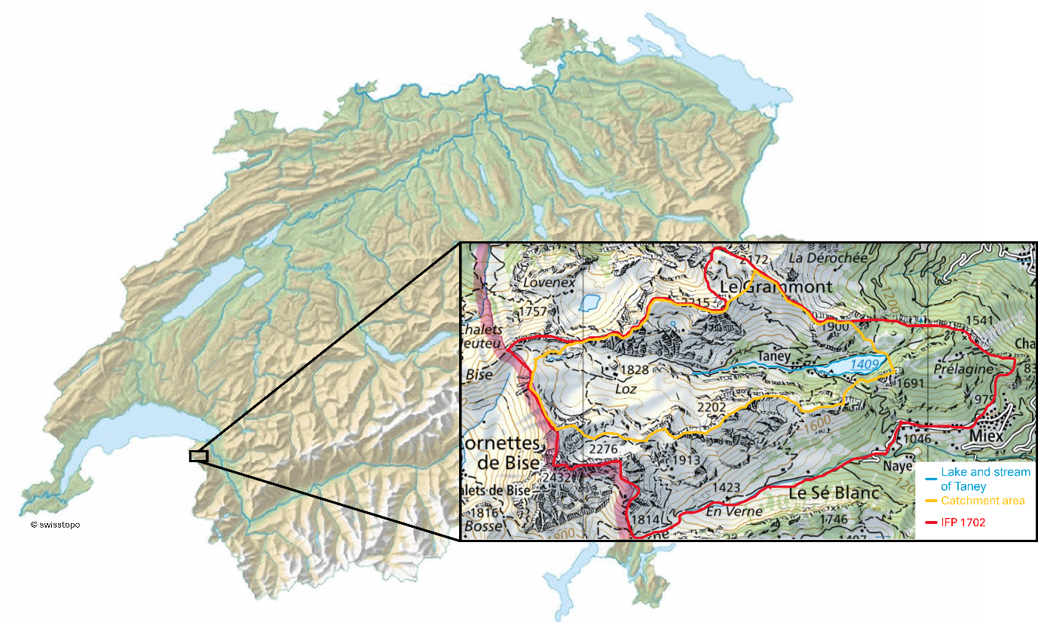
Figure 1. Location of Lake Taney, its catchment area and the area listed in the Federal Inventory of Landscapes, Sites and Natural Monuments (IFP)

1.2 Hydrological context
Data concerning the lake and its catchment area (CA) are shown in Tables 1 and 2 below and:
Table 1 and Table 2: Fact sheet on the Taney CA (data from the OFEV).
Length | 1’000 m |  | Area | 7.13 km²
Width | 250 m |  | Agricultural land | 44.6%
Maximum depth | 31 m |  | Unproductive land | 34.3%
Altitude | 1409 m a.s.l. |  | Wooded areas | 20.4%
 |  |  | Residential areas | 0.6%
1.3 Historical context and current pressures
The lake experiences multiple anthropogenic and climate-induced pressures. Although it is a popular tourist destination during summer, vehicle traffic is restricted and camping in the area has been banned since 2016.
- Motivations and objectives
2.1 Issues and challenges
Lake Taney may face growing environmental pressures in the future as tourism continues to expand in the area, potentially leading to increased nutrient inputs, shoreline disturbance, and degradation of water quality. These anthropogenic pressures could disrupt the lake’s natural equilibrium and accelerate eutrophication processes. Further concern lies in the physico-chemical state of the lake, particularly regarding temperature, dissolved oxygen, and oxygen saturation, which are key indicators of its ecological health. Insufficient lake mixing could limit oxygen renewal in deeper layers, promoting anoxic conditions detrimental to aquatic life and altering nutrient dynamics. With climate change, these issues may become more pronounced: higher air temperatures could intensify thermal stratification, reduce oxygen availability, and shift the lake’s seasonal regime. Together, these evolving pressures pose potential risks to the long-term stability and resilience of Lake Taney’s ecosystem.
2.2 Justification of the study
The physico-chemical monitoring of Lake Taney is justified by the need to preserve a site of national importance recognized for its natural, geological, and ecological values. Although the lake is of natural origin, its water level is artificially regulated, and part of its waters infiltrate a karstic network, making its hydrological balance particularly sensitive. Monitoring helps to assess water quality and the functioning of aquatic and wetland ecosystems that are essential for local biodiversity. It also allows the detection of anthropogenic pressures, such as tourism and hydroelectric use, and climate-related impacts on the lake’s chemistry and temperature. Finally, the regular collection of data provides a scientific basis for tracking the ecological status of the site and implementing appropriate management measures.

2.3 Objectives
Among the protection objectives defined by the FOEN, the following are directly addressed in this report:
- Preserve the ecological function of wetland habitats.
- Preserve the natural character of the lake and its confluence, as well as the quality of their aquatic and riparian ecosystems.
- Preserve the natural dynamics of the watercourse.
In this context, the project aims to establish Switzerland’s first student-led lake monitoring system, designed to serve as a long-term platform for studying and understanding the ecosystem dynamics of Lake Taney. Moreover, the specific objectives of the present report are to monitor the thermal structure, dissolved oxygen, and oxygen saturation of the lake; to interpret monitoring data from previous mooring deployments and field measurements in order to assess temporal and spatial representativity; and to design a long-term, relevant monitoring framework that will contribute to a scientific understanding of Lake Taney’s ecosystem and its evolution, particularly in relation to lake regime and water quality.
- Mooring Configuration and Transect Overview
Two successive mooring systems were deployed in Lake Taney to monitor vertical thermal and oxygen profiles. The first (“old mooring”) was in place from early April to early June 2025 and provided a preliminary temperature record across multiple depths. Following its retrieval on June 5th 2025, a new and improved mooring was installed on June 6th 2025 (Figure 2). This new setup comprised two interconnected buoys (one at the surface and one fixed near the bottom) allowing stable, depth-referenced temperature, pressure, and oxygen measurements throughout the water column. In addition to the fixed-point monitoring, transects were conducted across the lake to complement the mooring data and capture spatial variability in temperature and water clarity. Together, these measurements form the basis for assessing thermal structure and mixing dynamics in Lake Taney (see Annexes 1-4 for full methodological details).
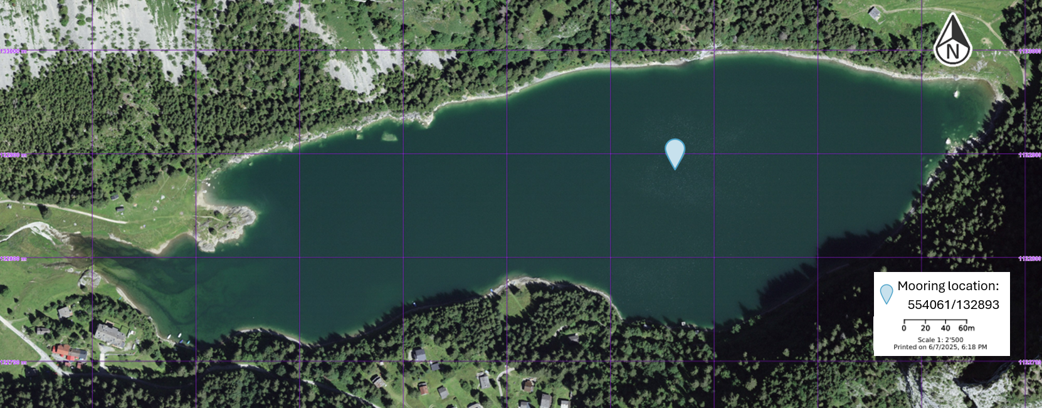Figure 2. Location of the mooring.

Results
- Old Mooring
The 2024 dataset includes temperature measurements at ten depths, from 0 m (surface) down to 25 m, recorded from late March to late November. Sensors were spaced every 2.5 m except for a 5 m gap between 20 m and 25 m. In Figure 3, two small surface‐temperature peaks are visible during late March and Arpil, while the water column is still nearly mixed. A pronounced stratification develops from late May to early June and persists until early September, after which a slow mixing starts around mid‑September and continues until roughly November. The surface temperature reaches a maximum of 22.5 °C, and this warmth extends to a depth of 2.5 m. The bottom temperature begins just below 5 °C, then rises to approximately 6 °C in May and remains stable at that level until measurements have ended. This confirms the presence of a cold, stable hypolimnion at the bottom of the lake.
According to the Aquatic Ecosystem course, based on the latitude and altitude of the lake, Lake Taney is likely to be dimictic. This means that there are two mixings during the year, one in autumn and one in spring. These mixings are consecutive to stratification in summer and inverse stratification in winter. In our case, we can indeed see in Figure 3 stratification in summer following a rise in water temperature. Subsequently, there is a complete mixing in autumn. In spring, there appears to be complete mixing. In Figure 3, this spring and autumn mixing appears as nearly uniform colors from the surface down to 25m (about 4-6°C in spring and 7-9°C in autumn), indicating that the whole water column is almost isothermal. No temperature data for winter is available, but it is known that the lake is frozen in winter, which supports the idea of inverse stratification.
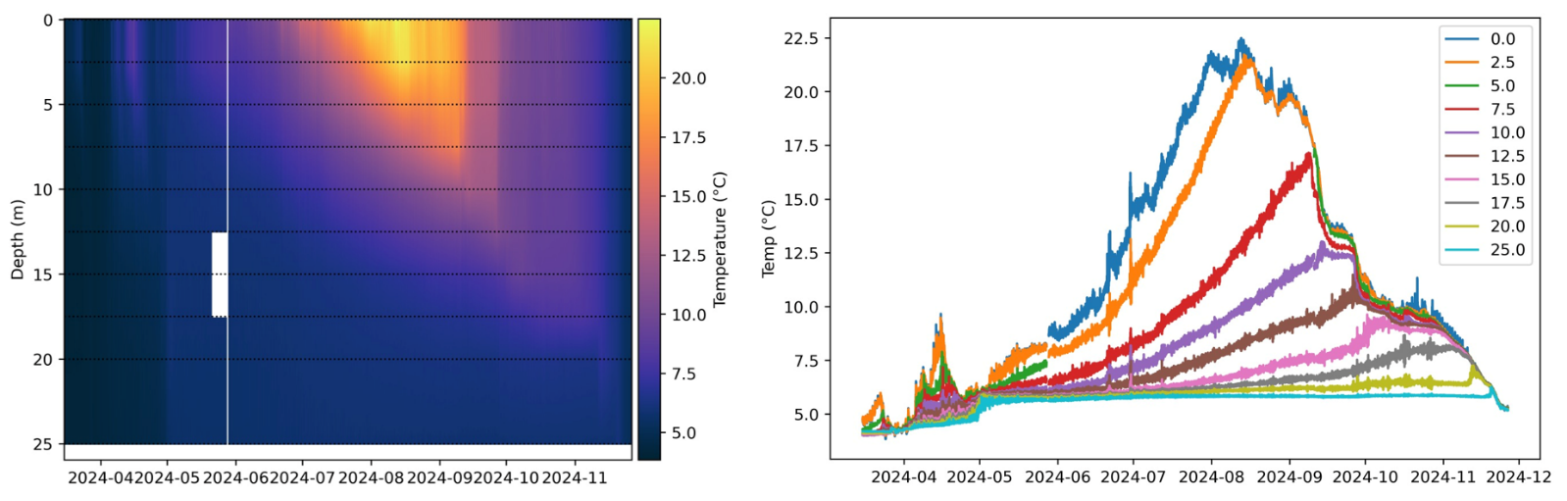Figure 3. Temperature collected by the old mooring station from March to December 2024.
In terms of temperature, the readings of May and June 2025 (Figure 4) are higher than in 2024. This difference could be explained by meteorological conditions: the spring of 2024 was particularly rainy. In April 2024, the average temperature in Switzerland (5.1 °C) was only 0.4 °C above the 1991–2020 average (4.7 °C), while in April 2025 it reached 6.7 °C, 2 °C above the same average. Similarly, May 2024 was slightly cooler (8.8 °C) than May 2025 (9.1 °C). [2, 3, 4, 5]
With global warming, instances of incomplete mixing of lakes are expected to become more frequent. This phenomenon can have major consequences, such as the disappearance of sensitive species, the release of phosphorus from sediments accelerating eutrophication, and the alteration of biogeochemical cycles.
We can also see in Figure 3 that an anomaly appears at the beginning of June: the 2.5 m sensor registers a sudden temperature drop, suggesting it was moved deeper in the water column, while the 0 m sensor simultaneously records a temperature rise, indicating it had been previously positioned below the true surface and was moved up the water column. Around the same date, there is a brief interruption of all sensors (visible as a thin vertical white line in Figure 3). This likely corresponds to a malfunction of those loggers.
For 2025, there is only a little over a month of data, as the mooring was not put back in the water until April. Despite this, the beginning of thermal stratification is already visible in Figure 4. From late April to early June, the surface temperature increases overall from about 9-10 °C to around 16 °C, with a brief cooling event in early May, while temperatures below ~15m remain close to 4-6 °C, showing a strengthening stratification. The readings indicate that temperatures in May and June 2025 are higher than in 2024 (as seen when comparing Figure 4 to the 2024 mooring record in Figure 3).
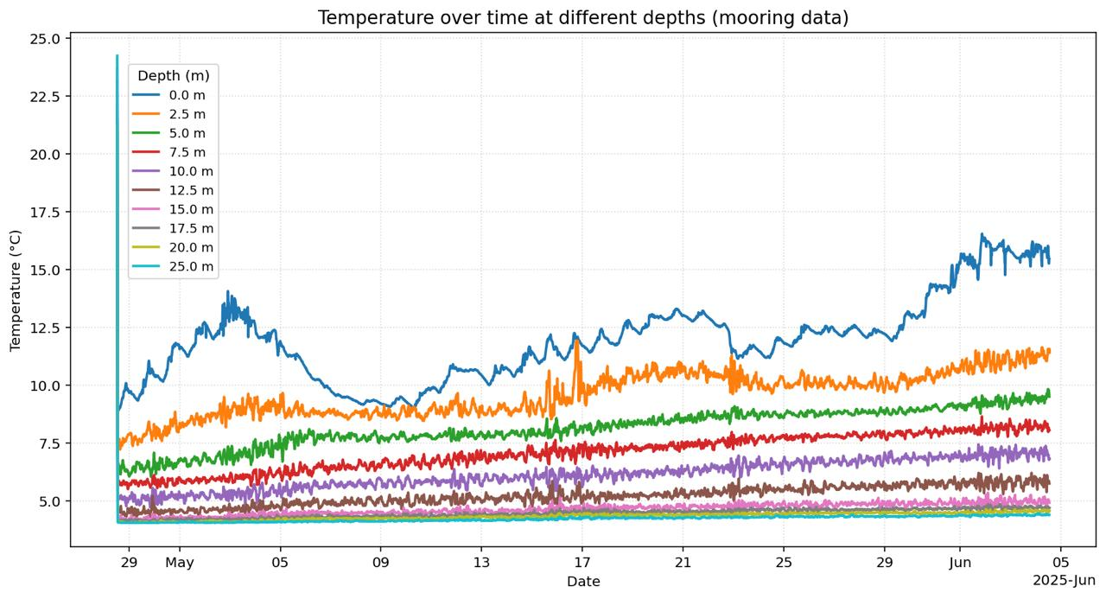
Figure 4. Temperature collected by the old mooring station from May to June 2025
- Transects
For transect 1, taken at the mouth of the river, the depth is limited. The whole water column there remains relatively warm compared with the deeper parts of the lake shown in transects 2 and 3 (Figure 5). At the deepest point of the transect, the vertical temperature gradient is weak but still present: temperatures decrease smoothly from about 15-16 °C at the surface to ~9-10 °C at ~10m depth. For transects 2 and 3 (Figure 5), a more pronounced thermal stratification is visible. At the bottom of the lake, a well-developed hypolimnion begins at a depth of about 15-17 m and extends to the deepest parts of the basin, where temperatures are nearly uniform at around 6 °C along both transects. Transect 3 is longer and deeper than transect 2 (down to >30m), yet the hypolimnion temperature remains almost constant horizontally, indicating a laterally homogeneous deep-water mass.
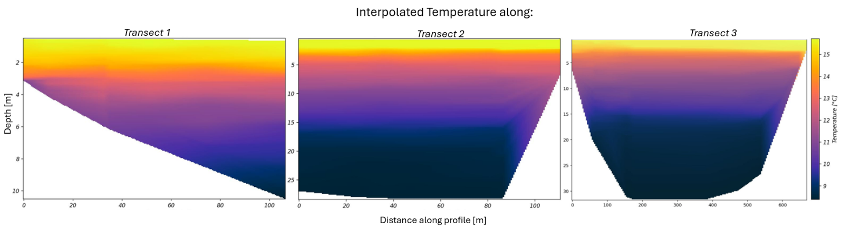Figure 5. Temperature measured on June 5, 2025, by a RBR profiler along transect 1, 2 and 3.
There is also clear stratification in the dissolved oxygen profiles (Figure 6). At the surface, oxygen saturation is high and largely supersaturated (about 120-145%), mainly due to photosynthesis and exchanges with the atmosphere. From 15 m downward, corresponding to the hypolimnion, values drop sharply, probably due to The degradation of organic matter at the bottom of the lake. At about 20-30m depth (the deep hypolimnion), oxygen saturation decreases roughly 30-40%, indication substantially depleted but still clearly non-anoxic conditions. This stratification is also visible in the oxygen saturation profiles, with supersaturation at the surface (>100 %) low saturation at depth (~30-40%), matching the base of the thermocline seen in the temperature transect (Figure 6).
Because these measurements were taken in June (early in the stratified period), it is likely that oxygen will continue to be consumed in the deep layers as the season progresses, as typically observed in stratified lakes. This vertical gradient is typical of stratified lakes in summer. What is noteworthy is that oxygen saturation in the deepest waters is already relatively low in June, which could suggest that winter or spring mixing did not fully reoxygenate the deep basin, although confirming this would require profiles from earlier in the year.
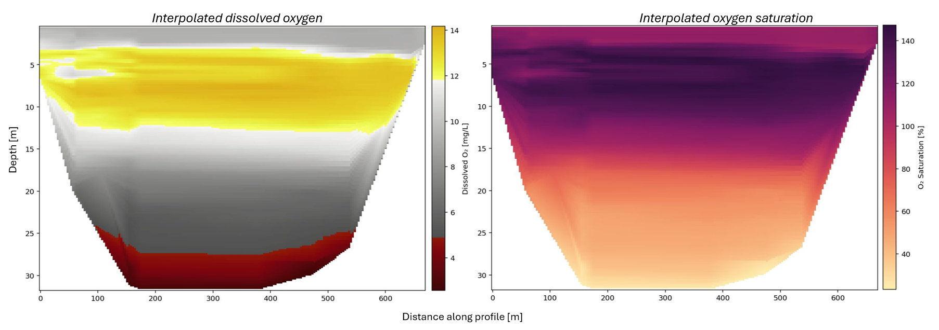Figure 6. Dissolved oxygen and oxygen saturation measured on June 5, 2025, by a RBR profiler along transect 3.

Conclusion and Recommendations
- Conclusion
Taken together, the 2024-2025 measurements show a small, dimictic lake with a clear seasonal cycle: the water column is nearly mixed in spring and autumn, but develops strong summer stratification with a warm, shallow epilimnion and a cold, stable hypolimnion below about 15-17m. The 2025 record suggests that surface warming and the onset of stratification are at least as strong as, and likely stronger than, in 2024, hinting as a sensitivity to interannual meteorological variability.
The transects confirm a strongly stratified lake: shallow river-mouth areas are uniformly warm, while the deep basin has a cold, homogeneous bottom layer beneath a sharp thermocline. Oxygen shows the same pattern, with supersaturated surface waters and much lower saturation in the deep hypolimnion already in June. These data indicates that deep-water conditions in summer are vulnerable to warming and to any weakening of seasonal mixing.
- Recommandations
Experience from previous deployments reveals several improvements are needed to enhance the reliability and year-round performance of the monitoring system. The following recommendations focus on mooring design and practical setup. A single surface buoy should be sized to support the full suspended load and remain stable under variable weather, maintaining tension in the mooring line. Because Lake Taney can experience winter ice cover, the buoy should withstand freezing and limit stress when submerged in ice. A flexible or semi-submerged, ice-rated, foam-filled polyethylene buoy (UV-stable, impact-tolerant, unsinkable) is recommended, as used in cold-region navigation systems. [6]
The total line length should be about twice the lake’s maximum depth to adapt to the ±10 m water-level variation and to make sensor replacement easier. A metal chain as the main vertical line helps by resting on the lakebed and adjusting naturally to level changes, preventing slack and keeping sensors properly spaced. The layout remains simple: one sensor near the surface and one near the bottom weight, with sensors between at wanted depths (avoiding sediment contact). The upper sensor should be fixed just below the buoy, deep enough to avoid ice yet shallow enough to capture surface-layer changes.
These recommendations describe a single, year-round layout; however, if possible, a seasonal setup change would improve durability. Replacing the surface buoy with a subsurface float 1-2 m below the surface in winter, common practice in northern and alpine lakes [7, 8], reduces ice complication and relieves stress on hardware.The same chain, sensors, and anchor would be reused, with only the buoy swapped for a small subsurface float each autumn. This adjustment increases stability during freeze-melt, extends equipment life, and minimizes data loss from buoy movement or breakage, all while remaining low-cost and practical for student-led servicing.

References
[1] Office fédéral de l’environnement (OFEV). 2017. IFP 1702 Lac de Tanay. Repéré à https://data.geo.admin.ch/ch.bafu.bundesinventare-bln/objectsheets/2017revision/nr1702.pdf
[2] Bulletin climatologique avril 2024—MétéoSuisse. (s. d.). Consulté 13 novembre 2025, à l’adresse https://www.meteosuisse.admin.ch/services-et-publications/publications/rapports-et-bulletins/2024/bulletin-climatologique-avril-2024.html
[3] Bulletin climatologique avril 2025—MétéoSuisse. (s. d.). Consulté 13 novembre 2025, à l’adresse https://www.meteosuisse.admin.ch/services-et-publications/publications/rapports-et-bulletins/2025/bulletin-climatologique-avril-2025.html
[4] Bulletin climatologique mai 2024—MétéoSuisse. (s. d.). Consulté 13 novembre 2025, à l’adresse https://www.meteosuisse.admin.ch/services-et-publications/publications/rapports-et-bulletins/2024/bulletin-climatologique-mai-2024.html
[5] Bulletin climatologique mai 2025—MétéoSuisse. (s. d.). Consulté 13 novembre 2025, à l’adresse https://www.meteosuisse.admin.ch/services-et-publications/publications/rapports-et-bulletins/climate-bulletins/klimabulletin-2025-5.html
[6] International Association of Marine Aids to Navigation and Lighthouse Authorities (IALA). 2018. G1006: Plastic Buoys. IALA, 4.1, revised 14 Dec.2018.
[7] Hughes, K. S., Forrest, A. L., Cortés, A. and Bombardelli, F. A. 2024. Transitional Circulation Patterns from Full Ice Cover to Ice-Off in a Seasonally Ice-Covered Lake. Aquatic Sciences, 86 (2).
[8] Austin, J. and Elmer, C. 2023. An Archive of Lake Superior Temperature and Current Measurements, 2005–2020. Limnology and Oceanography Letters, 8 (4), 595–602. https://doi.org/10.1002/lol2.10293

Appendices
- Mooring set up
Annex 1. Diagram of the old mooring with a surface buoy connected to a submerged buoy (Level 0) above a bottom weight. The associated logger identifiers were, respectively: 2171001_0m at 1.70 m; 21724000_2.5m at 4.30 m; 21723998_5 at 7.13 m; 21724003_7.5 at 9.93 m; 21724002_10 at 12.53 m; 21723997_12.5m at 15.20 m; 21723999_15 at 17.86 m; 21723996_17.5 at 20.42 m; 21723995_20 at 22.97 m; and 21723994_25 at 27.92 m. | Annex 2. Diagram of the new mooring showing two lines (buoy A and buoy B). Each logger ID encodes its depth. Temperature logger IDs on buoy A: 21724003_0.5; 21723994_1.5; 21723995_3.5; 21712001_5.5; 21723997_7.5; 21724002_10; 21723999_12.5. Temperature logger IDs on buoy B: B_3, B_5, B_9. Pressure loggers: 20598413_A_14 on buoy A and 20598412_B_15 on buoy B.
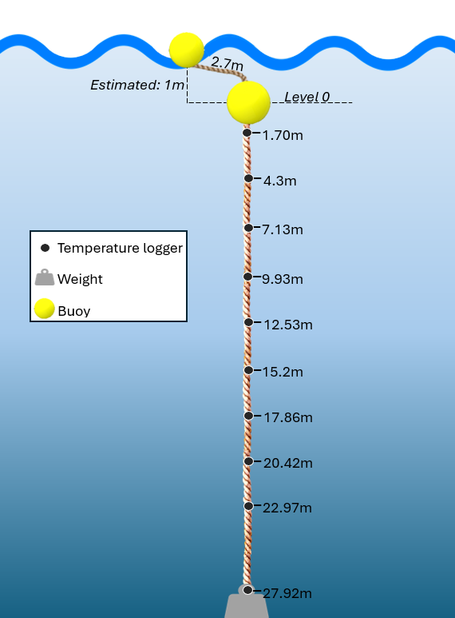 | 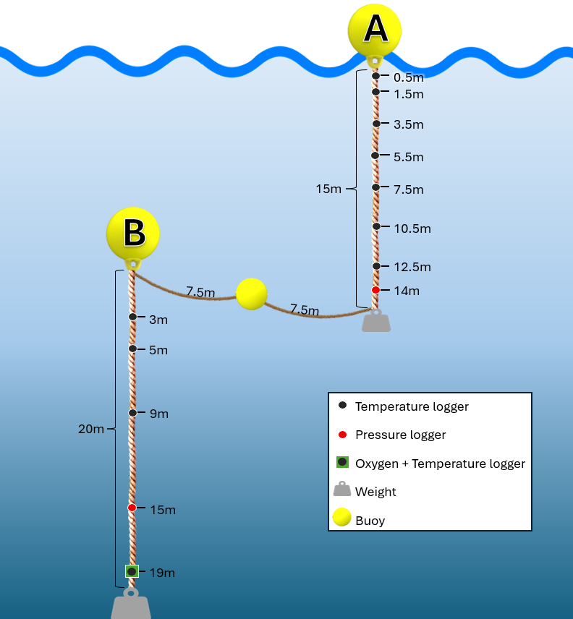

- Transects locations
Annexe 3. Map of Lake Taney showing three survey transects: Transect 1 follows the river inflow into the lake, Transect 2 spans the lake’s width, and Transect 3 runs along the lake’s length.
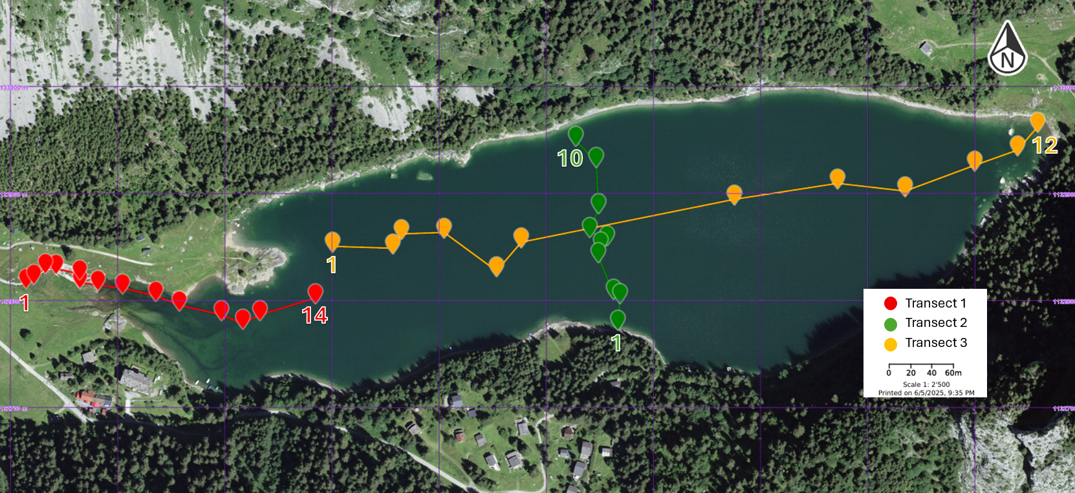
- Methods
3.1 Method of old mooring
A previously deployed mooring was retrieved on 5 June 2025 (Annexe 1). The data-logger servicing began on the 4th of April, the date the buoy was set in place. The mooring consisted of a surface buoy and a bottom weight. The surface buoy was connected to a submerged buoy by a rope measuring 2.70 m on deck. In the lake, the rope floated and the effective distance from the submerged buoy to the surface was about 1 m rather than 2.70 m. The submerged buoy is defined as Level 0. Temperatures were recorded by a series of data loggers mounted along the line. Logger depths were initially referenced from the bottom weight and then converted to a top-down scheme for consistency. From Level 0, loggers were positioned at 1.70, 4.30, 7.13, 9.93, 12.53, 15.20, 17.86, 20.42, 22.97, and 27.92 m. All loggers recorded temperature.
3.2 Method of new mooring
The new mooring on Lake Taney was deployed on 06/06/2025 at 10:39 local time (Europe/Zurich) at the recorded position 554061/132893 (Figure 2). The configuration comprised two buoys with complementary roles (Annexe 2). Buoy A served as the surface reference: it was rigged to a 15 m line with a light weight sized so the weight remained suspended above the lakebed, keeping A at the surface. Buoy B acted as a stable submerged reference: it was rigged to a 20 m line with a heavier weight that rested on the bottom, fixing B’s depth. The buoys were interconnected by a 15 m rope running from the weight of Buoy A up to the top of Buoy B. A small auxiliary float was added on this connector to keep the line buoyant and lightly tensioned, preventing excessive slack and reducing the risk of tangling with other lines. This linkage maintains their relative geometry while isolating B from surface motion and preserving A as a true surface datum.
Instrumentation followed two depth references. On Buoy A, depths are expressed relative to the lake surface; temperature loggers were installed at 0.5, 1.5, 3.5, 5.5, 7.5, 10, and 12.5 m. On Buoy B, depths are expressed relative to the submerged buoy; temperature loggers were mounted 3, 5, and 9 m below B. Pressure sensors were set at 14 m on A and 15 m on B. Prior to logging, the pressure units were labeled and referenced in UTC: serial 20598413 assigned to A at 14 m and serial 20598412 assigned to B at 15 m. An oxygen sensor was installed on B at 19 m, positioned at 1 m from the bottom of the lake to prevent burial and ensure accurate measurements of near-bottom dissolved oxygen. Because deployment time was recorded in local time while pressure sensors use UTC, post-processing should align time series accordingly.
To characterize light penetration at deployment, two Secchi measurements were taken (4.70 m and 4.90 m), providing a check on clarity and an estimate of the photic zone influencing the upper part of the temperature string. The deployment sequence was as follows: sensor packages, buoys, and weights were attached on land; the assembled system was transported by small boats to the deepest area of the lake; the mooring was then deployed in situ. Additional weights were brought along and adjusted on site to ensure that Buoy A remained afloat with its weight suspended and that Buoy B stayed submerged with its weight on the bottom. Final checks confirmed clear lines, appropriate tensions, correct depths, and proper logger IDs.

3.3 Method of Transects
The survey consisted of three transects designed to map the water column (Annexe 3). Measurements were collected with an RBR profiler on June 5th 2025. Each data record included profile name, depth, distance along track, and horizontal position as x and y coordinates referenced to the CH1903 coordinate system.
Transect 1 followed the river inflow. The boat first started slightly upstream of the lake–river junction and then drifted with the current from the river into the lake, creating a profile that captured mixing at the entry. Transect 2 crossed the lake’s width, providing a lateral section from one shore to the opposite shore. Transect 3 ran along the lake’s main axis, covering its length from one end to the other.
Transects 1 and 2 recorded temperature only, while Transect 3 recorded temperature along with dissolved oxygen and oxygen saturation. All measurements were logged continuously with depth to describe vertical structure, and x-y position and cumulative distance along each transect were recorded to capture horizontal changes. Collecting these variables together with coordinates and distance enables interpolation of conditions along each transect and throughout the water column.
- Links to the data/scripts
The data, code and data pipeline is available in the following GitHub repository: https://github.com/tdoda/taney-monitoring-masterfieldcamp/

