Rockland Scientific microCTD SOP Manual

Contents
1 List of equipment needed 2
1.1 For maintenance 2
1.2 For field campaign 2
2 Before deployment 2
2.1 Checking the status of the instrument 2
2.2 Connecting the microCTD to the computer 4
2.3 Checking the files 5
2.4 Checking/modifying the configuration file 5
2.5 Bench test and data acquisition checks 6
2.6 Checking the voltage and charging the battery 10
2.7 Checking & clearing the memory 10
2.8 Setting the time 10
2.9 Preparing the instrument 10
2.10 Installing the probes 11
2.11 Overview: check-list 12
3 Deployment 13
3.1 Initial checks 13
3.2 Downward profile 13
3.3 Upward profile 15
4 After deployment 15
4.1 Recovering the instrument 15
4.2 Removing the probes 15
4.3 Update configuration file 16
5 Data download, visualization and processing 16
5.1 Data download 16
5.2 Quick data visualization with Zissou 16
5.3 Complete data processing 16
5.4 Useful ODAS scripts 16
5.4.1 Bench test (quick_bench) 16
5.4.2 Configuration file modification 17
5.4.3 Data import (odas_p2mat): 17
5.4.4 Profiles detection (get_profile) 20
5.4.5 FP07 temperature calibration (cal_FP07_in_situ.m) 21
5.4.6 Shear spectra and dissipation (quick_look) 21

List of equipment needed

For maintenance
- Spare O-rings
- Spare CR123 battery
- Silicon grease
- Dessicants
- Wrench to change hardware configuration
- Stands to hold the microCTD horizontally

For field campaign
- MicroCTD case with probes and tools provided by Rockland
- Aluminum case for bench test + spare aluminum sheets
- Electric cable used for bench test
- Multimeter: to measure the battery voltage (optional) and to inspect the probes
- Screw driver for weights
- Microconductivity liquid (0.1% Triton X-100)
- KimTech tissues
- Compressed air (optional)
- Distilled water
- Calibration sheets
- Rope (diameter between 5mm and 8mm and a specific gravity of 1.30)
- Power source (e.g., battery and converter) to charge the microCTD
- Computer with RSILink and Motocross installed

Before deployment

Checking the status of the instrument

Perform the following checks regularly:
- Open the instrument to check the pressure tube (see manual, Sect. 2.1). After removing the rear head and disconnecting the cables, it might be easier to hold the instrument vertically between the legs and to pull the pressure tube upward by making sure that it is not touching the electronic board. Place the inner part of the instrument on a flat surface (e.g., foam or stands).
  - Inspect the two O-rings from the front and rear heads. Take them out, clean them with Kimtech tissues, add grease (without excess) or replace them.
  - Inspect the two cavities at each end of the pressure tube where the O-rings stand by moving the finger gently around them. Make sure they are clean (otherwise, clean them with Kimtech) and free of scratches.
  - Inspect the inner part of the pressure tube for scratches.
  - Change dessicants.

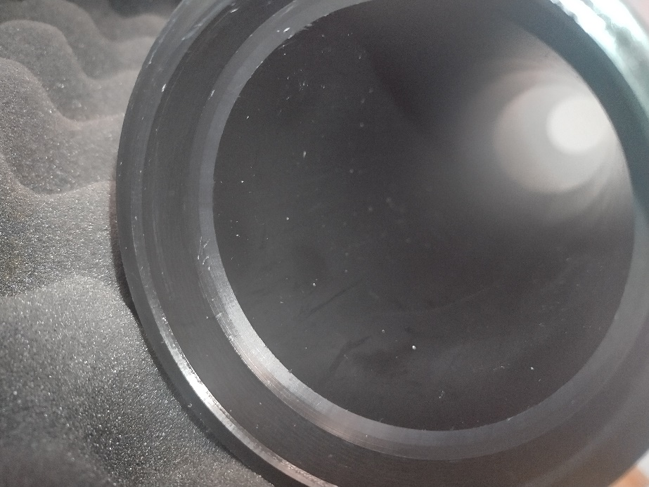
O-ring cavity (on each side of the tube)
Inner part

- While the instrument is open, make sure that the hardware configuration matches the deployment goal. If not, change it by unscrewing the S2/C1 cable with a wrench and moving it to the other port.
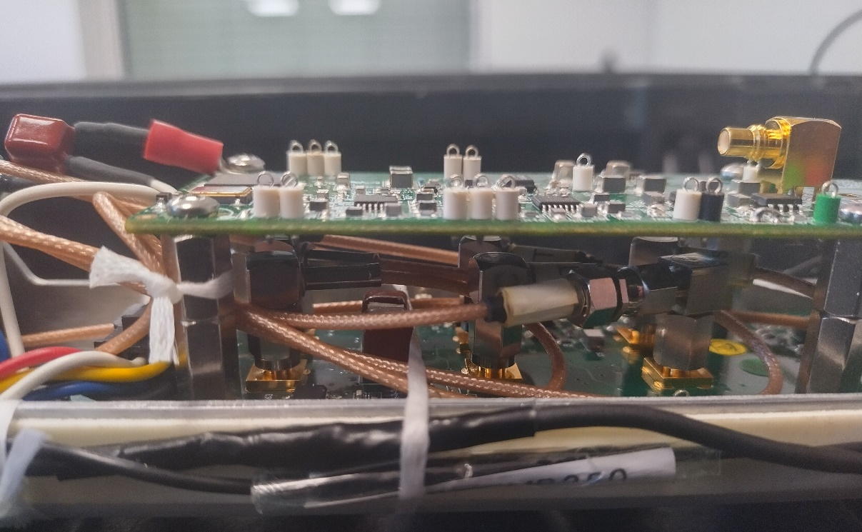
Screw
Adapter
S2 port
C1 port
S2/C1 cable

- Change battery CR123 if needed (annually).
- Check probes (including test probes) & ports: damages, O-rings (behind compression plate) and SBE connectors (discoloration marks). In case of any doubt, measure the capacitance with the multimeter (see TN067).
- Check other O-rings and sealing surfaces of the instrument (see list below). All O-rings should be replaced annually in theory. Here is the list of the different O-rings on the instrument (in addition to the probe O-rings):
- Pressure tube to bulkhead piston seal O-rings (x2)
- Sealing nut piston-seal O-rings (x2)
- LED indicator face-seal O-ring (x1)
- MCBH-8-FS connector face-seal O-ring (x1)

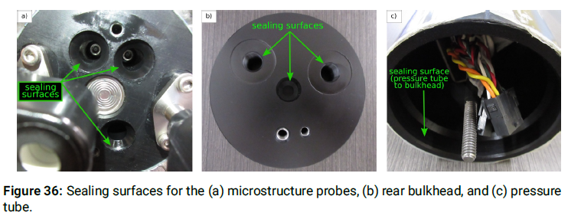
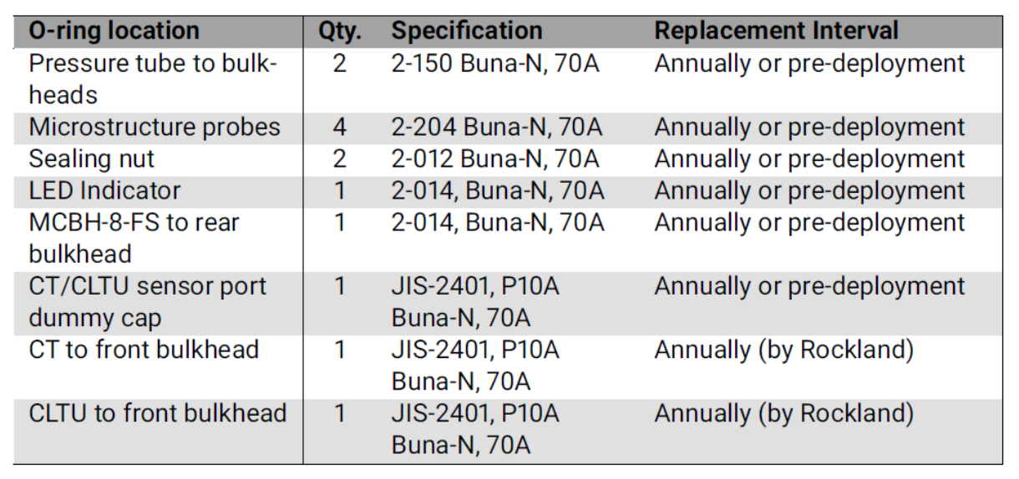

See manual (4.3).

Connecting the microCTD to the computer
- Open the "Device Manager" on the computer and go to the COM-port section.
- Connect the deck cable to the computer (USB) and not to the instrument.
- Identify the number of the two newly-created ports (named “USB Serial Port”). Both numbers should be equal or below 9. If it not the case, rename the port: right click > "Properties" > "Port Settings" > "Advanced". If the numbers are not showing up, it might be needed to connect the cable to the instrument. Check that the COM ports exist by going to “View” > “Show hidden devices” in Device Manager.
- Open MotoCross.
- Set the port number to the serial port number: "File" > "Communication Settings".
- Connect the deck cable to the instrument (MCBH): it should turn on and start to measure after 10 seconds (blue light on fluorometer). If not, enter odas5ir –n.
- To stop the measurements, press "q".
- To get the list of all commands: odas5ir -help

Checking the files
- Connect the microCTD to the computer and open MotoCross (Sect. 1.2).
- Type dir: the files in the current directory are displayed. They should be: folder with data files, file "autoexec.bat", file "usbl.run", file "setup.cfg".
- To check the data files, type cd data..

Checking/modifying the configuration file
- Open the configuration file "setup.cfg" in MotoCross or download it to your computer as follows and open it with a text editor:
  - Connect the microCTD to the computer and open MotoCross (Sect. 1.2).
  - Type usbl
  - Open RSILink and select the USB port (i.e., 2nd COM port).
  - Press "Get Root Directory"
  - Select the configuration file and press "Download".
  - Select the location to save it and press "OK".
- Modify the configuration before deployment if there is a need to change the sampled channels. Sensor calibration can be done in post-deployment.
- Add a comment in the first paragraph for any change made to the configuration file. Follow the format:
; YYYY-MM-DD Name_user Description_changes
- Root section: data acquisition parameters (no need to modify).
- Matrix section: matrix containing the channels identifiers (0-255) that will be sampled (see channel sections below). For each iteration, the order of sampling is from the first row to the last row of the matrix, and from left to right within each row. Each row is sampled at the sampling rate defined in the root section (512 Hz). A given row number is re-sampled at a rate of sampling_rate/number_rows (e.g., 64 Hz with 8 rows).
- Slow channels (64Hz sampling): identifier appears only once in the matrix (first two columns)
- Fast channels (512Hz sampling): identifier appears in each row (other columns)
The typical channel identifiers are listed at the end of the file:
id Name - rate - Description
-------------------------------------------------------------------
0 Gnd - slow - Reference ground
1 Ax - fast - horizontal acceleration in the direction of the pressure port or ON/OFF magnet
2 Ay - fast - horizontal acceleration orthogonal to the direction of the pressure port
4 T1 - slow - Temperature from Thermistor 1 without pre-emphasis
5 T1_dT1 - fast - Temperature from Thermistor 1 with pre-emphasis
6 T2 - slow - Temperature from Thermistor 2 without pre-emphasis
7 T2_dT2 - fast - Temperature from Thermistor 2 with pre-emphasis
8 sh1 - fast - velocity derivative from shear probe 1
9 sh2 - fast - velocity derivative from shear probe 2
10 P - slow - pressure signal without pre-emphasis
11 P_dP - slow - pressure signal with pre-emphasis
12 PV - slow - voltage on pressure transducer
32 V_Bat - slow - Battery or power supply voltage
40 Incl_Y - slow - Inclinometer, rotation around the y-axis
41 Incl_X - slow - Inclinometer, rotation around the x-axis
42 Incl_T - slow - Inclinometer, its temperature
48, 49 JAC_C - slow - JAC conductivity sensor
50 JAC_T - slow - JAC thermometer
52 Chlorophyll - fast - JAC fluorometer
53 Turbidity - fast - JAC backscatter sensor
64 C1 - fast - micro-conductivity without pre-emphasis
65 C1_dC1 - fast - micro-conductivity with pre-emphasis
255 sp_char - slow - special Character that always returns 32752D or 7FF0H and is used to test the integrity of communication.

- Instrument info section: information about the instrument (e.g., name and serial number), which is used for data processing and visualization.
- Cruise info section: information about the field campaign.
- Channel sections: used to convert and process the raw data (not used during data acquisition, could be modified after the field campaign). Only modify the part of the channels that depends on the sensors (i.e., calibration coefficients):
- FP07: serial number "SN" and coefficients "beta_1", "beta_2", "T_0" must be updated for each sensor. These coefficients correspond to the second-order model below and are found either from the calibration report of the sensor (if it was calibrated) or by performing an in-situ calibration of the FP07 using the JAC sensor, which is what is usually done (see TN039, Sect. 11.2).
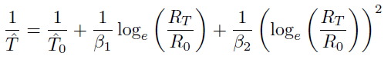
- Shear: serial number "SN" and sensitivity "sens" must be updated for each sensor. This information is found in the calibration report.
- Pressure: coefficient "coef0" could be changed to modify the pressure offset (coef0=-patm such that pcalc=pmeas+coef0=pmeas-patm)
- Once the configuration file has been modified, upload it to the data logger using RSILink (if modifications were made before the deployment).
  - Connect the microCTD to the computer and open MotoCross (Sect. 1.2).
  - Type usbl
  - Open RSILink and select the USB port (i.e., 2nd COM port).
  - Press "Upload" and select the new configuration file.

Bench test and data acquisition checks
- Make sure the instrument has the test probes installed. The test probes must match the configuration, i.e. do not use the C1 test probe on the S2-C1 port if the configuration uses S2. If there is no matching test probe, run the bench test without any test probe.
- Rest the instrument horizontally on a table or bench, preferably on something soft (e.g. open cell foam), with the pressure port/magnet centered and facing up.
- Ideally, cover the instrument by aluminum foil and connect this foil shielding to the sealing nut (rear bulk head) with an electrical cable.
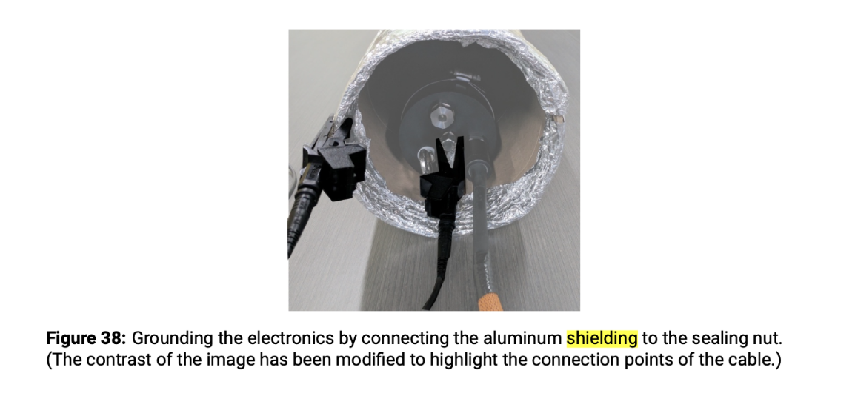
- Connect the microCTD to the computer and open MotoCross (Sect. 1.2).
- Run the calibration mode for all channels to get statistics of the raw data (min, max, mean, std):
odas5ir –f configuration_file.cfg –c all
Check that all channels have a reasonable noise level: refer to TN048 (Table 2) for the expected values.
In general, all std values should be close to zero: <1 for FP07 (channels 4, 6), <10 for FP07 with pre-emphasis (channels 5, 7), <5 for shear (channels 8, 9), <1 for P (channel 10) and <5 for P_dP (channel 11). Check channel 255: mean, min and max should be = 32752 and std should be = 0.
- Start data acquisition:
odas5ir –f configuration_file.cfg –l 3000 –n.
The terminal window should display lines with the format:
L last_record_count n next_record_count p pressure
Stop the data acquisition by pressing "q" after at least 3 minutes (i.e., line "L 180 n 181" is displayed).
- Download the data file (see Sect. 4.1).
- Display the data either with Zissou Essentials or with the Matlab function "quick_bench":
- Zissou Essentials: open the software, select the option "Analyse Bench Test" and load the data file.
- Matlab: quick_bench(file_name)
- At least two figures are displayed: time series of the raw data from the different channels and spectrum for each channel (click on "Generate Spectra" in Zissou). Follow the Bench Test check list to analyze the plots:
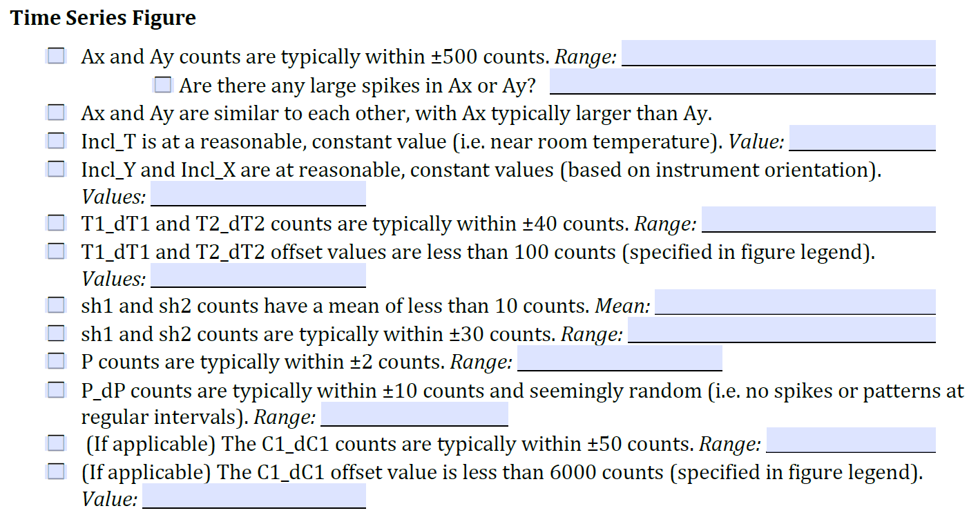
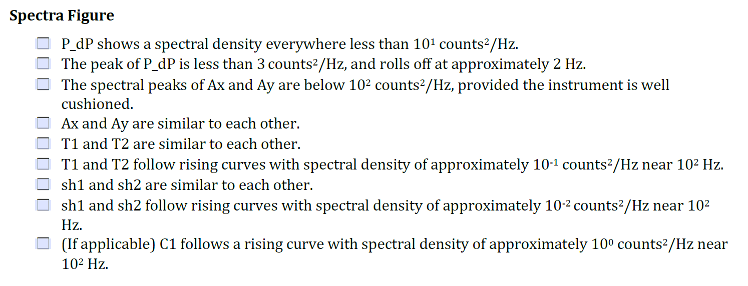
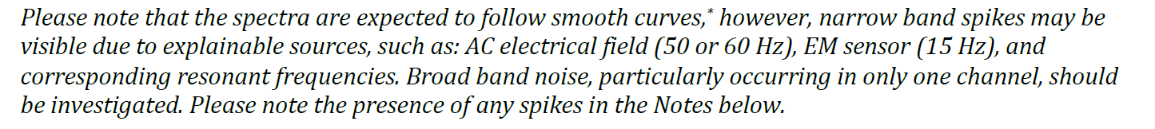
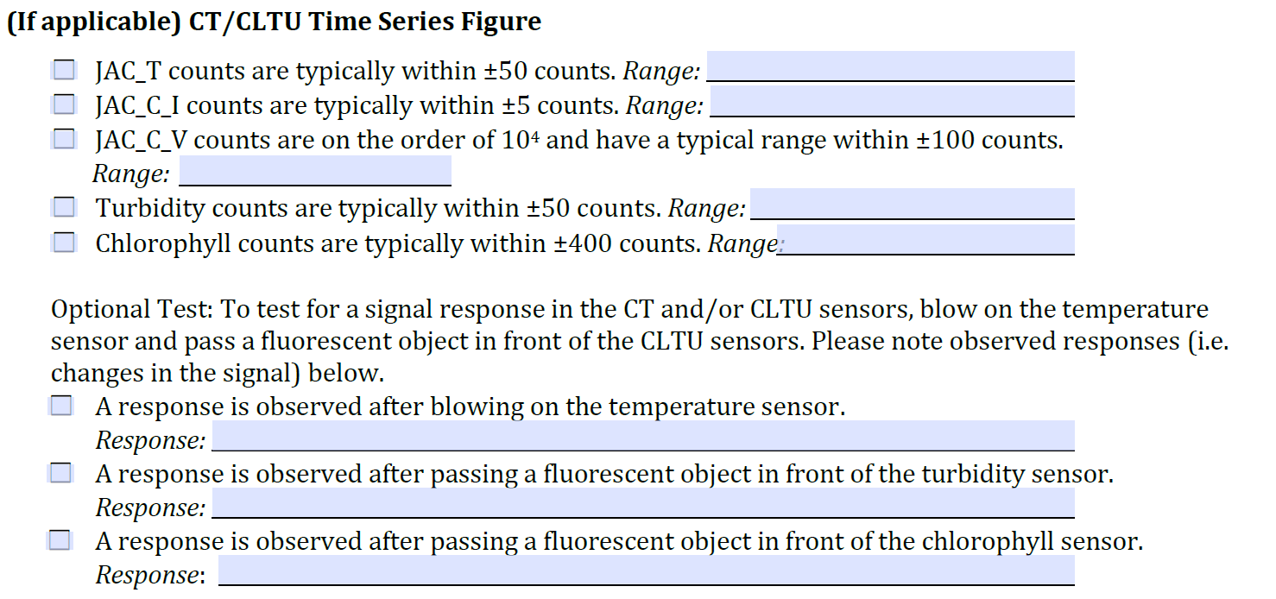
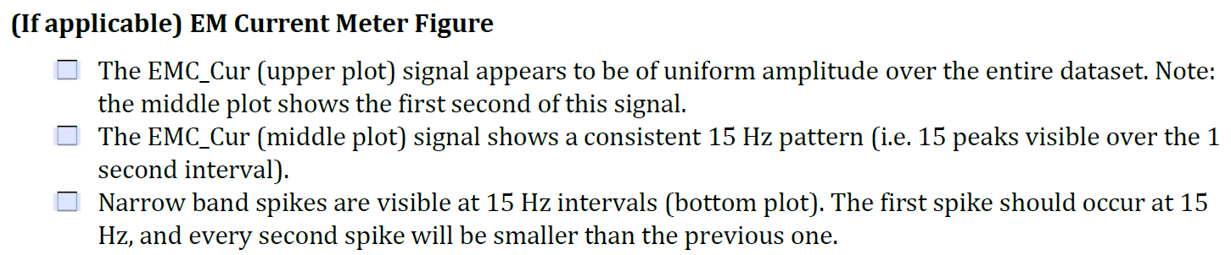
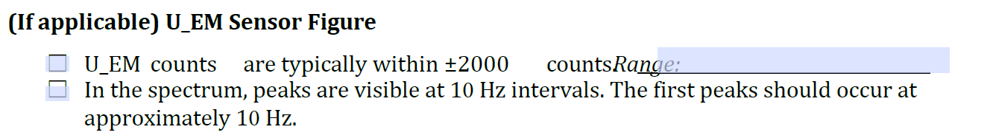
Example of typical spectra for configuration S1S2T1C1 (slide from Rockland training):
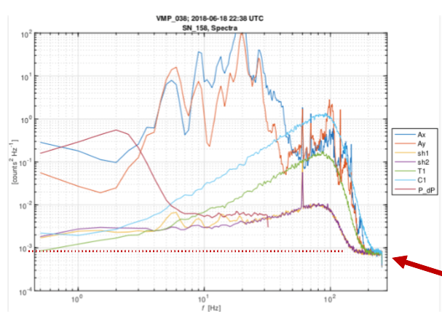
Example of typical spectra for configuration S1T1T2S2:
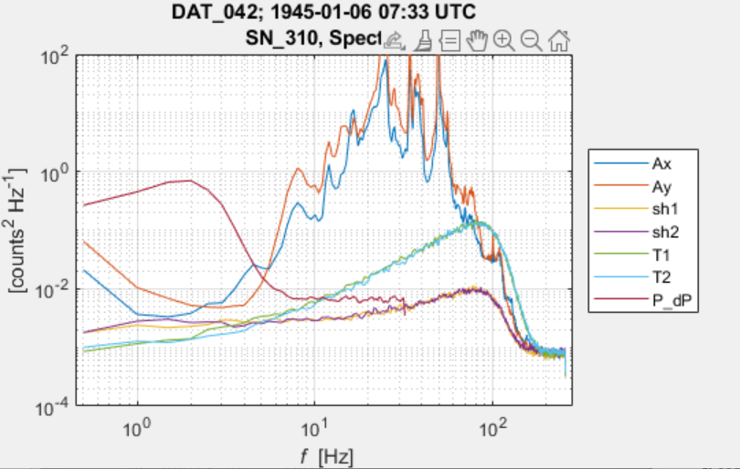

Notes:
- Peak at ~0.1 Hz in the temperature spectrum indicates that there is an issue with the temperature board.
- Environmental noise usually corresponds to a peak at ~60 Hz in the shear spectrum.
- To test fluorometer, a bright object can be moved in front of the sensor during data collection (producing a peak in the spectrum).

Checking the voltage and charging the battery
To check the voltage:
- Possibility 1: with voltmeter (see manual 4.3.1)
- Possibility 2: with MotoCross
- Connect the microCTD to the computer and open MotoCross (Sect. 1.2).
- Type: odas5ir –v
- The voltage is displayed in the window.
The maximum voltage is 16.7V. If the measured voltage is less than 14V, the battery must be charged.
To charge the instrument: see manual

Checking & clearing the memory
To check the memory:
- Connect the microCTD to the computer and open MotoCross (Sect. 1.2).
- Type dir: the free space is displayed. The maximum memory is 4 GB.
To clear the memory:
- Connect the microCTD to the computer and open MotoCross (Sect. 1.2).
- Format the CF card by typing restore. All the data files are deleted, except the DATA folder and the files USBL.RUN, SETUP.CFG, AUTOEXEC.BAT.

Setting the time
- Connect the microCTD to the computer and open MotoCross (Sect. 1.2).
- Type usbl
- Open RSILink and select the USB port (i.e., 2nd COM port).
- Press "Set Time".

Preparing the instrument
- Disconnect the instrument from the computer and replace the deck cable by a dummy plug.
- Install the drag net on the instrument (rear side).
- Install the ballast collars (weights) around the pressure tube:
- Downward profiling: the weights must be installed at the front side of the tube. Sinking speeds are 0.4 m/s with the small weight, 0.6 m/s with the big weight and 0.8 m/s with both weights.
- Upward profiling: the weights must be installed at the rear side of the tube. Rising speeds are 0.9 m/s with the small weight, 0.8 m/s with the big weight and 0.5 m/s with both weights.
- In case of upward profiling, install the flotation collar (front side). Do not overtight the clamp to avoid making cracks in the collar!
- Check that all the screws/clamps are tight.
- For the tether, use a rope with a diameter between 5mm and 8mm and a specific gravity of 1.30. Install the tether by making a nod (bowline) through the eyebolt of the rear bulkhead. Secure it with tape. Do not use a shackle!
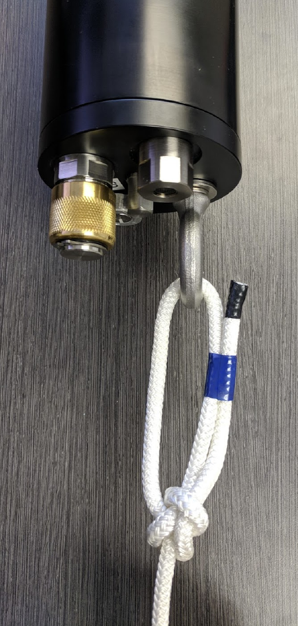

Installing the probes
- Place the instrument horizontally on a stable platform. Make sure the surroundings are dry to prevent any leakage of water.
- Loosen both screws of the compression plate until a clear gap is visible (2-3 mm) and the O-ring is completely decompressed: it should be possible to move the plate. But make sure that the O-ring does not slip out of its cavity (otherwise, re-insert it by making sure that it is still clean).

The steps 3-5 must be repeated for each probe, following the following order: micro-conductivity probe, shear probes and FP07.
- Remove the test probe corresponding to the sensor to install.
- Make sure the O-ring is still present and that it is clean and has enough grease before inserting the probe. Replace it or grease it if needed. Remove any humidity by using compressed air.
- Unscrew and take off the protective cap of the probe without touching the tip. Inspect the probe to be sure that it is not damaged (see manual, 4.4 & TN067) and that the SBE connector does not have any discoloration marks. In the case of the micro-conductivity probe, remove the protective cap with liquid and make sure that the electrodes are clean.
- Insert the probe until feeling a click. In case of a shear probe, orient it relative to the instrument axes: the flat surface with the serial number should be facing either the x-axis for S1 (crews from the compression plate) or the y-axis for S2 (JAC CT – Fluorometer).
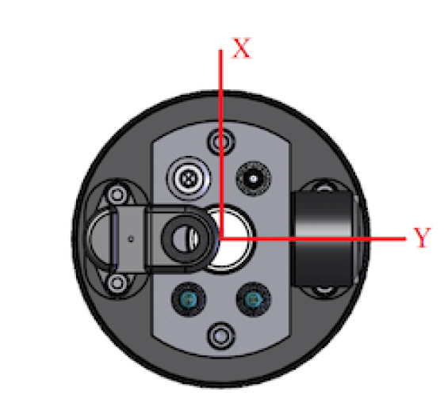
Once all probes have been installed:
- Check that all the probes are correctly inserted (they should all be at the same distance from the front end of the tube) and correctly oriented (shear probes).
- Tighten the screws of the compression plate without forcing. You should stop tightening them just when the screws stop to turn easily.
- Check that all the probes are tight.
- Write the serial numbers of all the probes used and update the configuration file (or do it after deployment): see Sect. 1.4.

Overview: check-list
Most of the previous steps are listed in the pre-deployment checklist below.
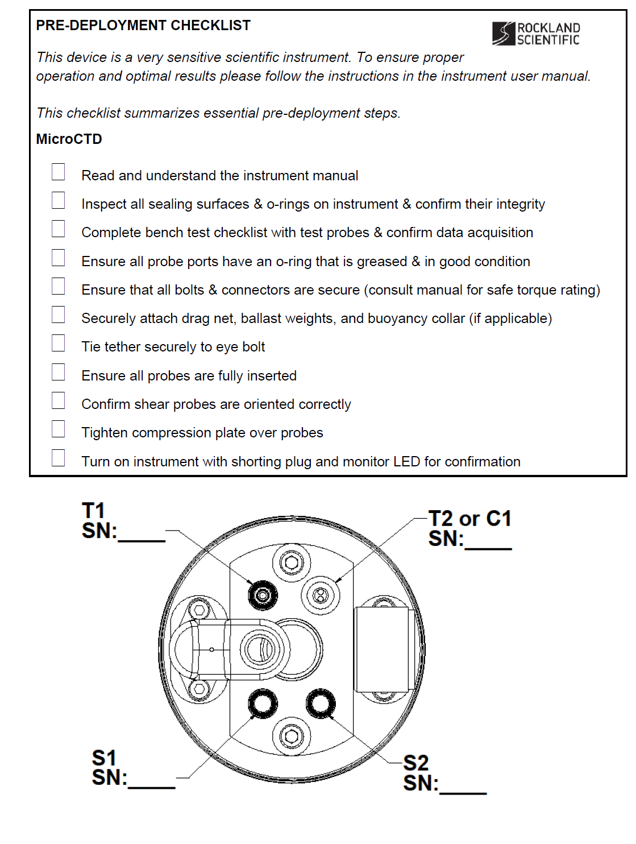

Deployment

Initial checks
- Check the wind and/or water current and deploy the microCTD such that it moves away from the ship/platform. If the ship/platform is not anchored and move with the wind, deploy the microCTD on the upwind side. If the ship/platform are fixed, deploy the microCTD on the downwind side or where the current moves away from the deck.
- Check the tether node before each deployment to make sure it is tight and the tape is still sticking.
- Turn on the instrument with the ON/OFF plug. Check that the LED is blinking and the blue light from the fluorometer is on.

Downward profile

- Make sure that the profiling depth is less than 100 m. It is recommended to attach the tether to the ship/platform a few meters after the targeted depth because the profiler will slow down over the last meters. If the targeted depth should not be exceeded (e.g., profiling near the bottom), use the "time of flight" method (see below).
- Lower the instrument into the water until it is completely submerged. Pull several times the tether while keeping the instrument submerged to purge trapped air.
- Wait for approx. 1 min to equilibrate the sensors to water temperature.
- Rise the microCTD to the surface (air pressure) and lower it by continuously giving extra rope. There should always be ~5 m of slack tether near the surface but not too much.
- Once all the rope has been used, wait until the profiler stops (the rope should be tense) and pull back the rope.
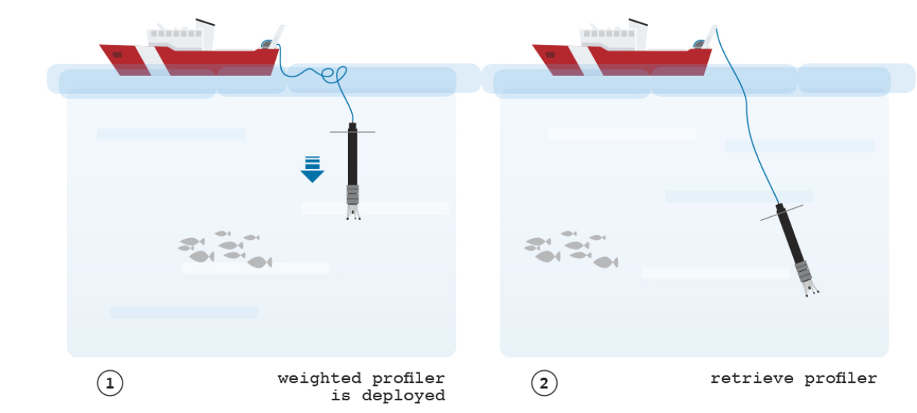
"Time of flight" method (e.g, for near-bed profiles):
- Perform a short profile or an entire profile with test probes (follow the procedure above) and measure the time between releasing the instrument and pulling back the rope.
- Recover the instrument, download the data and measure the maximum depth reached by the instrument.
- Calculate the mean falling speed and deduce the profiling time needed to reach the targeted depth.
- For each profile: measure the starting time, lower the microCTD by giving a bit more rope than the targeted depth and quickly pull it once the profiling time has been reached.

Upward profile
- Limitation to 30m!
- Continue to give tope while microCTD is rising
- Wait 2-4 min for the wake to disappear

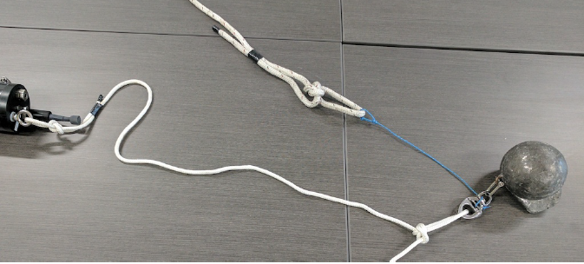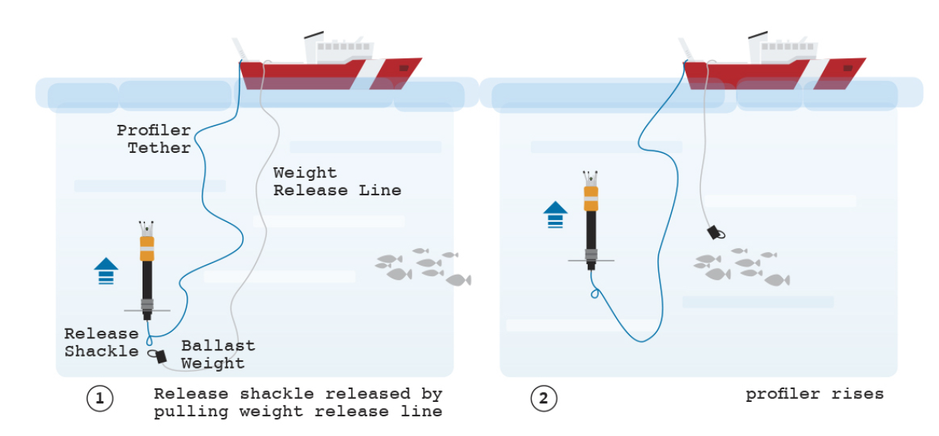

After deployment

Recovering the instrument
- Lift the instrument back on deck.
- Turn the instrument off by removing the ON/OFF plug and replacing it by a dummy plug.

Removing the probes
- Rinse the probes with distilled water.
- Use Kimtech tissues to remove water around the probe ports
- Loosen the compression plate.
- Leave the instrument to fully dry for 30 min. It is also possible to use compressed air but it could be difficult to remove water.
- Remove the probes, inspect for damage and inspect the SBE connector (discoloration) and the probe port (water drops, discoloration).
- Insert the test probes.
- MicroConductivity: add liquid if needed (0.1% Triton X-100).

Update configuration file
If the configuration file has not been updated before the deployment (e.g., serial numbers of the probes), do it now (see Sects. 2.4 and 5.1).

Data download, visualization and processing

Data download
- Connect the microCTD to the computer and open MotoCross (Sect. 1.2).
- Type usbl
- Open RSILink and select the USB port (i.e., 2nd COM port).
- Press "Get Root Directory"
- Open "Data" folder, select the files to download and press "Download".
- Select the location to save the files and press "OK".

Quick data visualization with Zissou
See Zissou User Guide

Complete data processing
See git repository https://github.com/tdoda/turbulence_methods.git
- Instructions to process new data: see README.md
- Detailed information on scripts: see notes/Turbulence_methods_manual.pdf

Useful ODAS scripts
See TN039 + manual ODAS for more information
Add the path to the ODAS library: addpath('…\odas')

Bench test (quick_bench)
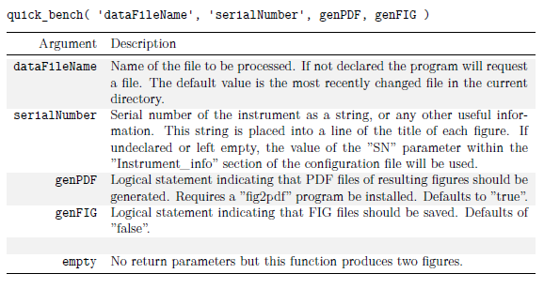

Configuration file modification
Each .P data file contains a configuration string that comes from the configuration file (can be seen by opening the .P file with a text editor). If FP07 probes are used, the configuration file needs to be updated after data acquisition to apply temperature calibration. If shear probes are used, the calibration coefficients of the probes found in calibration sheets must be included in the calibration file, either before or after data acquisition.
1. Extract the configuration string: extract_setupstr(data_filename, config_filename) creates the config file “config_filename.cfg”
2. Modify the config file
3. Patch the updated config file to the datafile: patch_setupstr(data_filename, config_filename)

Data import (odas_p2mat):
The raw data consist of .P files that can contain several profiles. These files are imported to Matlab with the ODAS function odas_p2mat.
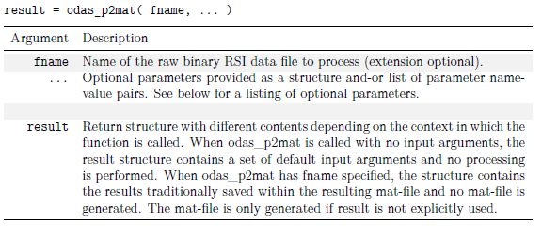
Arguments to provide to odas_p2mat (see ODAS manual, p.116-119 and TN039, Sect. 3):
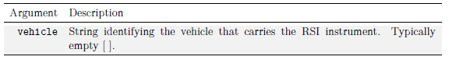
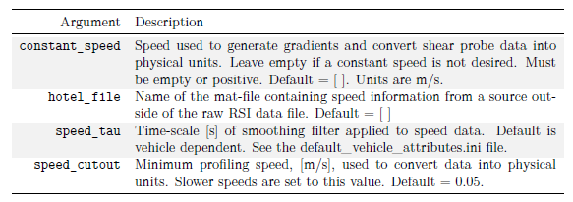
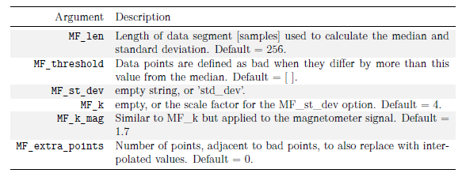
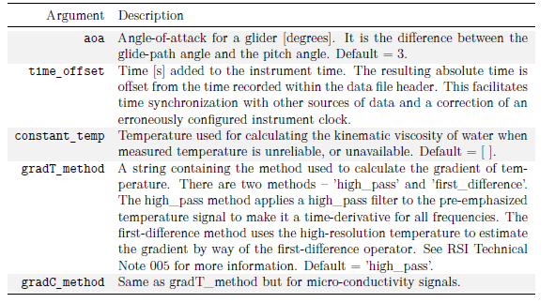

The following variables are exported by odas_p2mat (see also Tables 2 & 3 in TN039; Ns is the length of vectors with slow frequency = 64 Hz, Nf is the length of vectors with fast frequency = 512 Hz):
Variable name (alphabetical order) | Format | Unit | Description
Ax, Ay, Az | Nf*1 | counts | Piezo-accelerometer along the x, y and z-axes
C1_dC1, C2_dC2 | Nf*1 | counts | Raw microstructure conductivity with pre-emphasis*
C1_fast, C2_fast | Nf*1 | mS cm⁻¹ | Microstructure conductivity time series at fast frequency
C1_slow, C2_slow | Ns*1 | mS cm⁻¹ | Microstructure conductivity time series at slow frequency
cfgobj | Structure | - | Parsed configuration file
ch255 | Ns*1 | - | 7FF0 hexi-decimal, 32 752 Decimal
date | String | - | Date of the first measurement  (format yyyy-mm-dd)
Day | Integer | days | Day number of the first measurement
filetime | Float | Days since 01.01.0000 | Time of the first measurement
FL or Chlorophyll | Ns*1 | ppb | Chlorophyll from fluorescence sensor
fs_fast | Float | Hz | Sampling frequency of fast channels, i.e. microstructure sensors (512 Hz)
fs_slow | Float | Hz | Sampling frequency of slow channels, i.e. CTD sensors (64 Hz)
fullPath | String | - | Path to the data file
Gnd | Ng*1 | - | Ground on  first µASTP board?
Gnd_2 | Ns*1 | - | Ground on  first µASTP board?
gradC1 gradC2 | Nf*1 | mS cm⁻¹ dbar⁻¹ | Vertical conductivity gradient
gradT1, gradT2 | Nf*1 | °C dbar⁻¹ | Vertical temperature gradient
header | Numerical array | - | Header of every 1-second recor
header_version | Integer | - | Version of the header of every record in the .P file
Hour | Integer | h | Number of hours of the first measurement
input_parameters | Structure | Different for each parameter | Parameters sent to odas_p2mat. See ODAS Manual 4.4, p.117-120 for more details.
Milli | Float | msec | Number of milliseconds of the first measurement
Minute | Integer | min | Number of minutes of the first measurement
Month | Integer | months | Month number of the first measurement
NTU or Turbidity | Ns*1 | FTU | Turbidity
odas_version | Float | - | Version of ODAS
P | Ns*1 | counts | Raw pressure without pre-emphasis
params | Structure | Different for each parameter | Parameters used by odas_p2mat. See ODAS Manual 4.4, p.117-120 for more details.
P_dP | Ns*1 | counts | Raw pressure with pre-emphasis
P_fast | Nf*1 | dbar | Pressure at fast frequency (extrapolated)
P_slow | Ns*1 | dbar | Pressure at slow frequency
SBC or JAC_C | Ns*1 | mS cm⁻¹ | Conductivity from CTD sensor
SBT or JAC_T | Ns*1 | °C | Temperature from CTD sensor
Second | Integer | sec | Number of seconds of the first measurement
setupfilestr | String | - | Information from the setup  file
sh1, sh2 | Nf*1 | s⁻¹ | Shear time series
speed_fast | Nf*1 | dbar s⁻¹ | Instrument speed at fast frequency (absolute value)
speed_slow | Ns*1 | dbar s⁻¹ | Instrument speed at slow frequency (absolute value)
t_fast | Ns*1 numerical array | s | Time since the start of the measurements at fast frequency
t_fast_YD | Nf*1 | Days of the year | Time since the start of the measurements at fast frequency
t_slow | Nf*1 numerical array | s | Time since the start of the measurements at slow frequency
t_slow_YD | Ns*1 | Days of the year | Time since the start of the measurements at slow frequency
T1, T2 | Ns*1 | counts | Raw microstructure temperature time series without pre-emphasis
T1_dT1, T2_dT2 | Nf*1 | counts | Raw microstructure temperature time series with pre-emphasis
T1_fast, T2_fast | Nf*1 | °C | Microstructure temperature time series at fast frequency
T1_slow, T2_slow | Ns*1 | °C | Microstructure temperature time series at slow frequency
temperature_fast | Nf*1 | °C | Temperature to calculate kinematic viscosity.
time | String | - | Time of the first measurement  (format HH:MM:SS)
vehicle_info | Structure | - | Vehicle-speci  fic info including the profiling direction
W_fast | Nf*1 | dbar s⁻¹ | Rate of change of pressure at fast frequency
W_slow | Ns*1 | dbar s⁻¹ | Rate of change of pressure at slow frequency
Year | Integer | years | Year number of the first measurement

*pre-emphasis: addition of the signal with its time derivative to boost high frequencies and increase the resolution/reduce the noise of short-term fluctuations (see TN02: Mudge & Lueck, 1993)

Profiles detection (get_profile)
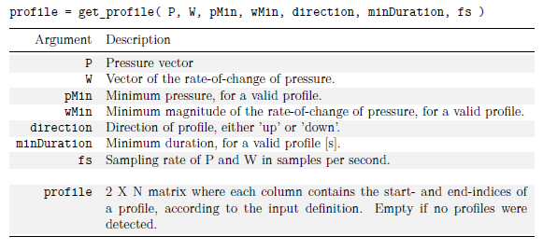

FP07 temperature calibration (cal_FP07_in_situ.m)
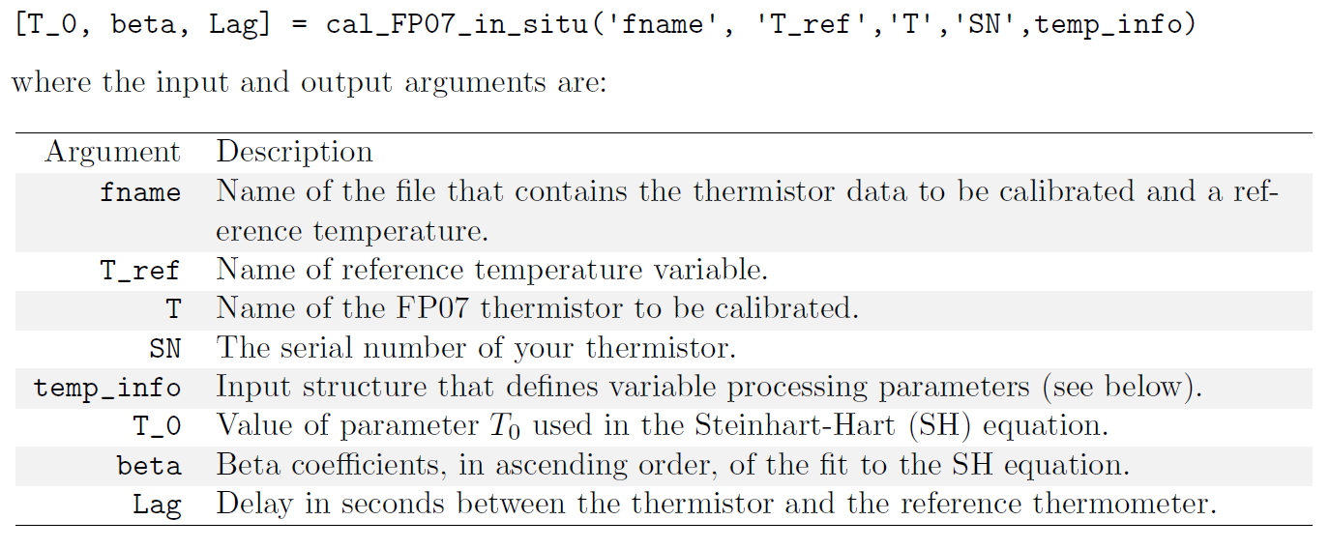

Shear spectra and dissipation (quick_look)

Arguments to provide to quick_look (see ODAS manual, p.139-144):
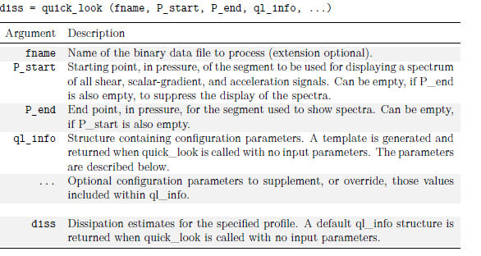
where ql_info contains the following parameters:
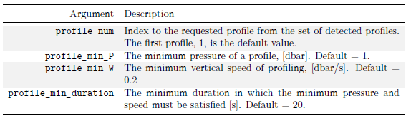
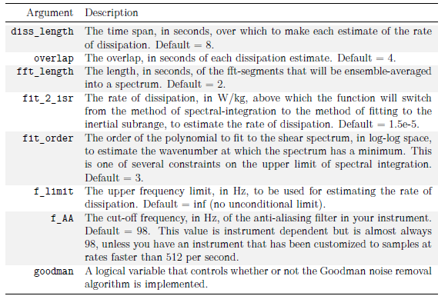
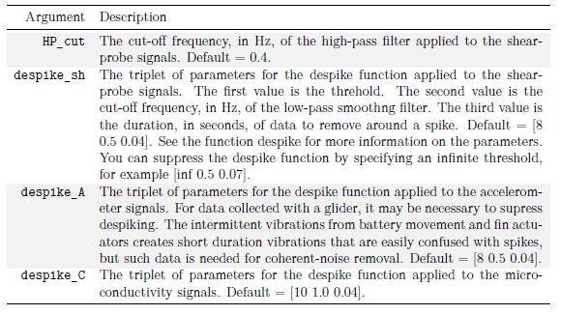
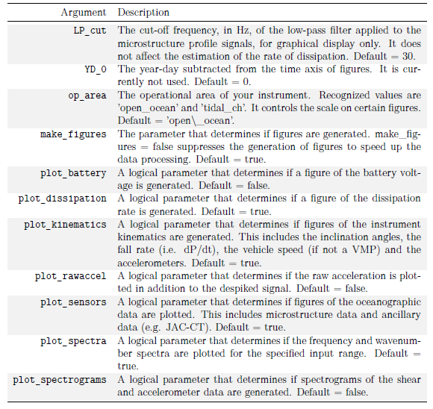
The variables in the diss structure output by quick_look are (see ODAS manual V.4.4, p.142-143 + output of function get_diss_odas in p.90-92):
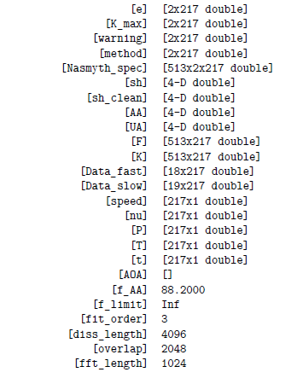
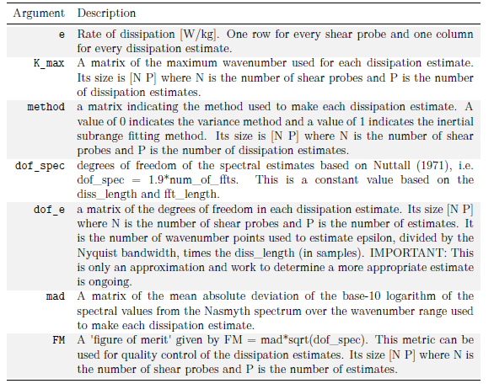
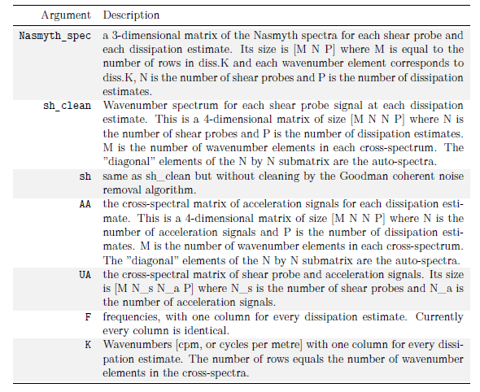
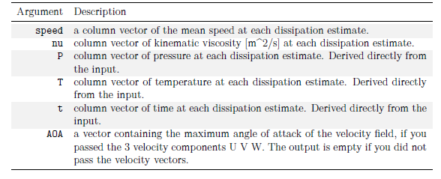
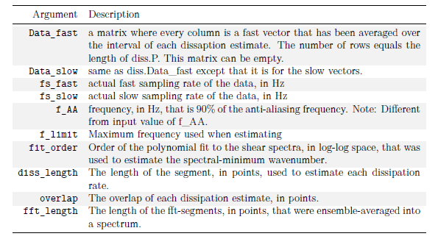

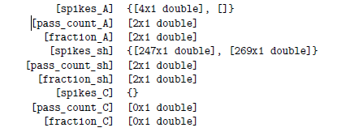
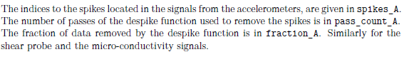
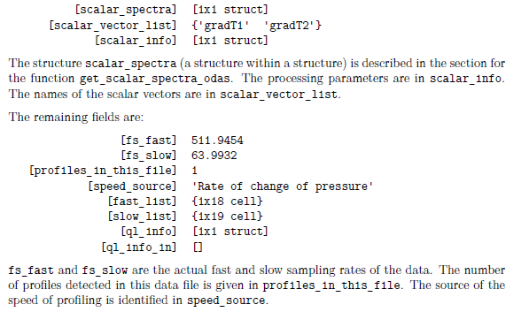
Procedure:
- To get the fields and the default values from the "ql_info" structure, type: ql_info=quick_look
- If needed, modify the default values of some of the fields of "ql_info":
- Profile detection parameters: profile_minP, profile_min_W, profile_min_duration
- Profile index to select from the cast: profile_num
- Spectra parameters
- Processing of microstructure signals
- Data visualization parameters
- Call the function quick_look:
diss=quick_look(filename,[],[],ql_info);
If a specific depth range must be analyzed (corresponding to a pressure P_start<P<P_end):
diss=quick_look(filename,P_start,P_end,ql_info);
- Outputs of the function:
- Raw file (.P) is converted into physical units using "odas_p2mat", which creates a .MAT file
- Data is plotted in several figures
- Profile of dissipation is calculated from the shear probe (structure "diss").

