# Sudoku Programming Assignment

This assignment is intended to allow you to showcase your skills in two areas:

1. Designing and implementing a simple HTML / JavaScript UI preferably using Angular.js (if you are not familiar with Angular you may use another framework such as jQuery).
2. Designing and implementing an interesting algorithm in JavaScript.

We expect that this assignment should take about 8 hours.

Your task is to build HTML/JavaScript application that solves a given Sudoku puzzle. Rules and the puzzle itself can be found on the following website: <http://www.sudoku.com/>

The application UI mockup:

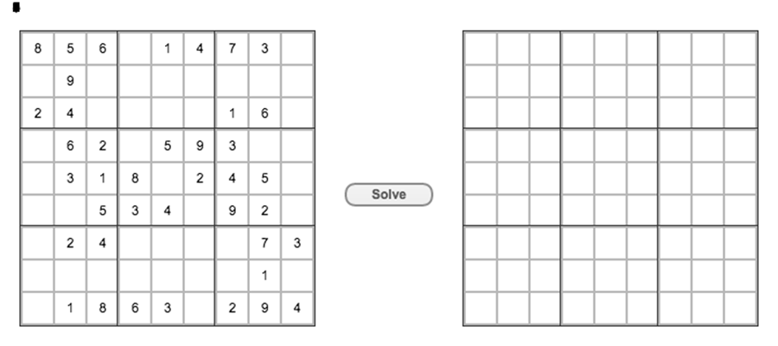

Clicking on the “Solve” button should populate the second board with a solution for the puzzle displayed on the first board.

Some specific requirements are listed below. You should be ready to discuss your work in detail in all of these areas.

## User Interface

* Aesthetics, usability and testability are important
* If using Angular the board should be implemented as components
* The initial puzzle should be hard-coded
* Entering a new puzzle definition should be easy

## Algorithm

* Performance of the algorithm is important (It will be tested with very difficult puzzles)
* Solutions can be found at <http://norvig.com/sudoku.html> however we recommend attempting to solve the problem yourself before reading the page
* You will be expected to understand and describe in detail how your solution works
* It should be able to accept puzzle strings in the format described in the norvig.com webpage:

**4.....8.5.3..........7......2.....6.....8.4......1.......6.3.7.5..2.....1.4......**

* Print the time taken to solve a puzzle in the UI or the Console

## Code Quality

* HTML, CSS and JavaScript code structure should be readable and well-reasoned
* Unit testing should be included to verify your logic
* Testability of the UI is important to consider and be able to discuss. (UI level auto-tests aren’t required)