The University of California at Berkeley

Masters of Information Data Science

DATSCI W281 Computer Vision (Spring 2024)

Final Project Proposal

By :

Meir Marmor

Thomas Dolan

Charlie Glass

Philippe Gagnon

**Proposal Name:**

The objective of this project is to build a custom image classifier, leveraging concepts and techniques learned in class. The chosen dataset contains 9,463 image files, which are x-rays of human joints. Each file has a “fractured” (4,480 training, 360 validation files) or “not fractured” (4,383 training, 240 validation files) label.

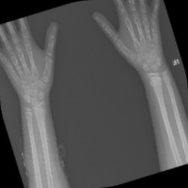 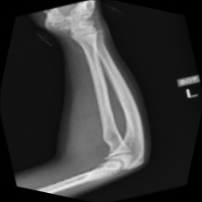

2 examples of images in the dataset: can you tell which is fractured?

Some challenges posed by this dataset are:

* Different body parts and sides of the body are represented, without any description.
* Images are around the same size/resolution. However there is a range of angles, rotations, zoom, sharpness and contrast.
* Images contain marks/identifiers which are not standardized and do not appear in the same location (as shown on sample images above).

For this binary classification problem, we expect concepts such as edge detection, convolution and perhaps image rotation/homography might be of use.

**Dataset**

Bone Fracture Detection Using X-Rays

<https://www.kaggle.com/datasets/vuppalaadithyasairam/bone-fracture-detection-using-xrays/data>

**References:**