Project

plan9

CIS 7310

Operating Systems

Fall 2012

Due December 18th

Instructor: Dayton Clark

Submitted by: | Tim Dooris
Id (4 digits): | 4459


Introduction
Plan9 is an operating system developed during the 80's and 90's at Bell Laboratories. I want you to investigate the operating system. I suspect that your most valuable resource will be the web, but you may find articles or books that will be helpful.
In gray boxes such as this, I will ask questions and otherwise suggest the information I would like you to find and report. You should download this document from the website and insert your answers and descriptions after the appropriate box.
Treat this as a report. I want full sentences and paragraphs, not single word answers or short phrases. Tie your answers together in an interesting and informative narrative. Use your own words. Do not cut and paste large chunks of text from the web.
Be sure to cite your sources.
You may consult with each other but each of you must submit a distinct and individual report. If you work closely with someone, you should cite them as a source also.

History and Overview
Describe the history of plan9.
- When was it developed?
- By whom?
- Why? What were their goals?
- What is it's lineage? That is, what operating systems is it descended from?
- Are there operating systems today that are descended from plan9?
- What are its main features? And why?
- It appears to me that plan9 is no longer actively supported or developed. Is this true? If true, try to find an explanation of why it has been abandoned. If not true, where is work being done on and by whom?

Development of Plan 9 started in the mid-1980s as a project at Bell Labs. It was a research project intended to address scalability issues that the UNIX and LINUX kernels don’t do particularly well—distributed computing, distributed name spaces, and distributed file systems. The idea was to build a system that was centrally administered and cost-effective using cheap modern microcomputers.
In Plan 9, everything is treated as a file. Resources are named and accessed like files. There is a standard protocol, 9P, for accessing these resources. And the disjoint hierarchies provided by different services are joined together into a single private hierarchical name space.
In many ways Plan 9 is similar to UNIX. It has a kernel, a command shell, and various C compilers. Its development tools and documentation assume a fair amount of familiarity with UNIX fundamentals. It also runs UNIX applications like awk, emacs, and cp. A major difference with UNIX is that all major applications understand 9P, the underlying distributed file system protocol. Everything under Plan 9 is distributed and is easily accessible as a file object. A plan 9 user builds a private computing environment and recreates it wherever desired, rather than doing all computing on a private machine.
Plan 9 does not use UNIX sockets for inter-process and inter-computer communications. Protocol stacks and network cards are implemented as file system objects.
Plan 9 was designed as a faster, cleaner multiprocessor operating system with better security in operation. Its system libraries were built with multi-processing and Unicode character support. These libraries make application development fast and reliable. Distributing resources is also easy. Network administrators enjoy it for its ease of use and developers like it because its libraries are elegant and its compilers are clean. Its advantages grow as the number of networked Plan 9 workstations increase.
However, Plan 9 does suffer from a lack of mainstream applications and commercial support. Its number of installations is estimated in the thousands. It offers few advantages to single workstation users. There are two web browsers available called Mothra and Abaco, but both have “not quite optimal” rendering of web pages. It is also possible to run Linux browsers such as Opera using linuxemu.
Although not widely popular, there is still active work being done on extending Plan 9 such as 9atom and 9front. These forks augment Plan 9 with additional hardware drivers and software. The full source code is freely available under Lucent Public License 1.02. In fact, The Seventh International Workshop on Plan 9 was held in Dublin, Ireland in November of 2012. The Inferno Operating system is a spin-off of Plan 9. It was also started at Bell Labs but is now maintained as free software.

Sources:

Osnews.com/story/15235/Investigating-the-Plan-9-Operating-System/
Plan9.bell-labs.com/sys/doc/9.html

Processes and Threads
Discuss processes and threads on plan9. Always support your conclusions.
- Characterize plan9 processes. Are they single threaded processes or multi-threaded processes?
- What are the primary system calls for manipulating processes? (creation, destruction, signaling, ...)
- What are the characteristics of plan9 process scheduling?
- Does plan9 support threads? Assuming that it does:
- What are the primary system calls for manipulating threads? (thread creation, destruction, cpu yielding, ...)
- Are threads preemptable?
- How do threads communicate?
- Are plan9 threads kernel level or user level threads?

Plan 9 provides a single class of processes but allows control of the sharing of a process’s resources such as memory and file descriptions. They are multi-threaded processes. Each process has a local filename space containing attachments to all services the process is using and to the files in those services. New processes are created using the rfork system call. Rfork takes a single argument, a bit vector that specifies which of the parent process’s resources should be shared, copied, or created anew in the child. Other system calls include exec which replaces the current process, exits which terminates the current process, and sfork which allows a process to control the degree to which it shares resources with its children.
Plan 9 uses a real-time scheduler. It has its origins in the earliest deadline first scheduler was first introduced by Liu and Layland. Instead of only sharing the CPU, the scheduler also considers other shared OS resources: applications indicate which resources they need and the scheduler determines if the set of applications can run concurrently and remain schedulable. The processes are managed through a file system interface. The plan 9 kernel uses a set of queues of runnable processes, one for each of the 20 or so priority levels. The scheduler scans the queues in order and picks the first process it finds. The Plan 9 kernel will not schedule a process holding a lock until that process gives it up. Each process has a count of the number of locks it holds. The scheduler is completely deadlock free and can be used for preemptive or non-preemptive real-time EDF scheduling.
Threads in Plan 9 are non-preemptive and run in a round-robin fashion. They communicate using communicating sequential processing channels. Primary system calls for manipulating threads include threadcreate, threadkill, threaddata, threadexits, and yield. Plan 9 uses kernel level threads.

Sources:
Plan9.bell-labs.com/sys/doc/9.html
Aiju.ed/misc/plan9-syscalls
Plan9.bell-labs.com/iwp9/Real-time.pdf
cissh implementation
How would our implementation of cissh differ under plan9? Describe any differences in process manipulation and how they would affect the implementation.
Include a copy of the entire file cisshPipe.c as it would appear under plan9. I am aware that you will not be able to test your plan9 cissh implementation but show me the file as accurately and completely as possible.

/* cisshPipe.c
*/
#include <u.h>
/* stored in /$objtype/include where $objtype is an environment variable storing the current CPU name, contains CPU-specific definitions.*/
#include <libc.h>
/* libc.h contains the definitions for the C library, which is linked into every Plan 9 program */
#include <sys/types.h>
#include <unistd.h>
#include <stdlib.h>
#include <sys/types.h>
#include <sys/wait.h>
/* External functions --
*/
extern void error(char* message);

/* cisshPipe(char* command1[], char* command2[])
* handles command lines with pipes.
*/
void
cisshPipe(char* command1[], char* command2[])
{
int fd[2];
pid_t pid;
int status;

pipe(fd);

if((fork()) == 0)
/* this child is generating output to the pipe*/
{
dup2(fd[1], 1); /* attach stdout to left side of pipe*/
close(fd[0]); /* not using the right side */
execvp(command1[0], command1);

}

if((fork()) ==0) {
/* This child is consuming input from the pipe */

dup2(fd[0], 0); /* attach stdin to the right side of pipe */
close(fd[1]); /* close unused part of pipe */
execvp(command2[0], command2);

}

close(fd[0]); close(fd[1]); //close both file descriptors on the pipe

}

Producer-Consumer w/messages
Below is a figure from Tanenbaum's book (Modern Operating Systems) which solves the producer-consumer problem (which we examined in the handout) using messages to synchronize the two threads.
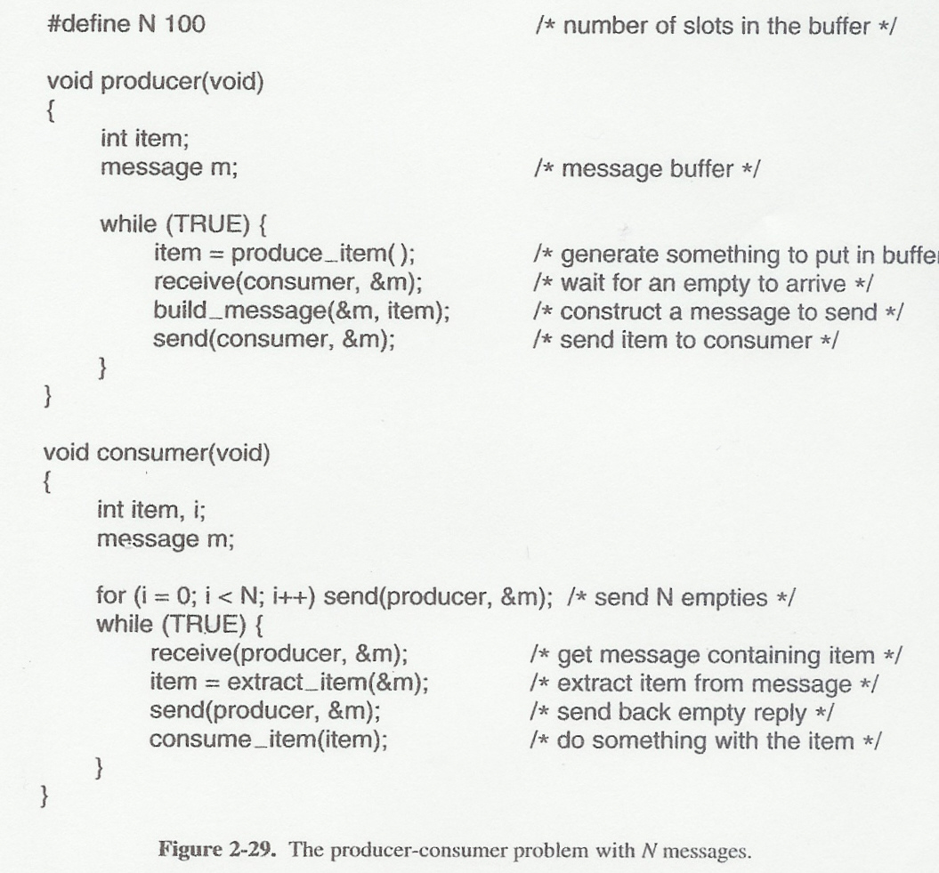
I want you to implement this on plan9 using threads. I've provided the beginning. Notice that you do not have to implement produce_item() and consume_item() but you should provide everything else needed to implement it. Again, I realize that you cannot test your code but make it as accurate as possible. And, as always, comment your code.

/* Producer-consumer on plan9
*/

extern int produce_item();
extern void consume_item(int item);

int
threadmain()
{
/* In Plan 9, a thread may not be preempted unless you call functions of the thread library to synchronize with other threads—meaning there should be no context switch between threads unless you allow it.
*/
threadcreate(producer, nil, 8*1024);
threadcreate(consumer, item, 8*1024);

}
int producer (){
while(TRUE){
item = produce_item();
receive(consumer, &m);
build_message(&m, item);
send(consumer, &m);
}}
void consumer{
int item, i;
message m;
for(I = 0; i<N;i++) send(producer, &m)
while(TRUE){
receive(producer, &m);
item = extract_item(&m);
send(producer, &m);
consume_item(item);
}}

}

Conclusion
Describe any problems, insights, or other comments you have about this project.

I enjoyed researching Plan 9 and learning about this operating system, especially since I knew nothing of its existence prior to this assignment. I do believe the two programming assignments within are not realistic, especially given the time frame, for at least three reasons. First, anytime you learn a new system or language it takes time to become comfortable and fluent. Since we are just learning about Plan 9 now, it would make much more sense to turn in that research and then have it verified to clear up any misunderstandings. Second, one of the assignments depended on another assignment which was also just recently assigned. If I don’t know if my cisshPipe implementation is correct, I’m certainly not going to be able to write a new implementation of it for Plan 9 which I just learned about. There is also no way to debug or check if the code is correct, so it is essentially a shot in the dark to get them running correctly. Third, these two assignments were given in the last few weeks of class. If you add to that the fact that the course content is very extensive and requires extra studying before the final exam, it seems to be an overwhelming and unrealistic amount of work. Although I think all of these assignments were interesting and valid, I think their implementation was rushed. I would recommend scaffolding the learning required for these assignments out over the course of the semester instead of waiting for the end of the term.

