**Creative Computing with **

**Build A Computer!**

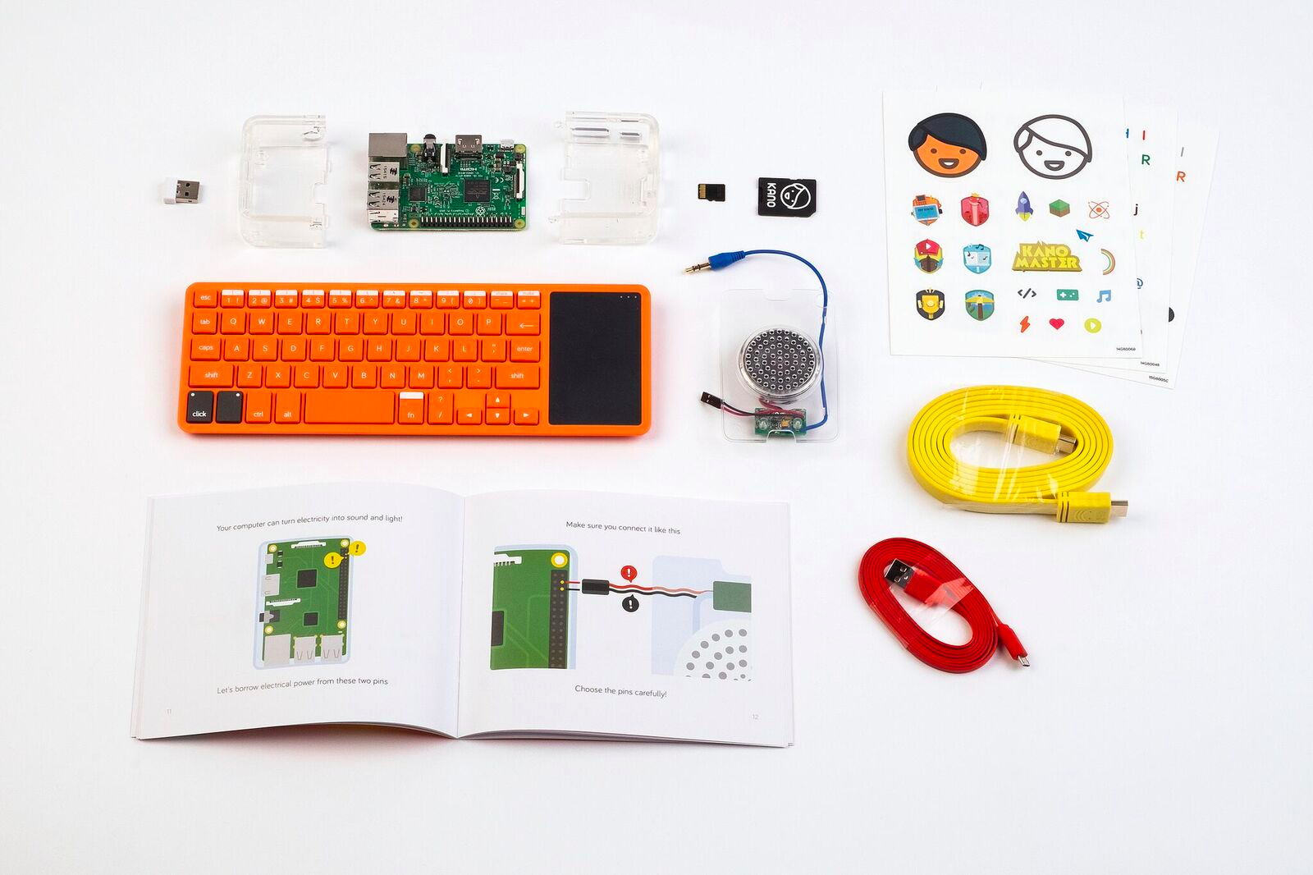

*Students will discuss ahead of time what are the components of a computer and then use that knowledge to BUILD.*

|  |
| --- |
| **Title:Build A Computer!**  **Time: 1 hour 10 min**  **Level: Beginner \*\*\***  **Note: Depending on the level of your student, you can adapt examples** |
| Learning Objectives:   * Learners can describe the components of a computer system, including hardware, operating systems, and applications. * Learners can give examples of how computers are used in the real world. * Learners build computers and write lines of code. |
| **Discovery:**  List all the parts that you think make up a computer. For each part think if it is an input or output of the computer. |
| **Procedure: Build your computer: 25 min**  Today learners will build a computer! Open your KANO boxes and follow through the process of building your computer.  Power on your computer and go through the setup process. You can skip signing up with Kano if you like. Enjoy the rabbithole!! |
| **Discovery:**  List all the parts that make up your Kano computer. For each part think if it is an input or output of the computer.  Now think about your phone. It’s a computer too by the way. |
| **Procedure: Explore the Kano 1hr**  Direct them to Make Art so they can start coding art! If you have a lot of time left to explore then move on the [Explore Kano lesson plan.](https://docs.google.com/document/d/18hBrXh6VKOyG2eNMiWEtX2CH62SS4aPOndQ8V-rpJaM/edit?usp=sharing)  **Challenge 3: Clean Up Time!10 min**  As you start using the Kanos in class, how you clean up will become important. Take a substantial amount of time (10 - 15 minutes) to practice your clean up routine with your students. |
| **Kano Cleanup:** 5 min |
| **Evaluation: 5 min**  Once the computers are picked up, ask a few reflection questions:   * What was your favorite part about today’s session? * What was your least favorite part about today’s session? * What are 3 things you learned today? * Why is it important to create, not just consume, technology?   Call on 4 people to answer 1 of the 4 questions above.  **Closing/Homework: 2 min**  Before everyone leaves, ask the learner to go home tonight and draw or write what it was like to build a Kano Computer. Did they enjoy it? Were they excited? What was the computer like?  If you want to give out a worksheet you can give learners [handout 1](https://drive.google.com/file/d/0B-L-w1thugqXc2o2R3pOTTVuOFU/view?usp=sharing) and [handout 2](https://drive.google.com/file/d/0B-L-w1thugqXa3lqejdyZnpIYzA/view?usp=sharing). Ask them to identify each part of the Kano Computer and explain in their own words what that part does. |
| **Kano Cleanup:** 5 min  **Power down and put away the Kanos** |