**Creative Computing with **

**Explore Computing!**

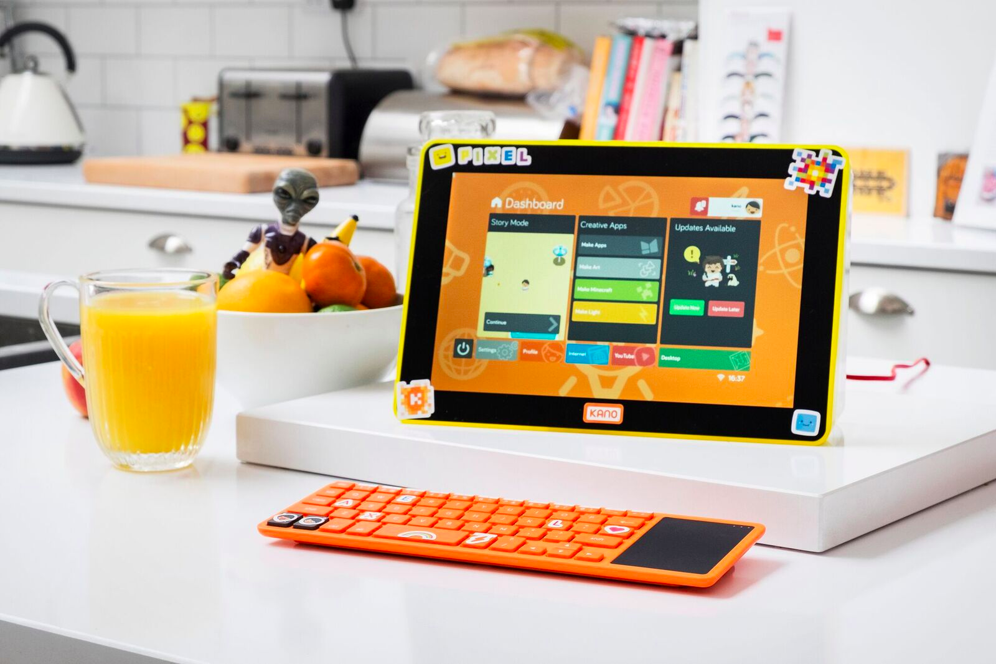

|  |
| --- |
| **Title: Explore Computing and Learn!**  **Total Time: 1.5 hours** |
| Learning Objectives:   * Learners will grasp the difference between hardware and software * Learners will understand how the Kano computer Operating System works * Learners will gain an understanding of the different uses of code * Be able to use code to make basic creations |
| **Discovery: What makes a computer? 10 min**  After watching the video, can you identify the matching parts to your KANO system? How has the Software and Hardware changed? What do you know now that would help you use this old computer? |
| **Discovery: How do computers understand what we want? 15 min**  Computers understand the instructions that we give it, but how do the understand our English words?  Computers use numbers to represent everything! Even letters! The turn letters into numbers using ASCII code. We turn into code breakers if we want to figure out how a computer understands:  ***Circle 100***  **Procedure: 10 min**  Using the ASCII Table, decode ***Circle 100*** and list the numbers we give the computer. Compare with your friends and see if you have the correct numbers. |
| **Discovery: How do computers understand numbers:**  Okay, computers use numbers for everything. Digging even deeper we could ask, how do the understand numbers?  Binary to the rescue! Computers use voltages to determine a ‘1’ (On) or ‘0’ (Off). You can think of this ‘0’ or ‘1’ as a light switch being On or Off.  **Procedure: 5 min**  Get into groups of 4. If we want to have the computer understand the number 6, what position (On or Off) would our switches be in and how many switches would we need. Discuss with your group. |
| **Procedure: Explore the Kano 45 min**  Build our computer again, but this time we will not use the light source or the power button. That way we have audio!  Minecraft . Playing and Hacking. |
| **Kano Cleanup:** 5 min  Power off your Kano but leave it at your station. |
| **Evaluation: 5 min**  Once the computers are picked up, ask a few reflection questions:   * What was your favourite part about today’s session? * What was your least favourite part about today’s session? * What are 3 things you learned today? * Why is it important to create, not just consume, technology? |
| **Test Time !!** 5 min |