**Creative Computing with **

**Intro to Kano Code**

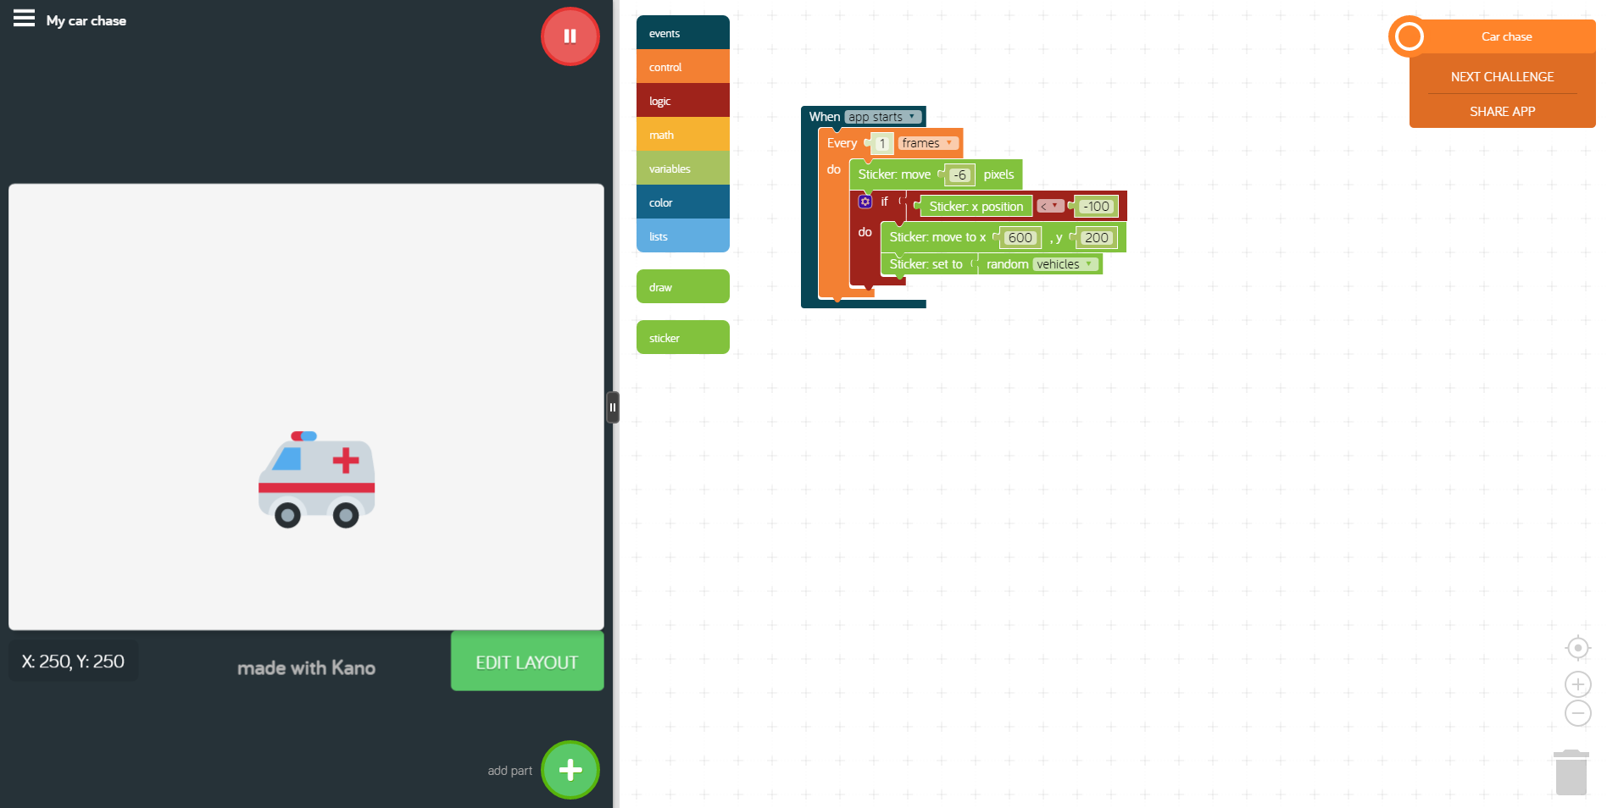

Have your creators gets used to Kano Code and begin creating unique creations to share!

|  |
| --- |
| **Title: Intro to Kano Code**  **Time: 1 hour 30 minutes**  **Level: Beginner** |
| Learning Objectives:   * Makers will understand how to access Kano Code * Makers will be able to identify the features of Kano Code and use them to create their own creations * Use sequence, selection and repetition in programs: work with variables and various forms of input and output |
| **Materials Needed:** world.kano.me |
| **Linking: (5 mins)**  Take 5 minutes to draw a picture of your favorite app and write 5 sentences explaining why it is your favorite app.  **Engage:** (5 minutes)  Apps are pretty awesome. From Angry Birds to Messenger, apps can do a lot of things. We are going to learn today about another feature of Kano called Kano Code . In this app we will learn how to use block codes to create apps and drawings that are fun, unique, and our own creations! |
| **Collect Kanos:** 5 min  **Retrieve Computers, Turn On, Log In..** |
| **Discovery:**  When writing code you will give commands, receive input, and determine the timing of these actions. (Much like a human…. Ex: I fell hungry and I tell myself I should go make myself a ham sandwich now before my next Fortnite game starts!)  **Challenge 0 A Walk Through of Kano Code**  Let’s get started! Click on Kano Code and open up an adventure:    You will be directed to the Kano Code page. At the top you will see a Challenges or Creations. To begin with you should select Challenges and the instructor will work through a few sample challenges to show you how this works.  When you open Kano Code you should see a screen that has a code block section as well as a Canvas. Because you are new to coding, the sample project will help you build your application. Follow the instructions to build your first program and as you go through pay attention to the different commands, events and timing.  **Procedure 1:** Explore Kano Code! Open up Kano Code and explore the projects that are available. Along with the Instructor investigate the It’s Alive challenge.  **Procedure 2:** Open Drop the Mic and follow through at your own pace.  **Procedure 3:** Are you kids ready for a challenge? Open up New Creation and build something fun. If you do not feel like creating your own, just go through another challenge.  When students are done, they will share their creations with the class.  **Save your work and share to Kano World!** |
| **Sharing: 15 min**  Use the remaining time in class to share what the students hacked or created on their own. Remind students to share their creations on Kano World!  **Evaluation:**  In your notebook, answer the following questions. What did you like about the creations? What was difficult? What is a new skill you learned that will help next time you use Kano Code . |
| **Kano Cleanup:** 5 min  **Power down and put away the Kanos** |