Use Case Specification

Hospital Data Analytics Platform

Authors: Todor Ioan Iulian todor.io.ioan@student.utcluj.ro

Document Number: UC01
Version: 1.0
Publish Date: 2026-03-30

Record of Processing
No. | Version | Date | Status | Who | Description
1
2
3
4
5
6
7

Record of Approval
No. | Version | Date | Who | Description
1 | … | … | …
2
3
4
5
6
7

Recipients of Document
No. | Version | Date of Distribution | Recipients
1 | … | …
2
3
4
5
6
7

Table of Contents
- <Use-Case Name> 2
  - Brief Description 2
  - Primary Actor 2
  - Stakeholders and Interests 2
  - References 2
- Flow of Events 2
  - Basic Flow 2
  - Alternative Flows 2
    - < First Alternative Flow > 2
    - < Second Alternative Flow > 2
- Special Requirements 2
  - < First Special Requirement > 2
- Preconditions 2
  - < Precondition One > 2
- Postconditions 2
  - < Postcondition One > 2
- Extension Points 2
  - <Name of Extension Point> 2
- Technology and Data Variation List 2
- Open Questions 2

Use Case Specification <Hospital Data Analytics Platform>

Brief Description
This use case describes how an authorized actor (Doctor or Hospital Manager) uses the HospitAI platform's frontend interface to interact with aggregated data from the Synthea dataset. The actor analyzes visualizations of K-Prototypes clustering results, PrefixSpan sequential pattern mining results, and requests natural language summaries generated by Gemini LLM to understand patient trends.

Primary Actor

Doctor or Hospital Manager.

Stakeholders and Interests
Hospital Manager: Wants easy visualization of aggregated statistics, identification of at-risk patient groups, and discovery of common treatment sequences through intuitive dashboards in order to make informed resource allocation decisions.
Doctor: Wants to visualize which cluster a specific patient belongs to, along with the frequent treatment sequences of that group, in order to improve individual treatment decisions.
Patient (Offstage Actor): Wants their personal medical data to be processed, aggregated, and analyzed under strict security conditions, ensuring the platform protects their confidentiality when data is used for global pattern extraction.
University Supervisor (Offstage Actor): Wants to validate requirements, approve the architecture, and ensure that clustering and sequence mining results are clinically meaningful and academically correct.
Developer (Offstage Actor): Wants consistent performance of the graphical interface and CRUD operations on the database models.

References

1.4.1 Vision Document (HospitAI).

1.4.2 System Architecture Specification (FastAPI / PostgreSQL / React).

1.4.3 UC02 - Conversational Database Querying via LLM (/ask page).

Flow of Events
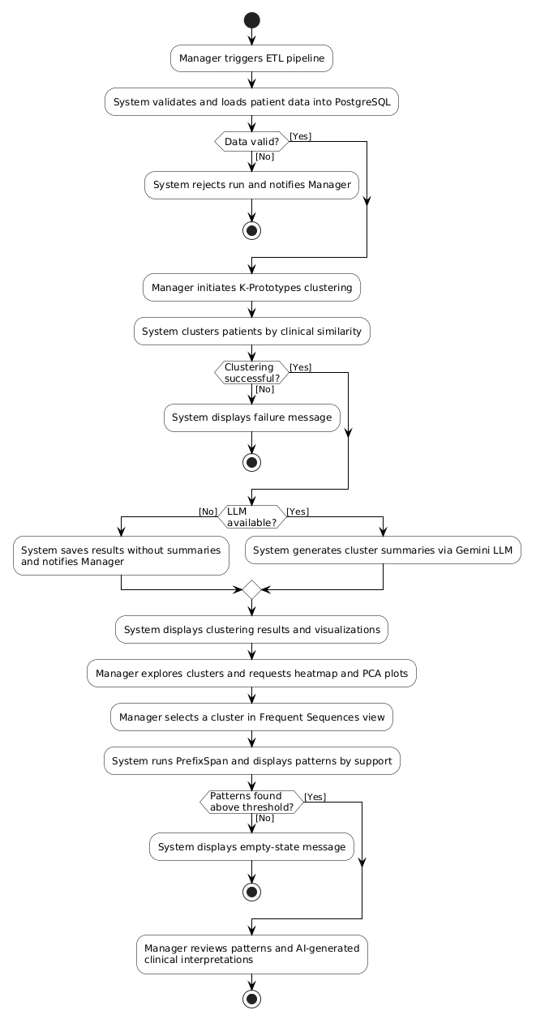

  - Basic Flow

Use-Case Start: This use case starts when an authorized Manager initiates the full analytical pipeline on the HospitAI platform to extract insights from the Synthea patient dataset.

1. Manager triggers the ETL pipeline on the HospitAI platform.
2. System validates and loads patient data from the Synthea dataset into PostgreSQL.
3. Manager initiates the K-Prototypes clustering analysis.
4. System applies the K-Prototypes algorithm to cluster patients by clinical and demographic similarity.
5. System generates natural-language summaries for each discovered cluster via Gemini LLM.
6. System displays the clustering results and visualizations to the Manager.
7. Manager explores the clusters and requests the heatmap and PCA comparison plots.
8. Manager selects a cluster in the Frequent Sequences view.
9. System runs PrefixSpan and displays the closed sequential patterns ordered by descending support.
10. Manager reviews the discovered patterns and their AI-generated clinical interpretations.

Use-Case End: The Manager has reviewed the K-Prototypes clustering results with AI-generated summaries and the frequent sequential clinical patterns for the selected patient cohort.

2.2 Alternatve Flows

2a. System detects invalid or incomplete data during ETL preprocessing:
- System identifies data quality violations or missing critical fields in the extracted records.
- System rejects the pipeline run and notifies the Manager via an error report.
- Use case ends.

4a. K-Prototypes algorithm fails to converge or produce valid clustering results:
1. System detects a convergence error or runtime exception in the clustering algorithm.
2. System displays an empty-state failure message to the Manager.
3. Use case ends.

5a. Gemini LLM service is unreachable or returns an error response:
- System detects that the Gemini API is unavailable or returns an error response.
- System saves the clustering results without AI-generated summaries.
- System notifies the Manager that cluster summaries are temporarily unavailable.
- Flow resumes at Step 6 of the Basic Flow.

9a. No closed sequential patterns exceed the minimum support threshold:
- System detects that no patterns meet the configured support threshold.
- System displays an empty-state message in the Frequent Sequences view.
- Use case ends.

Special Requirements
5.1 Performance: The dashboard shall load within 2 seconds using pre-calculated data stored in PostgreSQL.
5.2 UI/UX: The interface shall use color-coded, responsive visualizations and shall be accessible with a maximum of one click for any primary action ("one click away" principle).
5.3 AI Summarization: The Gemini API response shall be displayed within 5 seconds, with a visible loading indicator during processing.
5.4 Security: All API endpoints shall be protected through role-based access control (RBAC) using JWT tokens.

Preconditions
6.1 The actor is authenticated and authorized (role: Doctor or Hospital Manager).
6.2 The Synthea dataset has been imported, preprocessed, and cleaned into the PostgreSQL database.
6.3 The AI pipelines (K-Prototypes clustering, PrefixSpan sequence mining) have been executed at least once (successful or failed runs exist in the database for the system to report status).

Postconditions
7.1 The system remains in a consistent state. No visualization or summarization operation modifies the source data.
7.2 Any CRUD operation performed (Alternative Flow 2.2.8) is correctly recorded in observation_model and persisted in the database.
7.3 If a Save/Commit operation did not complete successfully, database entities remain unchanged.

Extension Points
8.1 Conversational LLM Querying
Location: After step 2.1.9 (system displays the AI-generated summary). The actor may choose to further explore the data by switching to the conversational querying interface. See UC02 - Conversational Database Querying via LLM (/ask page).
8.2 Patient Record CRUD
Location: At any step after 2.1.4 (system renders interactive visualizations). The actor may open a specific patient record from the visualization context to perform create, read, update, or delete operations. See UC03 - Patient Record Management (if defined separately).
8.3 Sequence Mining Visualization
Location: At step 2.1.4 (system renders visualizations). The actor may select the "Frequent Sequences" tab instead of interacting with the cluster visualization. See Alternative Flow 2.2.2.

Technology and Data Variation List

Component | Technology
Database | PostgreSQL
Backend Framework | FastAPI (Python)
Frontend Framework | React + TypeScript
Clustering Algorithm | K-Prototypes (k=4, RobustScaler, Huang init, gamma=auto)
Sequence Mining Algorithm | PrefixSpan
LLM Summarization | Gemini API (Google)
Authentication | JWT (JSON Web Token)
Containerization | Docker

Open Questions

System Sequence Diagram (SSD)


