Use Case Specification

Hospital Data Analytics Platform

Authors: Todor Ioan Iulian todor.io.ioan@student.utcluj.ro

Document Number: UC01
Version: 1.0
Publish Date: 2026-03-30

Record of Processing
No. | Version | Date | Status | Who | Description
1
2
3
4
5
6
7

Record of Approval
No. | Version | Date | Who | Description
1 | … | … | …
2
3
4
5
6
7

Recipients of Document
No. | Version | Date of Distribution | Recipients
1 | … | …
2
3
4
5
6
7

Table of Contents
- <Use-Case Name> 2
  - Brief Description 2
  - Primary Actor 2
  - Stakeholders and Interests 2
  - References 2
- Flow of Events 2
  - Basic Flow 2
  - Alternative Flows 2
    - < First Alternative Flow > 2
    - < Second Alternative Flow > 2
- Special Requirements 2
  - < First Special Requirement > 2
- Preconditions 2
  - < Precondition One > 2
- Postconditions 2
  - < Postcondition One > 2
- Extension Points 2
  - <Name of Extension Point> 2
- Technology and Data Variation List 2
- Open Questions 2

Use Case Specification <Hospital Data Analytics Platform>

Brief Description
This use case describes how an authorized actor (Doctor or Hospital Manager) uses the HospitAI platform's frontend interface to interact with aggregated data from the Synthea dataset. The actor analyzes visualizations of K-Prototypes clustering results, PrefixSpan sequential pattern mining results, and requests natural language summaries generated by Gemini LLM to understand patient trends.

Primary Actor

Doctor or Hospital Manager.

Stakeholders and Interests
Hospital Manager: Wants easy visualization of aggregated statistics, identification of at-risk patient groups, and discovery of common treatment sequences through intuitive dashboards in order to make informed resource allocation decisions.
Doctor: Wants to visualize which cluster a specific patient belongs to, along with the frequent treatment sequences of that group, in order to improve individual treatment decisions.
Patient (Offstage Actor): Wants their personal medical data to be processed, aggregated, and analyzed under strict security conditions, ensuring the platform protects their confidentiality when data is used for global pattern extraction.
University Supervisor (Offstage Actor): Wants to validate requirements, approve the architecture, and ensure that clustering and sequence mining results are clinically meaningful and academically correct.
Developer (Offstage Actor): Wants consistent performance of the graphical interface and CRUD operations on the database models.

References

1.4.1 Vision Document (HospitAI).

1.4.2 System Architecture Specification (FastAPI / PostgreSQL / React).

1.4.3 UC02 - Conversational Database Querying via LLM (/ask page).

Flow of Events

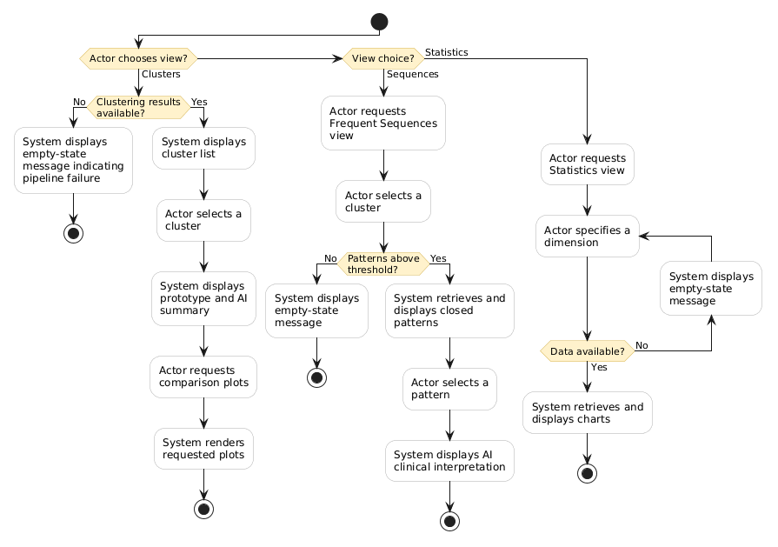

UC01: Analyze Clusters

Primary Actor: Manager Preconditions: Actor has been authenticated and authorized as Manager.

Main Success Scenario:

Actor requests the Clusters view in the Analytics area.

System displays the list of clusters and general information for each cluster.

Actor selects a specific cluster.

System displays the cluster prototype, feature distributions, and AI-generated summary.

Actor requests cluster comparison plots (heatmap and PCA) or dedicated feature plots.

System renders the requested plots. Use-Case End

Extensions (Alternate Flows): 2a. Clustering results not available (system detects no successful K-Prototypes run):

System displays an empty-state message indicating pipeline failure.

Use case ends.

UC02: Analyze Sequential Patterns

Primary Actor: Manager

Preconditions: Actor has been authenticated and authorized as Manager.

Main Success Scenario:

Actor requests the Frequent Sequences view in the Analytics area.

Actor selects a cluster to view its sequential patterns.

System retrieves and displays closed sequential patterns ordered by descending support.

Actor selects a specific pattern.

System displays the AI-generated clinical interpretation of the selected pattern. Use-Case End

Extensions (Alternate Flows): 3a. Sequence Mining results not available (system detects no patterns exceeding support threshold):

System displays an empty-state message.

Use case ends.

UC03: View Aggregate Statistics

Primary Actor: Manager Preconditions: Actor has been authenticated and authorized as Manager.

Main Success Scenario:

Actor requests the Statistics view in the Analytics area.

Actor specifies a dimension (e.g., conditions, medications, observations, procedures).

System retrieves aggregate data from the database.

System displays charts and tables with the aggregate information. Use-Case End

Extensions (Alternate Flows): 3a. Statistics data not available (system detects no records for selected dimension):

System displays an empty-state message.

Flow returns to step 2.

Special Requirements
5.1 Performance: The dashboard shall load within 2 seconds using pre-calculated data stored in PostgreSQL.
5.2 UI/UX: The interface shall use color-coded, responsive visualizations and shall be accessible with a maximum of one click for any primary action ("one click away" principle).
5.3 AI Summarization: The Gemini API response shall be displayed within 5 seconds, with a visible loading indicator during processing.
5.4 Security: All API endpoints shall be protected through role-based access control (RBAC) using JWT tokens.

Preconditions
6.1 The actor is authenticated and authorized (role: Doctor or Hospital Manager).
6.2 The Synthea dataset has been imported, preprocessed, and cleaned into the PostgreSQL database.
6.3 The AI pipelines (K-Prototypes clustering, PrefixSpan sequence mining) have been executed at least once (successful or failed runs exist in the database for the system to report status).

Postconditions
7.1 The system remains in a consistent state. No visualization or summarization operation modifies the source data.
7.2 Any CRUD operation performed (Alternative Flow 2.2.8) is correctly recorded in observation_model and persisted in the database.
7.3 If a Save/Commit operation did not complete successfully, database entities remain unchanged.

Extension Points
8.1 Conversational LLM Querying
Location: After step 2.1.9 (system displays the AI-generated summary). The actor may choose to further explore the data by switching to the conversational querying interface. See UC02 - Conversational Database Querying via LLM (/ask page).
8.2 Patient Record CRUD
Location: At any step after 2.1.4 (system renders interactive visualizations). The actor may open a specific patient record from the visualization context to perform create, read, update, or delete operations. See UC03 - Patient Record Management (if defined separately).
8.3 Sequence Mining Visualization
Location: At step 2.1.4 (system renders visualizations). The actor may select the "Frequent Sequences" tab instead of interacting with the cluster visualization. See Alternative Flow 2.2.2.

Technology and Data Variation List

Component | Technology
Database | PostgreSQL
Backend Framework | FastAPI (Python)
Frontend Framework | React + TypeScript
Clustering Algorithm | K-Prototypes (k=4, RobustScaler, Huang init, gamma=auto)
Sequence Mining Algorithm | PrefixSpan
LLM Summarization | Gemini API (Google)
Authentication | JWT (JSON Web Token)
Containerization | Docker

Open Questions

SSD


