Hospital Data Analytics Platform

Vision

Authors: Todor Ioan-Iulian(todor.io.ioan@student.utcluj.ro)
Document Number: 1
Version: 1
Publish Date: 2026-05-20

Record of Processing
No. | Version | Date | Status | Who | Description
1 | 1.0 | 2026-03-16 |  | O.Pop | Document first draft
2
3
4
5
6
7

Record of Approval
No. | Version | Date | Who | Description
1 | … | … | …
2
3
4
5
6
7

Recipients of Document
No. | Version | Date of Distribution | Recipients
1 | … | …
2
3
4
5
6
7
Table of Contents
1. Introduction 3
1.1 References 3
2. Positioning 3
2.1 Problem Statement 3
2.2 Product Position Statement 3
3. Stakeholder and User Descriptions 3
3.1 Stakeholder Summary 3
3.2 User Summary 3
3.3 User Environment 3
3.4 Summary of Key Stakeholder or User Needs 3
3.5 Alternatives and Competition 3
4. Product Overview 3
4.1 Product Perspective 3
4.2 Assumptions and Dependencies 3
5. Product Features 3
6. Other Product Requirements 3

Vision (Small Project)

Introduction
The purpose of this document is to collect, analyze, and define high-level needs and features of the Hospital Data Analytics Platform. It focuses on the capabilities needed by the stakeholders and the target users, and why these needs exist. The details of how the Hospital Data Analytics Platform fulfills these needs are detailed in the use-case and supplementary specifications.

References

Positioning

Problem Statement
Hospitals generate large amounts of patient data that is rarely used beyond individual treatment. Managers have no simple way to see which groups of patients share similar medical histories, what treatment sequences are most common, or what the data suggests about future resource needs. All of this analysis currently requires technical expertise that most hospital staff do not have.
The problem of | Hospital managers and doctors having no centralized tool to analyze patient data and identify meaningful patterns across large patient populations.
affects | Hospital managers and doctors who need to make decisions based on overall patient trends rather than individual records.
the impact of which is | Without specialized tools, it is impossible to identify at-risk patient groups, spot common treatment sequences, or extract any useful insight from the data without technical expertise.
a successful solution would be | A platform that automatically groups patients into clusters, discovers frequent sequences of medical events, and explains the results in plain language through an AI assistant.

Product Position Statement
The HospitAI project is a hospital data analytics platform developed in the context of a bachelor's thesis, with the potential to serve as a foundation for real-world clinical decision support tools.
Hospital managers currently have no simple way to analyze patient population trends. Identifying patient groups with similar medical histories, discovering common treatment sequences, or getting a plain-language explanation of what the data shows requires either expensive specialized software or technical expertise most medical staff do not have. This results in decisions made without proper data support and missed opportunities to improve patient care.
For | Hospital managers, doctors and patients.
Who | Need an hospital management tool and meaningful insights from clinical data without having to be data science experts.
The HopsitAI | is a web-based hospital data analytics platform.
That | provides interactive pDatient clustering, frequent sequence mining, and automatic AI-powered interpretation of results.
Unlike | manual reporting tools or generic business intelligence solutions.
Our product | combines machine learning and AI in an intuitive interface designed specifically for the medical domain.

Stakeholder and User Descriptions

Stakeholder Summary
Name | Description | Responsibilities
University Supervisor | Thesis coordinator at UTCN | Validates requirements, approves architecture and evaluates the final result
Developer | Student that implements the platform | Designs, implements and tests the platform
Hospital Manager | Representative of the hospital management domain | Defines the analytical needs of the platform and validates that the clustering and sequence mining results are clinically meaningful
Patient | Representative of the patient user group | Ensures the platform correctly and securely presents their own medical data

User Summary
The users discussed in the Vision document are presented in the bellow diagram (from Use Case Model).
It can be observed that all users extend the Authenticated User which is the user with login rights.
In addition the module users have access rights to the specific Use Cases.

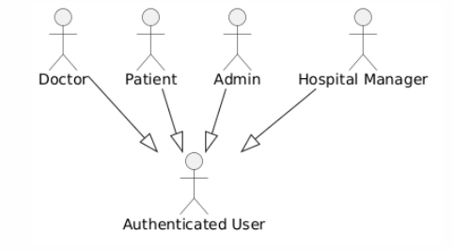

Name | Description | Responsibilities | Stakeholder
Authenticated User | User with login credentials to use the system | Is always extended by other roles | University Supervisor, Developer
Doctor | User with access to individual patient records | Views patient files, adds consultation notes | Hospital Manager
Patient | Registered user with access to their own medical data | Views their own encounter history, conditions and medications | Patient
Hospital Manager | User with access to analytical dashboards | Analyzes clusters, sequences, aggregated KPIs | Hospital Manager
Admin | System administrator | Manages user accounts and platform configuration | University Supervisor, Developer

User Environment

Users
The platform is intended for use in an academic context, supporting a small number of concurrent users across four roles: Admin, Doctor, Patient, and Hospital Manager.

Time Limits
There is no predictable time limit for most tasks. Browsing patient records and viewing dashboards can be done at any pace. The clustering and sequence mining computations run as background batch processes and do not block the user interface.

Collaboration
Multiple users with different roles can use the platform simultaneously. For example, a Doctor may be adding consultation notes while a Hospital Manager is reviewing clustering results on the analytics dashboard. User accounts are created and managed by the Admin.

Infrastructure
On the client side, the application runs in any modern web browser such as Chrome or Firefox, with no additional software required. Mobile browser compatibility is supported through the responsive Material UI layout.
On the server side, the application requires Python 3.10 or later for the FastAPI backend and Node.js 18 or later for building the React frontend. The database is PostgreSQL. The Gemini API is required for LLM-based cluster interpretation features. The system can be deployed on any platform supporting these technologies.

Summary of Key Stakeholder or User Needs

Need | Priority | Concerns | Current Solution | Proposed Solutions
Patient Clustering | 0 | Hospital Manager | No automated solution exists |  | FEAT HP02: K-Prototypes algorithm on mixed numerical and categorical patient features
Cluster Interpretation | 0 | Hospital Manager | Manual written reports by medical staff |  | FEAT HP04: Automatic natural language summaries per cluster generated via Gemini API
Sequence Pattern Discovery | 1 | Hospital Manager | Ad-hoc analysis, no dedicated tool |  | FEAT HP05: PrefixSpan algorithm applied to patient encounter and procedure sequences
Data Visualization | 1 | Hospital Manager | Static tables and raw database exports |  | FEAT HP03: Interactive scatter plots, heatmaps and dashboards in the React frontend
Patient Records Access | 1 | Doctor | Scattered data across multiple sources |  | FEAT HP06: Dedicated doctor interface with full patient history, conditions and medications.
Consultation Notes | 2 | Doctor | Paper-based or external tools |  | FEAT HP07: Integrated note-adding functionality within the patient record view
Patient Data Self-Access | 2 | Patient | No self-service portal available |  | FEAT HP08: Patient interface showing personal encounter history and medical records
User Management | 1 | Admin | No role management in existing tools |  | FEAT HP09: Admin interface for creating and managing user accounts and roles
Usability | 0 | All | Technical tools require expert knowledge |  | FEAT HP09: Admin interface for creating and managing user accounts and roles

Alternatives and Competition
External competition is represented by all existing hospital information and clinical analytics systems, as well as generic business intelligence tools that could be partially adapted for patient data analysis.

Product Overview
This section provides a high level view of the HospitAI platform capabilities, interfaces to external services, and system configuration. The product is described from two perspectives: how it fits into its environment, and what assumptions and dependencies it relies on.

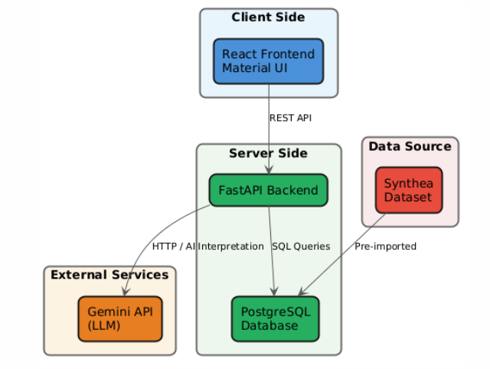

Product Perspective
The product will extend the existing features, making it more usable and attractive to potential customers.

Assumptions and Dependencies
Server side:
- Python 3.10 or later
- FastAPI framework
- PostgreSQL 14 or later
- Synthea dataset pre-imported into the database
- Valid Gemini API key for LLM features
Client side:
- Any modern web browser (Chrome, Firefox, Edge)
- No additional software or plugins required
- JavaScript must be enabled

Product Features
5.1 FEAT HP01: User Interface and Usability
The platform shall provide an intuitive web-based interface accessible from any modern browser. The interface shall be usable by non-technical users such as hospital managers and patients without any prior training. The design follows a clean Material UI layout with light and dark mode support.
5.2 FEAT HP02: Patient Clustering
The platform shall apply the K-Prototypes clustering algorithm to group patients based on mixed numerical and categorical features extracted from their medical history. Cluster quality shall be evaluated using Silhouette score, Davies-Bouldin index, Calinski-Harabasz index, Kruskal-Wallis test and Cramér's V.
5.3 FEAT HP03: Cluster Visualization
The platform shall display clustering results through interactive visualizations including PCA scatter plots, feature heatmaps and per-cluster distribution charts. All visualizations shall be rendered in the React frontend and be explorable by the hospital manager.
5.4 FEAT HP04: LLM Cluster Interpretation
The platform shall generate automatic natural language summaries for each patient cluster using the Gemini API. The summaries shall describe the dominant characteristics of each cluster in plain language targeted at non-technical hospital managers.
5.5 FEAT HP05: Sequential Pattern Mining
The platform shall apply the PrefixSpan algorithm to discover frequent sequences of medical events across the patient population. Results shall include support values and representative patient examples for each discovered pattern.
5.6 FEAT HP06: Doctor Interface
The platform shall provide a dedicated interface for doctors. Doctors shall be able to log in securely, browse the patient list, and view full patient records including demographics, encounter history, conditions, medications, procedures and observations.
5.7 FEAT HP07: Consultation Notes
The platform shall allow doctors to add consultation notes to patient records. Notes shall be saved and visible within the patient record view for future reference.
5.8 FEAT HP08: Patient Interface
The platform shall provide a self-service interface for patients. Patients shall be able to log in and view their own medical records including encounter history, active conditions, medications and observations.
5.9 FEAT HP09: Admin Interface
The platform shall provide an administration interface for managing user accounts. The admin shall be able to create, update and delete user accounts and assign roles such as Doctor, Patient and Hospital Manager.

Other Product Requirements
6.1 High Visual Application
The application UI shall be visually clear and informative. Cluster results, patient group characteristics and sequence patterns shall be represented through color-coded charts, heatmaps and interactive dashboards. The design follows a Balsamiq-inspired sketch aesthetic using Material UI components.

6.2 Usability
The user interface shall be easy to use and intuitive. Two goals shall be pursued:
- One click away functionality - key information and actions shall be reachable in as few steps as possible.
- Intuitive interface - the platform shall require zero training for basic use by hospital managers, doctors and patients.
6.3 Open
The platform shall preserve an open and modular architecture to allow future enhancements. It shall be designed to accommodate additional analytical modules such as predictive modeling or real-time data ingestion, and to integrate with future hospital information systems if needed.

6.4 PASSME Requirements Brief
6.4.1 Performance
The application performance shall be measured in:
- API response times for interactive queries, which shall not exceed 2 seconds.
- Clustering and sequence mining computation times, which run as offline batch processes and shall complete in a reasonable time over the full Synthea dataset.
6.4.2 Availability
The application shall be available at all times during normal use. Maintenance tasks and downtime shall be planned outside active usage periods and shall be kept to a minimum.
6.4.3 Security
All data stored in the system shall be protected through JWT-based authentication and role-based access control. Although the platform uses synthetic data, the architecture shall follow data privacy best practices including sensitive information handling and secure API communication.
6.4.4 Scalability
The platform shall be able to accommodate a growing number of users and larger datasets without requiring changes to the core application architecture. The modular backend design allows individual components to be scaled or replaced independently.
6.4.5 Maintainability
The FastAPI backend shall be organized into distinct modules for clustering, sequence mining, LLM integration and authentication. The React
frontend shall use reusable components throughout. This structure shall make the codebase easy to understand, update and extend.
6.4.6 Extendibility
The platform shall be designed to accommodate additional features as requirements grow. New analytical algorithms, additional user roles or integrations with external systems shall be possible without restructuring the existing application.

6.5 Documentation
A technical README shall be provided covering setup, configuration and deployment. This Vision document serves as the primary project requirements artifact and shall be maintained alongside the codebase.

