**Introduction**

The aim of my coursework was to extend my cypher from the first coursework to make a more cohesive website that can interact and this time I was going to be using web servers and client elements.

The client element was going to be the user interface which would let the user sign up, write plain text messages and even encode the messages.

My website is very easy to use and user friendly, you can navigate through it easily. I decided to use a dropdown menu because I realized it would be easier to navigate that way.

I went back to read some of the lectures so as to get a deeper scope into what I was going to be doing.

**Software Design**

I had a clear plan in my head as to what I want my design to look like and I tried to achieve it. I wrote the html code and the CSS before implementing them together with the JavaScript and my server.

My list of requirements includes where I was going to write the code, how I was going to implement it and if I was stuck, what websites I could use to help myself.

I installed some node packages to help with the hosting of my server.

**Short Description**

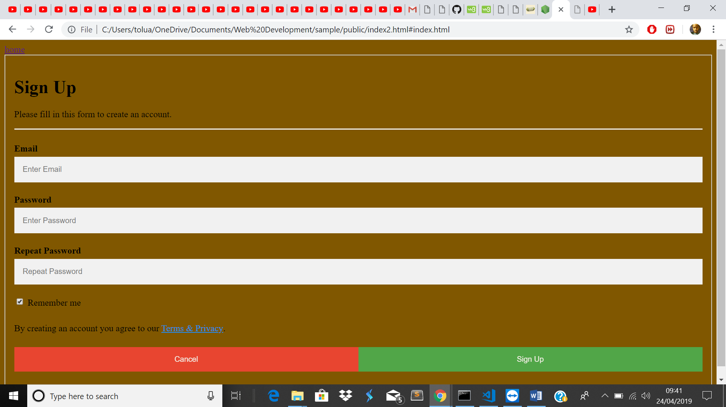

Sign up page

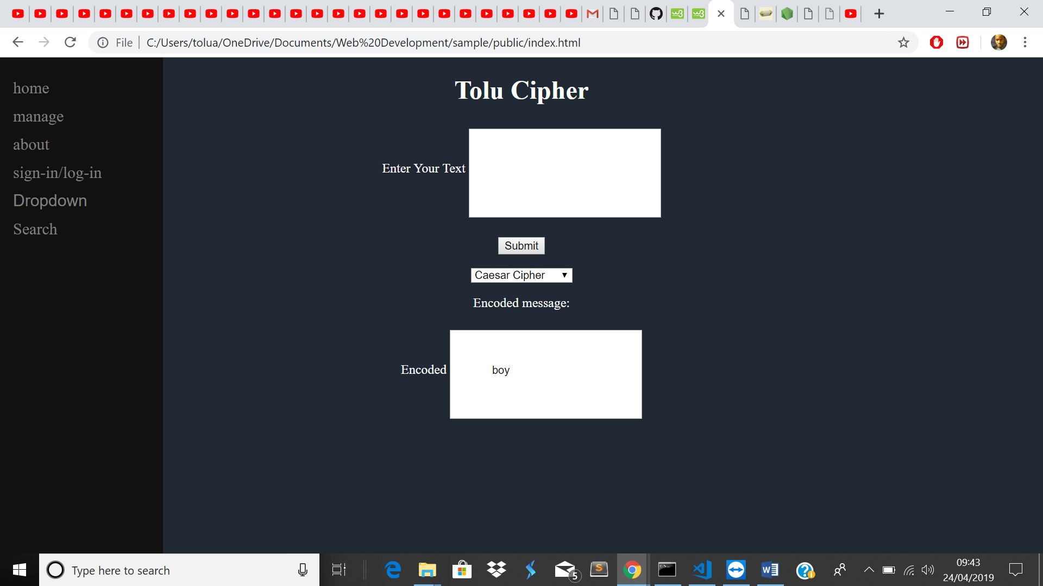

Actual page

**Critical Evaluation**

If I was to critic myself about this coursework, I would say that I was not able to put my full vision into it. The dropdown menu does not do what it is supposed to do, the boxes could have been a lot more central and my server failed me. I was able to run the server, but I was not able to host it. Also, big texts in my main area and the sign-up page does not match the colour of the main page.

One possible improvement I would have done is to get my website running and show the database that I created for this coursework and change the colour to match both systems.

**Personal Evaluation**

It was a big learning curve from what I am used to, I had to go read over again so that I could understand it better, I also had to ask for help when I needed it and realize that I cannot do this myself.

I do not feel like I have performed to the best of my abilities because for a long time I was stuck in one place and was not able to move, I had to swallow my pride to ask for help.

By the time I got the help it was too late, and I just need to get help sometimes.

**References**