PARKMINJAE just joined the server - glhf!28/01/2020

We've been expecting you touboutou28/01/2020

8e6 has arrived. Party's over.28/01/2020



8e6**28/01/2020**

Just seeing how this works



JonBoy**28/01/2020**

I started populating the Kanban last night



8e6**28/01/2020**

Yeah, got the emails . I started migrating the code, will check later today what still has to be migrated

Where on here do we access these messages to save the thread or print it off if needs be for proof?



JonBoy**28/01/2020**

Il be looking into that after my lecture this morning. There is a bit in the privacy section of the settings that mentions data



8e6**28/01/2020**



JonBoy**28/01/2020**

So I have had a quick look at it can take up to 30 days to get transcripts etc. However you can always screenshot chats as the time stamps always show. I can change peoples nicknames in the chat to be real names



Nicholas Obara**28/01/2020**

Sounds good. Currently working on the site map & branding design. going to wrap it up this week & upload some wireframes too. as for the questions, I have 11 of them so far so if You could review them that'd be great.(edited)



JonBoy**28/01/2020**

good stuff! Il look at it later tonight or tomorrow



Nicholas Obara**28/01/2020**

[projex_survey.docx](https://cdn.discordapp.com/attachments/671521764635049997/671774945516322837/projex_survey.docx)

12.26 KB



Nicholas Obara**28/01/2020**

so Xd has a web export addon. seems good

[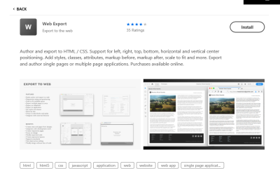](https://cdn.discordapp.com/attachments/671521764635049997/671826484901576721/unknown.png)



JonBoy**28/01/2020**

if it’s something that will help us we can look into it. Is it free?



Nicholas Obara**28/01/2020**

yea ofc it's free

wait

you mean the plugin?



JonBoy**28/01/2020**

It’s just the last sentence in the blurb that’s throwing me sideways “Purchases available online”



Nicholas Obara**28/01/2020**

oh yea they have their own app apparently but the xd addon is free



JonBoy**28/01/2020**

Can I just say that the PMIS is asking for simple things on a complicated manner which is annoying

In a*

29 January 2020



JonBoy**Last Wednesday at 11:15**

One of yous will need to book the room for 10th feb. I can’t book it as I don’t be here and they won’t let me book it under somebody else’s name



8e6**Last Wednesday at 11:17**

Do I need to go in to book it? Or can you book it online?



JonBoy**Last Wednesday at 11:18**

I don’t know if there is an online booking system

Il ask them now.



8e6**Last Wednesday at 11:19**

I'm in tomorrow, so if no one has booked it before then I'll do it. Just pop it up here if someone else books it.



JonBoy**Last Wednesday at 11:22**

Played the puppy dog eyes with her and booked it under your name Karen. So if you just go to the desk with your student card it’s room 7 from 2 until 4.



Nicholas Obara**Last Wednesday at 13:23**

[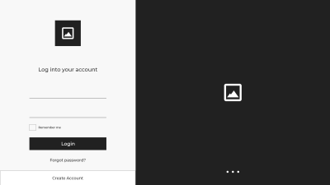](https://cdn.discordapp.com/attachments/671521764635049997/672069273102975016/Web_1920_8.png)

[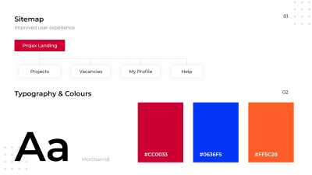](https://cdn.discordapp.com/attachments/671521764635049997/672069440149520394/Web_1920_6.png)



JonBoy**Last Wednesday at 13:25**

Nice



Nicholas Obara**Last Wednesday at 13:44**

business cards in

[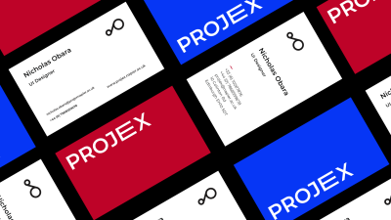](https://cdn.discordapp.com/attachments/671521764635049997/672074536618950666/Slide_2_7.png)

so when's the next client meeting?

30 January 2020



8e6**Last Thursday at 10:53**

@JonBoy just on the 10th of Feb? Or do I need to go and show my student I'd today to confirm it?



JonBoy**Last Thursday at 10:56**

No just in 10th.



8e6**Last Thursday at 10:56**

1 February 2020



Nicholas Obara**Last Saturday at 01:57**

[](https://cdn.discordapp.com/attachments/671521764635049997/672983857137713152/unknown.png)

[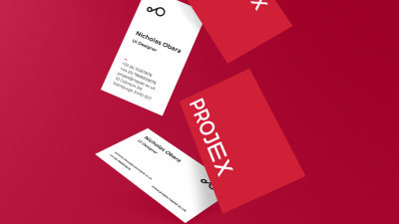](https://cdn.discordapp.com/attachments/671521764635049997/672983995494957067/unknown.png)



Nicholas Obara**Last Saturday at 03:43**

User Flow Diagram

[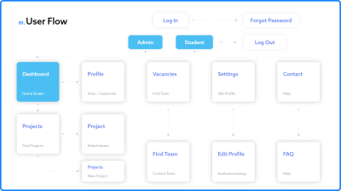](https://cdn.discordapp.com/attachments/671521764635049997/673010470453641246/user_flow.png)



JonBoy**Last Saturday at 03:52**

Your doing amazing work Nicholas



Nicholas Obara**Last Saturday at 17:04**

[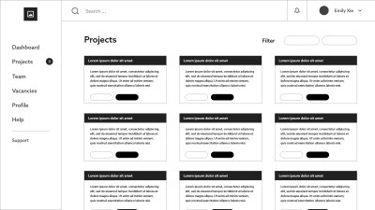](https://cdn.discordapp.com/attachments/671521764635049997/673212012808896532/Web_1920_12.png)



Nicholas Obara**Last Saturday at 17:48**

2 different navigation styles. let me know which one you prefer

[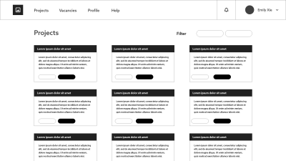](https://cdn.discordapp.com/attachments/671521764635049997/673223126259073044/Web_1920_13.png)



Nicholas Obara**Last Saturday at 18:56**

Home Page

[](https://cdn.discordapp.com/attachments/671521764635049997/673240212251475983/Home_Page.png)

now this is still a wireframe so it will look 100x better next week



JonBoy**Last Saturday at 19:07**

I like the look of the tabs across the top for the projects. Keeps the projects more clear/less cluttered looking

Also you are a work horse. Please tell me you have been having some time to yourself



Nicholas Obara**Last Saturday at 19:08**

this isn't work this brings me joy



JonBoy**Last Saturday at 19:08**

Well they do say if you enjoy your job you never have to work a day in your life



Nicholas Obara**Last Saturday at 19:10**

indeed



8e6**Last Saturday at 20:06**

I prefer the one with the tabs across the top too. Looks neater if we make it sticky in the working Web page too.

2 February 2020



Nicholas Obara**Last Sunday at 04:53**

[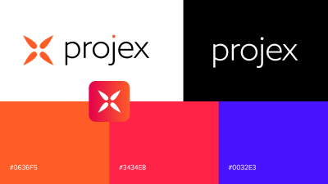](https://cdn.discordapp.com/attachments/671521764635049997/673390409405169664/unknown.png)

thoughts on this logo?



8e6**Last Sunday at 09:39**

Be good to give Brian a choice, I like it, but I still prefer the original one as it give the notion of scrum behind it. But guess it'll depend on his feed back. Are we emailing 'the client' choices or do we approach it at next client meeting? When is next client meeting?



8e6**Last Sunday at 13:59**

@JonBoy i don't seem to be able to access the kanban board through zube (it's not appearing in my login through github) have you added me?

If you go to 'organisation settings', you can send me an invite.

Or I think anyone else in the group can add me to it. Pleeaaseee



JonBoy**Last Sunday at 14:14**

Il look into it now



JonBoy**Last Sunday at 14:24**

Looking at it now only myself and Gregoire are on it. Will need your emails for github to invite you.

Was able to add you @8e6 but can’t add Nicholas and Tolu for some reason.

As for the client meeting will ask brian in the sponsor meeting how he wants that handled.



8e6**Last Sunday at 15:39**

Thanks for that



Nicholas Obara**Last Sunday at 16:13**

whens the sponsor meeting?



JonBoy**Last Sunday at 16:16**

Same time as last week

It’s 245 every week



Nicholas Obara**Last Sunday at 16:17**

oh okay and do we have the library room booked for tomorrow?



JonBoy**Last Sunday at 16:17**

Yup

And next week



Nicholas Obara**Last Sunday at 18:10**

[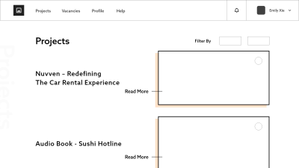](https://cdn.discordapp.com/attachments/671521764635049997/673591142193037333/Web_1920_17.png)

experimenting with the projects site(edited)



Nicholas Obara**Last Sunday at 19:02**

FYI Im going to contact Brian about this tomorrow. If We have enough time towards the end of the project, I can provide translations so We can make the website available in Korean and Polish



8e6**Last Sunday at 19:27**

Is this the layout for the available projects page @Nicholas Obara ? Remember we've not to take on too much too as we have other classes etc and exams at the end. Looks good though.

Think the overview with multiple projects per page might (your earlier design idea) be a bit easier to navigate from a usability point of view if people are trying to find projects.



Nicholas Obara**Last Sunday at 19:30**

Yea i know i still have a few other layouts

That's for tomorrow though



8e6**Last Sunday at 19:30**

Look forward to seeing them tomorrow



Nicholas Obara**Last Sunday at 19:31**

It's still just a wireframe though



8e6**Last Sunday at 19:34**

How's everyone getting on with their mindmaps for their areas?? What software did you use? Are we just putting them together into one mindmap tomorrow before the meeting?

3 February 2020

It's a bird! It's a plane! Nevermind, it's just tdrizzy.Yesterday at 10:11



8e6**Yesterday at 11:54**

Configuration Map finished and uploaded to github



8e6**Yesterday at 17:19**

Slack set up (I think lol)



JonBoy**Yesterday at 17:47**

looking at it now



JonBoy**Yesterday at 17:55**

Add me on slack: 40432720@live.napier.ac.uk



Nicholas Obara**Yesterday at 19:47**

40435293@live.napier.ac.uk



8e6**Yesterday at 20:40**

Think I've joined the group chat on slack



tdrizzy**Yesterday at 20:46**

Add me on 40288696@live.napier.ac.uk



8e6**Yesterday at 20:53**

Think I have added you?? Have I?? Your emails are showing up as members in the group?



JonBoy**Yesterday at 20:58**

Il check mine in a bit



tdrizzy**Yesterday at 20:58**

I just created slack now so there was no way I had it before



8e6**Yesterday at 21:52**

@Nicholas Obara can you see the message I sent you on slack? Not sure of the notifications on it



JonBoy**Yesterday at 23:36**

So iv set up a slack workspace for projects. We have 14 days free standard slack trial then it goes back to the free version.

Sent out emails to your Serc emails as I didn’t know which ones you have signed up on. Sorry it’s later in the day than I said, was having a reminiscing mourning session with an old mate from home