**Detection and segmentation of wind turbine blade faults using Mask R-CNN, YOLOV7, And YOLOV8 with different Intersection of Unions**

**Pavan Sai Prasanth Sabnaveesu and Dr. Md Monirul Islam**

**Keywords**: Object detection, semantic segmentation, wind turbine blade faults, Mask R-CNN, YOLOV7, And YOLOV8

**Abstract**

Wind turbines are at the heart of sustainable electricity generation from renewable sources. These blades, however, are constantly exposed to a myriad of environmental conditions, rendering them prone to wear and tear. This vulnerability underscores the importance of consistent monitoring not just to reduce risks, maintenance costs, and downtime but also to safeguard against structural damages that could compromise the constant supply of power. This research delves into the intricate task of detection and segmentation of prevalent faults in turbine blades, specifically surface damage, and edge erosion. Furthermore, we've extended our investigation to two crucial components: the lightning receptor and the VG panel. To ensure the highest efficiency possible, we conducted a comparative analysis of three state-of-the-art models: Mask R-CNN, YOLOv7, and YOLOv8. We also researched the YOLOv8 model with three different Intersections of Unions, and they are IoU@0.6, IoU@0.7, and [IoU@0.8](mailto:IoU@0.8).

**Introduction**

The primary driver of greenhouse gas emissions stems from fossil fuel-based energy sources. Renewable energy sources must be incorporated into our daily lives to reduce emissions and address environmental problems. The Paris Agreement, signed by 165 nations in 2015, marked a significant milestone in fortifying the global commitment to curbing carbon dioxide emissions and bolstering investments in renewable energy solutions [1]. Following the agreement, there was a significant increase in expenditure for green energy infrastructure. Notably, solar and wind energy emerged as front-runners in the competition for renewable energy production. Solar power provides 9% and wind production 24%, respectively, to the nation's energy supply, according to the United States Energy Information Administration [2]. Advancements in technology have revolutionized the design and production of wind turbines, resulting in a reduction in the cost of power generation compared to other renewable sources. The efficiency of a wind turbine is nearly double that of solar panels [3]. As of now, wind energy stands out as one of the most cost-effective renewable resources, with production costs averaging between one and two cents per kilowatt-hour [4]. Moreover, it is worth noting that harnessing one megawatt of wind energy can potentially offset approximately 2600 tons of carbon dioxide emissions [5].

The wind turbines are built on land (onshore) or in large bodies of water like oceans and lakes (offshore). Irrespective of the categories, the wind turbine architecture consists of many mechanical and electrical components such as a rotor, blades, generator, controller, and gearbox. Notably, turbine blades, typically measuring an impressive 100-140 meters in length, play a crucial role in electricity generation. Its efficiency in rotating determines the amount of electric power generated. These gigantic blades are subjected to aerodynamic and gravitational loads while operating under extreme climatic conditions, which causes vibration forces that result in structural damages such as cracks on the surface, erosion of the edge, pitch angle, and twisting blades [ 4] [ 5].

Traditional inspection of these blades relies on time-based maintenance techniques. This approach is not only inefficient but also fraught with challenges. For instance, rope-based inspections pose significant risks to personnel, and telephotography methods can overlook microscopic structural damages due to human limitations. Furthermore, faults in wind turbines don't just compromise efficiency; they also pose environmental hazards. Traditional inspection methods, relying on visual or manual techniques, are often time-consuming and are becoming increasingly impractical with the growing size and complexity of wind farms and prone to human error [27].

As wind turbine technology advances, so does the need for robust fault detection and segmentation methods to ensure optimal performance and mitigate potential failures. It is necessary for the adoption of deep-learning approaches for efficient and precise fault detection and segmentation. Mask R-CNN, YOLOv7, and YOLOv8 are advanced object detection models capable of both bounding box detection and instance segmentation. So, this research addresses these challenges by proposing an autonomous detection system using Mask R CNN, YOLOv7, and YOLOv8 algorithms. The goal is to precisely identify faults, thereby reducing O&M costs while elevating safety standards. Our approach leans on cutting-edge object detection algorithms, namely Mask R-CNN, YOLOV7, and YOLOV8, to navigate the challenges of manual inspections. First, let's start with contributions and then data acquisition.

**Contributions**

* The primary contribution of our project lies in the extensive data acquisition process, wherein we utilized drones to capture turbine blade images across diverse backgrounds.
* The incorporation of the MaskRCNN algorithm, a single-stage detector chosen for its excellent masking capabilities tailored to wind turbine blades, was succeeded by the application of YOLOv7, a multi-stage detector that potentially offers a superior mean Average Precision (mAP) score.
* Finally, YOLOv8, a multi-stage detector, was applied due to its exceptional mean Average Precision (mAP) score and masking capabilities. Variable Intersection of Union thresholds were hyper tuned to analyze model accuracy and efficiency.

**Data Acquisition**

In this research, we developed a dataset containing 2,127 augmented drone images. These images capture four distinct categories: edge erosion, surface damage, VG panel, and lighting receptor. These images encompass various backgrounds and fault variations. It's worth noting that while VG panels and lighting receptors aren't specific fault types, they are external components typically visible during wind turbine blade inspections [7]. We systematically divided the dataset into training, validation, and test subsets, consisting of 2,127, 181, and 41 images. Addressing concerns of underfitting and overfitting, we harnessed data augmentation strategies like flipping, rotating, shearing, blurring, and cropping. Each image underwent precise annotation, employing bounding boxes and labels to spotlight specific faults in wind turbine blades using the Roboflow Annotator tool, a publicly available resource. Though initially set to a pixel dimension of 856 x 856, images are resized to a 640 x 640 resolution for both the training and testing phases. Elevating the models' effectiveness, we incorporated transfer learning techniques, resulting in a notable enhancement in model performance.

**Transfer learning**

Transfer learning is used to leverage pre-trained models, reducing the need for extensive data and computational resources. Recognizing the challenge of amassing several labeled datasets, we adopted the transfer learning method. Specifically, we utilize a pre-trained model from the Microsoft Common Objects in Context (MS COCO) dataset [8]. Additionally, our study includes an analysis of the performance of transfer learning, with experiments involving the freezing of layers in the initial stages of the Mask R-CNN, YOLOv7, and YOLOv8 models. In the next section, we will delve into the algorithms utilized in this project.

**Algorithms and methodology:**

In this study, we leverage three cutting-edge object detection algorithms—Mask R-CNN, YOLOv7, and YOLOv8—to effectively detect and segment wind turbine faults. Our approach begins with the mAP-focused segmentation tasks handled by Mask R-CNN. Subsequently, we transitioned to the deployment of YOLOv7 and YOLOv8 for robust and real-time fault detection. The overarching goal is to achieve a harmonious balance between accuracy and efficiency in identifying defects in turbine blades. Additionally, our investigation delves into the YOLOv8 model, exploring its algorithms with different Intersection of Union parameters, further enhancing our understanding of its capabilities. First, we chose the Mask R-CNN algorithm because of its good segmentation capabilities.

**Mask R-CNN**

Mask R-CNN is a state-of-the-art instance segmentation model that builds on top of Faster R-CNN. It is a two-stage framework, where the first stage proposes regions of interest (RoI), and the second stage performs classification, bounding box regression, and instance segmentation on each RoI. The backbone of Mask R-CNN is Res Net, which handles the vanishing gradient problem in deep networks by introducing skip or residual connections, and it is integrated with a Feature Pyramid Network (FPN) to improve model detection accuracy and training time. Feature Pyramid Network is a top-down architecture with lateral connections developed to extract and build high-level semantic feature maps at different spatial resolutions by a bottom-up pathway, a top-down pathway, and lateral connections [19]. The feature maps produced by the Feature Pyramid Network (FPN) serve as input to the Region Proposal Network (RPN). Utilizing the concept of anchors, the RPN generates region proposals at various scales and aspect ratios for objects in the image. RPN processes all feature maps', and extracts RoI (Region of Interest) features from different sizes of the feature pyramids based on the size of the specific fault type. It operates like a sliding window and efficiently identifies areas containing objects in parallel due to its convolution operation. RoI Align is a critical layer in implementing the Mask R-CNN algorithm. It is responsible for extracting "M×M" feature maps from each RoI and unifying the output size of each RPN. Unlike RoI Pool, RoI Align eliminates aggressive quantization, significantly improving lo cation accuracy. The RoI is divided into 2×2 sub-windows or bins, and bi-linear interpolation is used to interpolate values of generated features within each RoI bin. The layer then aggregates the results using the max operation [10]. The loss function in Mask R-CNN is a combination of RoI loss, classifier loss, and mask head loss.

Lcls (Pi, Pi*) = -lb [PiPi* + (1- Pi) (1- Pi*)] Where pi represents the predicted probability that anchor point i is the target; p i represents the predicted value of the corresponding real area label; lb represents the log loss function [23]. Lbox (ti,ti*)= R(ti- ti*) ti signifies the four parameterized coordinate vectors of the predicted frame; t i signifies the coordinate vector corresponding to the border of the real area [24]. The total loss function as Lall=Lcls + Lbox + Lmask, where Lcls, Lbox, Lmask represent the classification loss, bounding box loss and the average binary cross-entropy loss respectively [22]. The total architecture is shown below in Figure 1. Next, we chose YOLOv7 because of its speed and efficiency.

**Figure 1**

**YOLOv7**

YOLOv7 introduces several innovative features to enhance detection accuracy. One standout is its multi-head architecture, which incorporates a unique approach. Additionally, it implements the E-ELAN network, surpassing its predecessors in efficiency by focusing on layer aggregation. This network consists of residual blocks, each housing expands, shuffles, and merges cardinality operations. In the design of YOLOv7, a series of actions, including expansion, channel mixing, and merging, work in harmony to significantly enhance the network's learning capacity. The integration of the Bidirectional Feature Pyramid Network is particularly noteworthy. This design aims to optimize the flow of information throughout the network, significantly improving object detection accuracy. Building on this, the Path Aggregate Network enhances the structure by strengthening connections between feature pyramid levels. As a result, the features at each level of the feature pyramid combined to increase their degree of information [20]. It introduces a dual-head system for detection. The auxiliary head, being the first, is pivotal during training phases in intermediate layers, as it predicts coarse bounding boxes and class probabilities. Then, the lead head focuses on final detection outcomes, forecasting precise bounding boxes and class probabilities. Later in the process, refinement comes through a deliberate model re-parameterization strategy. Especially the identity connection is omitted in RepConv. This strategic design enhances gradient diversity for different feature maps, optimizing the network structure. Another notable aspect of YOLOv7 is its dynamic feature, which reviews model outcomes and ground truths, assigning soft labels to detected objects. These soft labels, derived from ground truth, contribute to fine-tuning predictions. Lastly, YOLOv7 collaborates with YOLACT, known for its rapid instance segmentation capabilities. While YOLACT autonomously handles instance segmentation tasks on feature maps without requiring bounding box regression, it's important to note that its accuracy slightly lags multi-stage algorithms like Mask R-CNN. The combination of YOLOv7 and YOLAC makes YOLOv7 the most precise and fastest instance segmentation algorithm for Wind turbine blade fault detection and instance segmentation. The Loss function of Yolov7 is 𝐿𝑡𝑜𝑡𝑎𝑙_𝑙𝑜𝑠𝑠=𝐿𝑜𝑏𝑗_𝑙𝑜𝑠𝑠+𝐿𝑏𝑜𝑥_𝑙𝑜𝑠𝑠+𝐿𝑐𝑙𝑠_𝑙𝑜𝑠𝑠.  BCE cross-entropy loss formula is represented as Ln=−wn[yn*logσ(xn)+(1−yn)*log(1−σ(xn))] and σ(xn)=1/(1+(e)^-x where σ(xn) represents the sigmoid function, wn signifies the average of the results, and yn signifies the real sample label. Intersection of Union (𝐼𝑜𝑈)=(|𝐴∩𝐵|) / (|𝐴∪𝐵|) where A represents the predicted frame, B represents the real frame. YOLOV7 uses CIoU loss. In the below Figure 5 loss function formulae of YOLOv7 are mentioned.

Here, v is to measure the aspect ratio's consistency, α is the weight function. The projected bounding box's width and height are represented by 𝑤 and ℎ, respectively, the ground truth bounding box's width and height are represented by 𝑤gt and ℎgt. The diagonal distance of a bounding box that may at least contain the two bounding boxes is denoted by c, and the center point distance between two bounding boxes is represented by 𝜌2 (b, bgt) [25]. Finally, we chose YOLOv8 as the latest version of the YOLO family whose accuracy and speed are higher than previous versions. Below figure 2 is YOLOv7 architecture.

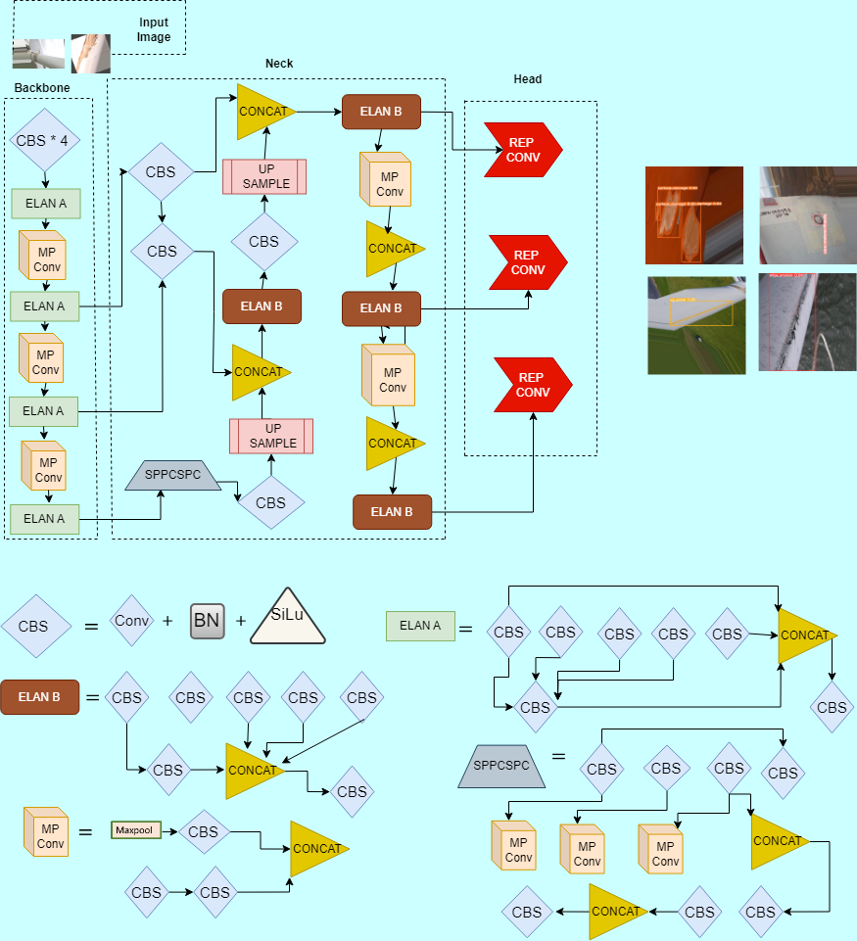

**Figure 2**

**YOLOv8**

YOLOv8 is the latest version of the YOLO family. The architecture of YOLOv8 is state-of-the-art, capable of accommodating different resolutions, and even includes an instance segmentation model reminiscent of YOLACT. It is also anchor-free and a constituent of the Feature Pyramid Network (FPN) Path Aggregation Network (PAN), and SPPF modules. These enhance the ability to discern object shapes and textures across various scales and lead to improved accuracy. The backbone of the model is composed of four sections, each introduced by a single convolution and succeeded by an innovative C2f module [12]. This new addition to CSPDarknet53 involves a bottleneck segment featuring two 3x3 convolutions with residual connections. The model features a revamped detection head that separates classification and detection tasks. The loss computations have been refined, utilizing BCE Loss for classification and a combination of Complete Intersection of Union (CIOU) Loss + Distributed Focal Loss (DFL) for regression. The DFL approach models the box position as a general distribution, while VFL introduces an asymmetric weighting operation. These enhancements contribute to the robust performance of YOLOv8 in object detection tasks. [17][18]. Below Figure 3 is YOLOv8 architecture. Below Figure 4 are equations of DFL [26].

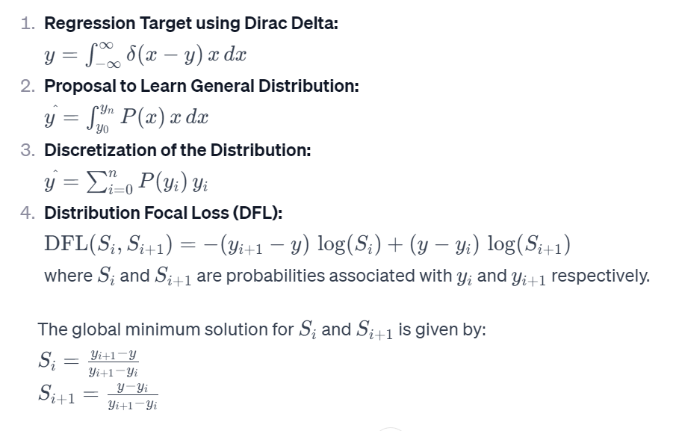

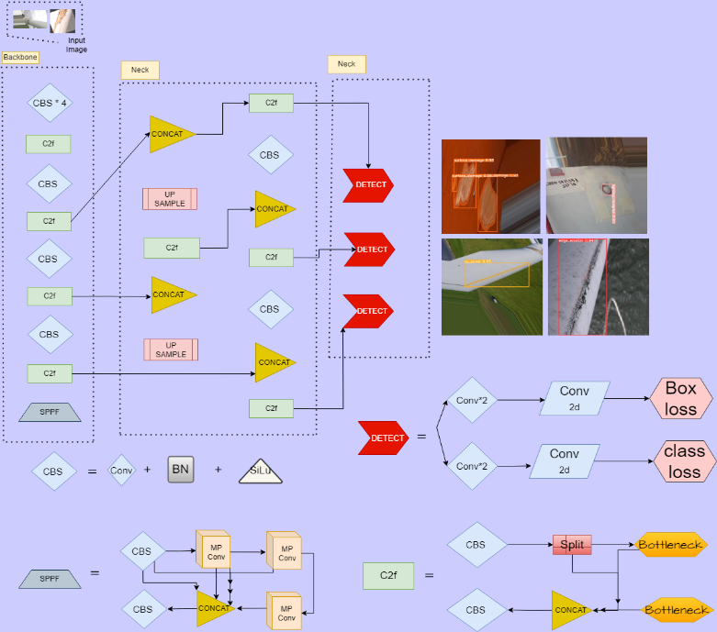

**Our research and results**

We applied advanced detection and segmentation algorithms—Mask R-CNN, YOLOv7, and YOLOv8—to wind turbine blades, achieving noteworthy results. Specifically, Mask R-CNN exhibited a detection mAP@IoU (0.5) of 86.30% and a segmentation mAP@mask (0.5) of 84.56%. YOLOv7 performed with a detection mAP@IoU (0.5) of 95.80% and a segmentation mAP@mask (0.5) of 96.30%. Subsequently, our research extended to the implementation of the YOLOv8 algorithm, introducing the Intersection of Union (IoU) tuning at thresholds of 0.6, 0.7, and 0.8. YOLOv8 outperformed with a detection mAP@IoU (0.7) of 97.30% and a segmentation mAP@mask (0.8) of 97.60%. This comprehensive exploration showcases the nuanced performance of these algorithms in the realm of wind turbine fault detection and segmentation.

**Sample Image outputs:**

**Table:1** Performance comparison between Mask R-CNN, YOLOv7, and YOLOV8

|  |  |  |  |  |
| --- | --- | --- | --- | --- |
| **Performance Metrics** | **Mask R-CNN** | **YOLOv7** | **YOLOV8** | **Improvement** |
| mAP@IoU (0.5) | 86.30% | 95.80% | 97.3% | +1.50% |
| mAP@mask (0.5) | 84.56% | 96.30% | 97.6% | +1.30% |

**Table2:** Performance of YOLOv8 algorithm with different IoU’s

|  |  |  |
| --- | --- | --- |
| **Performance of different IoU’s** | **Detection** | **Segmentation** |
| mAP@IoU (0.7) | 97.3%/ 96.9% | 96.5 % /97.2 % |
| mAP@IoU (0.6) | 97.1%/ 96.9% | 97% |
| mAP@IoU (0.8) | 97.1%/ 96.9% | 97.6%/ 97.6 % |

**Conclusion**

This research successfully employed deep learning models for automated detection and segmentation of wind turbine blade faults, paving the way for improved wind farm inspections. YOLOv8 surpassed Mask R-CNN and YOLOv7 in accuracy and efficiency, achieving an impressive mAP@IoU of 97.3% for detection and 97.6% for segmentation. YOLOv8 demonstrated robustness to different IoU thresholds, suggesting its adaptability to diverse detection requirements. Integrating these models into real-world systems can significantly reduce maintenance costs, downtime, and safety risks associated with manual inspections. Overall, this study highlights the effectiveness of deep learning algorithms for automated wind turbine blade fault detection and segmentation, contributing to a more efficient and sustainable wind energy future. The proposed research potentially revolutionized wind turbine maintenance by enabling automated, accurate, and cost-effective fault identification.

**References**

1. Seo, S. N. (2017). Beyond the Paris Agreement: Climate change policy negotiations and future directions. Regional Science Policy & Practice, 9(2), 121-140.
2. (June 10, 2022). U.S. Energy Information Administration - EIA - Independent Statistics and Analysis. U.S. energy facts explained - consumption and production - U.S. Energy Information Administration (EIA). https://www.eia.gov/energyexplained/us-energy-facts/
3. Wiser, R., Bolinger, M., Hoen, B., Millstein, D., Rand, J., Barbose, G., and Paulos, B. (2022). Land-based wind market report: 2022 edition. Lawrence Berkeley National Lab. (LBNL), Berkeley, CA (United States).
4. Stetco, A., Dinmohammadi, F., Zhao, X., Robu, V., Flynn, D., Barnes, M., and Nenadic, G. (2019). Machine learning methods for wind turbine condition monitoring: A review. Renewable Energy, 133, 620-635.
5. Kusiak, A., and Li, W. (2011). The prediction and diagnosis of wind turbine faults. Renewable Energy, 36(1), 16-23.
6. Nielsen, J. J., and Sørensen, J. D. (2011). On risk-based operation and maintenance of offshore wind turbine components. Reliability Engineering & System Safety, 96(1), 218-229.
7. Shihavuddin, A. S. M., Xiao Chen, X., Fedorov, V., Nymark Christensen, A., Andre Brogaard Riis, N., Branner, K., and Reinhold Paulsen, R. (2019). Wind turbine surface damage detection by deep learning aided drone inspection analysis. Energies, 12(4), 676.
8. Lin, T. Y., Maire, M., Belongie, S., Hays, J., Perona, P., and Ramanan, D., and Zitnick, CL (2014, September). Microsoft COCO: Common objects in context. In European Conference on Computer Vision (pp. 740-755).
9. Roboflow Annotator. Roboflow. <https://roboflow.com/>.
10. Kaiming He Georgia Gkioxari Piotr Dollar Ross Girshick Facebook AI Research (FAIR) Mask R-CNN
11. YOLOv7: Trainable bag-of-freebies sets new state-of-the-art for real-time object detectors Chien-Yao Wang1, Alexey Bochkovskiy, and Hong-Yuan Mark Liao1 1 Institute of Information Science, Academia Sinica, Taiwan
12. Real-Time Flying Object Detection with YOLOv8 Dillon Reis*, Jordan Kupec, Jacqueline Hong, Ahmad Daoudi Georgia Institute of Technology
13. Fu, Y., Wu, J., Hu, Y., Xing, M., and Xie, L. (2021, January). Desnet: A multi-channel network for simultaneous speech dereverberation, enhancement and separation. In *2021 IEEE Spoken Language Technology Workshop (SLT)* (pp. 857-864). IEEE.
14. Soudy, M., Afify, Y., and Badr, N. (2022). RepConv: A novel architecture for image scene classification on Intel scenes dataset. *International Journal of Intelligent Computing and Information Sciences*, *22*(2), 63-73.
15. Bolya, D., Zhou, C., Xiao, F., and Lee, Y. J. (2019). Yolact: Real-time instance segmentation. In *Proceedings of the IEEE/CVF International Conference on Computer Vision* (pp. 9157-9166).
16. Jacob Solawetz and Francesco. What is yolov8? the ultimate guide., 2023. 04-30-2023. 1, 5, 8
17. DC-YOLOv8: Small size Object detection algorithm based on camera sensor Haitong Lou1, Xuehu Duan1, Junmei Guo1, Haiying Liu1 *, Jason Gu2, Lingyun Bi1, Haonan Chen 1 7 April 2023 doi:10.20944/preprints202304. 0124.v1
18. DCF-Yolov8: An Improved Algorithm for Aggregating Low-Level Features to Detect Agricultural Pests and Diseases by Lijuan Zhang 1,2, Gongcheng Ding 1,2, Chaoran Li 3 and Dongming Li 1,*ORCIDAgronomy 2023, 13(8), 2012; https://doi.org/10.3390/agronomy13082012.
19. Feature Pyramid Networks for Object Detection Tsung-Yi Lin, Piotr Dollar , Ross Girshick , Kaiming He, Bharath Hariharan, and Serge Belongie
20. Path Aggregation Network for Instance Segmentation Shu Liu† Lu Qi† Haifang Qin§ Jianping Shi‡ Jiaya Jia†,[ †The Chinese University of Hong Kong §Peking University ‡SenseTime Research [YouTu Lab, Tencent arXiv:1803.01534v4
21. Representation Learning: A Statistical Perspective Jianwen Xie1 , Ruiqi Gao2 , Erik Nijkamp2 , Song-Chun Zhu2 , and Ying Nian Wu2 1Hikvision Research Institute, 2Department of Statistics, University California, Los Angeles arXiv:1911.11374v1 [stat.ML] 26 Nov 2019
22. Baruah P. Types of tea, value addition and product diversification of Indian tea. 2015.
23. Chen J, Chen Y, Jin X, et al. Research on a parallel robot for green tea flushes plucking/Proceedings of the 5th International Conference on Education, Management, Information and Medicine. 2015: 22–26.
24. Hu G, Wu H, Zhang Y, Wan M. A low shot learning method for tea leaf’s disease identification. Comput Electron Agric
25. Channel Pruning-Based YOLOv7 Deep Learning Algorithm for Identifying Trolley Codes by Jun Zhang, Rongxi Zhang *, Xinming Shu, Lulu Yu and Xuanning Xu Appl. Sci. 2023, 13(18), 10202
26. Generalized Focal Loss: Learning Qualified and Distributed Bounding Boxes for Dense Object Detection Xiang Li1,2, Wenhai Wang3,2, Lijun Wu4, Shuo Chen1, Xiaolin Hu5, Jun Li1, Jinhui Tang1, and Jian Yang1∗ arXiv:2006.04388v1 [cs.CV] 8 Jun 2020
27. Xu, B., Li, W., Yang, M., & Liu, Y. (2023). Fast detection of wind turbine blade damage using Cascade Mask R-DSCNN-aided drone inspection analysis. Signal, Image and Video Processing, 17(10), 2333-2341