Detection and segmentation of wind turbine blade faults using Mask R-CNN, YOLOV7, And YOLOV8 with different Intersection of Union

Pavan Sai Prasanth Sabnaveesu and Dr. Md Monirul Islam

Keywords: Object detection, semantic segmentation, wind turbine blade faults, Mask R-CNN, YOLOV7, And YOLOV8

Abstract

Wind turbines are at the heart of sustainable electricity generation from renewable sources. These blades, however, are constantly exposed to a myriad of environmental conditions, rendering them prone to wear and tear. This vulnerability underscores the importance of consistent monitoring not just to reduce risks, maintenance costs, and downtime but also to safeguard against structural damages that could compromise the constant supply of power. In light of this, our research delves into the intricate task of detection and segmentation of prevalent faults in turbine blades, specifically surface damage and edge erosion. Furthermore, we've extended our investigation to two crucial components: the lightning receptor and the VG panel. To ensure the highest efficiency possible, we conducted a comparative analysis of three state-of-the-art models: Mask R-CNN, YOLOv7, and YOLOv8. We also researched the YOLOv8 model with three different Intersections of Unions, and they are IoU@0.6, IoU@0.7, and IoU@0.8.

Introduction

The primary driver of greenhouse gas emissions stems from fossil fuel-based energy sources. Renewable energy sources must be incorporated into our daily lives to reduce emissions and address environmental problems. The Paris Agreement, signed by 165 nations in 2015, marked a significant milestone in fortifying the global commitment to curbing carbon dioxide emissions and bolstering investments in renewable energy solutions [1]. Following the agreement, there was a significant increase in expenditures for green energy infrastructure. Notably, solar and wind energy emerged as front-runners in the competition for renewable energy production. Solar power provides 9% and wind production 24%, respectively, to the nation's energy supply, according to the United States Energy Information Administration [2]. Advancements in technology have revolutionized the design and production of wind turbines, resulting in a reduction in the cost of power generation compared to other renewable sources. The efficiency of a wind turbine is nearly double that of solar panels [3]. As of now, wind energy stands out as one of the most cost-effective renewable resources, with production costs averaging between one and two cents per kilowatt-hour [4]. Moreover, it is worth noting that harnessing one megawatt of wind energy can potentially offset approximately 2600 tons of carbon dioxide emissions [5].

The wind turbines are built on land (onshore) or in large bodies of water like oceans and lakes (offshore). Irrespective of the categories, the wind turbine architecture consists of many mechanical and electrical components such as a rotor, blades, generator, controller, and gearbox. Notably, the turbine blades, typically measuring an impressive 100-140 meters in length, play a crucial role in electricity generation. Its efficiency in rotating determines the amount of electric power generated. These gigantic blades are subjected to aerodynamic and gravitational loads while operating under extreme climatic conditions, which causes vibration forces that result in structural damages such as cracks on the surface, erosion of the edge, pitch angle, and twisting blades[ 4][ 5].

These forces can induce vibrations that manifest as structural damages, such as surface cracks, edge erosion, and even issues with pitch angles or twisted blades. Traditional inspection of these blades relies on time-based maintenance techniques. This approach is not only inefficient but also fraught with challenges. For instance, rope-based inspections pose significant risks to personnel, and telephotography methods can overlook microscopic structural damages due to human limitations. Furthermore, faults in wind turbines don't just compromise efficiency; they also pose environmental hazards. The operation and maintenance (O&M) can account for up to 30% of the costs of wind electricity generation, so an efficient and reliable inspection method becomes indispensable. This research addresses these challenges by proposing an autonomous detection system using Mask R CNN, YOLOv7, and YOLOv8 algorithms. The goal is to precisely identify faults, thereby reducing O&M costs while elevating safety standards. Our approach leans on cutting-edge object detection algorithms, namely Mask R-CNN, YOLOV7, and YOLOV8, to navigate the challenges of manual inspections. We'll begin by discussing our data sources.

Data Acquisition

In this research, we developed a dataset containing 2,127 augmented drone images. These images capture four distinct categories: edge erosion, surface damage, VG panel, and lighting receptor. These images encompass various backgrounds and fault variations. It's worth noting that while VG panels and lighting receptors aren't specific fault types, they are external components typically visible during wind turbine blade inspections [7]. We systematically divided the dataset into training, validation, and test subsets, consisting of 2,127, 181, and 41 images. Addressing concerns of underfitting and overfitting, we harnessed data augmentation strategies like flipping, rotating, shearing, blurring, and cropping. Each image underwent precise annotation, employing bounding boxes and labels to spotlight specific faults in wind turbine blades using the Roboflow Annotator tool, a publicly available resource. Though initially set to a pixel dimension of 856 x 856, images are resized to a 640 x 640 resolution for both the training and testing phases. Elevating the models' effectiveness, we incorporated transfer learning techniques, resulting in a notable enhancement in model performance.

Transfer learning

Transfer learning is used to leverage pre-trained models, reducing the need for extensive data and computational resources. Recognizing the challenge of amassing several labeled datasets, we adopted the transfer learning method. Specifically, we utilize a pre-trained model from the Microsoft Common Objects in Context (MS COCO) dataset [8]. Additionally, our study includes an analysis of the performance of transfer learning, with experiments involving the freezing of layers in the initial stages of the Mask R-CNN, YOLOv7, and YOLOv8 models. In the next section, we will delve into the algorithms utilized in this project.

Algorithms and methodology:

This study uses three state-of-the-art object detection algorithms, Mask R-CNN, YOLOv7, and YOLOv8, to detect and segment wind turbine faults and types. Specifically, we initially employed the Mask R-CNN for precise segmentation tasks. Later, YOLOv7 and YOLOv8 are applied for robust and real-time fault detection. By these models, we aim to ensure accuracy and efficiency in pinpointing defects on turbine blades. We also research our model YOLOv8 algorithms with different Intersection of Unions. Let’s go through Mask R CNN.

Mask R-CNN

Mask R-CNN is a state-of-the-art instance segmentation model that builds on top of Faster R-CNN. It is a two-stage framework, where the first stage proposes regions of interest (RoI), and the second stage performs classification, bounding box regression, and instance segmentation on each RoI. The backbone of Mask R-CNN is Res Net, which handles the vanishing gradient problem in deep networks by introducing skip or residual connections, and it is integrated with a Feature Pyramid Network (FPN) to improve model detection accuracy and training time. Feature Pyramid Network is a top-down architecture with lateral connections developed to extract and build high-level semantic feature maps at different spatial resolutions by a bottom-up pathway, a top-down pathway, and lateral connections [19]. The feature maps produced by the Feature Pyramid Network (FPN) serve as input to the Region Proposal Network (RPN). Utilizing the concept of anchors, the RPN generates region proposals at various scales and aspect ratios for objects in the image. RPN processes all feature maps', and extracts RoI (Region of Interest) features from different sizes of the feature pyramids based on the size of the specific fault type. It operates like a sliding window and efficiently identifies areas containing objects in parallel due to its convolution operation. RoI Align is a critical layer in implementing the Mask R-CNN algorithm. It is responsible for extracting "M×M" feature maps from each RoI and unifying the output size of each RPN. Unlike RoI Pool, RoI Align eliminates aggressive quantization, significantly improving location accuracy. The RoI is divided into 2×2 sub-windows or bins, and bi-linear interpolation is used to interpolate values of generated features within each RoI bin. The layer then aggregates the results using the max operation [10]. The total architecture is shown below in Figure 1.

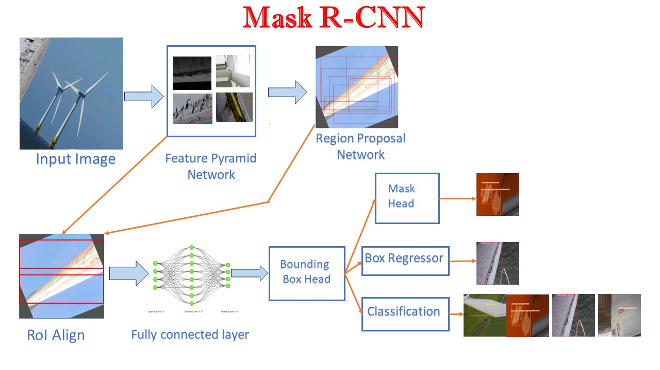
Figure 1

YOLOv7

YOLOv7 introduces several innovative features to enhance detection accuracy. One standout is its multi-head architecture, which incorporates a unique approach. Additionally, it implements the E-ELAN network, surpassing its predecessors in efficiency by focusing on layer aggregation. This network consists of residual blocks, each housing expands, shuffle, and merge cardinality operations. In the design of YOLOv7, a series of actions, including expansion, channel mixing, and merging, work in harmony to significantly enhance the network's learning capacity. The integration of the Bidirectional Feature Pyramid Network is particularly noteworthy. This design aims to optimize the flow of information throughout the network, significantly improving object detection accuracy. Building on this, the Path Aggregate Network enhances the structure by strengthening connections between feature pyramid levels. As a result, the features at each level of the feature pyramid combined to increase their degree of information [20]. It introduces a dual-head system for detection. The auxiliary head, being the first, is pivotal during training phases in intermediate layers, as it predicts coarse bounding boxes and class probabilities. Then, the lead head focuses on final detection outcomes, forecasting precise bounding boxes and class probabilities. Later in the process, refinement comes through a deliberate model re-parameterization strategy. Especially the identity connection is omitted in RepConv. This strategic design enhances gradient diversity for different feature maps, optimizing the network structure. Another notable aspect of YOLOv7 is its dynamic feature, which reviews model outcomes and ground truths, assigning soft labels to detected objects. These soft labels, derived from ground truth, contribute to fine-tuning predictions. Lastly, YOLOv7 collaborates with YOLACT, known for its rapid instance segmentation capabilities. While YOLACT autonomously handles instance segmentation tasks on feature maps without requiring bounding box regression, it's important to note that its accuracy slightly lags multi-stage algorithms like Mask R-CNN. The combination of YOLOv7 and YOLAC makes YOLOv7 the most precise and fastest instance segmentation algorithm for Wind turbine blade fault detection and instance segmentation.

