Caro AI Research Program

Week 01 Rules Representation and Language Boundary

STATUS  Evidence reconstruction |  | OWNER  Nguyen Tam Duc |  | LAST UPDATED  18 September 2026

Authors | Nguyen Tam Duc
Reviewers | Course reviewer
Related docs | Week 01 Google Document and Markdown report
Scope | Formalize the game rule, 15 by 15 representation, and TypeScript to Rust/WASM boundary before algorithm comparison.

1. Research Summary
This research report establishes the rule and representation contract needed before evaluating AI algorithms. Source inspection confirms a 15 by 15 finite board and a TypeScript winner rule that accepts five or more stones. The report distinguishes this observed Freestyle behavior from the official Gomocup Caro definition, which requires exactly five stones not blocked at both ends.
The system is reconstructed from current evidence. TypeScript is observed at the browser and contract boundary, while a sibling Rust engine is compiled to WebAssembly. This supports an architectural division, but no controlled language-performance result is claimed.

2. Research Goals and Scope
Goals | Out of scope
Name one explicit rule profile before search evaluation. | Do not infer that the label Caro proves Standard Caro semantics.
Record the finite board and legal-coordinate contract. | Do not claim the game-tree size is exhaustively searchable.
Separate UI/runtime responsibilities from engine computation. | Do not claim a Rust speedup without a controlled benchmark.
Create a fixture-oriented basis for later research. | Do not assign unverified implementation work to a calendar date.

3. Evidence and Problem Statement
The central research risk is rule ambiguity. `FreestyleGomokuWinRule` uses `cells.length >= 5`, while the official Gomocup Caro definition requires exactly five and excludes a line blocked at both ends. Because rule semantics determine terminal evaluation, tactical threats, and pattern scores, deeper search cannot compensate for an unspecified game.
A 225-cell board has an unconstrained upper bound of 3^225 nominal cell assignments. Legal alternation and terminal states reduce the reachable graph, but the scale still motivates candidate generation, ordering, and controlled search. Alpha-Beta is therefore studied as a way to avoid evaluating branches that cannot affect the minimax decision.

4. Research Model and Source Ownership

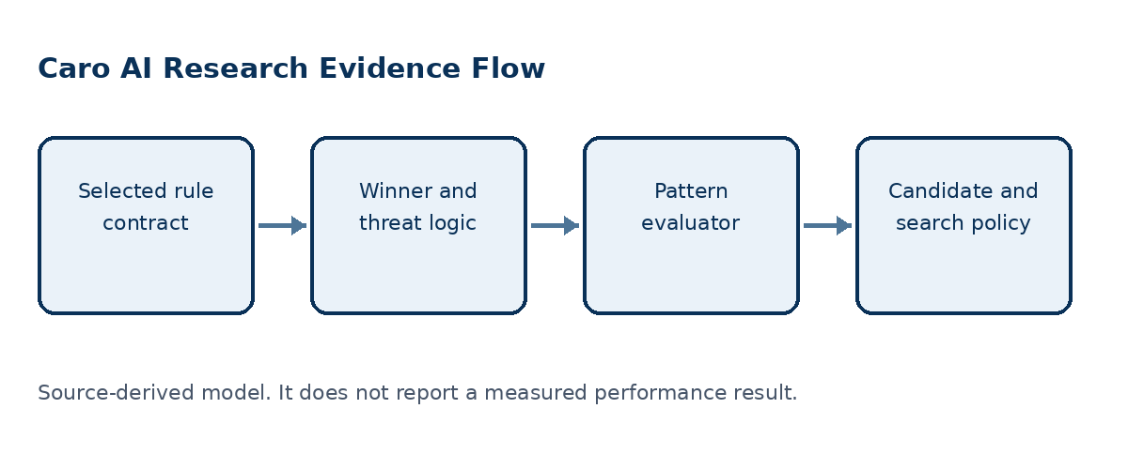
Figure 1. Rule semantics feed winner detection, tactical classification, evaluation, and search.

Core components

Component | Responsibility | Primary storage | Evidence limit
Rule profile | Defines exact-five, overline, and blocked-end semantics. | RuleConfig or WinRule | Wrong rule invalidates every downstream claim.
Board contract | Bounds the playable grid to rows and columns 0 through 14. | BOARD_SIZE = 15 | Out-of-bounds moves must be rejected.
TypeScript layer | Owns browser-facing bounds, UI events, and typed contracts. | Web application state | Must not fabricate engine statistics.
Rust/WASM boundary | Exposes compiled game functions through a worker interface. | WASM Game API | Binary provenance requires separate evidence.
Evidence register | Connects each report claim to source or external authority. | Google Document and Markdown report | Unlinked claims remain unverified.

5. Method and Evidence Lifecycle
- State the selected rule profile and accepted winning patterns.
- Define a finite 15 by 15 coordinate and occupancy contract.
- Classify observations as source evidence, external evidence, inference, or recommendation.
- Use the shared rule profile in winner, threat, pattern, and fixture definitions.
- Record the language/runtime boundary rather than claiming a performance outcome.
- Prepare fixed positions and configuration fields for future search experiments.
- Publish only conclusions that match the available evidence scope.

6. Source and Data Contracts

Traceability contract

Field | Type | Required | Description
Rule profile | Configuration | Yes | Must be named by every fixture and algorithm result.
Board size | Integer | Yes | Observed 15 by 15 UI and engine domain.
Cell state | Empty X O | Yes | Defines nominal state-space representation.
Move | Row column player | Yes | Requires bounds and occupancy validation.
Fixture ID | Identifier | For experiments | Connects a metric to a reproducible position.
Language boundary | TS worker WASM | Yes | Describes ownership, not a benchmark result.
Evidence class | A B C D | Yes | Prevents inference from being reported as observation.

Evidence guarantees

- Winner and threat conclusions use one named rule profile and the finite 15 by 15 bounds contract.
- A fixture records ordered moves, side to move, and rule profile so its state can be reconstructed.
- Each claim records a source path and symbol or an authoritative URL, plus its evidence class.
- The weekly register is a claim index; it is not raw engine telemetry or proof of performance.
The source-to-claim mapping is preserved in the companion Google Document and Markdown report for Week 01.
Companion source: Markdown report and native Google Document evidence narrative for Week 01.

7. Reproducibility and Validity

Rule choice is a reproducibility prerequisite: replaying the same coordinates under a different exact-five or overline policy can change terminal truth. The evidence register preserves claim provenance, while performance remains outside this report until controlled experiments are run.
Scenario | Expected behavior | Reasoning
Overline position | Result depends on selected rule profile. | Five-or-more and exact-five are distinct rules.
Blocked exact-five | Do not label it Caro until profile is selected. | Blocked-end behavior changes terminal truth.
UI versus engine claim | Report ownership separately. | TypeScript integration is not evidence of Rust performance.
Future benchmark | Use one fixture/configuration per observation. | Same input is required for a fair comparison.

8. Evidence Scope and Limitations

- No Rust-versus-TypeScript benchmark was found or run.
- The production WASM binary is not provenance-linked to sibling Rust source.
- No browser/device run establishes final visual or touch behavior.
- Current source proves Freestyle behavior in the examined TypeScript rule.
- Original weekly timing is not reconstructed as a fact.

9. Verification Status
Signal | Evidence | Status | Report gate
Source inspection | Relevant rule and board owners read | Completed | Required
TypeScript tests | 18 tests in 5 files | Passed | Supporting
TypeScript typecheck | tsc noEmit | Passed | Supporting
Rust test suites | caro-core-reference 9 passed; gomoku-main engine 22 passed; one unused-import warning | Passed with warning | Supporting
Evidence gaps | Browser, vendored WASM, and device condition is not established | Open | Required later
Evidence boundary: apply only the listed verification outcomes; untested environments remain unverified.

10. Alternatives and Research Options

Alternative | Why considered | Why not selected or limited
Freestyle Gomoku | Matches observed TypeScript rule. | Does not establish a Standard Caro report claim.
Exact-five rule | Removes overline wins. | Blocked-end policy remains a separate decision.
Blocked-ends Caro profile | Matches the formal Caro research question. | Must be specified and tested at board edges.
Language speed claim | Would strengthen the engineering narrative. | Requires a controlled benchmark that is absent.

11. Open Evidence Questions
- Which formal rule profile is the project evaluating?
- What edge behavior counts as a blocked end?
- Can the WASM binary be linked to a versioned Rust source build?
- Which fixed positions will form the shared fixture suite?

12. Decision References and Next Evidence
Adopt one written RuleSet contract before reporting bot strength or search efficiency. The report recommends shared rule fixtures across TypeScript integration and Rust-core tests. Key references: Gomocup official rules; Knuth and Moore (1975).

Evidence labels: [A] source observation; [B] authoritative external source; [C] inference; [D] recommendation.

