Caro AI Research Program

Week 02 Core Engine and Correctness Evidence

STATUS  Evidence reconstruction |  | OWNER  Nguyen Tam Duc |  | LAST UPDATED  18 September 2026

Authors | Nguyen Tam Duc
Reviewers | Course reviewer
Related docs | Week 02 Google Document and Markdown report
Scope | Recover an evidence-backed model of board state, legal moves, terminal evaluation, undo, and measurable core correctness.

1. Research Summary
This report studies the headless game core independently of visual presentation. The current TypeScript application has an explicit `GameState`, move validation, a controller-level transaction, and finite draw detection. A Rust reference core separately models an undoable fixed array board, turn, status, and rule configuration.
The report records what source inspection and executed TypeScript and Rust checks establish. The Rust suites passed separately, but this does not treat a typecheck or unit test as proof of the compiled vendored WASM binary, mobile interaction, or browser behavior.

2. Research Goals and Scope
Goals | Out of scope
Define one mutation boundary for legal moves. | Do not use rendering as evidence of core correctness.
Make win, draw, reset, and undo testable from fixtures. | Do not merge separate TS and Rust paths without a contract audit.
Record meaningful search statistics data fields. | Do not publish unmeasured performance values.
Separate source facts from execution results. | Do not treat separate Rust unit suites as proof of the vendored WASM binary.

3. Evidence and Problem Statement
A game core is trustworthy only when every move transition has an explicit validation and mutation boundary. The state must reject invalid input without partial mutation, record an accepted move once, evaluate terminal conditions using the selected rule, and support reset or undo semantics required by UI and search.
The examined web state uses a sparse keyed map plus move history. The Rust reference uses a fixed numeric board and an UndoToken. These are distinct implementation choices. The current evidence supports their ownership and API roles, not a general performance ranking.

4. Research Model and Source Ownership

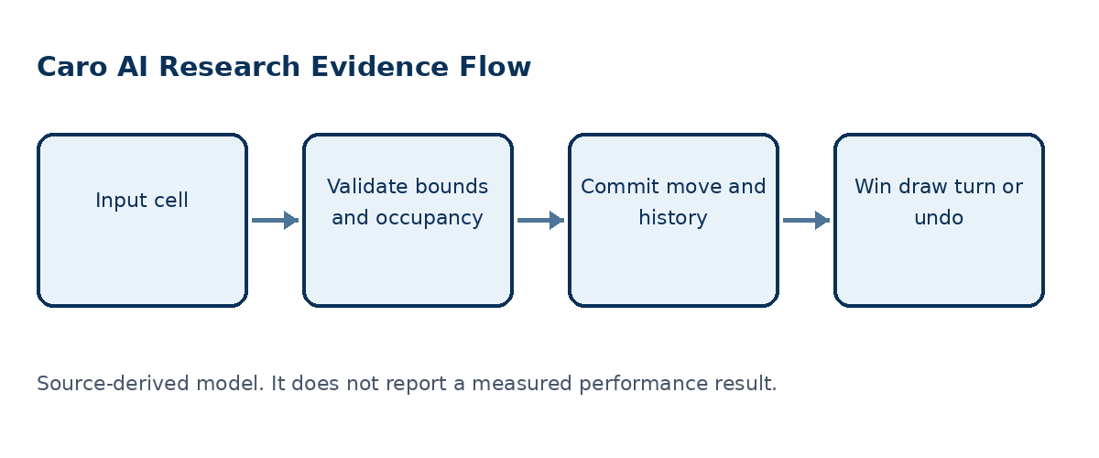
Figure 1. A move transaction must validate before mutation and make terminal state explicit.

Core components

Component | Responsibility | Primary storage | Evidence limit
GameState | Owns web-side board map, history, occupied bounds, and reset. | Private map and history | Rejects duplicate cell commit.
MoveRules | Checks out-of-bounds and occupancy. | Board bounds and state | Returns a typed rejection reason.
GameController | Advances round/turn and publishes snapshots. | GameState plus MatchController | Invalidates stale AI on reset or pause.
Rust reference state | Maintains fixed board, turn, status, and rule config. | Flat i8 board | Play returns error; undo restores token.
SearchStats | Defines nodes, cutoffs, candidates, TT hits, depth. | Per-search record | Needs runtime instrumentation to be measured.

5. Method and Evidence Lifecycle
- Receive a requested cell and current round context.
- Validate finite bounds and occupancy before a state mutation.
- Commit one move and append one history record.
- Evaluate a win only under the selected rule profile.
- Set a draw only when the finite board is full without a win.
- Switch player or record terminal state; search can use undo token.
- Publish a snapshot or a typed rejection without partial state.

6. Source and Data Contracts

Traceability contract

Field | Type | Required | Description
Cell coordinate | Row col | Yes | Must satisfy finite board bounds.
Move validation | Valid or reason | Yes | Rejects occupied and out-of-bounds moves.
Move history | Ordered moves | Yes | Reconstructs state and supports UI/WASM handoff.
Rule configuration | Profile | Yes | Controls terminal win interpretation.
Game status | Playing won draw | Yes | Prevents illegal continuation after terminal state.
Undo token | Prior state | Search path | Restores state after a simulated move.
Search statistics | Counts and depth | Experiment | Requires real engine-returned values.

Evidence guarantees

- Bounds and occupancy are validated before a committed move can change authoritative game state.
- Ordered move history and the active player identify the replay sequence and each state transition.
- A test/fixture must capture rule profile, board state, side to move, and expected terminal result.
- A report can summarize validation; it is not a substitute for runtime search statistics.
The source-to-claim mapping is preserved in the companion Google Document and Markdown report for Week 02.
Companion source: Markdown report and native Google Document evidence narrative for Week 02.

7. Reproducibility and Validity

Correctness depends on one authoritative state transition: validate first, commit once, derive terminal state, then expose a snapshot. Replays use ordered history and the same rule profile; rejected or duplicate moves must not create partial state.
Scenario | Expected behavior | Reasoning
Out-of-bounds input | Reject without mutation. | Bounds validation precedes commit.
Occupied cell | Reject without history update. | One board state must remain authoritative.
Winning move | Set terminal winner under RuleSet. | Winner logic is rule dependent.
Search branch | Undo exactly restores earlier state. | Independent branches require clean state.

8. Evidence Scope and Limitations

- The observed TypeScript test suite does not prove Rust or WASM behavior.
- Rust suites passed separately, but their source-to-vendored-WASM-binary relationship remains unverified.
- Browser/device acceptance is outside this core verification.
- The reference core is not proven to build the vendored WASM binary.
- No performance measurement is reported.

9. Verification Status
Signal | Evidence | Status | Report gate
State source audit | GameState, MoveRules, Controller, RuleConfig | Completed | Required
TypeScript tests | 18 tests in 5 files | Passed | Supporting
TypeScript typecheck | tsc noEmit | Passed | Supporting
Rust test suites | caro-core-reference 9 passed; gomoku-main engine 22 passed; one unused-import warning | Passed with warning | Supporting
Evidence gaps | Browser, vendored WASM, and device condition is not established | Open | Required later
Evidence boundary: apply only the listed verification outcomes; untested environments remain unverified.

10. Alternatives and Research Options

Alternative | Why considered | Why not selected or limited
Sparse keyed map | Fits UI-oriented occupied bounds. | Needs explicit coordinate conversion.
Flat fixed array | Fits finite search-state indexing. | Requires an adapter for UI-facing objects.
Controller-only rules | Simple short-term path. | Duplicates rule semantics across search/UI.
Shared RuleSet | One source for terminal truth. | Needs migration/fixture discipline.

11. Open Evidence Questions
- Which core is the canonical source for published experiments?
- How will rule fixtures be shared across TS and Rust?
- Which search statistics return from the engine?
- What build ID joins source, WASM artifact, and results?

12. Decision References and Next Evidence
Keep game-state mutation, rules, and metrics as separate named core responsibilities. The Rust reference and engine suites now pass separately; next establish a fixture manifest and source-to-binary build identity before using one canonical core as the stable basis for algorithm experiments.

Evidence labels: [A] source observation; [B] authoritative external source; [C] inference; [D] recommendation.

