Caro AI Research Program

Week 03 Web Integration and Execution Lifecycle

STATUS  Evidence reconstruction |  | OWNER  Nguyen Tam Duc |  | LAST UPDATED  18 September 2026

Authors | Nguyen Tam Duc
Reviewers | Course reviewer
Related docs | Week 03 Google Document and Markdown report
Scope | Trace Player-vs-Player and Player-vs-AI interaction through TypeScript lifecycle ownership, a worker boundary, and guarded WASM result commitment.

1. Research Summary
This report maps the visible request lifecycle from board input to state transition and, for AI turns, to a tactical pre-check and a Web Worker/WASM strategic request. The central result is an ownership mapping: the TypeScript controller owns round state, cancellation, token validation, and snapshot publication; the worker owns WASM initialization, history hydration, and response forwarding.
The evidence establishes the wiring and stale-result guards in source. It does not establish browser rendering, physical-device latency, or the internal algorithm/actual depth of the compiled WASM binary.

2. Research Goals and Scope
Goals | Out of scope
Trace UI input to a bounded core operation. | Do not treat a source flow as device acceptance.
Prevent an obsolete AI reply from mutating a new round. | Do not trust a worker result before validation.
Keep browser lifecycle in TypeScript and compute boundary explicit. | Do not claim WASM metrics that are not returned by the engine.
Record reproducible worker request/response fields. | Do not use static depth mapping as completed depth.

3. Evidence and Problem Statement
An asynchronous search response may return after pause, reset, mode change, difficulty change, or a new round. The application therefore needs a lifecycle owner that can invalidate work and re-check the context before committing a move. Web Worker examples in the wasm-bindgen guide illustrate asynchronous WASM initialization and message boundaries, but project-specific correctness still depends on the surrounding contracts.
The examined worker hydrates a WASM Game from move history and calls `ai_move`. It reports elapsed time, but maps a configured difficulty to static depth and zero nodes. Thus current telemetry is a wrapper label plus elapsed time, not evidence of real internal search depth or node count.

4. Research Model and Source Ownership

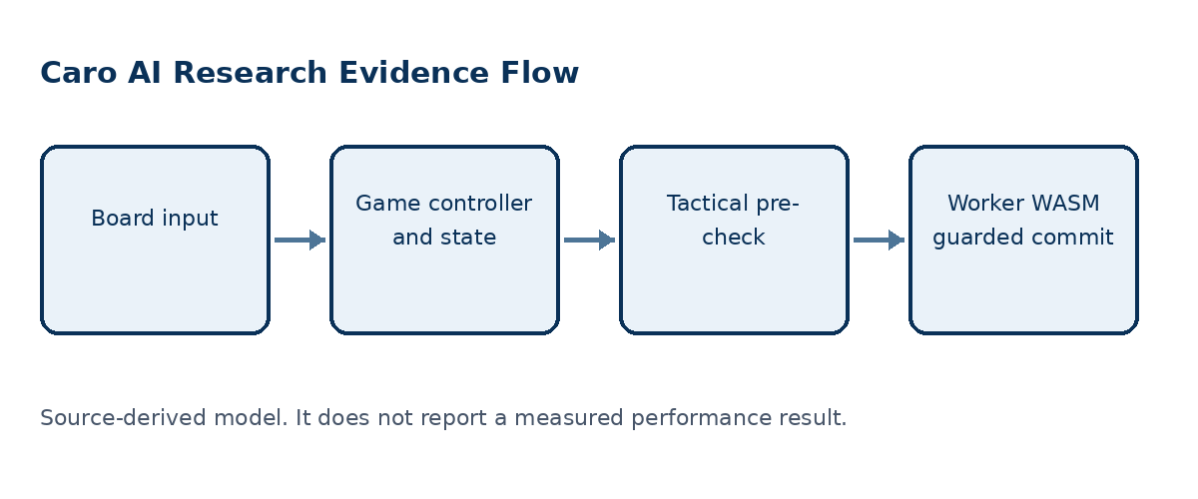
Figure 1. An AI result must pass round and lifecycle guards before it can mutate state.

Core components

Component | Responsibility | Primary storage | Evidence limit
GameController | Owns state, match, turn token, pause, snapshots, and AI commit guard. | App controller | Discards stale or invalid results.
AIController | Runs immediate win/block before strategic delegation. | AI service | Returns tactical move or engine promise.
WASM engine wrapper | Owns worker lifecycle and pending request cancellation. | Worker client | Cancels pending work on invalidation.
Worker | Initializes, hydrates, invokes ai_move, and posts result. | WASM Game instance | Returns an error message on worker failure.
Renderer | Consumes controller snapshot for board display. | Read-only snapshot | Must not own game truth.

5. Method and Evidence Lifecycle
- Player input reaches GameController.playCell.
- Controller validates and commits the human move through the core transaction.
- For an AI turn, controller captures token, round ID, difficulty, and history.
- AIController returns an immediate win/block or delegates strategic search.
- Worker initializes WASM, hydrates a Game from ordered history, and invokes ai_move.
- Worker posts a move result; controller checks token, round, phase, mode, pause, and player.
- Only a current valid response is committed and published as a new snapshot.

6. Source and Data Contracts

Traceability contract

Field | Type | Required | Description
requestId | Identifier | Yes | Correlates worker request and response.
roundId | Integer | Yes | Rejects a result from another round.
History | Ordered moves | Yes | Rehydrates the worker-side Game.
Difficulty | Named level | Yes | Maps to a WASM-facing numeric value.
Move result | Row col or null | Yes | Needs application-level validity guard.
Elapsed time | Milliseconds | Observed | Measured around worker invocation.
Depth and nodes | Search stats | For experiments | Current wrapper does not expose actual values.

Evidence guarantees

- Only a result matching the current token, round, phase, mode, pause state, and player may commit.
- Request IDs and ordered history correlate a worker request with its return and rehydrated state.
- Record worker-facing history, difficulty mapping, error path, and any build identifier before comparison.
- The renderer consumes snapshots; it does not become the source of truth for gameplay state.
The source-to-claim mapping is preserved in the companion Google Document and Markdown report for Week 03.
Companion source: Markdown report and native Google Document evidence narrative for Week 03.

7. Reproducibility and Validity

The user-facing contract is that stale, paused, wrong-round, or wrong-player AI results do not mutate current state. Worker work may finish after invalidation, but the controller guard makes that late result non-authoritative; browser and compiled-WASM runtime behavior still need direct tests.
Scenario | Expected behavior | Reasoning
Reset during search | Invalidate pending request. | Round state is no longer the same.
Pause during search | Do not commit result while paused. | Pause is a lifecycle boundary.
Late result | Discard if token or round differs. | A message receipt is not a valid move.
Tactical move found | Return before worker delegation. | Immediate safety is explicit in TypeScript.

8. Evidence Scope and Limitations

- No browser or target-device session was run in this reconstruction.
- Static reported depth is not a completed-depth measurement.
- Nodes are set to zero in the visible worker wrapper.
- WASM internal algorithm remains unproven by this wrapper alone.
- Visual and accessibility acceptance are outside the source checks.

9. Verification Status
Signal | Evidence | Status | Report gate
Lifecycle source audit | Controller, AI, worker, contracts | Completed | Required
TypeScript tests | 18 tests in 5 files | Passed | Supporting
TypeScript typecheck | tsc noEmit | Passed | Supporting
Browser and worker run | No CUA/runtime session performed | Not run | Required later
Evidence gaps | Browser, vendored WASM, and device condition is not established | Open | Required later
Evidence boundary: apply only the listed verification outcomes; untested environments remain unverified.

10. Alternatives and Research Options

Alternative | Why considered | Why not selected or limited
Direct UI search | Fewer message boundaries. | Risks blocking UI and mixing responsibilities.
Worker/WASM strategic engine | Separates compute from interaction. | Requires explicit telemetry and provenance.
Static depth labels | Simple UI display. | Cannot support experimental depth claims.
Engine-returned SearchStats | Supports reproducible evidence. | Requires a canonical engine interface change.

11. Open Evidence Questions
- Which engine build ID is returned with each result?
- Which cancellations reach the worker versus only the controller?
- How will actual depth and nodes cross the interface?
- Which browser/device matrix is required for acceptance?

12. Decision References and Next Evidence
Keep TypeScript as lifecycle and validity owner. Define one engine result contract that exposes actual stats, a rule profile, and a build ID. Pair the source evidence with a fixed-history worker harness before making UI responsiveness or algorithm-performance claims.

Evidence labels: [A] source observation; [B] authoritative external source; [C] inference; [D] recommendation.

