Caro AI Research Program

Week 04 Baseline Bots Patterns and Heuristics

STATUS  Evidence reconstruction |  | OWNER  Nguyen Tam Duc |  | LAST UPDATED  18 September 2026

Authors | Nguyen Tam Duc
Reviewers | Course reviewer
Related docs | Week 04 Google Document and Markdown report
Scope | Establish a reproducible baseline ladder from Random selection through rule-based tactics and pattern-aware heuristic evaluation.

1. Research Summary
This report recovers the bot foundations required before deeper game-tree experiments. The inspectable Rust reference includes a seeded Random policy, a rule-based immediate win/block policy, candidate-driven one-ply heuristic selection, pattern weights, and a SearchStats structure. The runtime TypeScript layer also performs an immediate win/block pre-check before strategic WASM delegation.
The report does not claim that all reference algorithms are currently the production strategic engine, nor does it present fabricated strength or speed measurements. It defines a controlled baseline and ablation plan instead.

2. Research Goals and Scope
Goals | Out of scope
Keep Random selection reproducible with state and seed. | Do not call random behavior a benchmark without a seed/protocol.
Make immediate win/block priorities inspectable. | Do not let tactical rule semantics drift from winner semantics.
Treat heuristic weights as parameters to evaluate. | Do not call a larger score table a stronger engine.
Prepare comparable search ablations. | Do not report speed/strength without raw outcomes.

3. Evidence and Problem Statement
A baseline is valuable only when it is repeatable and uses the same rule/profile/fixtures as the system it compares against. Random selection establishes a minimum policy. Rule-based tactics establish safety for immediate wins and blocks. A heuristic ranks candidates using pattern features, but its weights are assumptions until tests or experiments show their effect.
Alpha-Beta later benefits from high-quality candidate generation and move ordering; historical Go-Moku research also motivates selective threat-space methods. These ideas are future experimental treatments. The current Week 04 evidence is the availability of baseline components and an explicit measurement plan.

4. Research Model and Source Ownership

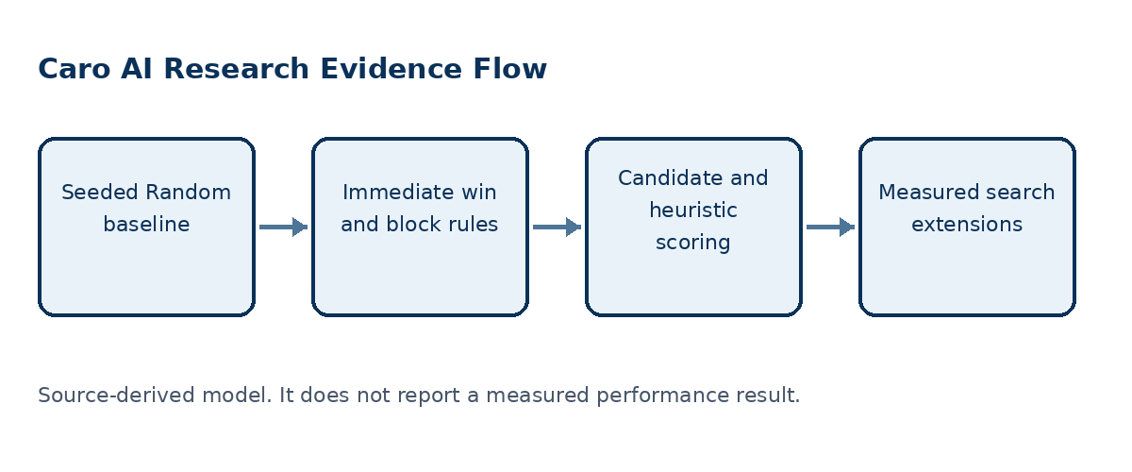
Figure 1. Each stronger policy must share rule fixtures with the baseline it is compared against.

Core components

Component | Responsibility | Primary storage | Evidence limit
Random baseline | Selects a legal move from seeded pseudo-random output. | SplitMix64 and legal moves | Returns no move if none are legal.
Rule-based bot | Checks own immediate win, then opponent immediate win. | Candidate moves and state | Falls back to heuristic selection.
Heuristic bot | Scores one simulated candidate at a time then undoes. | EvalWeights and candidates | Depends on rule-aware patterns.
Pattern evaluator | Weights five/four/three/two attack and defense features. | PatternCounts | Weights are not empirical outcomes.
Search statistics | Defines future nodes/cutoffs/TT/depth records. | SearchStats | Requires actual engine instrumentation.

5. Method and Evidence Lifecycle
- Load a fixed fixture, rule profile, side to move, and seed.
- Generate legal or candidate moves under the shared rule profile.
- Run Random or tactical rule-based policy as the chosen baseline.
- For heuristic policy, simulate one candidate, evaluate, and undo.
- Record chosen move and tactical outcome without changing fixture truth.
- For search variants, add one optimization at a time and collect actual metrics.
- Compare outcomes only on the same fixture/configuration/repetition protocol.

6. Source and Data Contracts

Traceability contract

Field | Type | Required | Description
Seed | Unsigned integer | Random baseline | Makes a random decision repeatable.
Candidate config | Radius cap policy | Yes | Controls which moves each policy may inspect.
Eval weights | Integer weights | Heuristic | Must follow selected rule semantics.
Fixture | Board plus side | Yes | Defines a reproducible test position.
Expected move set | Coordinates | Tactical tests | Allows more than one correct defensive move.
SearchStats | Counts depth time | Search variants | Required for performance conclusions.
Result class | Observed inference recommendation | Yes | States claim strength clearly.

Evidence guarantees

- Every baseline runs under the same named rule profile, fixture, side to move, and candidate policy.
- Seed, ordered fixture moves, configuration, and repetition number identify a reproducible trial.
- Record engine/build ID, policy version, fixture ID, metric definition, and raw outcome for each comparison.
- A heuristic score or a single game result is not by itself proof of playing strength.
The source-to-claim mapping is preserved in the companion Google Document and Markdown report for Week 04.
Companion source: Markdown report and native Google Document evidence narrative for Week 04.

7. Reproducibility and Validity

A comparison is valid only when fixture, rule profile, side, seed, budget, policy version, and metric definition are held or recorded. Randomness is repeatable through a seed; heuristic evaluation and search claims require raw outcomes rather than inferred strength.
Scenario | Expected behavior | Reasoning
Random replay | Same seed/state yields same selected move. | Baseline must be reproducible.
Immediate win | Rule bot chooses a terminal winning move. | Rule profile defines terminal truth.
Immediate block | Rule bot prevents opponent win where possible. | Tactical safety differs from strategic strength.
Ablation trial | Change one search mechanism only. | Metrics need a fair baseline/treatment pair.

8. Evidence Scope and Limitations

- No tactical-suite or head-to-head outcomes were measured here.
- Reference bots are not proven to be the production WASM strategic path.
- Five-or-more pattern scoring may not fit exact-five/blocked-ends Caro.
- No actual node, cutoff, or TT statistics return from the observed worker.
- Heuristic weight values are not calibration evidence.

9. Verification Status
Signal | Evidence | Status | Report gate
Baseline source audit | Random, rule, heuristic, evaluator, metrics | Completed | Required
Runtime tactical audit | AIController and TacticalMoveResolver | Completed | Required
TypeScript tests | 18 tests in 5 files | Passed | Supporting
Benchmark suite | Fixed fixture corpus not available | Not run | Required later
Evidence gaps | Browser, vendored WASM, and device condition is not established | Open | Required later
Evidence boundary: apply only the listed verification outcomes; untested environments remain unverified.

10. Alternatives and Research Options

Alternative | Why considered | Why not selected or limited
Random only | Simple minimum baseline. | No tactical safety or strategic comparison.
Rule plus heuristic | Inspectable staged baseline. | Weights still need validation.
Opaque WASM only | Existing strategic route. | Algorithm/metrics cannot be fully evidenced from wrapper.
Canonical instrumented engine | Enables ablations and calibration. | Requires source/interface discipline.

11. Open Evidence Questions
- Which engine is canonical for the thesis experiments?
- Which tactical fixture corpus is accepted?
- How are rule-sensitive patterns encoded?
- Which statistics and quantiles define a difficulty level?

12. Decision References and Next Evidence
Preserve seeded Random, rule-based, and one-ply heuristic policies as named baselines. Build a shared tactical corpus, instrument the canonical engine for real statistics, then run one-change-at-a-time ablations before making performance or playing-strength conclusions. Key references: Knuth and Moore (1975); Allis, van den Herik, and Huntjens (1996).

Evidence labels: [A] source observation; [B] authoritative external source; [C] inference; [D] recommendation.

