Caro AI Research Program

Final Caro AI Research Report

STATUS  Evidence reconstruction |  | OWNER  Nguyen Tam Duc |  | LAST UPDATED  18 September 2026

Authors | Nguyen Tam Duc
Reviewers | Course reviewer
Related docs | Weeks 01 to 04 Google Documents and Markdown reports
Scope | Synthesize Weeks 01 to 04 into one evidence-bounded account of rule semantics, engine correctness, web execution, and AI experiment design.

1. Research Summary
This final report synthesizes four research weeks for a Caro AI project. The evidence supports a clear separation of concerns: TypeScript owns the browser-facing application and lifecycle contracts, while Rust and WebAssembly represent an engine path whose runtime build provenance and performance remain to be demonstrated. The report therefore treats the work as a validated research foundation rather than a completed algorithm benchmark.
The central conclusion is methodological. A named rule profile, reproducible fixtures, one authoritative state transition, stale-result protection, and real engine telemetry are prerequisites for fair AI comparison. The report records what source inspection, TypeScript checks, and separately passing Rust suites establish, what remains an inference, and what needs a future controlled experiment.

2. Research Goals and Scope
Goals | Out of scope
Connect rule semantics, engine state, lifecycle, and baseline bots in one traceable research narrative. | Do not convert source observations into unmeasured speed or playing-strength claims.
Explain the TypeScript to Rust/WASM boundary without rewriting the project history. | Do not call Rust superior without a controlled same-fixture comparison.
Define the evidence needed for search, heuristic, and difficulty conclusions. | Do not use static wrapper labels as measured depth or node counts.
Prepare a reproducible next experiment rather than a speculative final result. | Do not imply browser, device, or compiled-engine tests were performed.

3. Evidence and Problem Statement
The original proposal named a TypeScript implementation. Current source inspection instead shows TypeScript at the web application and state/lifecycle boundary, alongside Rust reference/core source and a worker-mediated WebAssembly route. This is an architectural evolution, not evidence of a language-performance result. Any report must distinguish observed ownership from a benchmark conclusion.
Weeks 01 to 04 expose one dependency chain. Rule semantics determine terminal truth and tactical patterns; correct state mutation determines the positions an AI may evaluate; lifecycle guards determine whether an asynchronous answer may commit; reproducible baselines and instrumentation determine whether algorithms can be compared. Breaking any earlier contract invalidates later performance interpretation.

4. Research Model and Source Ownership

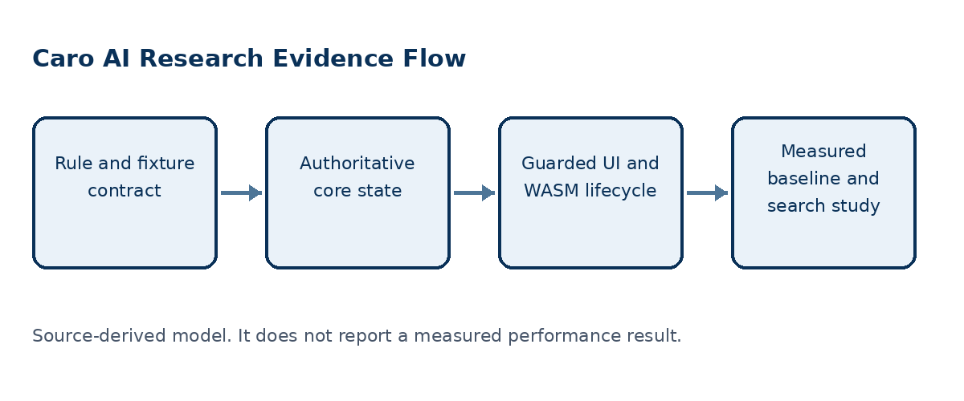
Figure 1. The final research pipeline moves from formal game definition to controlled, evidence-backed algorithm comparison.

Core components

Component | Responsibility | Primary storage | Evidence limit
Rule profile | Names exact-five, overline, and blocked-end terminal semantics. | RuleConfig or WinRule | A search result is invalid if its rule profile is implicit.
Core state | Validates and commits legal moves, history, terminal state, and undo. | GameState or Rust state | Correctness needs shared fixtures across implementations.
Application lifecycle | Owns rounds, pause/reset, turn tokens, worker requests, and commit guards. | GameController | Browser/runtime behavior remains a separate verification scope.
Baseline policies | Provides seeded Random, immediate win/block, and heuristic comparators. | Reference bot modules | Weights and policies are assumptions until measured.
Experiment record | Connects a fixture, build, policy, metrics, and raw outcome. | SearchStats and evidence log | The observed wrapper does not yet provide complete statistics.

5. Method and Evidence Lifecycle
- Choose one written rule profile and construct a shared fixture corpus.
- Validate bounds and occupancy before the canonical state commits a move.
- Preserve ordered history, side to move, terminal state, and reset or undo behavior.
- Route player input through the controller and discard stale or invalid AI responses.
- Run a seeded Random or rule-based policy as the selected reproducible baseline.
- Instrument the canonical engine with build identity and real search statistics.
- Compare one changed mechanism at a time and retain raw fixture outcomes.

6. Source and Data Contracts

Traceability contract

Field | Type | Required | Description
Rule profile | Named configuration | Yes | Defines the meaning of win, overline, and blocked ends.
Fixture | Board, side, ordered history | Yes | Makes tactical and replay checks reproducible.
Move transaction | Validated state transition | Yes | Rejects invalid input before mutation.
Lifecycle token | Round and turn identity | Web AI route | Prevents stale worker results from committing.
Engine identity | Build and source reference | Experiments | Required to connect a metric to the evaluated engine.
SearchStats | Nodes, cutoffs, candidates, time | Experiments | Must be actual engine-returned values.
Raw outcome | Per-fixture result | Experiments | Supports aggregate strength or latency claims.

Evidence guarantees

- Every conclusion carries its rule profile, implementation boundary, and evidence scope.
- A fixture and ordered history make a source observation or experiment replayable.
- A comparison identifies canonical engine build, policy version, metrics, and raw outcome.
- The final report is a synthesis of evidence; it is not a substitute for runtime benchmark data.
The source-to-claim mapping is preserved in the companion Google Document and Markdown report for the final synthesis.
Companion sources: the Week 01 to Week 04 Google Documents and their Markdown research reports.

7. Reproducibility and Validity

The final claim boundary is deliberately conservative. Source inspection and passing TypeScript checks support the identified contracts, but a performance or playing-strength statement requires one canonical build, shared rule-sensitive fixtures, real engine telemetry, and a recorded protocol. Late asynchronous work may complete, but lifecycle guards must keep it non-authoritative after invalidation.
Scenario | Expected behavior | Reasoning
Rule-sensitive win | Same coordinates are evaluated under the named profile. | Terminal truth must be explicit before scoring patterns.
Invalid move | Occupied or out-of-bounds input changes no authoritative state. | A search or UI retry cannot create partial history.
Stale AI response | Wrong-round, paused, or reset response is discarded. | Asynchronous work is non-authoritative after invalidation.
Ablation experiment | One algorithm mechanism changes on the same fixture protocol. | Observed metrics remain attributable to a defined treatment.

8. Evidence Scope and Limitations

- No controlled TypeScript versus Rust performance benchmark was executed.
- Rust source-to-WASM-binary provenance is not established by the inspected wrapper.
- Rust suites passed separately, but this does not establish the source-to-vendored-WASM-binary relationship.
- Browser, device, audio, and production-runtime acceptance were not performed.
- The observed worker exposes mapped depth and nodes equal to zero, not complete measured search telemetry.

9. Verification Status
Signal | Evidence | Status | Report gate
TypeScript unit tests | 18 tests across 5 files in 10_caro | Passed | Supporting
TypeScript typecheck | Project typecheck command | Passed | Supporting
Rust test suites | caro-core-reference 9 passed; gomoku-main engine 22 passed; one unused-import warning | Passed with warning | Supporting
Controlled algorithm benchmark | Shared fixtures and real telemetry are absent | Not run | Required later
Evidence gaps | Browser, vendored WASM, and device condition is not established | Open | Required later
Evidence boundary: apply only the listed verification outcomes; untested environments remain unverified.

10. Alternatives and Research Options

Alternative | Why considered | Why not selected or limited
Treat the current UI wrapper as the whole engine | Fastest report path. | Does not establish internal algorithm or metric provenance.
Claim a Rust replacement is automatically faster | Matches a common implementation narrative. | No controlled benchmark or binary provenance supports it.
Use only heuristic score tables | Easy to demonstrate. | A score table is not evidence of strength or calibration.
Instrument one canonical engine and compare named baselines | Connects algorithms to repeatable evidence. | Requires fixtures, build identity, and execution time.

11. Open Evidence Questions
- Which exact rule profile is the thesis target?
- Which engine build is canonical for experiments?
- Which tactical corpus and repetition protocol are accepted?
- Which observed statistics define a difficulty or strength claim?

12. Decision References and Next Evidence
The final decision is to treat the current project as a research-ready foundation, not a completed performance study. Retain TypeScript for application-facing contracts and lifecycle control; define one canonical engine build; share rule-sensitive fixtures; return real SearchStats; and run reproducible, one-variable-at-a-time comparisons before reporting search efficiency, playing strength, or a TypeScript-to-Rust performance conclusion. Key references: Gomocup official rules; Knuth and Moore (1975); Allis, van den Herik, and Huntjens (1996); wasm-bindgen worker guidance.
Milestone | Deliverable | Exit criteria
M1 | Rule and fixture contract | One formal profile plus edge-case tests.
M2 | Canonical engine and telemetry | Build ID and real statistics returned.
M3 | Ablation benchmark | Raw fixture results and comparison protocol saved.
M4 | Thesis evidence chapter | Every claim links to source or raw result.

Evidence labels: [A] source observation; [B] authoritative external source; [C] inference; [D] recommendation.

