Wildcrown Arena and Cooperative PvE
  - Formation combat and 9v3 dungeons
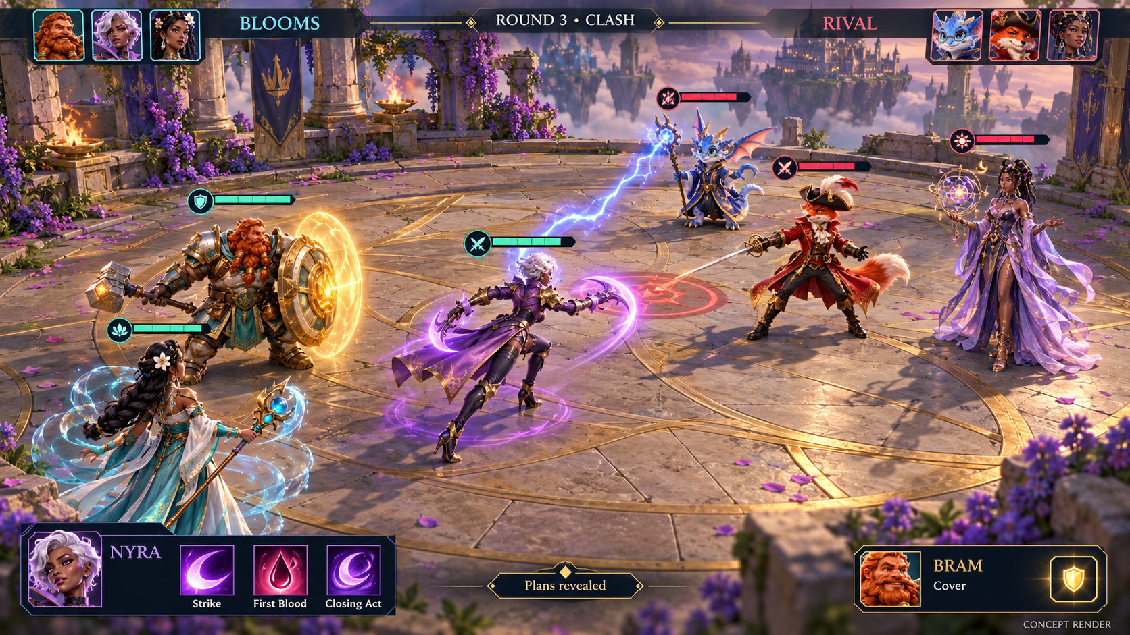
Concept screen 1. Revised 3v3 Arena with separated formations, an angled camera and compact ability controls.
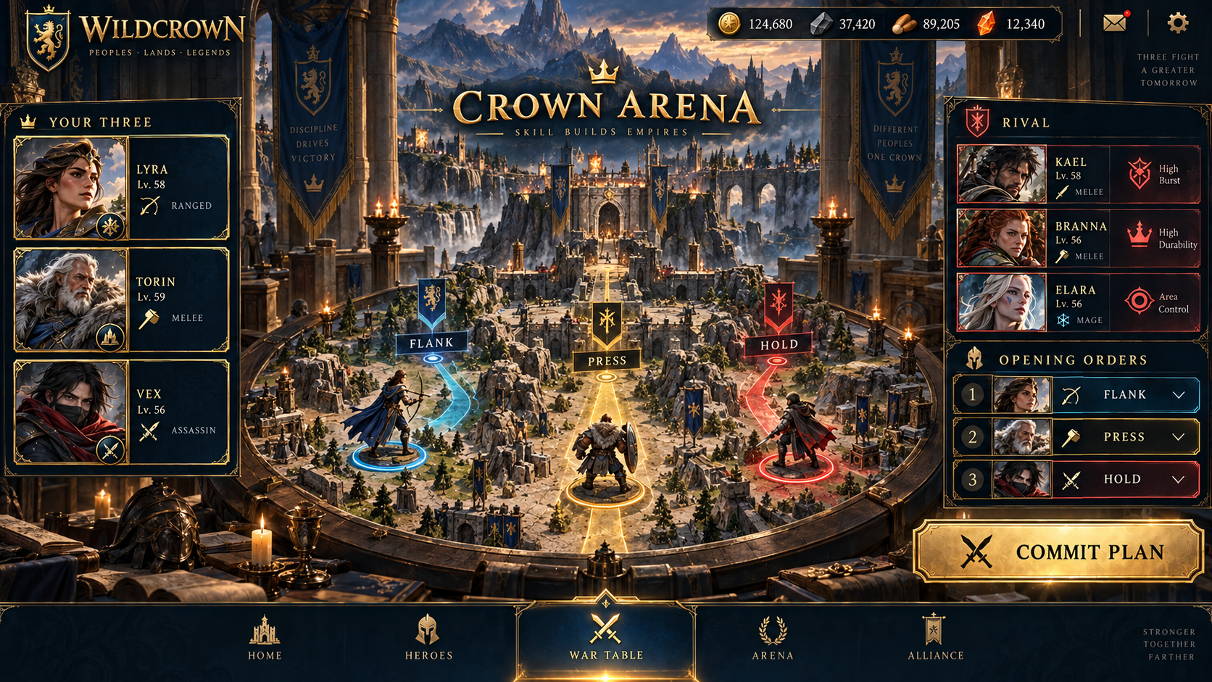
Arena War Table prototype. Selected UI direction 1.
Design handoff. Version 1.0 | 30 September 2026 | For the lead designer and prototyping engineers.
Recommendation. Adopt a pulled-back, angled formation view for 3v3 Arena and prototype a shared cooperative PvE encounter with three players bringing three heroes each. Nine allied heroes face three computer-controlled enemies. Each enemy attack threatens every surviving player squad.
Purpose. Establish the visual direction, ownership model, proposed round rules, example encounter and test plan. The two embedded screens illustrate intended presentation. Combat values and timings are prototype settings that require testing.
Continuity. Owned hero and gear strength continues to matter. Governor commands remain exclusive to March combat. This document specifies the new cooperative encounter direction alongside the existing Arena design.

One shared cooperative battlefield
  - Three players control nine heroes against three shared enemies
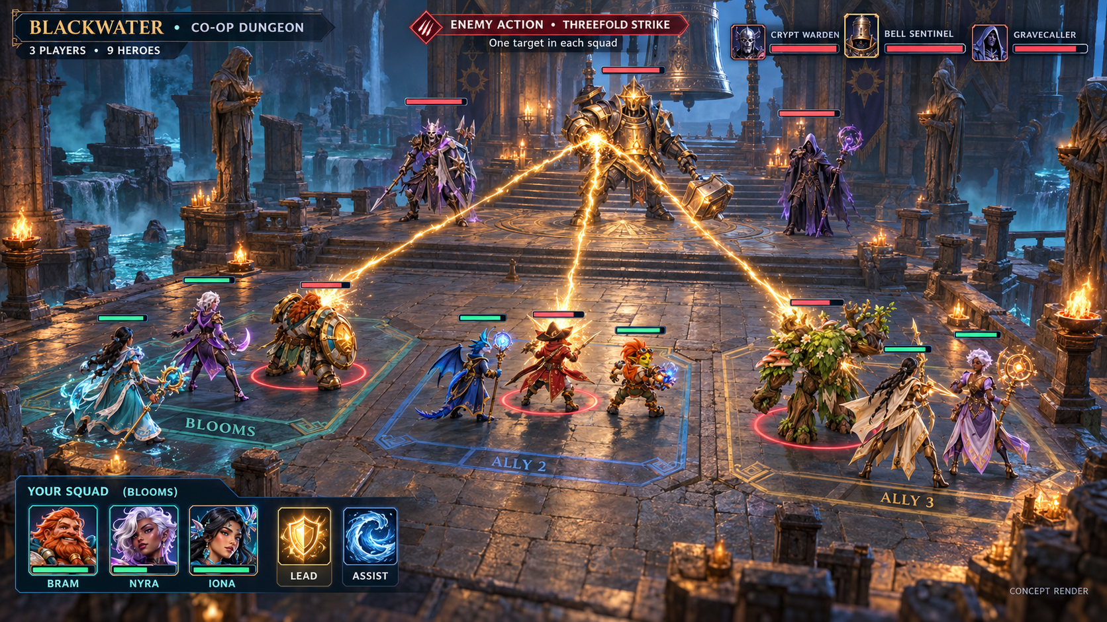
Concept screen 2. One enemy ability branches into three strikes inside a single 9v3 cooperative battle.
Ownership. Blooms controls Bram, Nyra and Iona. Ally 2 controls Rook, Volt and Pip. Ally 3 controls Moss, Sable and Astra. These are illustrative lineups; the mode does not require those exact heroes or a prescribed class combination.
Shared state. The three enemies exist once, with three individual health pools shared across the party. Damage, approved debuffs and enemy deaths are visible to everyone. Each allied hero still has its own health, cooldowns and owner.
Incoming pressure. The pictured Threefold Strike has one target in each squad: Bram, Rook and Moss. Shields and other defenses are calculated separately for each target. A clearly signaled area attack may instead threaten all nine allied heroes.
Readable controls. Only the local squad has full action controls. Other squads show ownership, health, status and ready indicators. The screen is a concept; final UI must retain the original character identities and distinguish friendly health from enemy targeting markers.

Design decisions and presentation
  - Preserve the founder direction while making prototype assumptions explicit
Confirmed direction. Use a formation-based hero RPG presentation inspired by the user’s Raid reference. Add a PvE mode with three players, three heroes per player and three computer-controlled opponents. Enemy moves attack each player’s squad.
Camera and staging. Use a stable elevated three-quarter camera behind the friendly side. Show the floor, formation spacing and all relevant targets. Begin around 30–40 degrees downward for 3v3 and test a more elevated, wider view for 9v3. These are art-blockout settings, not fixed production camera specifications.
Animation. Heroes occupy presentation slots. A lead may step or dash forward for its attack, then return. Camera movement and attack animation must not determine damage order. Maintain a reduced-motion option and avoid cuts that hide another squad’s incoming attack.
Interface. Keep enemy health, squad ownership, selected targets, energy and the planning deadline readable. Use symbols and labels as well as colors. Display allies’ planned lead, assist and target in PvE so players can coordinate; each player retains control of their own plan.
Status | Rule
Confirmed | Three human squads of three heroes; one enemy team of three; pressure on every squad.
Proposed | Retain one lead and one assist per player per round, with simultaneous party planning.
Proposed | Ordinary attacks hit one hero per surviving squad; designated area attacks hit every living hero.
Proposed | Use shared enemy conditions and a small set of explicit cross-squad support options.
Open | Final enemy action budget, revive policy, encounter difficulty bands, timing and reward profile.

A round in the hands of three players
  - Parallel planning preserves the pace of a small Arena match
Player actions. Each participant chooses one living lead, an available lead ability and its target, plus a different living hero’s available assist or Brace. The third hero remains targetable and available to act in later rounds. A player with one survivor can still attack and Brace.
Independent resources. Each squad has its own energy pool and hero cooldowns. Start the prototype with the existing pool rules: 3 starting energy, 2 restored after a nonterminal round and a cap of 5. There is no shared party energy bank. Snapshot owned loadouts on encounter entry.
Enemy action budget. For the first fixture, the enemy team chooses one lead attack and at most one supporting action from a different living enemy. Its third member remains a future lead or assist. The lead attack creates one damage branch per surviving squad. Multiple enemy lead actions per round are a later difficulty variant with an explicit budget.
Timing. Propose 20 seconds for planning and approximately 4 seconds for reveal and resolution. All three accepted locks can resolve early. Aim for 8–12 rounds and a 4–6 minute encounter including transitions; these are targets to measure, not established results.
Stage | Authoritative behavior
Prepare | Freeze round-start state. Commit the enemy plan and show its attack type and intended targets.
Plan | Players select their own lead, assist and targets concurrently. Allies can inspect and discuss intentions.
Commit | Validate all plans against the same snapshot. Lock targets, spend energy and set cooldowns once.
Support | Resolve approved debuffs, cleanses, healing, shields and wards before calculating damage.
Clash | Calculate all committed attacks, then apply health losses and deaths as one batch.
Reset | Clear temporary effects, evaluate the outcome, recover energy if continuing, and start the next round.

Targeting and effect scope
  - Define squad and party effects before extending the combat resolver
Enemy targeting. A normal enemy attack selects one living hero independently in each nonempty squad. Threefold Strike targets the highest-current-HP hero in each squad at round start, breaking ties by slot order. Show these targets before players commit. Healing during the round does not reroll the target.
Shared defenses. Enemy shields are finite amounts on a shared enemy, consumed once by aggregate incoming damage. Do not copy the full shield into each attacker’s calculation. Preserve each attack’s piercing amount, then aggregate shield-eligible damage and consume the shared shield once. A ward caps total post-shield loss for that recipient across the clash.
Shared debuffs. Store one combined, capped debuff state on each enemy. Expose modifies each applicable primary hit, so coordinated focus can amplify its value. Weaken on the acting enemy modifies each primary branch of its attack. These interactions need PvE tuning; a three-player encounter cannot inherit every PvP value without review.
Scope | Meaning | Prototype restriction
Self | The acting hero only. | No implied transfer to teammates.
Squad | The owner’s three heroes. | Existing team-wide heals and shields stay within this scope.
Cross-squad | One eligible hero belonging to another participant. | Only an explicitly supported ability can select this target.
Party | All living heroes across the three squads. | Reserved for expressly labeled effects; no automatic expansion of squad abilities.
Enemy team | The three shared enemies. | Area attacks hit each living enemy once, not once per human squad.
Per squad | One selected living target in each nonempty squad. | Skip an empty squad; do not redirect its strike into another squad.

Blackwater encounter fixture
  - A protector and a healer create shared target priorities
Encounter. The Bell Sentinel, Crypt Warden and Gravecaller defend the monastery. All three are opponents with shared, visible health. Each can take the lead in a later round; the first fixture uses one enemy lead and one enemy assist per round.
Opening problem. The Sentinel uses Threefold Strike while the Warden assists with Aegis. The party can attack the Warden to prevent future shields, attack the Gravecaller to prevent later healing, or spend more resources to pressure the Sentinel immediately. Change the enemy’s schedule through public health and survival conditions.
Coordination. Players see each other’s intended targets and can agree on a priority. Shared damage and debuffs create a reason to coordinate burst. Each squad must still protect its own incoming target. A stronger account contributes more damage without automatically absorbing the other squads’ attacks.
Worked arithmetic. For a resolver fixture only, let Threefold Strike deal 40 raw damage per squad. Local shields of 15, 10 and 0 produce health losses of 25, 30 and 40. Separately, three player attacks of 50, 60 and 40 into a shared 30-point Sentinel shield cause 120 total health loss. This example excludes pierce, wards and other modifiers; the values are test data, not production balance.
Committed support. If the Warden was alive at round start, its accepted shield still resolves even if the same clash defeats it. Removing the Warden stops its future actions. Animation must not imply that killing it early cancelled an already committed assist.
Enemy | Illustrative lead action | Illustrative assist
Bell Sentinel | Threefold Strike: one marked target in every nonempty squad. | A defensive effect on one living enemy.
Crypt Warden | A strike against one target in every nonempty squad. | Aegis: shield one enemy for the current clash.
Gravecaller | A clearly signaled area spell against all living allied heroes. | Reknit: restore one living enemy before damage.

Cooperation and power progression
  - Make coordination useful while preserving owned strength
Cooperative decisions. Start with three things players can influence together: which enemy to remove first, when to combine primary attacks with a shared debuff, and when to preserve energy for a signaled threat. These decisions should affect the outcome visibly in the combat recap.
Cross-squad experiment. Test one approved variation in which Bram’s Cover can protect a single hero in another squad using the same assist action slot. Compare it with own-squad-only support. Label the PvE override clearly, keep it outside PvP, and do not add an extra free party action. Broader cross-squad support follows evidence from this test.
Investment. Use owned hero and equipment strength. Players choose a published difficulty tier and receive a recommended team-strength range before entry. The encounter’s parameters remain fixed for that tier and version; an upgrade should not trigger an invisible enemy rescale. A powerful friend can help weaker members progress.
Fair access. Pressure on every squad does not itself guarantee fair difficulty. Test mixed-strength parties for unavoidable deaths, excessive carrying and whether weaker players have useful choices. Match recommendations should consider each selected squad, not only the party’s combined power.
Tuning. Measure damage, healing, prevention, shared-debuff amplification, rounds to defeat and decision quality. Tune enemy health, outgoing pressure, action budget and support caps together. Simply tripling enemy health will not establish balance. Keep PvE encounter parameters separate from ranked PvP configuration.
Combat enjoyment. Hidden choices and complex bosses cannot guarantee resistance to automation. Test whether players voluntarily replay without rewards and whether changing targets or defense plans improves results. Optional routine PvE autoplay remains a separate product decision; the first live co-op test uses manual choices.

Runtime contract and recovery
  - One authoritative encounter with explicit ownership and outcomes
State. Store encounter ID and version, ruleset, difficulty tier, three participant seats, squad IDs, hero instances and loadout snapshots, the three enemy instances, round snapshot, accepted plans, enemy intent, combat events and outcome. Every command includes its owner, round and idempotency key.
Authority. Validate hero ownership, distinct lead and assist, living targets, scope, energy and cooldowns on the server. AI narrative text and clients cannot set damage or outcomes. Record the selected targets before resolution so a reconnect cannot reroll them. All accepted attacks by round-start survivors still resolve.
Deadline fallback. If a participant misses the deadline, use its last complete legal submitted plan. If none exists, select that squad’s highest-HP living hero, Strike the lowest-HP living enemy and Brace; ties use stable slot order. Show that the fallback was used. It grants no extra decision or intelligent substitute teammate.
Disconnection. For the private prototype, allow one shared 60-second reconnect pause at a planning boundary per encounter. Resume the saved state and remaining planning time. If the player does not return, continue with the documented fallback; other participants can leave. Repeated disconnects do not create more pauses. Real reward eligibility for inactive seats must be defined before a rewarded release.
Eliminated squads. A squad with no living heroes submits no actions. Its incoming attack branch is skipped, while enemies retain their remaining health. The eliminated player can watch and send pings. Revives are outside the first fixture and require a separate rule if later added.
Outcome. After the full clash, victory requires all three enemies defeated and at least one allied hero alive. All allies defeated is a PvE failure, including mutual elimination. Otherwise continue. Use a proposed 20-round cap: resolve round 20 and check victory before failing an unfinished encounter. Do not import PvP overtime damage automatically.
Receipts. The initial tests use fictional rewards. A future rewarded version issues each eligible account one result receipt per encounter, with idempotent claims. No creator or host may choose a different payout after the battle has begun.

Integration with adventures and March
  - Use the shared battle as the cooperative dungeon finale
Adventure revision. For adventures that use this mode, use three participants and one optional nonplaying host. A March chapter gives each participant one formation; the regroup checkpoint stops March simulation before all three enter the shared 9v3 hero battle. Governor commands stop at that boundary.
Design precedence. This is the new proposed combat module for the Blackwater adventure. It supersedes that module’s earlier four-player, four-parallel-Arena proposal and its three-of-four victory rule. The earlier Adventures document remains a separate artifact; its creator tools, publishing controls and bounded hosting still apply where compatible.
Story consequences. The party’s earlier choice can select a reviewed encounter variant, reveal a target priority or provide a bounded modifier. Rescue may supply the guide’s tactical information; sabotage may remove one hazard; bargaining may grant one approved support effect. All variants must remain playable with the supported hero roster.
Three-player voting. Propose three equally weighted private ballots, a quorum of two valid option ballots and resolution at the deadline by plurality. A tie gets one short runoff, then the published always-legal fallback. A ballot cannot spend another player’s permanent inventory. Quorum loss pauses the decision and offers save-and-exit if reconnection fails; the host has no extra vote.
Authoring controls. Creators select three approved enemy definitions, encounter tier, target policies, limited phase triggers, story modifiers and reviewed endings. They can write narrative context while the engine resolves combat. Arbitrary damage scripts, new currencies and unreviewed power changes remain outside the initial authoring module.
Hosting and rewards. Live hosts operate within the published intervention budget. Once combat plans are committed, they cannot add enemies, change targets, reverse damage or alter rewards. The encounter version and any permitted interventions are recorded. Sandbox adventures keep permanent progression rewards off; reviewed rewards remain subject to the existing economy controls.

Prototype plan and acceptance gates
  - Prove readability and cooperation before expanding the mode
First build. Create a greybox 3v3 camera comparison and one deterministic Blackwater 9v3 fixture. Add three real player seats, simultaneous planning, one shared enemy team, the per-squad attack adapter and a combat recap. Reuse existing hero definitions and owned-stat inputs where supported.
Study. Use six groups of three players, including midcore and experienced players, on representative phones and tablets. Counterbalance the order of variants and compensate participants independently of wins or replays. The thresholds below are proposed direction checks for a small study, not statistically validated benchmarks.
Required correctness. Verify that Threefold Strike produces one branch per nonempty squad; two players cannot command the same hero; a shared shield is consumed once; squad healing never silently reaches nine heroes; committed attacks survive same-round deaths; eliminated-squad strikes do not retarget; and reconnects cannot duplicate damage, costs or result receipts.
Next decision. The lead designer should confirm the player and enemy action budgets, public enemy intent, effect scopes, cross-squad support and loss conditions. The engineering lead should estimate the resolver, networking and mobile UI changes. Expand to public matchmaking, additional bosses and real rewards after this fixture demonstrates value.
Test | Question | Proposed continuation signal
Readability | Can players identify ownership, targets and pending attacks on mobile? | At least 15 of 18 correctly identify their trio and all threatened squads without explanation.
Cooperation | Does shared planning change play? | At least 4 of 6 groups make an observed, useful coordination decision and can explain it.
Support scope | Does one cross-squad assist improve the experience? | Players understand its target scope; preference and success justify the extra targeting step.
Pacing | Does simultaneous input keep three-person play moving? | At least 15 of 18 complete a legal plan within the deadline by their third round.
Power spread | Can mixed-strength parties contribute meaningfully? | Each cohort has viable defensive choices; no unavoidable first-round wipe inside the advertised band.
Replay | Is combat enjoyable beyond progression rewards? | At least 12 of 18 voluntarily choose another unrewarded encounter; investigate reasons by cohort.

