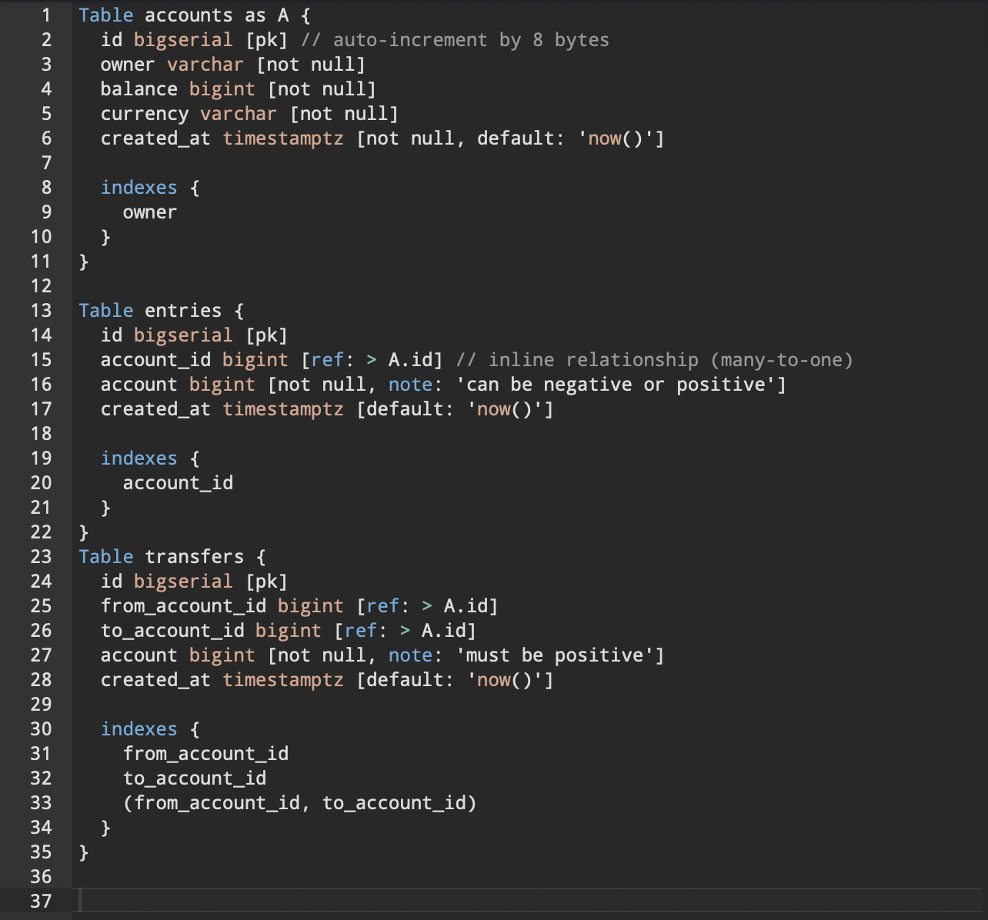

<https://dbdiagram.io/d/629d701354ce26352764a0ec>

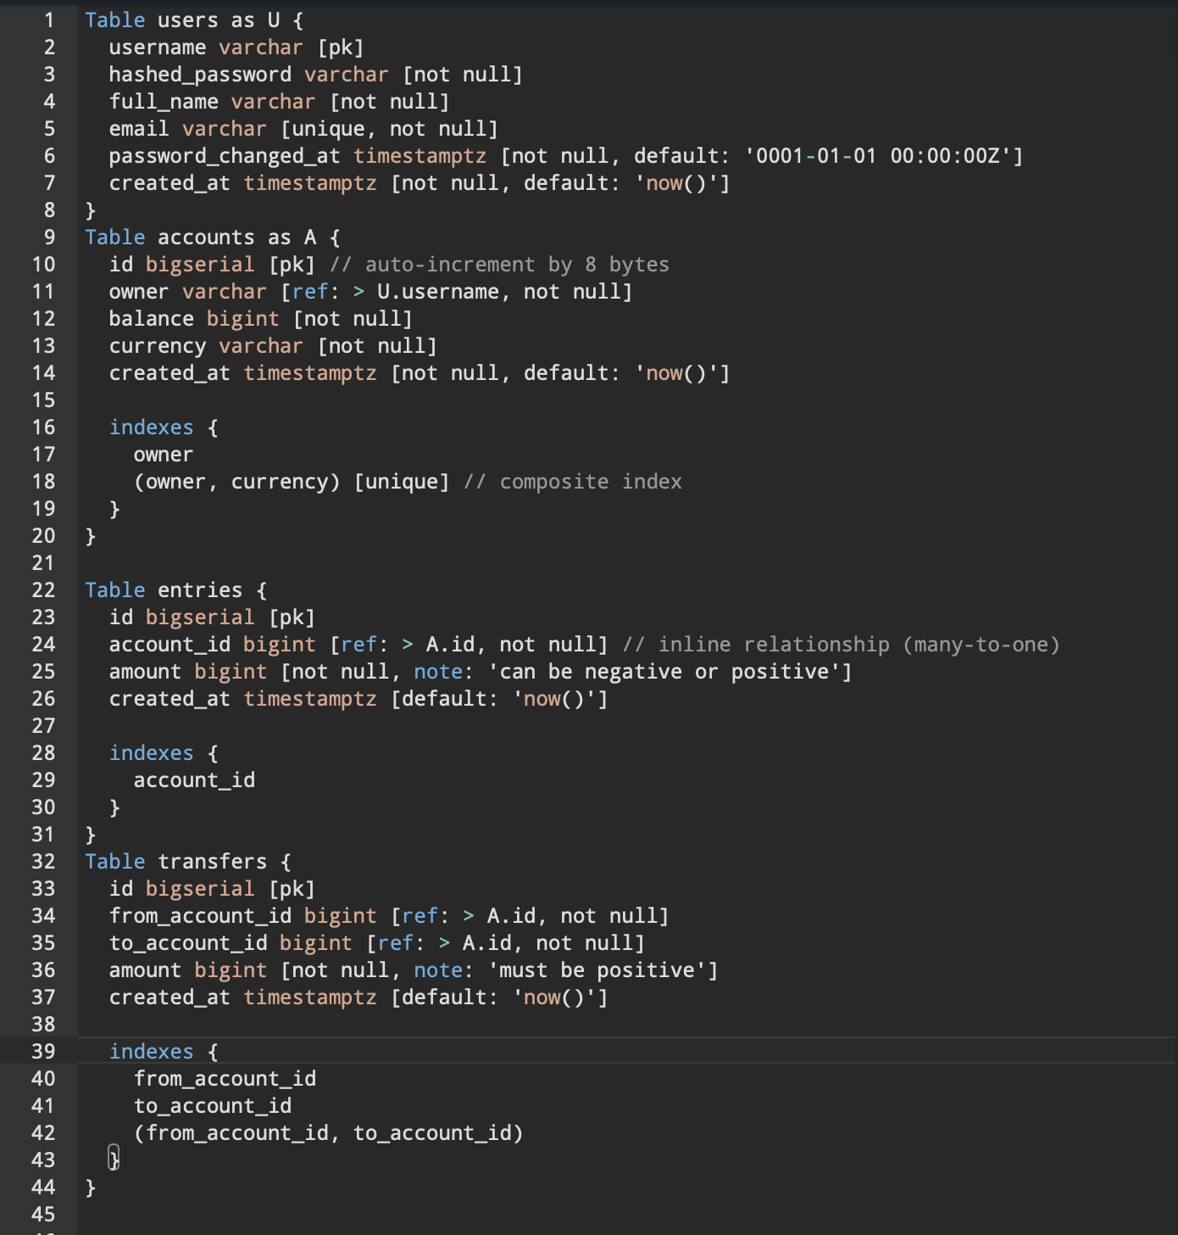

https://dbdiagram.io/d/629d701354ce26352764a0ec