Review for the Final Exam—Math 121, Revised for Spring 2008

You will be allowed a 4x6 index card for the final. The following is a summary of topics covered and should be viewed as a sampling only. There is a sample final also posted on this web site. You will NOT be allowed to use any graphing calculator as an aid on this final.
To be prepared for the final exam, you need to know how to:

- Solve linear, quadratic, rational, radical, exponential and logarithmic equations.

- Solve systems of linear and non-linear equations.

- Solve linear inequalities including writing the answer in interval notation and graphing the solution set on the
real number line.

- Solve applications involving:
- Perimeter and area of rectangles, circles and triangles.
- Interest and percentages.
- Revenue and cost,
- Finding linear relationship between two variables,
- Points on graphs and the distance formula.
- Finding the maximum (or minimum) value of a function,
- Exponential and logarithmic equations and
- Exponential growth and decay.

- Work with the Cartesian plane and use the distance formula (everywhere).

- Work with graphs of equations including:
- The definition of the graph of an equation and
- Intercepts of graphs,
- Graphs of circles

- Understand linear equations in two variables including:
- How to recognize a linear equation,
- Finding the slope of a line,
- Slope-intercept and general form of the equation,
- Vertical and horizontal lines, and
- The relationship between parallel and perpendicular lines.

- Understand functions including:
- Using function notation,
- Recognizing the graph of a function using the vertical line test,
- Understanding and reading the graph of a function,
- Domain and range,
- Finding and describing where functions are increasing and decreasing,
- Finding the local maximum (or minimum) value of a function,
- Even and Odd functions,
- Composition of functions
- How to construct functions
- Determine whether a function has an inverse, and find it in simple cases (including exponential and logarithmic functions)

- Know your library of functions including

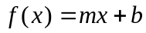 | 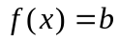 | 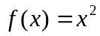 | 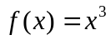 | 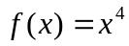
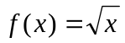 | 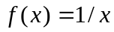 | 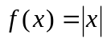 | 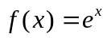 | 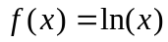
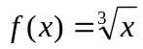 | 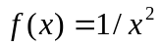 | 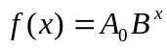 | 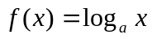

You need to know:
- Their graphs (b) Their domains and ranges (c) How to graph transformations of them

- Know how transformations work in general (Table on page 269)

- Analyze the graphs of specific kinds of functions, including:
- Quadratic functions. Know how to find the vertex, axis of symmetry, and intercepts and relate these to transformations of 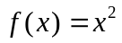
- Polynomial functions. Know how to find intercepts, analyze behavior at x-intercepts and end behavior and graph transformations of power functions such as and .
- Simple rational functions. Know how to find vertical and horizontal asymptotes and domain in particular, graph transformations of 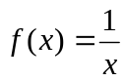, and include the asymptotes in your graph.

- Work with the following formulas.
- Distance formula.
- Midpoint formula
- Use the slope formula to find the average rate of change of a function.
- Slope-intercept form of a linear equation
- Quadratic formula.
- Revenue formula.
- x-coordinate of the vertex of a parabola. (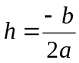)
- Perimeter and area of rectangle, triangle and circle.
- Standard form of the equation of a circle
- Exponential growth and decay 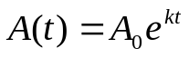

13. Work with properties of logs (On pages 442-443).

