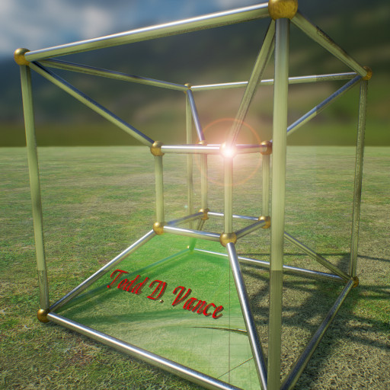

Circuit Fall
Game Design Document Version 0.9
Solve satisfiability in Internet time
© 2016 Todd D. Vance
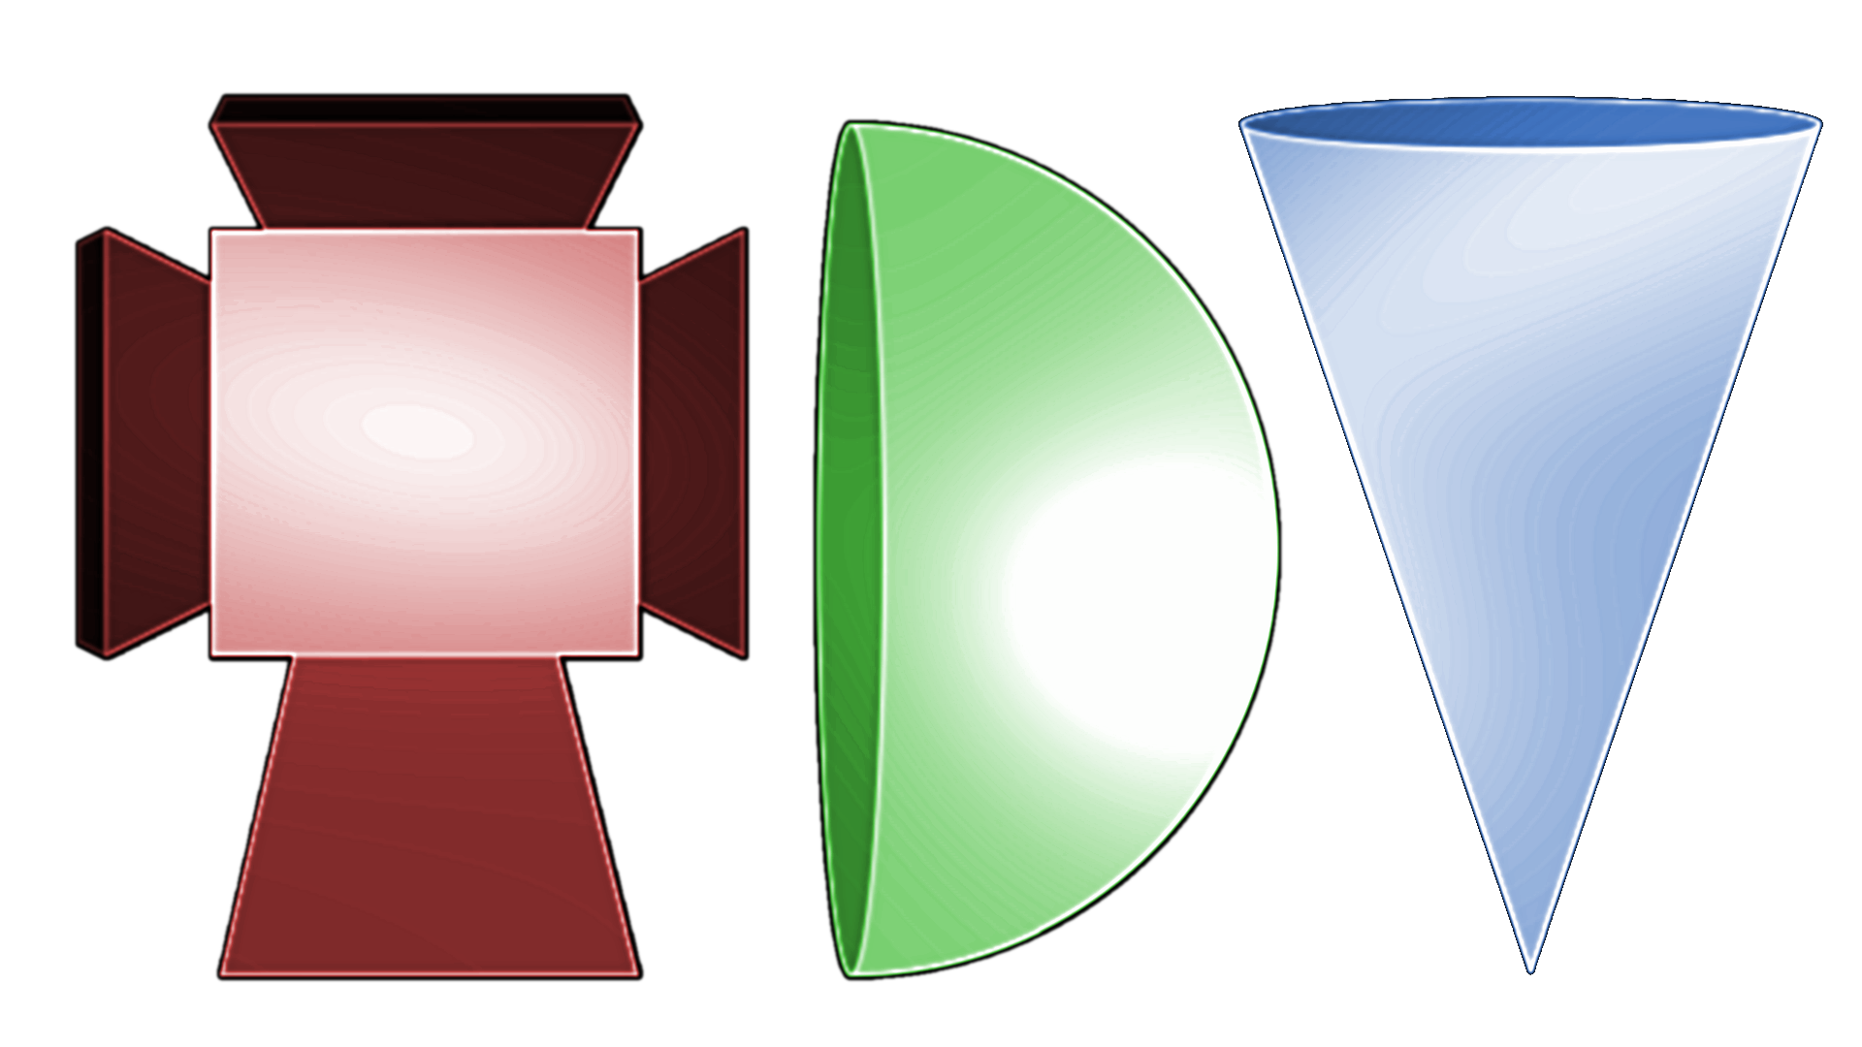
Permission is hereby granted, free of charge, to any person obtaining a copy of this software and associated documentation files (the "Software"), to deal in the Software without restriction, including without limitation the rights to use, copy, modify, merge, publish, distribute, sublicense, and/or sell copies of the Software, and to permit persons to whom the Software is furnished to do so, subject to the following conditions:
The above copyright notice and this permission notice shall be included in all copies or substantial portions of the Software.
THE SOFTWARE IS PROVIDED "AS IS", WITHOUT WARRANTY OF ANY KIND, EXPRESS OR IMPLIED, INCLUDING BUT NOT LIMITED TO THE WARRANTIES OF MERCHANTABILITY, FITNESS FOR A PARTICULAR PURPOSE AND NONINFRINGEMENT. IN NO EVENT SHALL THE AUTHORS OR COPYRIGHT HOLDERS BE LIABLE FOR ANY CLAIM, DAMAGES OR OTHER LIABILITY, WHETHER IN AN ACTION OF CONTRACT, TORT OR OTHERWISE, ARISING FROM, OUT OF OR IN CONNECTION WITH THE SOFTWARE OR THE USE OR OTHER DEALINGS IN THE SOFTWARE.

Table of Contents
1 Design History 2
1.1 Version 0.1 2
2 Game Overview 3
2.1 Philosophy 3
2.1.1 Description 3
2.1.2 Role and purpose of game 3
2.1.3 Setting 3
2.1.4 Player 3
2.1.5 Primary Game Objects 3
2.1.6 Goals 3
2.1.7 Difference from other similar games 4
3 Feature Set 4
4 The Game World 7
4.1 The Physical World 7
4.1.1 scale 7
4.1.2 objects 7
4.2 Rendering System 8
4.2.1 Camera 8
4.2.2 Game Engine 8
4.2.3 Lighting Models 8
5 User Interface 8
6 Sound and Music 8

Design History

Version 0.1

Initial draft version of the document

Game Overview

Philosophy

Description
This is an arcade-like game in which circuit elements fall (like Tetris pieces) and the player must direct them to fall in such a way to make consistent Boolean circuits. Inconsistencies block the player from adding more to the section of circuit. A closed, consistent circuit will vanish, leaving room for more circuit elements to be placed and add to the score. When the screen fills and there is no room for more circuit elements, the game is over.

Role and purpose of game
The game is partly twitch strategy, and partly thought about how Boolean circuits combine. Two modes, basic and expert, choose how much the latter is emphasized: beginner mode uses graphical elements to show how the circuits are interpreting truth values, whereas with the expert mode, the player must keep in mind the meanings of the logic gates.

Setting
The setting is a circuit board that fills most of the screen.

Player
The player controls the left-to-right position and the screen space rotation of the circuit elements as they fall.

Primary Game Objects
The primary game objects are Boolean circuit elements, hexagon-shaped, that fit together into a honeycomb.

Goals
The goal is to make closed, consistent circuits out of the pieces and avoid creating inconsistencies (unsatisfiable circuits).

Difference from other similar games
Unlike Tetris, which also involves rotating and shifting pieces to fit, the “fitting” is according to Boolean logic, not geometric shape. Thus, context matters more—not just adjacent pieces affect how they fit together, but arbitrarily-long chains of adjoining pieces.

Feature Set
- Circuit board play space
- hexagon-shaped circuit elements
- each of the six sides is a pin (terminal) of the circuit
- basic mode and expert mode
- elements fall until they land on another element or the bottom of the play space
- elements can be shifted left or right as they fall
- elements can be rotated in 60-degree increments as they fall
- Elements, when landing, try to fit into the honeycomb efficiently
- Inconsistent regions of elements are “dead” and are grayed out
- Closed regions (consistent and having a unique solution on all exposed pins) disappear and add to the score
- A piece spawns at the top whenever the previous piece “lands”
- If a spawned piece has no room to fall, the game is over
- Sound on a piece landing and adding to a consistent circuit
- Sound on an inconsistent circuit forming
- Sound on a closed circuit disappearing
- Sound at game over
- Basic mode: pins determined to have a definite truth value get a color showing that value
- Basic mode: conflicting pins of inconsistent circuits highlighted
- Score is shown at the top of the screen
- Game modes: attract, play, demo, pause, set options, game over
- High scores are maintained
- High scores are displayed on one screen of the attract mode
- Game title on one screen of the attract mode
- Game description on one screen of the attract mode
- Attract mode switches to demo mode, which reverts to attract mode when the demo AI player loses or after a fixed time
- Music A during attract mode and during demo mode
- Music B during pause mode and during options mode
- Music C during play mode
- Music D during game over mode
- Attract mode (which cycles through its screens) to demo mode to attract mode cycles till user decides to play or set options
- Options mode reverts to attract mode (title screen) when user is done setting options
- Play mode goes to pause mode if selected by user
- When pause mode is done, play mode resumes
- When player loses, game over mode appears till user is done, then attract mode, title screen resumes
- Game over mode gives score, and info if player made a high score
- Options include sound volume, music volume, player name, basic or expert mode, tick rate
- Pause menu shows a pause screen
- More than one play mode music, changes with progress
- Circuit look balanced between realistic and easy to visually parse
- Game text uses custom font(s)
- Logos and symbols on title screen in addition to title/author/etc
- Well-designed borders/background for all modes and screens, balancing artistic with readability
- All game piece movement is in discrete steps at a definite (tuneable) tick rate
- More points-per-closed-circuit for higher tick rate and for expert mode
- Support stand-alone, web, and mobile
- Support sites like itch.io and Windows Store
- Animations to some of the pieces
- Pieces have states: falling, settling, stable, scoring, dead
- Falling piece becomes settling piece when it lands on another
- Settling piece becomes stable when it integrates with the honeycomb
- Stable piece becomes dead on becoming part of unsatisfiable circuit
- Stable piece becomes scoring on becoming part of a closed circuit
- Scoring piece vanishes
- Stable piece or dead piece becomes falling piece if an adjacent piece below it vanishes
- Dead pieces become stable pieces if they are no longer unsatisfiable
- Controllable by keyboard, gamepad, touch screen, and/or mouse
- Screen buttons for rotate left, rotate right, and pause in play mode
- Screen button for Done in pause, options, and game over modes
- Screen button for Play in attract and demo modes
- Screen buttons for mute and unmute in pause mode
- Screen controls for all the options in options mode
- All controls and buttons have keyboard, mouse button, and/or gamepad shortcuts
- High scores are persistent on architectures that support it
- High scores are networked on architectures/venues that support it
- Local high scores can be cleared in options mode
- Attract mode has Next buttons to immediately go to next screen (happens automatically after a time)
- Attract mode has Demo button to immediately go to Demo mode (happens automatically after a time)
- Demo mode has Done button to immediately return to attract mode title screen (happens automatically after a time)
- Core screen space is ratio 9:16 (portrait mode) but playable on 3:4 and 10:16
- Target resolution is 1080x1920 but playable at lower and higher resolutions
- Play space wide enough for 9 hex tiles, tall enough for 14 hex tiles
- Hex tiles target resolution is 128x128
- Button target resolution is 128x128
- Target font size is 96 pt and larger
- Background image resolution for screens is 1080x1920
- Playspace area is hex-tiled honeycomb, 128x128 image tiles approx 1 per hexagon

The Game World

The Physical World
A circuit board

scale
- Circuit elements are approximately an inch in diameter, real world
- Circuit board is about 9 inches wide by 14 inches tall in the real world
- In game space, this will fit whatever the screen size is

objects
- Circuit elements with up to 6 pins each, circuit board

Rendering System

Camera
Orthographic camera

Game Engine
Unity 3D

Lighting Models
Flat shaded

User Interface
On-screen buttons and controls for major items with keyboard/mouse/gamepad shortcuts.

Sound and Music
Background music for various game modes, sounds for game events

