Classic FPS Game Project Design Document
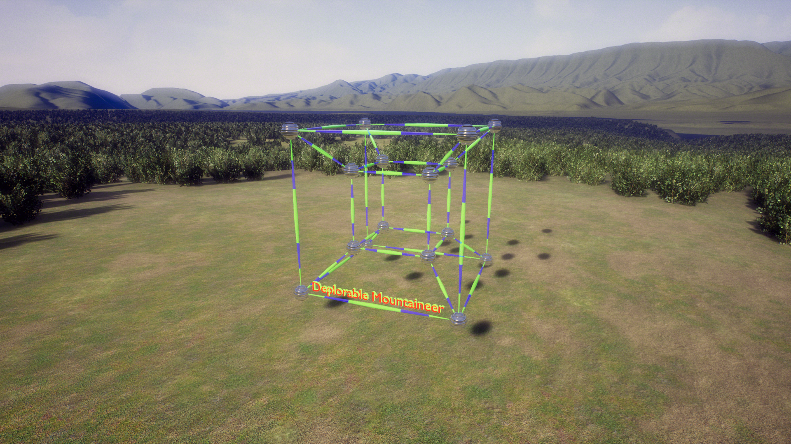
© 2018 Deplorable Mountaineer
Table of Contents
Game Information 5
Folder Structure 6
Assets 9
Material Bases 9
PBR Settings 9
Material Masters 11
Parameter Names 11
Material Functions and Layers 11
Textures 12
Particles 12
Actor Base 13
Properties 13
Controllable Objects 13
Doors 13
Door Actions 13
Door Properties 14
Lights 14
Light Actions 14
Light Properties 15
Switches 15
Switch Actions 15
Switch Properties 15
Architectural Parameters 15
Static Meshes 16
Gameplay Base 17
Gameplay States 17
Main Menu 17
Main Menu Classes 20
Pause Menu 21
HUD 21
ClassicFPS Game Mode 22
ClassicFPS Game State 23
ClassicFPS Player State 23
Gameplay Effects 23
Character 24
Default Character Properties 24
Character Capabilities 29
Axis Bindings 31
Axis Bindings 33
Character Properties 34
Character Property Value Modification 34
Health 34
Strength 35
Current Weapon Slot 35
Third Person Mode 35
Enemies Killed 35
Secrets Found 35
Powerups Found 35
Weapons Found 35
Ammo Found 35
Health Found 36
Keys Found 36
Falling Counter 36
FOV 36
Carried Item 36
Inventory 36
Third Person Camera Arm Length 36
Character Structure 36
Character Operating Items 37
Text Messages 37
Character Animation 38
State Machine 39
Idle 39
Jog 40
Run Jump 40
Fall 40
Jump 40
Crouch 40
Crouch Walk 40
Simple Character AI 41
Bot_Random 41
Bot_Waypoint_Flee_Attack 41
More Complex AI 41
Bot_Best 41
Wants Health 41
Needs Health 41
Wants Ammo 42
Focused Ammo is Full 42
Focused Powerup is Full 42
Needs Ammo 42
In Mortal Danger 42
Has Ammo 42
Knows Enemy Location 42
Suspects Enemy Location 42
In Attack Range of Enemy 42
Focused Bot 42
Focused Bot Forward 42
Focused Bot Backward 42
Near Another Bot Neither Attacking or Fleeing 42
Near Another Bot that is Attacking 43
Near Another Bot that is Fleeing 43
Focused Health 43
Near Health 43
Knows Location of Health 43
Bored 43
Focused Waypoint 43
Near Waypoint 43
Far From Home 43
Focused Ammo or Weapon 43
Near Ammo or Weapon 43
Knows Location of Ammo or Weapon 44
Focused Powerup 44
Near Powerup 44
Knows Location of Powerup 44
States 44
Attacking 44
Fleeing 44
Patrolling 45
Wandering 45
Finding Health 46
Finding Ammo or Weapon 46
Collecting Health 46
Collecting Ammo or Weapon 46
Collecting Powerup 46
Defending Teammate 46
Attacking With Teammate 46
Inventory 47
Key Base 47
Health Base 47
Powerup Base 47
Ammo Base 47
Weapon Base 47
Comparison of Weapons 49
New Weapon Creation 49
Physics Mesh Base 51
Other Blueprint Objects 51
Stair builder 51
Pipe builder 51
Fence builder 51
Hose Builder 51
Railing builder 51
Jump pad 51
Placeable shooters 52
Day and night skies 52
Lighted signs 52
Monitors 52
security cameras 52
Teleporter 52
Spawner 52
Fan 52
Sounds 52
Physics 53
Collision 53
Physical Surfaces 54
Utility 55
Tutorials 58
Make A New Touchplate Switch 59

Game Information
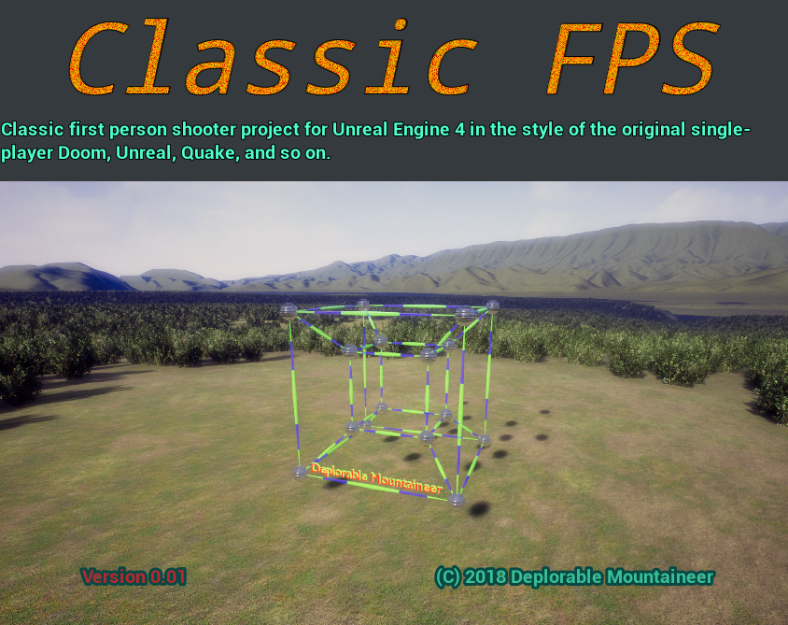
Unique Project ID: {AED64A86-47D8-D36A-F0A9-2093602951A6}
Name: Classic FPS Version 0.01
Description: Classic first person shooter project for Unreal Engine 4 in the style of the original single-player Doom, Unreal, Quake, and so on.
Company: Deplorable Mountaineer
Website: https://deplorablemountain.wixsite.com/games
Copyright: © 2018 Deplorable Mountaineer
Contact: Deplorable.Mountaineer@gmail.com
Palette Colors: #38c098, #F8BE00, #B52930, #10655E, #ffffff, #42484f, #1EF858, #F89245, #A057F8, #45F8B5, #613F29

Palette Gradient:


Folder Structure
Under Content:
├───AnimStarterPack
│ └───UE4_Mannequin
│ ├───Materials
│ │ └───MaterialLayers
│ ├───Mesh
│ └───Textures
├───ClassicFPS
│ ├───Base
│ │ ├───Blueprints
│ │ ├───Icons
│ │ ├───MaterialMasters
│ │ │ ├───Data
│ │ │ └───Functions
│ │ └───Physmats
│ │ └───Data
│ ├───Characters
│ │ ├───Animations
│ │ │ ├───AnimationSequences
│ │ │ ├───Blueprints
│ │ │ └───FirstPerson
│ │ ├───Data
│ │ ├───Materials
│ │ │ └───Textures
│ │ ├───NPC
│ │ │ └───Data
│ │ └───Player
│ │ └───Data
│ ├───Dev
│ ├───Effects
│ │ ├───Controllable
│ │ ├───Materials
│ │ │ ├───Ceramic
│ │ │ ├───Data
│ │ │ ├───Decals
│ │ │ │ └───Textures
│ │ │ ├───Fabric
│ │ │ │ └───Textures
│ │ │ ├───FloorCeiling
│ │ │ │ └───Textures
│ │ │ ├───FluidAndIce
│ │ │ ├───Glass
│ │ │ │ └───Textures
│ │ │ ├───Glow
│ │ │ ├───Ground
│ │ │ │ └───Textures
│ │ │ ├───Metal
│ │ │ │ ├───Painted
│ │ │ │ │ └───Textures
│ │ │ │ └───Textures
│ │ │ ├───Paper
│ │ │ │ └───Textures
│ │ │ ├───Plastic
│ │ │ ├───Rock
│ │ │ │ └───Textures
│ │ │ ├───Rubber
│ │ │ │ └───Textures
│ │ │ ├───Special
│ │ │ ├───Textures
│ │ │ ├───Wall
│ │ │ │ └───Textures
│ │ │ └───Wood
│ │ │ └───Textures
│ │ └───Particles
│ │ └───Materials
│ ├───Environment
│ │ ├───Background
│ │ ├───Buildings
│ │ │ ├───Commercial
│ │ │ ├───Fixtures
│ │ │ ├───Furniture
│ │ │ ├───Pipes
│ │ │ └───Residential
│ │ ├───Foliage
│ │ ├───Landscape
│ │ │ └───Rocks
│ │ ├───Props
│ │ │ ├───Lights
│ │ │ │ └───Meshes
│ │ │ ├───Meshes
│ │ │ └───Shapes
│ │ ├───Sky
│ │ └───Water
│ ├───Gameplay
│ ├───Maps
│ │ ├───Episode_01
│ │ ├───Episode_02
│ │ ├───Episode_03
│ │ └───TestMaps
│ ├───Pickups
│ │ ├───Health
│ │ ├───Keys
│ │ ├───Powerups
│ │ │ └───Permanent
│ │ └───Weapons
│ │ ├───Ammo
│ │ ├───Materials
│ │ │ └───Textures
│ │ │ └───Crosshairs
│ │ └───Rifle
│ ├───PostProcess
│ ├───Sound
│ ├───UI
│ │ ├───HUD
│ │ │ └───Materials
│ │ ├───MainMenu
│ │ │ └───Materials
│ │ ├───Monitor
│ │ └───PauseMenu
│ └───Vehicles
├───Collections
├───Developers
│ └───tdvance
│ └───Collections
├───FirstPerson
│ ├───Animations
│ ├───Audio
│ ├───Character
│ │ ├───Materials
│ │ │ └───MaterialLayers
│ │ ├───Mesh
│ │ └───Textures
│ ├───FPWeapon
│ │ ├───Materials
│ │ │ └───MaterialLayers
│ │ ├───Mesh
│ │ └───Textures
│ ├───Meshes
│ └───Textures
├───FirstPersonBP
│ ├───Blueprints
│ └───Maps
├───Geometry
│ └───Meshes
├───Mannequin
│ ├───Animations
│ └───Character
│ ├───Materials
│ │ └───MaterialLayers
│ ├───Mesh
│ └───Textures
├───ThirdPerson
│ └───Meshes
└───ThirdPersonBP
├───Blueprints
└───Maps

Assets

Material Bases

PBR Settings
For game use only—I made up some of the values.

Material Masters
Base, Translucent_Expensive, Mask

Parameter Names

Material Functions and Layers
MF_MaskLerpRGB

Textures
Crosshairs: Cross, X, Dot, Triangle, Trefoil, Box, Circle, Rangefinder
Metal: dimpled, rough and scratchy, Rusty, Holey, verdigris, Brushed, galvanized, Corrugated, Grate, Fence, Louvred Vent, Duct
Rock: smooth, conglomerate, Sandy, Gravelly, Pitted, jagged, marble, slate, limestone, Granite, Sandstone
Icons: Default, Actor, Character, Weapon, Carryable
Cloth: Fine Weave, Coarse Weave, Carpet
Decals: bullet holes, footprints, Stain, signs, puddles, Dirt, Scratches,
Wall: Plaster, wood, wood with grain, particleboard, Wood with knots, brick, concrete, concrete block, Stone
Floor: tiles of various types and shapes, cobblestone, Concrete, Concrete grime, Concrete Panels, Concrete Tiles, Concrete grooved, Concrete Pitted, Concrete Plank-like
Painted metal, colored glass, patterned cloth, etc.
Leather, Rubber, Plastic, Ceramic, etc. to match PhysMats

Ground: Dirt, Mud, Gravel, Grass, Snow, Patchy Grass, Ice, Dirty Ice, Rough Ice, Dirty Snow, Patchy Snow, Exposed Rock, muddy rocks, Moss, Dirt and Pebbles, Ground with Foliage
Utility: noise, clouds, gradients
Hazard patterns
Grids and tile patterns, hex and square, etc. Holey patterns, Vent louvre patterns, etc.
Diamond Plate, Duct, Planks, Parquet

Particles
Explosions, Hit effect, sparks (fire, electric, hammered metal), Fires, Beams, Projectile particles, Splash from water, slime, lava, Snow, Steam, Smoke, Lightning, Shrapnel, Gibs, Dust, Contrail, Light halo,

Actor Base

Properties
Name
Unique Name (just use name-in-world)
Icon
Colors
Additional Tags (automatically populates list of actor tags)

Controllable Objects
Controllable objects have actions (of type Name) that can be called by a switch (a switch is really a state machine). Doors and Lights are examples, but so is a switch: so one switch can affect the state of another, allowing three-way switches, combo lock switches, etc.
A controllable object inherits from the BPI_Controllable interface, which provides the method “Do Action”, which takes an Action:Name input to select the action, as well as input parameters (which are used or ignored depending on the action) Float Input:Float, Vector Input:Vector, Rotator Input:Rotator, Color Input:Linear Color, Transform Input:Transform, and Name Input:Name. It returns Success:Bool, True if successful, and False if not (for example, parameter out of range or action of given name does not exist).
One way to implement this method is to switch on the Action name, each branch calling a function named the same as the action and taking exactly the arguments they need. Another way is to inherit from BP_Controllable, and set the Allowed Actions array to be the list of action names, and override Do Action By Number to switch on the integer index of the action and perform the actions using the variables Float Input, etc., for inputs.

Doors

Door Actions
Open
Close
Open Reverse
Close Reverse
Lock
Unlock
Operate
- If operated from -X direction:
  - if open, close
  - if open reverse, close reverse
  - if closed and unlocked, open
- If operated from X direction
  - if open, close
  - if open reverse, close reverse
  - if closed and unlocked and reversible, open reverse
  - if closed and unlocked and not reversible, open (note sliding doors typically not reversible)

Door Properties
Auto Close Delay: if 0, never auto close, otherwise after delay of that many seconds
Open Speed
Close Speed
Auto Open: if character is in trigger volume, opens automatically
Auto Open Reverse: if character is in reverse trigger volume, opens automatically in reverse
Operatable: “operate” opens the door; otherwise need to find a switch somewhere.
reversible: if false, open reverse fails.
Locked: if true, open and open reverse fail; if physics mode and closed, door becomes immovable
open state, closed state, open reversed state

Lights

Light Actions
Actions typically follow a curve (ease-in ease-out) though some lights might have other behavior (E.G. fluorescent light flicker).
On: turn on to previous dimmer amount
Off: turn off regardless of dimmer amount
Toggle: (usual action for Operate)
- if on, turn off regardless of dimmer amount.
- If off, turn on to previous dimmer amount.
Set Dimmer Amount: value from 0 to 1, min brightness to max brightness
Set Light Color
Set Light Direction

Light Properties
Max Brightness
Min Brightness (for dimmer, nonzero for technical reasons, but can be so near 0 it is essentially off)
Direction (rotator): direction a light faces, if applicable
Color
Dimmer Amount (from 0 to 1)

Switches

Switch Actions
Toggle: Change to next state (states are ordered in an array by integer; next state is the next-indexed state)
Set State: set to one of the states available to the switch.

Switch Properties
State: usually on or off, though could be more; represented by a value of type “Name”
On Enter State: mapping from states to actions on a controlled object (door, light, etc.); action taken when state is entered.
On Exit State: mapping from states to actions on a controlled object (door, light, etc.); action taken when state is exited.

Architectural Parameters

Static Meshes
Window,
Shapes: Cube, sphere, slope, Square pyramid, Tetrahedron, Octahedron, Icosahedron, Torus, Plane, Cube Chamfer, Cube Inset, Cone, Platform, Circular platform, Platforms of various polygon shapes, Annular platform, Arrows
Arch: Walls, Walls with window/door openings
Pipes and joints, fence parts,. Stair parts, hose parts
Barrels, Crates, including exploding barrel, Boxes, bags
Bricks, Cement blocks, Rocks, Boulders
Foliage
Cones, Saw horses, Signs, Manhole covers
Trash cans, chairs, desks, tables, Benches, Couches, Barstools,
Grates, vents,

Gameplay Base

Gameplay States

Main Menu
Available choices: New Game, Load Game, Options, Statistics, Quit
The main menu is brought up by the BeginPlay event of the Level Blueprint of the Entry map. This same level blueprint has properties UI Colors and UI Text for changing various menu properties for all menus.
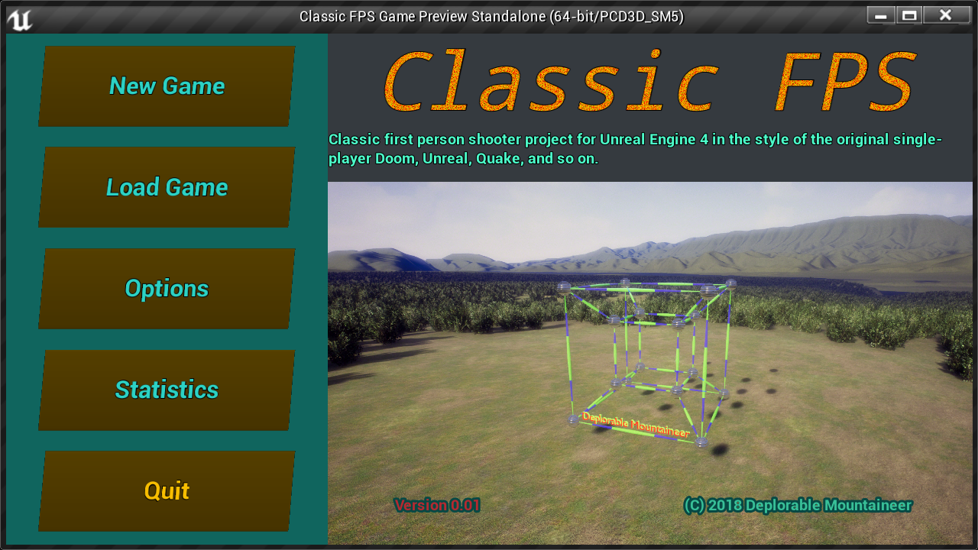
New Game: Select Skill, Select Episode, Play, Return
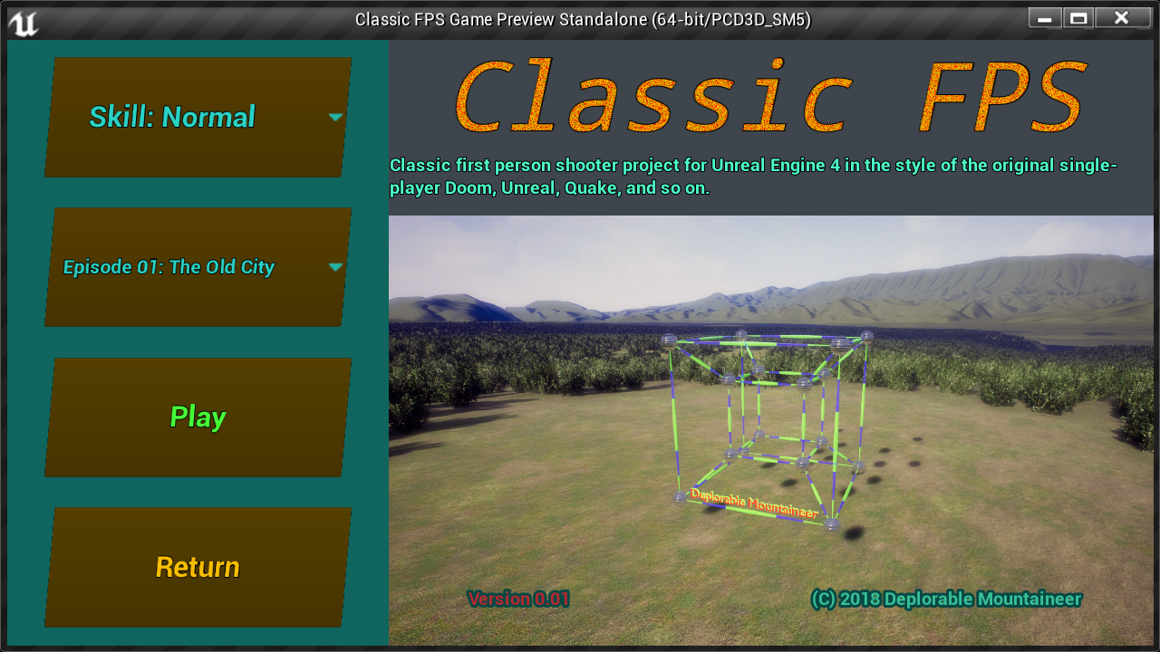
Load Game: Select Game, Play, Return
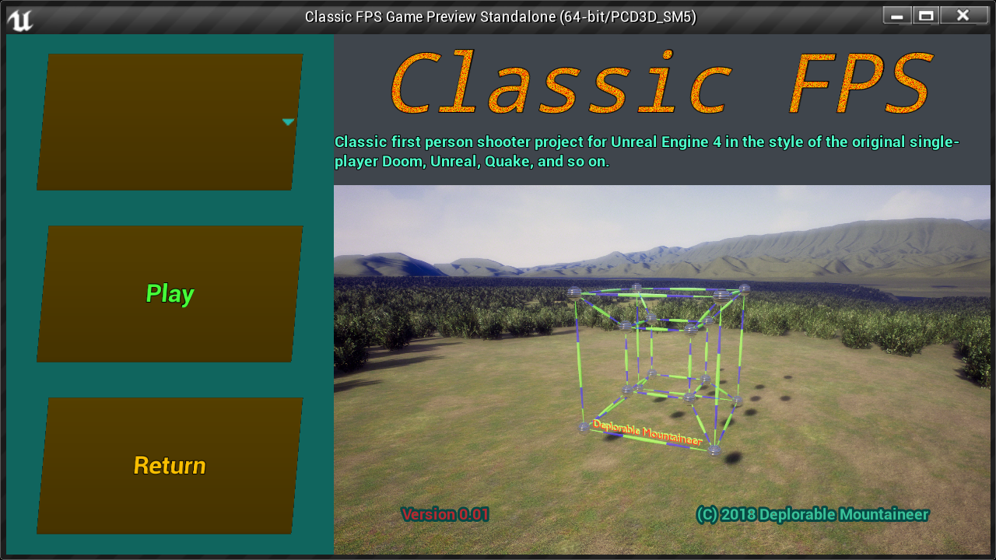
Options: Action Input, Mouse and Axis Input, Graphics and Sound, Weapons, Return
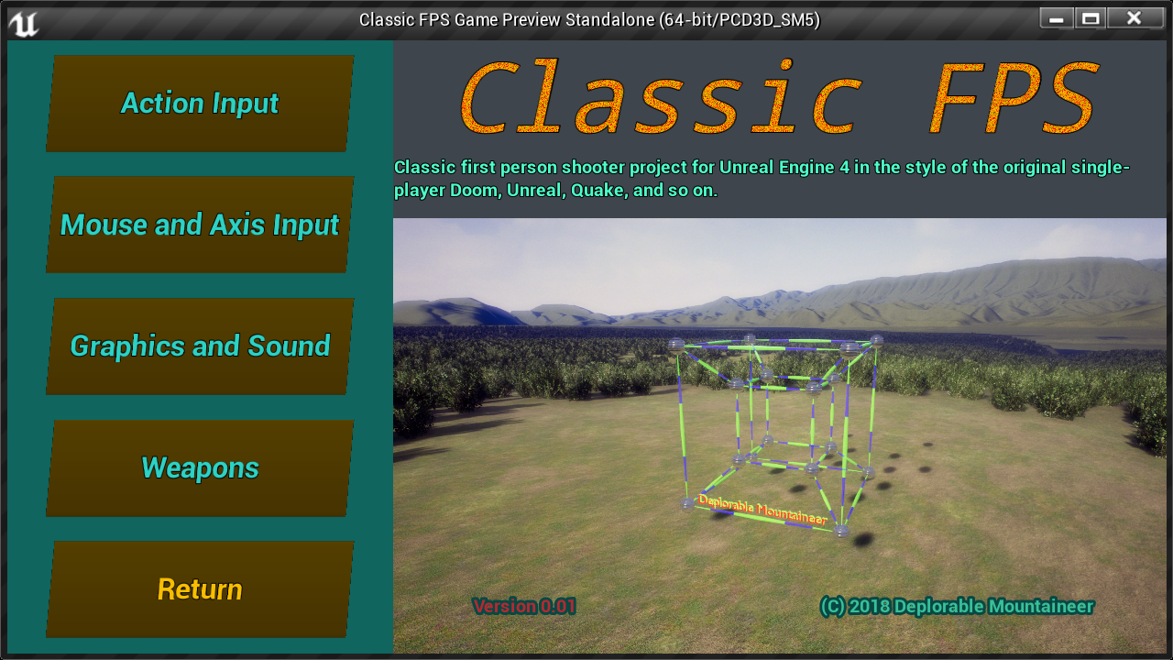
Action Input: Add New Key Binding, Remove Selected Key Binding
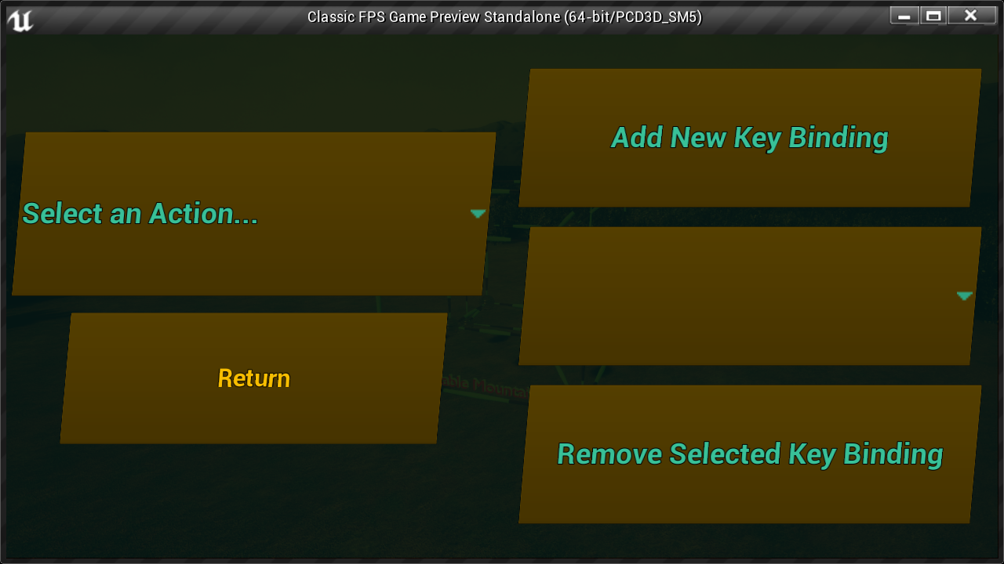
Mouse and Axis Input: invert mouse, mouse sensitivity
Statistics: top scores, achievements
Graphics and Sound: Resolution, Effects Volume, Music Volume
Weapons: Priority, Auto Switch on Pickup (always, never, if better) Switch to Best Weapon when Out of Ammo

Main Menu Classes
BP_Pawn_Menu:
- Maintains Last Key Pressed, Last Key or Modifier Pressed, and Last Chord Pressed
- Chord to Text function
- Clear Keys event
MainMenu_GameMode:
- Get Bindings
- Action Key Mapping to Text
- Debug Print Bindings
- Axis Key Mapping to Text
BP_MainMenu (HUD class):
- Event Play Game
- Maintains array of First Levels of Episodes
- Sets input mode to UI and game, and shows mouse cursor for menu use

Pause Menu

HUD

Ammo on bottom right, change color when low, with flash when it turns low and audible noise;
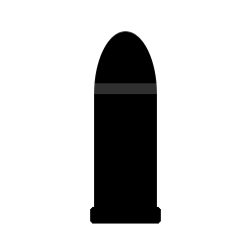
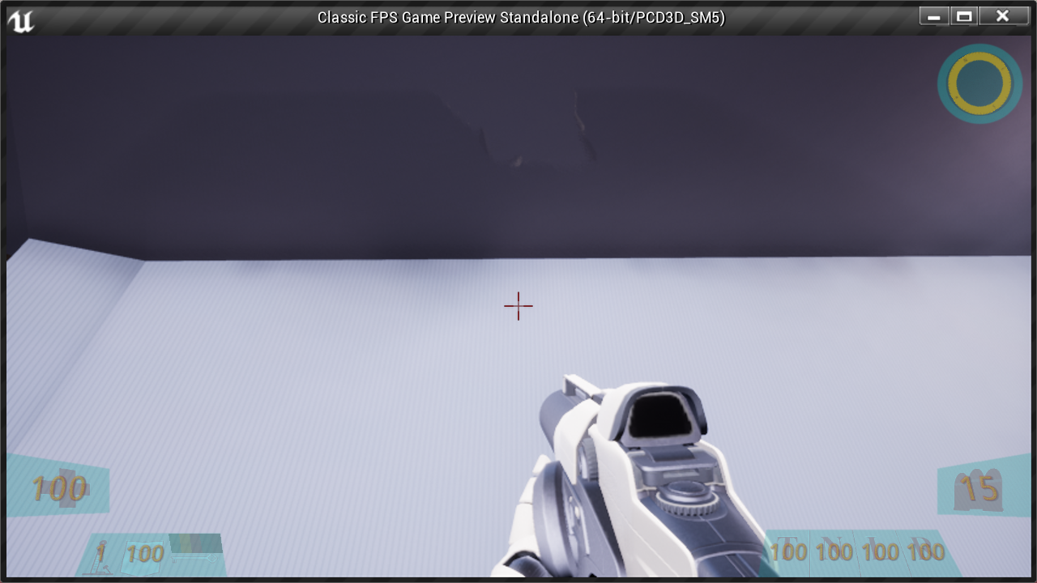
Radar Top right (as a powerup?), different color for enemies that are close; compass style
Health on bottom left; flash, audio warning when turns low, change color when low.
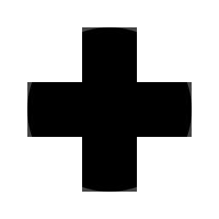
Next to health are Strength, Shield, and Keys.
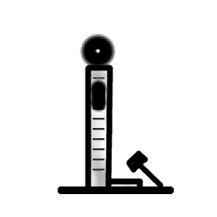
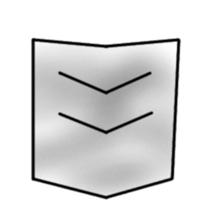
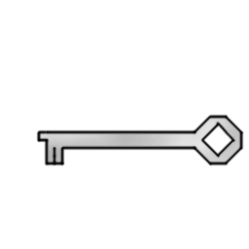
Next to ammo are the powerups: Turbo, Night vision, Lift belt, and Radar.

Crosshair: fine lines, duplex (outer parts of lines highlighted); also dot and range-finding for long-range weapons.

ClassicFPS Game Mode
- Player is spawned at the beginning of the level, or at a saved point
- When player dies, can respawn at beginning or a saved point (state reset to the point)
- Upon reaching the end of level volume, there is a summary screen followed by starting the next level, keeping all inventory except keys.
- The Game Mode class maintains the list of weapons and default slots, up to 9 of which can be mapped to keys.

ClassicFPS Game State
- Current level
- Levels Completed
- Strength Achieved

ClassicFPS Player State
- Skill Level
- Name

Gameplay Effects
Hurt screen
Dead screen
Night Vision screen
Turbo screen
Low health screen?
Health increase screen
Shield used screen
Effects when enemy hit or killed
Pickup Effects
Low Ammo/Health/Inventory effects
In Battle Effects
Boredom Effects
Goal Achieved Effects

Character

Default Character Properties
Property | Float Value | String Value | Vector Value X | Vector Value Y | Vector Value Z
Actor Properties
Additional Tag 1
Additional Tag 2
Additional Tag 3
Color 1 |  | Salem | 0.039546 | 0.527115 | 0.313989
Color 2 |  | Gold Drop | 0.941177 | 0.513726 | 0
Color 3 |  | Tall Poppy | 0.462077 | 0.022174 | 0.029557
Color 4 |  | Eden | 0.005182 | 0.130136 | 0.111932
Color 5 |  | White | 1 | 1 | 1
Color 6 |  | Bunker | 0.05098 | 0.062745 | 0.078431
Icon | 0 | T_Man_Icon_M
Name |  | Character
AI Characteristics
Accuracy | 0.5
Aggressiveness | 0.5
Alertness | 0.5
Jumpiness | 0.5
Map Awareness | 0.5
Reaction time | 0.5
Tactics | 0.5
Character Movement
Air Control | 0.05
Air Control Boost Multiplier | 2
Air control Boost Velocity Threshold | 25
Base Jump Velocity | 400
Base Running Jump Velocity | 600
Brake Deceleration Falling | 0
Default Ground Friction | 8
Falling Lateral Friction | 0
Max Crouch Walk Speed | 300
Max Fly Speed | 600
Max Step Height | 45
Max Swim Speed | 300
Max Walk Speed | 600
Walkable Floor Angle | 45
Other Character Properties
Auto-Kill Fall Time | 10
Base Eye Height | 64
Camera Boom Location |  |  | -30.846336 | 17.973167 | 44.23
Carry Distance | 100
Character Height | 192
Character Width | 84
Crouch Time | 0.2
Crouched Character Half Height | 40
Crouched Eye Height | 32
Gravity Scale | 1
Mass | 100
Max FOV | 120
Max survivable fall time | 2
Min FOV | 30
Min Time for Fall Damage | 0.4
Min Velocity for Falling Counter | 700
Minimum Strength | -2
Num Zoom Levels | 4
Operate Range | 200
Spring Arm Multiplier per Increment | 1.1
Strength Adjust | 0
Strength Multiplier per Increment | 1.1
Third Person Camera Arm Length | 300
Mesh Properties
First Person Anim Class |  | ABP_Arms
First Person Arms Location Rel Camera |  |  | -0.510596 | -4.410996 | -155.712738
First Person Arms Rotation Rel Camera |  |  | 5.287787 | 1.921141 | -19.911278
First Person Gun Socket Bone |  | middle_01_r
First Person Gun Socket Location |  |  | -2.457152 | 6.927716 | 0.000142
First Person Gun Socket Rotation |  |  | 4.847672 | 15 | 175
First Person Mesh |  | SK_Arms
First Person Mesh Override Material 1
First Person Mesh Override Material 2
Third Person Anim Class |  | ABP_Character
Third Person Gun Socket Bone |  | middle_01_r
Third Person Gun Socket Location |  |  | -1.342635 | 3.318012 | -1.679417
Third Person Gun Socket Rotation |  |  | -22.681015 | 12.774652 | 162.533691
Third Person Mesh |  | SK_Character
Third Person Mesh Override Material 1
Third Person Mesh Override Material 2
Weapon Order
Weapon preference 1 | 1
Weapon preference 2 | 2
Weapon preference 3 | 3
Weapon preference 4 | 4
Weapon preference 5 | 5
Weapon preference 6 | 6
Weapon preference 7 | 7
Weapon preference 8 | 8
Weapon preference 9 | 9

Character Capabilities
Assuming for falling damage, falling on default surface, health at 100 and no shielding. Computed values are rounded. Max survivable fall height actually varies according to physmat of surface hit. For jump height, remember to add max step height to determine max height of platform that can be jumped onto. Also all values appear to be approximate: in-game values differ slightly from computed values for reasons the author doesn’t know.
 |  |  | Strength
 |  | -4 | -3 | -2 | -1 | 0 | 1 | 2 | 3 | 4 | 5
Gravity acceleration per G | -980
Factor |  | 0.62 | 0.68 | 0.75 | 0.83 | 0.91 | 1.00 | 1.10 | 1.21 | 1.33 | 1.46
Inverse Factor |  | 1.61 | 1.46 | 1.33 | 1.21 | 1.10 | 1.00 | 0.91 | 0.83 | 0.75 | 0.68
Jump Velocity |  | 248.37 | 273.21 | 300.53 | 330.58 | 363.64 | 400.00 | 440.00 | 484.00 | 532.40 | 585.64
Running Jump Velocity |  | 372.55 | 409.81 | 450.79 | 495.87 | 545.45 | 600.00 | 660.00 | 726.00 | 798.60 | 878.46
Walk Speed |  | 372.55 | 409.81 | 450.79 | 495.87 | 545.45 | 600.00 | 660.00 | 726.00 | 798.60 | 878.46
Crouch Walk Speed |  | 186.28 | 204.90 | 225.39 | 247.93 | 272.73 | 300.00 | 330.00 | 363.00 | 399.30 | 439.23
Fly Speed |  | 372.55 | 409.81 | 450.79 | 495.87 | 545.45 | 600.00 | 660.00 | 726.00 | 798.60 | 878.46
Swim Speed |  | 186.28 | 204.90 | 225.39 | 247.93 | 272.73 | 300.00 | 330.00 | 363.00 | 399.30 | 439.23
Jump Time |  | 0.25 | 0.28 | 0.31 | 0.34 | 0.37 | 0.41 | 0.45 | 0.49 | 0.54 | 0.60
Double Jump Time |  | 0.51 | 0.56 | 0.61 | 0.67 | 0.74 | 0.82 | 0.90 | 0.99 | 1.09 | 1.20
Running Jump Time |  | 0.38 | 0.42 | 0.46 | 0.51 | 0.56 | 0.61 | 0.67 | 0.74 | 0.81 | 0.90
Running Double Jump Time |  | 0.76 | 0.84 | 0.92 | 1.01 | 1.11 | 1.22 | 1.35 | 1.48 | 1.63 | 1.79
Jump Height |  | 31.47 | 38.08 | 46.08 | 55.76 | 67.47 | 81.63 | 98.78 | 119.52 | 144.62 | 174.99
Double Jump Height |  | 62.95 | 76.16 | 92.16 | 111.51 | 134.93 | 163.27 | 197.55 | 239.04 | 289.23 | 349.97
Running Jump Height |  | 70.81 | 85.69 | 103.68 | 125.45 | 151.80 | 183.67 | 222.24 | 268.92 | 325.39 | 393.72
Running Double Jump Height |  | 141.63 | 171.37 | 207.36 | 250.90 | 303.59 | 367.35 | 444.49 | 537.83 | 650.78 | 787.44
Time To Reach Kill Velocity |  | 0.71 | 0.71 | 0.71 | 0.71 | 0.71 | 0.71 | 0.71 | 0.71 | 0.71 | 0.71
Distance to Reach Kill Velocity |  | 250.00 | 250.00 | 250.00 | 250.00 | 250.00 | 250.00 | 250.00 | 250.00 | 250.00 | 250.00
Min Time for Fall Damage |  | 0.25 | 0.27 | 0.30 | 0.33 | 0.36 | 0.40 | 0.44 | 0.48 | 0.53 | 0.59
Max Survivable Fall Time |  | 1.24 | 1.37 | 1.50 | 1.65 | 1.82 | 2.00 | 2.20 | 2.42 | 2.66 | 2.93
Min Height for Fall Damage |  | 454.08 | 477.82 | 504.62 | 534.95 | 569.34 | 608.40 | 652.86 | 703.59 | 761.57 | 828.01
Max Survivable Fall Height |  | 1,874.95 | 2,120.57 | 2,408.21 | 2,745.73 | 3,142.56 | 3,610.00 | 4,161.60 | 4,813.64 | 5,585.66 | 6,501.17

Formulas used (assumes no air resistance, assumes character movement is physically accurate):
Jump Height: jump velocity * time + 0.5*-980*G*time*time
Velocity curve when jumping: Jump velocity – 980*G*time
Time for (single) jump: time = jump velocity / 980 / G
Double jumps double the height and time, but not velocity.

Axis Bindings
Action | Key | Shift | Ctrl | Alt | Cmd | Key2 | Shift2 | Ctrl2 | Alt2 | Cmd2
Crouch | C
Fire | LeftMouseButton
Jump | SpaceBar
Toggle First/Third Person View | F7
Zoom | Z
Switch to Next Weapon | MouseWheelUp |  |  |  |  | ]
Switch to Previous Weapon | MouseWheelDown |  |  |  |  | [
Switch to Best Weapon | B
Switch to No Weapon | 0
Toss Current Weapon | T
Alt Fire | MiddleMouseButton
Operate | E |  |  |  |  | F
Select Weapon 1 | 1
Select Weapon 2 | 2
Select Weapon 3 | 3
Select Weapon 4 | 4
Select Weapon 5 | 5
Select Weapon 6 | 6
Select Weapon 7 | 7
Select Weapon 8 | 8
Select Weapon 9 | 9
Toggle Night Vision | N
Toggle Lift Belt | L
Toggle Nitro Boost | R
Pause | Esc |  |  |  |  | Pause
Increase Third Person Follow | MouseWheelUp |  | x |  |  | [ |  | x
Decrease Third Person Follow | MouseWheelDown |  | x |  |  | [ |  | x
Lunge | V

Axis Bindings
Axis | Key | Scale | Key2 | Scale2 | Key3 | Scale3 | Key4 | Scale4 | Key5 | Scale5
Look Up/Down | MouseY | 1
Move Right/Left | A | -1 | D | 1
Turn Right/Left | MouseX | 1 | Right | 1 | Left | -1
Move Forward/Backward | W | 1 | S | -1 | Up | 1 | Down | -1 | RightMouseButton | 1
(Dodge by double-tap, or forward with V key)
Increase/Decrease Third Person Follow | Ctrl-MousewheelUp | 1 | Ctrl-MousewheelDown | -1

Character Properties
Property | Type
Health | Float
Strength | Float
Inventory | Array of Inventory Item Structs
Current Weapon Slot | Integer
Third Person Camera Arm Length | Float
Is Third Person Mode | Bool
Location | Vector
Rotation | Rotator
Enemies Killed | Set of Unique Names
Secrets Found | Set of Names
Powerups Found | Set of Unique Names
Weapons Found | Set of Unique Names
Ammo Found | Set of Unique Names
Health Found | Set of Unique Names
Keys Found | Set of Names
Falling Counter | Float
FOV | Float
Carried Item | Physics Mesh Property Struct

Character Property Value Modification

Health
On picking up a health item, its value is added to the current health, capped at 100 (no cap if it is a super health item). If there is no change in health from the item, the item will not be picked up.
On taking damage, the health is diminished by the modified amount of damage, where the amount of damage is modified both by strength and amount of shielding possessed. Sometimes damage is multiplied if it hits certain bones instead of others (such as a head shot).

Strength
The strength of most NPCs is fixed according to the character the NPC represents. The strength of the player can increase with “experience.” The strength can temporarily increase upon consuming a turbo power boost (“Nitro”) power up, but reverts when the power up runs out.

Current Weapon Slot
This is the slot number of the weapon currently being carried. Weapons are numbered from 1 through unlimited (no hard limit to number of weapons, but only 1 through 9 can be selected by a keypress, others must be scrolled to with the scroll wheel, for example). It is changed when a weapon is dropped or selected. If dropped or tossed or stashed, the slot changes to 0 (no weapon). If selected (manually, or if auto-select is triggered in certain cases), it changes to whatever weapon slot is selected.

Third Person Mode
If true, the character is in third-person mode (relevant to player only).

Enemies Killed
A list of unique names of enemies killed, for statistics purposes. Added to whenever this character kills someone, and reset on starting or restarting a level.

Secrets Found
A list of names of secrets found, for statistics purposes. Secrets given the same name will be considered the same secret and not be counted more than once. Added to whenever this character overlaps a “Secret Area” volume not yet found, and reset on starting or restarting a level.

Powerups Found
A list of unique names of powerups found, for statistics purposes. Added to whenever a character walks over or attempts to pick up a powerup, whether or not successful, and reset on starting or restarting a level.

Weapons Found
A list of unique names of weapons found, for statistics purposes. Added to whenever a character walks over or attempts to pick up a weapon, whether or not successful, and reset on starting or restarting a level.

Ammo Found
A list of unique names of ammo pickups found, for statistics purposes. Added to whenever a character walks over or attempts to pick up ammo, whether or not successful, and reset on starting or restarting a level.

Health Found
A list of unique names of health pickups found, for statistics purposes. Added to whenever a character walks over or attempts to pick up health, whether or not successful, and reset on starting or restarting a level.

Keys Found
A list of names of keys found, for statistics purposes, and to determine if character can pass through certain areas or not. Keys with the same name are considered equal. Added to whenever a character picks up a key not yet found, and reset on starting or restarting a level.

Falling Counter
How long (in seconds) a character has been falling at more than a specified minimum velocity, used to compute damage from falling. It is incremented while the character is falling at greater than the minimum velocity, and reset when the player lands (whence damage is taken if appropriate).

FOV
Field of view in degrees, relevant only to the player. Adjusted when the player changes zoom level.

Carried Item
A struct holding data for the item currently being carried (so it can be reproduced on loading a saved game). It is modified when a player picks up or drops a physics item.

Inventory
An array of structs, each of which holds data for an inventory item being carried (so it can be reproduced on loading a saved game). It is modified when a player picks up or drops an inventory item of the type that stays with the character (such as a weapon).

Third Person Camera Arm Length
Follow distance of the third-person camera. Relevant only for the player, and then only in third-person mode. Can be adjusted by the player.

Character Structure
Note that there is currently a bug (as of Version 4.18.3) in UE4 that causes the third-person character mesh to sometimes disappear in a level when the game isn’t being played. The first-person arms mesh is still visible, though. It can be fixed by recompiling the appropriate character blueprint. It appears to be harmless: the mesh reappears when you play the game.
A character has a BP_Character_Base as its parent, which in turn has the built-in Character class as its parent. Thus it already comes with a Capsule component as its root, as well as an arrow component (for convenience), and a skeletal mesh component. It also has a character movement component.
The assets in this project are designed for a character 192cm high and 84cm wide, so the capsule half-height is 96, and the capsule radius is 42. One can use a different-sized character, but things like doorway sizes might have to be adjusted.
The camera boom is attached to the capsule component, and the camera is attached to the camera boom. By shortening the camera boom to 0 length, we achieve first-person mode; otherwise, there is an adjustable-length boom third person mode.
The camera has a first-person arms mesh attached to it, visible only to the owning player and in first person mode (in which the other mesh, the third-person mesh, is made invisible to the owning player, but not to others).

Character Operating Items
When a character “operates” an item, it first checks if the item is an actor implementing the BPI_Operatable interface. If so, it calls the actor’s Operate function.
If not, it checks if it is a pickup. If so, it tries to pick up the item. If not or if picking up fails, it checks if it simulates physics. If so, and if it is not too heavy, the character carries the item.
When the Operate action occurs and the character is already carrying something, it drops the item instead of performing the usual Operate procedure.

Text Messages
Characters can receive text messages. In a blueprint, on a Character actor, just call “Receive Text Message” with the appropriate inputs.
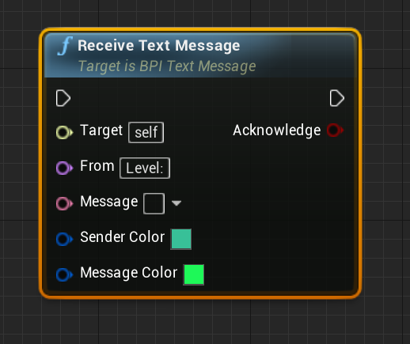
Mostly, the messages have no effect. But with a player character, the message is displayed on the Player’s HUD.

Character Animation
Animation for the default third-person character mesh is controlled by the ABP_Character blueprint.
On each animation update, the BP_Character actor is queried for rotation, velocity, and whether jump button and crouch button are down. The Direction, Speed, Horizontal Speed, Falling, Enable Jump, and Crouching variables are set as a result. These variables then control the animation through the state machine (“Locomotion”). After a brief delay, Enable Jump is reset.

State Machine
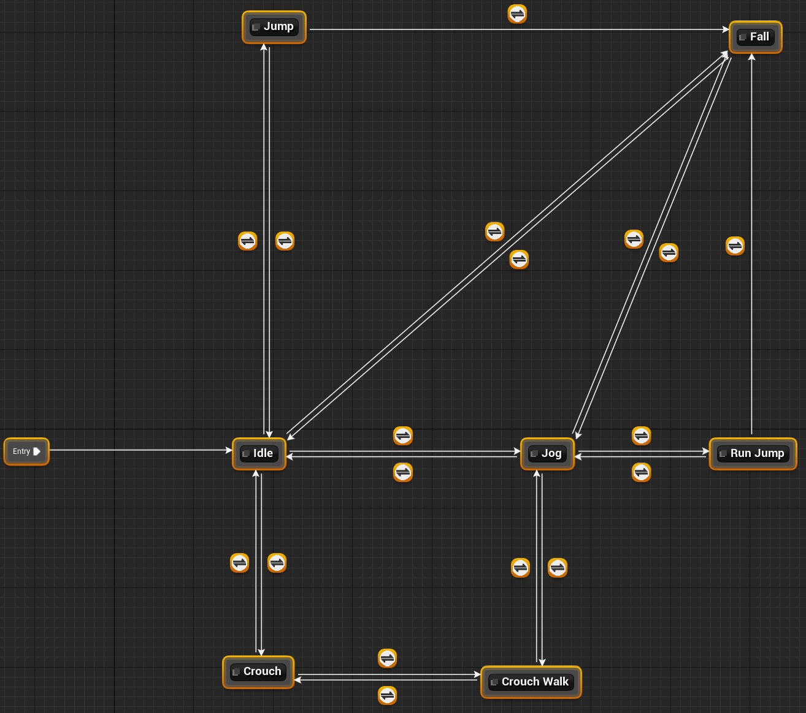

Idle
The entry state. Idle animation.
If Jump is enabled and Horizontal Speed is less than 10, transition to the Jump state.
If Jump is not enabled and Falling is true, transition to the Fall state.
If Horizontal Speed is greater than or equal to 10, transition to the Jog state.
If Crouching is true, transition to the Crouch state.

Jog
Blend Space BS_Jog animation, parametrized by Direction and Horizontal Speed.
If Horizontal Speed is less than 10, transition to the Idle state.
If Horizontal Speed is greater than or equal to 10 and Jump is enabled, transition to the Run Jump state.
If Falling is true and Jump is not enabled, transition to the Fall state.
If Crouching is true, transition to the Crouch Walk state.

Run Jump
Jump from Jog animation.
If animation done and falling, transition to Fall state.
If animation done and not falling, transition to Jog state.

Fall
Idle animation.
If not Falling and Horizontal Speed is greater than or equal to 10, transition to Jog state.
If not Falling and Horizontal Speed is less than 10, transition to Idle state.

Jump
Jump from Stand animation.
If animation finished and falling, transition to Fall state.
If animation finished and not falling, transition to Idle state.

Crouch
Crouch Idle animation.
If not Crouching, transition to Idle state.
If Horizontal Speed is greater than or equal to 10, transition to Crouch Walk state.

Crouch Walk
Blend Space BS_CrouchWalk parametrized by Direction and Horizontal Speed.
If not Crouching, transition to Jog state.
If Horizontal Speed is less than 10, transition to Crouch state.

Simple Character AI
Note that for the AI to work correctly, the player needs to be tagged with Player and all bots with NPC. The Additional Tags are currently set up to do this for the provided player and NPCs.

Bot_Random
Moves in a straight line, turning right when it approaches an obstacle (as viewed straight ahead from its centroid), and at random times, turning in a random direction. Tries to use navmesh if one exists instead of just going in straight lines. If nav movement fails, then moves randomly without the nav mesh. Red.

Bot_Waypoint_Flee_Attack
This bot has four states: waypoint, wander, chase, and flee. It starts in the Waypoint state where, if there are one or more waypoints added to the bot’s properties, it tries to go to them in a sequence, 0, 1, 2, to the last and back to 0 again to complete the circuit. It tries nav walking, and if that fails, it tries moving directly toward the waypoint. , turning on meeting an obstacle.
If there are no waypoints, it goes to the Wander state and wanders in a similar way to Bot_Random. If stuck, it attempts randomly jumping and crouching to try to get out of it.
If it is within a specified distance from the player, it will either go to the chase state or the flee state, the former if its health is at least 50, the latter if not. In the chase state, it chases the player (nav walking to player if possible, moving toward player if not, turning at obstacles). In the flee state, it tries to move in the direction away from the player, turning at obstacles. Upon exceeding the specified distance from the player, it reverts to the Waypoint state.
At random times, it changes to a wander state, or if already in a wander state, to a waypoint state, to keep its behavior from being monotonous. Also at random times, it fires the weapon at the player if close enough. White

More Complex AI

Bot_Best
Following are definitions of Bot “substates”. Numbers mentioned are usually configurable. Blue

Wants Health
True if health is less than 75%

Needs Health
True if health is less than 50%

Wants Ammo
True if less than 100 hit points worth of ammo left

Focused Ammo is Full
True if the Focused Ammo is set and the bot has that weapon and it can take no more ammo

Focused Powerup is Full
True if the Focused Powerup is set and the bot has that powerup and it can take no more charge

Needs Ammo
True if less than 50 hit points worth of ammo left

In Mortal Danger
True if health is less than 25%

Has Ammo
True if has any ammo in any possessed weapon

Knows Enemy Location
True if enemy (i.e. the player) detected by sight, hearing, or being shot at

Suspects Enemy Location
True if enemy detected less than 5 seconds ago

In Attack Range of Enemy
True if enemy within range of its current weapon

Focused Bot
Teammate bot that is referred to in the next three boolean variables.

Focused Bot Forward
A point 400 Unreal Units forward from the Focused Bot

Focused Bot Backward
A point 400 Unreal Units backward from the Focused Bot

Near Another Bot Neither Attacking or Fleeing
If neither Attacking nor Fleeing, nor Needs Ammo nor Needs Health, and suspects location of other bot (on same team), within 4000 Unreal Units of the bot, and the bot is neither attacking or fleeing

Near Another Bot that is Attacking
If neither Attacking nor Fleeing, nor Needs Ammo nor Needs Health, and suspects location of other bot (on same team), within a range of 4000 Unreal Units of the bot, and the bot is Attacking

Near Another Bot that is Fleeing
If neither Attacking nor Fleeing, nor Needs Ammo nor Needs Health, and suspects location of other bot (on same team), within 4000 Unreal Units of the bot, and the bot is Fleeing

Focused Health
Health that is referred to in the next two boolean variables

Near Health
If Knows Location of Health and health is within 4000 Unreal Units of self

Knows Location of Health
If knows location of health (bot never forgets if has seen the health, or if it is granted sufficient “knowledge of map” even if it hasn’t seen the health; but will forget once the health is taken up unless it is a respawnable health)

Bored
In the same state for more than 60 seconds (with some randomness)

Focused Waypoint
Waypoint that is referred to in the next boolean variable

Near Waypoint
If a waypoint is within 4000 Unreal Units of self

Far From Home
If no waypoint is within 10000 Unreal Units of self and there are waypoints for this bot

Focused Ammo or Weapon
Ammo or weapon that is referred to in the next two boolean variables

Near Ammo or Weapon
If Knows Location of Ammo or Weapon and ammo or weapon is within 4000 Unreal Units of self

Knows Location of Ammo or Weapon
If knows location of ammo or weapon (bot never forgets if has seen the health, or if it is granted sufficient “knowledge of map” even if it hasn’t seen the ammo or weapon; but will forget once the ammo or weapon is taken up unless it is a respawnable ammo or weapon)

Focused Powerup
Powerup that is referred to in the next two boolean variables

Near Powerup
If Knows Location of Powerup and powerup is within 4000 Unreal Units of self

Knows Location of Powerup
If knows location of powerup (bot never forgets if has seen the powerup, or if it is granted sufficient “knowledge of map” even if it hasn’t seen the powerup; but will forget once the powerup is taken up unless it is a respawnable powerup)

States
Here are the states the Bot can be in. The conditionals for transitioning to other states are listed in priority order, that is the first is checked, then if no transition occurs, the second is checked, and so on.

Attacking
If Suspects Enemy Location AND (In Mortal Danger OR NOT Has Ammo), transition to Fleeing
If Needs Health and Near Health, transition to Collecting Health
If Needs Ammo and Near Ammo or Weapon and can use that ammo or weapon, transition to Collecting Ammo or Weapon
If NOT Suspects Enemy Location, transition to Wandering
(Action) Move toward enemy unless closer than 400 Unreal units, back up instead; Also move left or right randomly

Fleeing
(Action) Move away from enemy
If Has Ammo AND In Attack Range of Enemy AND Knows Enemy Location AND NOT In Mortal Danger, transition to Attacking
If Needs Health and Near Health, transition to Collecting Health
If Needs Ammo and Near Ammo or Weapon and can use that ammo or weapon, transition to Collecting Ammo or Weapon
After 10 seconds, transition to patrolling
If NOT Suspects Enemy Location, transition to Wandering

Patrolling
If there are no waypoints, transition to Wandering
(Action) If there is a Focused Waypoint, make that the next waypoint then clear the Focused Waypoint
(Action) go to next waypoint, then increment waypoint
If Needs Health, transition to Finding Health
If Needs Ammo, transition to Finding Ammo or Weapon
If suspects enemy location, transition to Attacking.
If Near Another Bot that is Attacking, transition to Attacking With Teammate
If Near Another Bot that is Fleeing, transition to Defending Teammate
If Wants Health and Near Health, transition to Collecting Health
If Wants Ammo and Near Ammo or Weapon and (Weapon is not Full OR doesn’t have weapon), transition to Collecting Ammo or Weapon
If Near Powerup and NOT Focused Powerup is Full, transition to Collecting Powerup
If Bored, transition to Wandering

Wandering
(Action) Move randomly, avoiding obstacles
If Needs Health, transition to Finding Health
If Needs Ammo, transition to Finding Ammo or Weapon
If suspects enemy location, transition to Attacking.
If Near Another Bot Neither Attacking nor Fleeing, transition to Patrolling
If Near Another Bot that is Attacking, transition to Attacking With Teammate
If Near Another Bot that is Fleeing, transition to Defending Teammate
If Wants Health and Near Health, transition to Collecting Health
If Wants Ammo and Near Ammo or Weapon and can use that ammo or weapon, transition to Collecting Ammo or Weapon
If Near Powerup and can use that powerup, transition to Collecting Powerup
If Far From Home, transition to Patrolling

Finding Health
If Knows Location of Health, transition to Collecting Health
Otherwise, transition to Wander

Finding Ammo or Weapon
If Knows Location of Ammo or Weapon, transition to Collecting Ammo or Weapon
Otherwise transition to Wander

Collecting Health
(Action) Move toward Focused Health
On collection of Health, or failure, transition to Wander

Collecting Ammo or Weapon
(Action) Move toward Focused Ammo or Weapon
On collection of Ammo or Weapon, or failure, transition to Wander

Collecting Powerup
(Action) Move toward Focused Powerup
On collection of Powerup, or failure, transition to Wander

Defending Teammate
If Suspects Enemy Location AND (In Mortal Danger OR NOT Has Ammo), transition to Fleeing
(Action) Move toward Focused Bot Backward
If Knows Enemy Location, transition to Attacking
If NOT Near Another Bot that is Fleeing, transition to Wandering

Attacking With Teammate
If Suspects Enemy Location AND (In Mortal Danger OR NOT Has Ammo), transition to Fleeing
(Action) Move toward Focused Bot Forward
If Knows Enemy Location, transition to Attacking
If NOT Near Another Bot that is Attacking, transition to Wandering

Inventory
The pickup procedure is roughly as follows: if a pickup is overlapped, or if the player “operates” the pickup, its unique name (or just the regular name in the case of keys) is added to the list of pickups found. Then it is determined whether or not the item can in fact be picked up.
If the player does not already have the item, it is picked up (depending on the pickup, it might be destroyed and its data added to the player rather than the object literally being attached to the player). If the player already has the item but it is of a type that can be depleted (such as ammo or a weapon), the item the player has is replenished with the pickup’s amount (if it is positive) and the pickup is destroyed. Otherwise, the pickup is ignored (though if it is a physics body, it may be nudged by the player).

Key Base

Health Base
Two properties: Amount (of health to be added when picked up, float), and Super (if true, ignores the maximum of 100 health points, Boolean).

Powerup Base

Ammo Base

Weapon Base
Property | Float Value | String Value | Vector Value X | Vector Value Y | Vector Value Z
Actor Properties |  | (Section Name)
Name |  | Weapon
Color 1 |  | Shamrock | 0.039546 | 0.527115 | 0.313989
Color 2 |  | Amber | 0.941177 | 0.513726 | 0
Color 3 |  | Tall Poppy | 0.462077 | 0.022174 | 0.029557
Color 4 |  | Eden | 0.005182 | 0.130136 | 0.111932
Color 5 |  | White | 1 | 1 | 1
Color 6 |  | Mako | 0.05098 | 0.062745 | 0.078431
Color 7 |  | Malachite | 0.013439 | 0.938686 | 0.098834
Color 8 |  | Tan Hide | 0.938686 | 0.28677 | 0.060298
Color 9 |  | Heliotrope | 0.351294 | 0.096177 | 0.938686
Color 10 |  | Aquamarine | 0.060758 | 0.938686 | 0.462131
Color 11 |  | Irish Coffee | 0.119792 | 0.049934 | 0.02294
Additional Tag 1
Additional Tag 2
Additional Tag 3
Icon |  | T_Weapon_Icon_M
State |  | (Section Name)
Current Ammo | 15
Last Fire Time | 0
Weapon Properties
Ammo Capacity | 15
Time Between Shots | 0.1
Crosshair |  | T_Crosshair_Cross_D
Damage Per Shot | 10
Range | 10000
Blender Trigger Offset |  | for info only | 0.026997 | 0.102511 | 0.034303

Also current ammo, last-fire-time
Weapon types include:
Hitscan (beam, fast projectile, or invisible), Projectile (particle or mesh), Bouncing Projectile (grenade), Controllable Projectile, Homing Projectile, Sticky Projectile (Mine), Wide-angle hit (flame thrower).
Effects on target include damage to health and physics. Can add other effects, like stealing powerups.

Comparison of Weapons

New Weapon Creation
The following tasks need to be performed to create a new weapon.
- Suppose {NAME} is the weapon’s name.
- Create a folder under {ProjectDirectory}/Content/ClassicFPS/Pickups/Weapons called {NAME} (you may have to modify the name, such as replacing spaces with underscores or using camelcase or pascal case, to make it a valid folder name). All weapon assets will go here (or in subdirectories).
- Use a 3D digital content creation tool (such as Blender) to create a skeletal mesh and import it into Unreal Editor (be sure to create a skeleton for it). It is recommended you use the Universal Gun Base as a guide for easy fitting to the default character Idle Rifle Hip pose. Give it the name SK_{NAME} or something similar. (Blender Tip: make sure your armature is not called “Armature” or there will be scaling bugs for some reason).
- Open the SK_{NAME} mesh in UE4 and apply appropriate material(s) to it.
- Open the skeleton and add a socket called “Muzzle” to an appropriate bone. Move it to an appropriate location, and rotate it so the X axis points forward and the Y axis points right (from the gun holder’s point of view), and the Z axis points up. If it is a projectile weapon, projectiles will be spawned here, so make sure it won’t collide with the gun.
- Make sure the skeleton has a physics asset (single convex hull usually works well), and make sure the mesh uses it.
- In the new folder you created, create a new blueprint whose parent blueprint is one of the weapon base blueprints in the directory {ProjectDirectory}/Content/ClassicFPS/Pickups/Weapons. Most likely you do not want to use the simple BP_Weapon_Base as the parent, because you would have to reinvent the wheel a bit to get it working. Use one of the others.
- Name this new blueprint BP_{NAME} (again the name might need to be modified to make it a valid blueprint name).
- Copy the data table from the folder {ProjectDirectory}/Content/ClassicFPS/Pickups/Weapons to the newly created folder. The data table is called DefaultWeaponProperties. Rename the copy to {Name}Properties or something similar.
- In the BP_{NAME} blueprint, change the icon if you wish (in the Actor section of the Details panel in the Class Defaults). You might select from an existing icon, which has the string “Icon” in its name for easy searching.
- In the BP_{NAME} Blueprint, change the crosshair if you wish (in the Actor|Pickup|Weapon section of the details panel in the Class Defaults). You might select from an existing crosshair image, which has the string “Crosshair” in its name for easy searching.
- In the BP_{NAME} Blueprint, change the Pickup Mesh, First Person Mesh, and Third Person Mesh skeletal mesh values to the skeletal mesh you created (you must use a skeletal mesh weapon; it must have a socket at the appropriate location called “Muzzle”). Optionally, the pickup, first person, and third person meshes can be different (e.g. first person mesh very detailed with ammo counters, etc.)
- In the {NAME}Properties data table, adjust values for fields as needed. For all weapons, you likely want to change the name, possibly the UI colors and additional tags, current ammo (the ammo it starts with), ammo capacity, and Time Between Shots. Other properties will change depending on what the weapon type is. For example, the Hitscan requires Damage Per Shot and Range to be set. Currently Crosshair and Icon are not set from this table, but are set directly in the blueprint.
- In the BP_{NAME} Blueprint, change the Data Table to Use variable to point to your newly-created data table.
- Note that if you set these properties in the blueprint, they will be overridden by the data table! Change the properties in the data table instead. Note some things like the crosshair and icon are still selected in the blueprint; for those, consider the data table entries to be “documentation”.
- To make the weapon useable, it needs to be added to the ClassicFPS_GameMode: open the {ProjectDirectory}/Content/ClassicFPS/Gameplay/ClassicFPS_GameMode blueprint. Under MyBlueprint, select the Weapon Slots array variable. The variable is now shown in the Details panel.
- Add another entry to the array, and select your BP_{NAME} weapon as its value. Then rearrange the array at will: the 0th element will be the weapon slot 1, the 1st element the weapon slot 2, and so on that are mapped (by default) to the keys 1, 2, 3, and so on.

Physics Mesh Base

Other Blueprint Objects
Characters, Weapons, ammo, pickups, projectiles, Pickup Spawner

Stair builder
Enter the number of steps. Default step has a rise and run both of 15. If using a different step mesh, it must have a socket named “Next” for the next step.
To ensure bots can walk up and down the stairs, click the RecastNavMesh actor and change Cell Height to 22.5.

Pipe builder

Fence builder

Hose Builder

Railing builder

Jump pad
Use any actor for jump target (suggested: Target Point actor). Set this in the Target property of the jump pad. If jump pad fails, it could be that there is no solution in the velocity range given, so try changing the min speed and max speed. Use the curved beam to help with positioning (it can be left on or turned off in game—it only gives the approximate path, since it is a spline and not a parabola). The landing area should be at least as large as the jump pad’s trigger volume (default radius of 80 so landing area needs diameter of 160 or more) because of inaccuracies due to approaching the pad from different directions.

Placeable shooters

Day and night skies

Lighted signs

Monitors

security cameras

Teleporter

Spawner

Fan

Sounds
Guns firing, reloading
Footsteps, thud from fall
Object dropped
Projectile impact
Door open close lock
computery
fans
Elevator
Pickup, injury, death sounds
Powerup use sounds
Menu UI sounds
Fire, Explosion, Steam hiss
Rocket travel
Grenade clink
Running water
Wind
Outdoor ambience
City Ambience
Starter music
Water drip

Physics

Collision
Note, most values are the UE4 Defaults.
 |  |  | Collision Response Trace Type |  |  |  |  |  | Collision Response Object Type
Profile | Collision | Object Type | Visibility | Camera | Shootable |  |  |  | WorldStatic | WorldDynamic | Pawn | PhysicsBody | Vehicle | Destructible | Projectile |  |  |  |  |  | Description
NoCollision | None | WorldStatic | Ignore | Ignore | Ignore |  |  |  | Ignore | Ignore | Ignore | Ignore | Ignore | Ignore | Ignore
BlockAll | Both | WorldStatic | Block | Block | Block |  |  |  | Block | Block | Block | Block | Block | Block | Block
OverlapAll | Query | WorldStatic | Overlap | Overlap | Overlap |  |  |  | Overlap | Overlap | Overlap | Overlap | Overlap | Overlap | Overlap
BlockAllDynamic | Both | WorldDynamic | Block | Block | Block |  |  |  | Block | Block | Block | Block | Block | Block | Block
OverlapAllDynamic | Query | WorldDynamic | Overlap | Overlap | Overlap |  |  |  | Overlap | Overlap | Overlap | Overlap | Overlap | Overlap | Overlap
IgnoreOnlyPawn | Query | WorldDynamic | Block | Block | Block |  |  |  | Block | Block | Ignore | Block | Ignore | Block | Block
OverlapOnlyPawn | Query | WorldDynamic | Block | Overlap | Overlap |  |  |  | Block | Block | Overlap | Block | Overlap | Block | Block
Pawn | Both | Pawn | Ignore | Ignore | Block |  |  |  | Block | Block | Block | Block | Block | Block | Overlap
Spectator | Query | Pawn | Ignore | Ignore | Block |  |  |  | Ignore | Ignore | Ignore | Ignore | Ignore | Ignore | Ignore
CharacterMesh | Query | Pawn | Ignore | Block | Block |  |  |  | Block | Block | Ignore | Block | Ignore | Block | Overlap
PhysicsActor | Both | PhysicsBody | Block | Block | Block |  |  |  | Block | Block | Block | Block | Block | Block | Block
Destructible | Both | Destructible | Block | Block | Block |  |  |  | Block | Block | Block | Block | Block | Block | Block
InvisibleWall | Both | WorldStatic | Ignore | Block | Block |  |  |  | Block | Block | Block | Block | Block | Block | Ignore
InvisibleWallDynamic | Both | WorldDynamic | Ignore | Block | Block |  |  |  | Block | Block | Block | Block | Block | Block | Ignore
Trigger | Query | WorldDynamic | Ignore | Ignore | Ignore |  |  |  | Overlap | Overlap | Overlap | Overlap | Overlap | Overlap | Ignore
Ragdoll | Both | PhysicsBody | Block | Block | Block |  |  |  | Block | Block | Ignore | Block | Block | Block | Overlap
Vehicle | Both | Vehicle | Block | Block | Block |  |  |  | Block | Block | Block | Block | Block | Block | Overlap
UI | Query | WorldDynamic | Block | Overlap | Block |  |  |  | Overlap | Overlap | Overlap | Overlap | Overlap | Overlap | Block
Projectile | Query | Projectile | Ignore | Ignore | Ignore |  |  |  | Block | Block | Overlap | Block | Overlap | Block | Ignore
PhysicsPickup | Both | PhysicsBody | Block | Block | Block |  |  |  | Block | Block | Overlap | Block | Block | Block | Block

Physical Surfaces
These values are for game purposes—in some cases I just made them up.
Surface | Hollowness | Resonance | Fiberousness | Brittleness | Dentableness | Friction | Restitution | Density | Roughness | Metallic | Specular
Asphalt | 0.1 | 0.1 | 0.1 | 0.1 | 0.1 | 0.5 | 0.9 | 2.5 | 0.6 | 0 | 0.5
Brick | 0.1 | 0.1 | 0.1 | 0.4 | 0 | 0.9 | 0.5 | 2 | 0.8 | 0 | 0.5
Ceramic | 0.2 | 0.5 | 0 | 1 | 0 | 0.2 | 0.8 | 2 | 0.1 | 0.1 | 0.5
Concrete | 0.1 | 0.1 | 0.1 | 0.5 | 0 | 0.6 | 0.5 | 2 | 0.7 | 0 | 0.5
Dirt | 0 | 0 | 0 | 0 | 0.4 | 0.6 | 0.5 | 3 | 0.7 | 0 | 0.5
Energy | 0 | 0 | 0 | 0 | 0 | 0 | 1 | 0 | 0 | 0.1 | 0.5
Fabric | 0 | 0 | 1 | 0 | 0.1 | 0.3 | 0.6 | 1.5 | 0.5 | 0 | 0.5
Foam | 0 | 0 | 0 | 0 | 0.5 | 0.7 | 0.1 | 0.075 | 0.4 | 0 | 0.5
Glass | 0.2 | 0.7 | 0.2 | 1 | 0 | 0.5 | 0.65 | 2 | 0.1 | 0.1 | 0.5
Glass Broken |  |  |  |  |  |  |  | 2 |  | 0.1 | 0.5
Grass | 0 | 0 | 0.5 | 0 | 0.2 | 0.2 | 0.5 | 3 | 0.6 | 0 | 0.5
Ice | 0.1 | 0.1 | 0.3 | 0.5 | 0 | 0.03 | 0.5 | 0.9 | 0.2 | 0 | 0.224
Lava | 0 | 0 | 0 | 0 | 0 | 0 | 0 | 3 | 0.6 | 0 | 0.5
Leather | 0 | 0 | 0.1 | 0 | 0.5 | 0.8 | 0.3 | 1.5 | 0.5 | 0 | 0.5
Metal Rough | 0.3 | 0.8 | 0 | 0 | 1 | 0.8 | 0.6 | 7 | 0.7 | 1 | 0.5
Metal Smooth | 0.3 | 0.8 | 0 | 0 | 1 | 0.5 | 0.6 | 7 | 0.4 | 1 | 0.5
Mud | 0 | 0 | 0 | 0 | 1 | 1.5 | 0 | 1.5 | 0.7 | 0 | 0.5
Oil | 0 | 0 | 0 | 0 | 0 | 0 | 0 | 0.5 | 0 | 0.1 | 0.5
Paper | 0 | 0 | 0.4 | 0 | 0 | 0.3 | 0.3 | 0.7 | 0.4 | 0 | 0.5
Plaster | 0.1 | 0.1 | 0.5 | 0.5 | 0.1 | 0.5 | 0.5 | 2 | 0.7 | 0 | 0.5
Plastic | 0.1 | 0.1 | 0.1 | 0.2 | 0.5 | 0.35 | 0.7 | 1.2 | 0.3 | 0 | 0.5
Rock Gravel | 0.1 | 0.1 | 0.1 | 0.1 | 0.1 | 0.6 | 0.8 | 3 | 0.7 | 0 | 0.5
Rock Rough | 0.1 | 0.1 | 0.1 | 0.4 | 0.1 | 0.75 | 0.8 | 3 | 0.7 | 0 | 0.5
Rock Smooth | 0.1 | 0.1 | 0.1 | 0.4 | 0.1 | 0.4 | 0.8 | 3 | 0.7 | 0 | 0.5
Rubber | 0.2 | 0.1 | 0.2 | 0.1 | 0.1 | 1 | 0.9 | 1.1 | 0.7 | 0 | 0.5
Sand | 0 | 0 | 0 | 0 | 0.3 | 0.5 | 0.1 | 3 | 0.7 | 0 | 0.5
Slime | 0 | 0 | 0 | 0 | 0 | 0 | 0 | 1 | 0.2 | 0 | 0.5
Snow | 0 | 0 | 0 | 0 | 0.3 | 0.5 | 0.1 | 0.1 | 0.25 | 0 | 0.5
Water | 0 | 0 | 0 | 0 | 0 | 0 | 0 | 1 | 0 | 0 | 0.255
Water Shallow | 0.1 | 0.1 | 0 | 0 | 0 | 0 | 0 | 1 | 0 | 0 | 0.255
Wood | 0.6 | 0.5 | 0.5 | 0.2 | 0.3 | 0.7 | 0.6 | 0.7 | 0.6 | 0 | 0.5

Utility
Default Grid for visualizing UV maps:
Red Orange Yellow Yellow-Green Green Blue-Green Blue Blue-Violet Violet Red-Violet
J0 J1 J2 J3 J4 J5 J6 J7 J8 J9
I0 I1 I2 I3 I4 I5 I6 I7 I8 I9
H0 H1 H2 H3 H4 H5 H6 H7 H8 H9
G0 G1 G2 G3 G4 G5 G6 G7 G8 G9
F0 F1 F2 F3 F4 F5 F6 F7 F8 F9
E0 E1 E2 E3 E4 E5 E6 E7 E8 E9
D0 D1 D2 D3 D4 D5 D6 D7 D8 D9
C0 C1 C2 C3 C4 C5 C6 C7 C8 C9
B0 B1 B2 B3 B4 B5 B6 B7 B8 B9
A0 A1 A2 A3 A4 A5 A6 A7 A8 A9
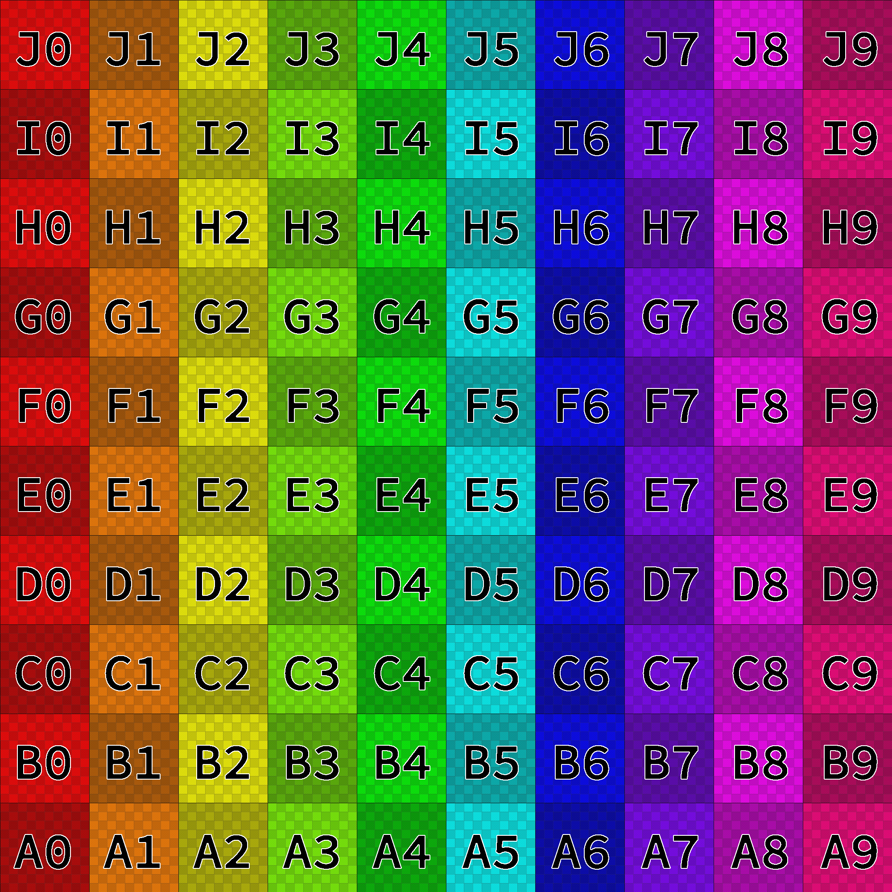
Version to test tileability of a mesh:
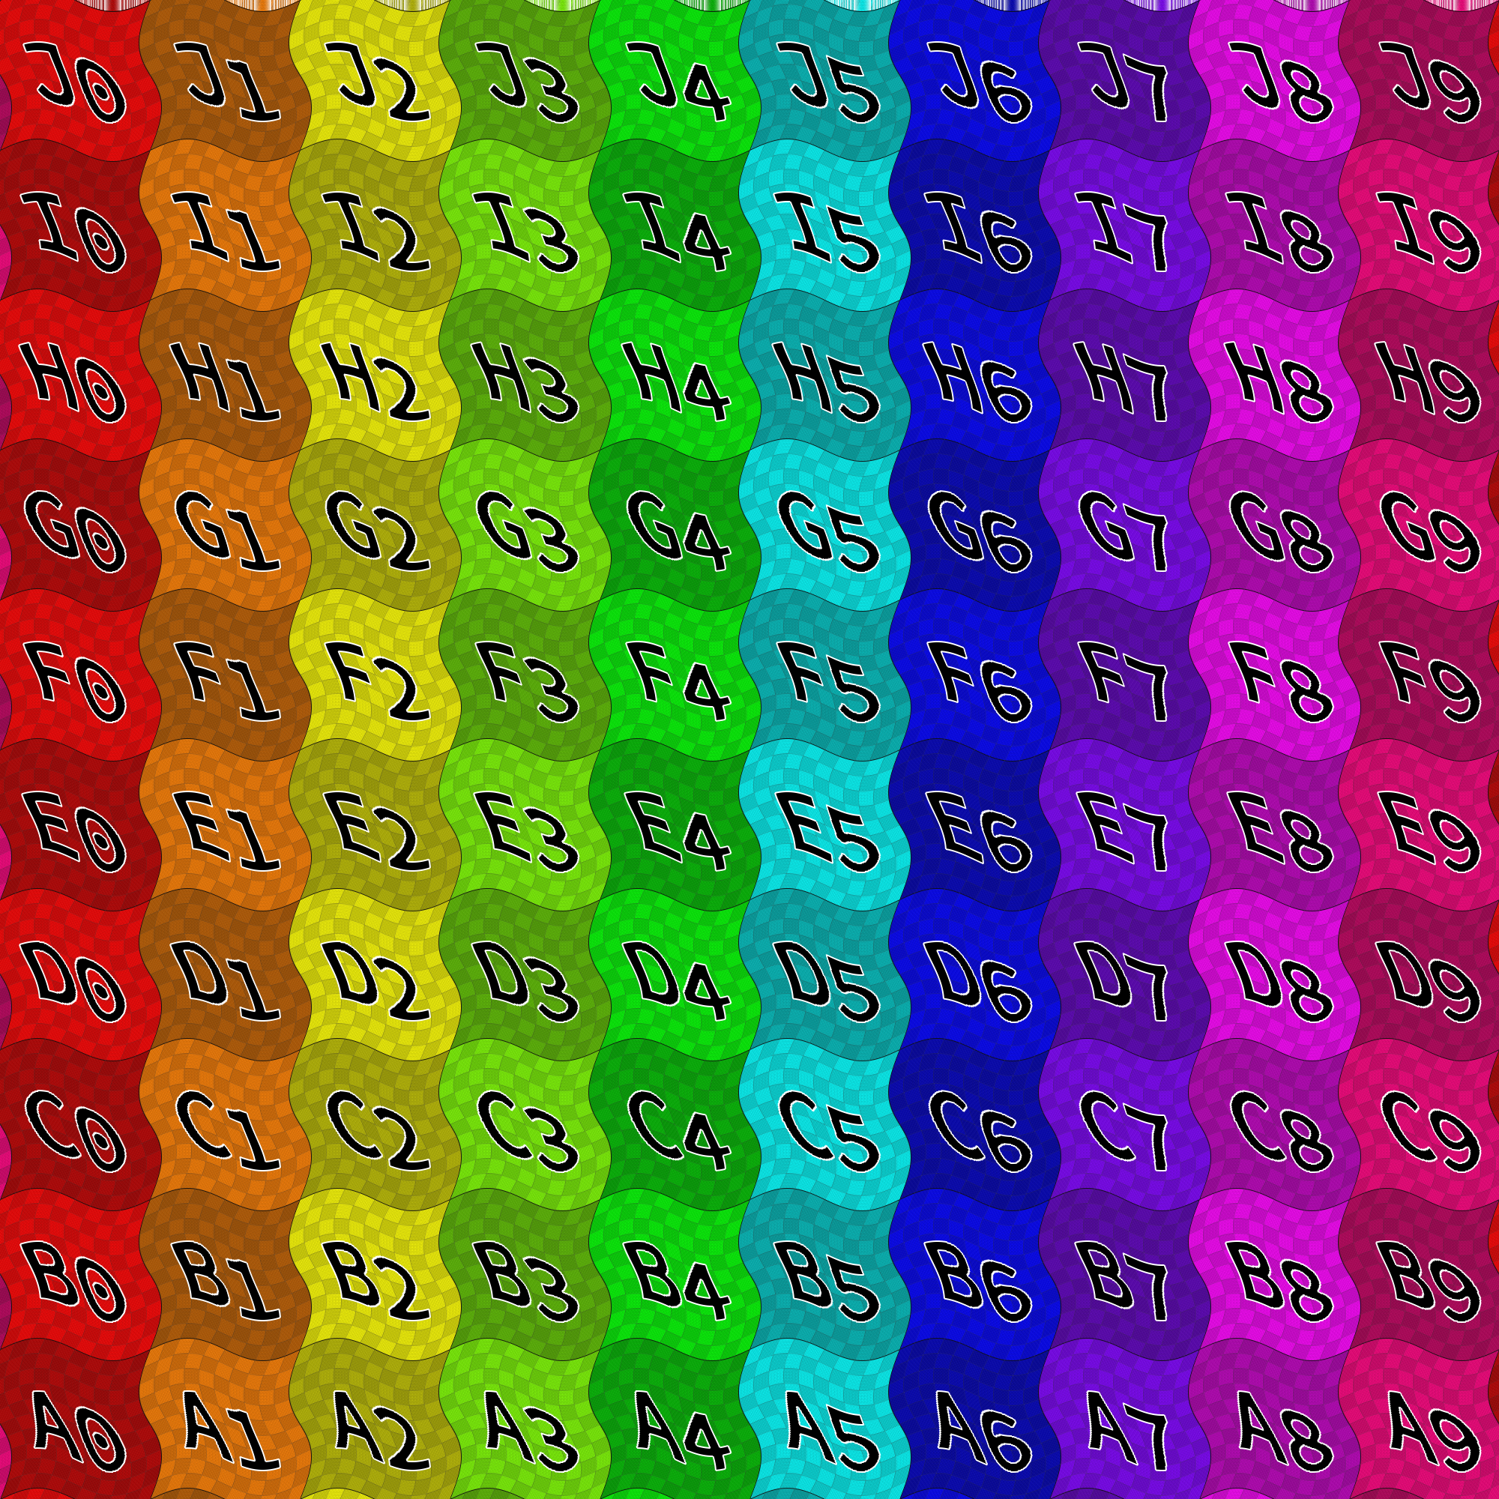

Tutorials
All assets made in tutorials are in a folder “Solutions/Tutorials” under the top-level Content folder so you can either check your work or just use the assets.

Make A New Touchplate Switch
A touchplate is a type of switch that is activated by a character standing on it. This tutorial can be used as a guide for making other kinds of switches as well. Switches already in the project include the BP_Switch_Toggle (a standard light switch the character “operates”) and BP_Switch_Button (a big button to push the character “operates”). These can be studied for further information.
- Setup. Open (a copy of) the ClassicFPS project. In the Content Browser, navigate to the top-level Content folder, and ensure there is a folder called Tutorials, and in the Tutorials folder, create a new folder called Touchplate.
- Create a touchplate mesh. This can be done in Blender, 3DS Max, Maya, or some other 3D content-generation package. Or you can use the SM_Touchplate asset already in the Content/Solutions/Tutorials/Touchplate folder. For this tutorial, I shall use the free Blender.
  - Open Blender and delete the default Cube Mesh
  - Shift-A to add mesh, select Mesh→Cylinder.
  - In the Add Cylinder properties panel (by default, lower left side), ensure the following properties:
    - Vertices: 32
    - Radius: 1
    - Depth: .1
    - Cap Fill Type: Ngon
    - Generate UVs: Yes
    - Align to View: No
    - Location: x=0.000, y=0.000, z=0.000
    - Rotation: x=0◦, y=0◦, z=0◦
  - Ctrl-S to save. Choose an appropriate directory and filename (such as “Touchplate.blend”), and save it.
  - Make sure the touchplate mesh is selected (right-click to select), and nothing else.
  - In the top menubar, select File→Export→FBX (.fbx)
  - In the Export FBX properties panel (by default, lower left side), ensure the following properties under the given tabs:
    - Main Tab:
      - Version: FBX 7.4 binary
      - Scale: 1.00
      - Apply Scale: All Local
      - Forward: -Z Forward
      - Up: Y Up
      - Selected options: all of them (Empty, Camera, Lamp, Armature, Mesh, Other)
      - !EXPERIMENTAL! Apply Transform: No
      - Custom Properties: No
      - Path Mode: Auto
      - Batch Mode: Off
    - Geometry Tab
      - Apply Modifiers: Yes
      - Use Modifiers Render Setting: Yes
      - Smoothing: Face
      - Loose Edges: No
      - Tangent Space: No
    - Armature Tab
      - Only Deform Bones: No
      - Add Leaf Bones: No
      - Primary Bone Axis: Y Axis
      - Secondary Bone Axis: X Axis
      - Armature Node Type: Null
    - Animation Tab
      - Baked Animation: Yes
      - Key All Bones: Yes
      - NLA Strips: Yes
      - D: All Actions: Yes
      - Force Start/End Keying: Yes
      - Sampling Rate: 1.00
      - Simplify: 1.00
  - Navigate to your Unreal project, then Content directory, then Tutorials directory, then Touchplate directory.
  - Set the name of the file to save to be SM_Touchplate.fbx
  - Click the Export FBX button.
  - Go to UE4 Editor.
  - You should see a popup; select “Import” (if not, click the Import button in the content browser, navigate to where you saved the FBX file, and import it).
  - Now you see an FBX Import Options panel. Ensure the following properties:
    - Skeletal Mesh: No
    - Auto Generate Collision: Yes
    - Leave advanced properties at their defaults
    - Transform: leave default all zero except scale is 1.0
    - Miscellaneous: Convert Scene yes, Force Front X Axis No, Convert Scene Unit No, advanced properties, leave defaults
    - LOD Settings: Auto Compute LOD Distance Yes
    - Materials: Search Location: Local, Import Materials: no, Import Textures: no, leave advanced options as defaults
  - Click Import All.
  - Your touchplate mesh is now in the Content Browser under Content/Tutorials/Touchplate.
  - Optional: give the touchplate a material of some kind (such aSs MI_Rubber_Blue2).
  - Close the static mesh editor window.
- Create a Touchplate Blueprint.
  - In the Content Browser in the UE4 Editor, navigate to the Content/Tutorials/Touchplate folder, the same folder where the SM_Touchplate mesh asset is.
  - Right click, then select Blueprint Class. A popup appears titled “Pick Parent Class”
  - If necessary, click the arrow next to “All Classes” to show all classes. In the search bar, begin typing BP_Switch_Base. You do not need to type it all; the BP_Switch_Base class will appear in the hierarchy below the search box.
  - Select BP_Switch_Base (because of a bug, you might have to select it twice to get it highlighted). Then click the green Select button at the bottom of the popup.
  - A new blueprint with the name “NewBlueprint” will appear in the content browser. While the name is still highlighted (if it is not, clicking the asset and hitting F2 will let you rename it), change its name to BP_Touchplate.
  - Double click the new BP_Touchplate asset to open the blueprint editor for it.
  - Make sure the Viewport tab is active (you will see a white sphere in the viewport).
  - To the left (by default), in the Components panel, click the green Add Component button. A dropdown menu will appear
  - Start typing “Static Mesh”, and select the Static Mesh option (not either of the two instanced static mesh options, just plain “Static Mesh”). Accept the entry. Hit ENTER to keep the name “StaticMesh” without renaming it.
  - With the StaticMesh component still highlighted, find the Static Mesh section of the Details panel (by default, on the right).
  - Click the box with the down arrow on it and start typing “SM_Touchplate”, and when it comes up, select SM_Touchplate for the static mesh. The newly-created Touchplate mesh will appear in the viewport.
  - Find the Collision section in the Details tab. Ensure Generate Overlap Events is checked, and that Collision Presets is set to Overlap All Dynami9c
  - Open the Event Graph tab. If the tab is not there, you can open it by double-clicking the Event Graph item under Graphs in the My Blueprint panel (by default, to the left below the Components panel; if the My Blueprint panel is not there, it can be opened from the menu bar, Window menu). There is a bug in some versions of UE4 so if clicking the EventGraph item doesn’t work, right-click and select “Open in New Tab”.
  - Highlight the Static Mesh component in the Components tab.
  - To the right (by default), in the Details tab, scroll down, and find a green button with a plus sign in it labeled On Component Hit. Click it. An On Component Begin Overlap (StaticMesh) node appears in the Event Graph blueprint.
  - On the On Component Begin Overlap event node, click and drag rightward from the right-pointing white-outlined arrow to place a new node. When you let go of the mouse button, an Executable Actions popup will appear.
  - Type “Toggle Action” in the search bar, and when it appears, click on Toggle Action. A new node should appear called Toggle Action, connected to the On Component Begin Overlap node by a white line. (This represents an execution path from the event node to the toggle action node, so that whenever the touchplate is hit, the toggle action event will be thrown. In the Switch Base, this toggle action just toggles the switch between on and off).
  - Compile the blueprint (Click the compile button in the toolbar), then save the blueprint (click the Save button in the toolbar). Close the blueprint.
- Place the Touchplate in the Level and Wire it up to something.
  - Create a new level: select File→New Level, and click Default. Use Ctrl-S to save it, and give it the name Touchplate_Test, and save it in the Content/Tutorials/Touchplate directory.
  - Ensure the Content Browser is in Content/Tutorials/Touchplate where you can see the BP_Touchplate and the SM_Touchplate assets.
  - Drag the BP_Touchplate asset into the scene in the viewport, and set it on the default platform somewhere. Currently the touchplate does not do anything because it is not connected to anything controllable.
  - Navigate to Content/ClassicFPS/Environment/Props/Lights in the Content Browser, and find BP_Lamp_Ceiling. Drag this asset into the scene and move it somewhere reasonable (lift it up above the platform by selecting the viewport, clicking W to show the Move widget, and clicking and dragging the blue arrow on the Move widget) to make it visible.
  - Click the Touchplate actor in the scene to select it.
  - In the details panel, in the State section, are a lot of inputs. We shall only use a few of them. Click the white Plus sign to the right of Controlled Objects to add a new array element. Element 0, set to the value None, appears
  - Click the box containing None and the down-pointing triangle to see a list of assets in the current scene. Find and select the BP_Lamp_Ceiling asset. Thus, this touchplate will control the lamp we just placed in the level.
  - Click the right-pointing right triangle next to On Enter State Actions. Currently the action for state 0 is None. Change that to “Off”, so when the touchplate is in state 0, the light will be turned off.
  - Click the white Plus sign to the right of On Enter State Actions to add another element to the array. A new element 1 will appear, with value None.
  - Change the None to “On”. Thus, when the touchplate enters state 1, the light will be turned on.
  - Note the touchplate’s current state is 0. Thus, it starts “Off”. Let us make sure the light is off so the states are sync’d when the level is played. Click the light asset in the scene. In the controllable section, click the right-pointing white arrow next to Light. Change the Light is On checkbox to “Unchecked”. In the scene, the light will turn off. Now the light and the touchplate are sync’d, both in the “Off” state.
  - Test by clicking the Play button in the toobar. When you walk on the touchplate, the light should turn on. When you walk away and walk back onto the touchplate, the light should turn off.
  - Type CTRL-S to save the level.

