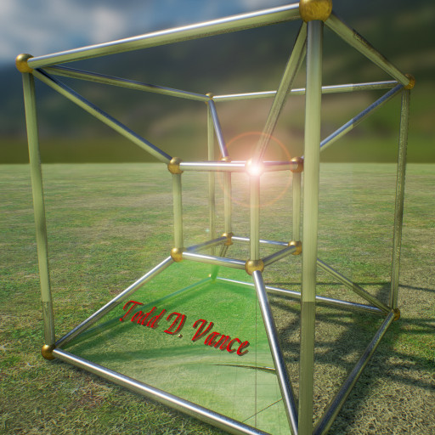

Hexagon Tutorial
How to make hexagons in Gimp
© 2016 Todd D. Vance
Mathematics, Geometry, Images
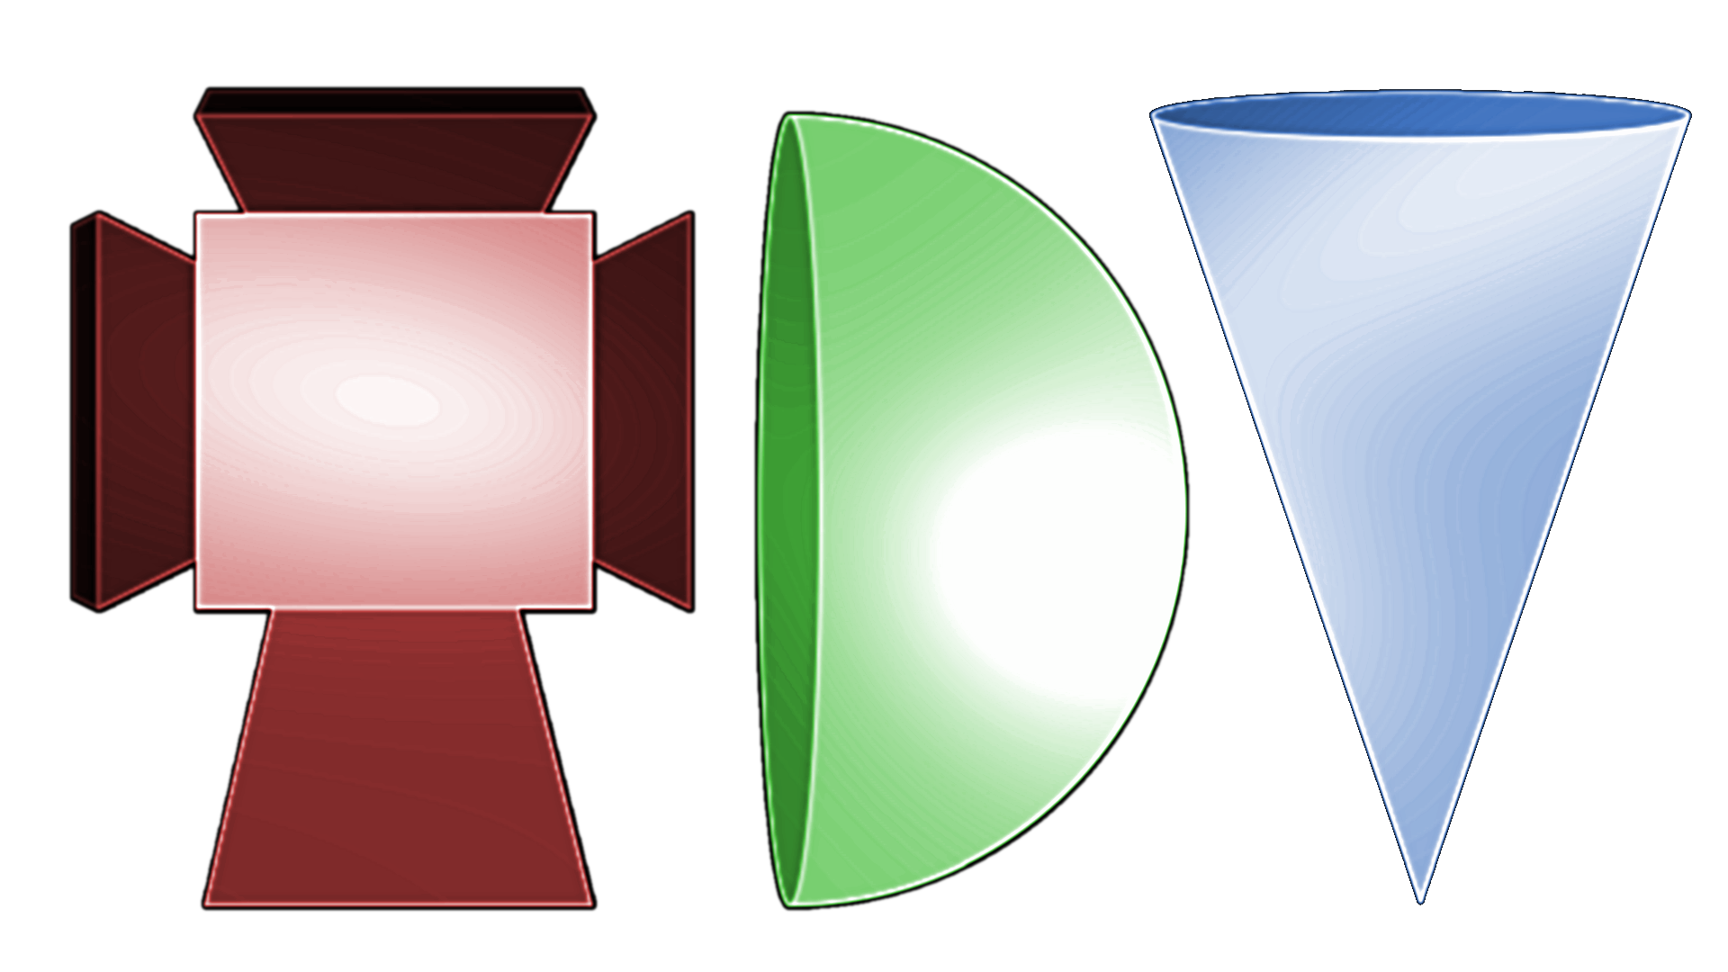
Permission is hereby granted, free of charge, to any person obtaining a copy of this software and associated documentation files (the "Software"), to deal in the Software without restriction, including without limitation the rights to use, copy, modify, merge, publish, distribute, sublicense, and/or sell copies of the Software, and to permit persons to whom the Software is furnished to do so, subject to the following conditions:
The above copyright notice and this permission notice shall be included in all copies or substantial portions of the Software.
THE SOFTWARE IS PROVIDED "AS IS", WITHOUT WARRANTY OF ANY KIND, EXPRESS OR IMPLIED, INCLUDING BUT NOT LIMITED TO THE WARRANTIES OF MERCHANTABILITY, FITNESS FOR A PARTICULAR PURPOSE AND NONINFRINGEMENT. IN NO EVENT SHALL THE AUTHORS OR COPYRIGHT HOLDERS BE LIABLE FOR ANY CLAIM, DAMAGES OR OTHER LIABILITY, WHETHER IN AN ACTION OF CONTRACT, TORT OR OTHERWISE, ARISING FROM, OUT OF OR IN CONNECTION WITH THE SOFTWARE OR THE USE OR OTHER DEALINGS IN THE SOFTWARE.

Table of Contents
1 Introduction 2
2 A Simple Hexagon 2
3 A Tileable Hexagon 5

Introduction
I was playing around with some game ideas and needed some hexagon-shaped tiles. Rather than find some on the web, I decided to see if I could make some. I’m a retired mathematician, so I figured that’s something I should be good at. Of course, it’s been a long time since I took Geometry in high school, so I had some remembering to do….

A Simple Hexagon

While we like images to have dimensions that are powers of two, a regular hexagon’s height and width are different, so one or the other dimension is not a power of two. We shall make a regular hexagon in which the width is a power of two, and the height is a little less. It will be oriented so that the top and bottom are edges and the left and right ends are vertices:
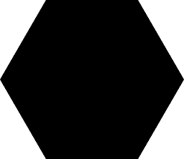
First some mathematics. You might recall from high school Euclidean Geometry class that one can construct a hexagon with a compass and straightedge by first drawing a circle, then keeping the same radius, mark off six vertices on the circle. It is remarkable that the radius (from the center to a vertex) of a hexagon is equal to the length of one of its sides (so a regular hexagon is made up of six equilateral triangles arranged like slices of a pie).
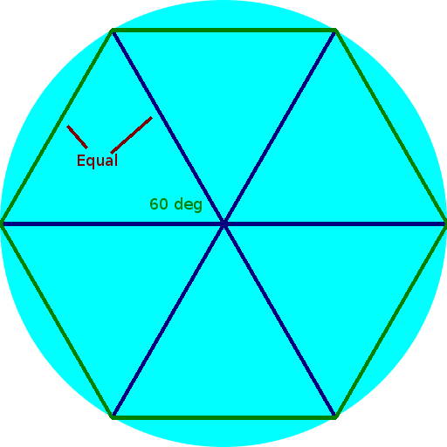
Also, recall from geometry that if you cut an equilateral triangle in half by dropping a diagonal from a vertex to the midpoint of the opposite side, each half-triangle will be a 30-60-90 right triangle. There is a theorem in high school geometry that says that in a 30-60-90 triangle, if the hypotenuse (the longest side, opposite the 90-degree angle) is of length x, then the side opposite the 30-degree angle is x/2 (intuitively obvious), and (also provable with the Pythagorean theorem) the side opposite the 60-degree angle is x/2 times the square root of 3.
This is all the information we need to determine the coordinates of the vertices of the hexagon.
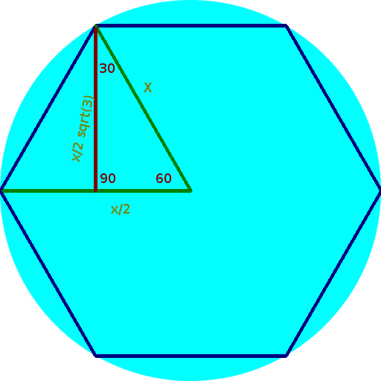
So, let’s fire up the free, open-source Gnu Image Manipulation Program (Gimp) (other tools should also work, but it’s easiest if the tool lets you define a grid).
Suppose you want to make a hexagon that is 512 pixels wide. Then the radius (the distance from the center to a vertex) is 256, so each equilateral triangle has side-length x = 256. Thus x/2 is 128, so the x coordinate of the upper left vertex of the hexagon is 128. The lower left vertex has the same x coordinate. The upper right and lower right vertices both have x coordinate 512 – 128 or 384. Thus, we would like a grid whose horizontal size is 128.
As for the vertical size, we need to do some computation. The height of the upper-left vertex above the central horizontal line is (x/2)*sqrt(3). Since x is 256 and sqrt(3) is about 1.732, this is 256/2*1.732 = 221.6, or call it 222. Thus, we want a vertical grid size of 222. The image, we now see, is 512 units wide by 222*2 = 444 units tall.
- So, in Gimp, select File→New and create a blank image of size 512x444, and hit OK.
- Now, select Image→Configure Grid, and hit the tiny “chain link” icon below the Spacing section to break the “keep aspect ratio” feature. Change the grid spacing width to 128 and the grid spacing height to 222, and hit OK.
- The grid is not visible yet, so select View→Show Grid.
- Finally, select View→Snap to Grid to ensure drawing and selection operations use the grid for accuracy.
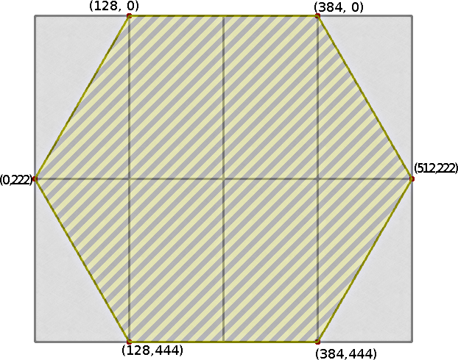
Now, it is easy to draw a hexagon on the grid using a pen or pencil tool, or use the free select tool to select a hexagon region and the paint tool to fill it in with a color.

A Tileable Hexagon
But what if you want a tileable hexagon? The same grid works, but you need to change the image size. If the grid size is 128 by 222, the image has to be 6 grid units wide by 4 grid units tall: create a new image 768x888 pixels, set the grid size to 128x222, and now draw lines or select regions with this pattern instead:
