Robot Dynamite

Game Design Document

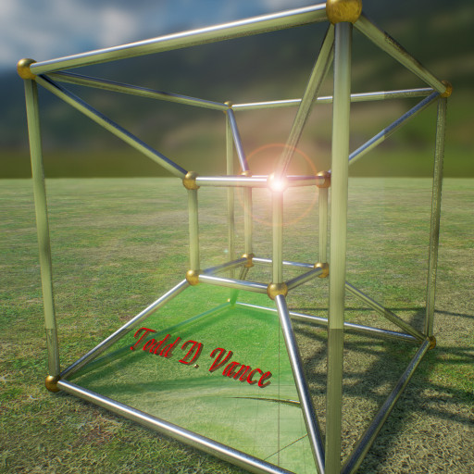

Prepared by:

Todd D. Vance
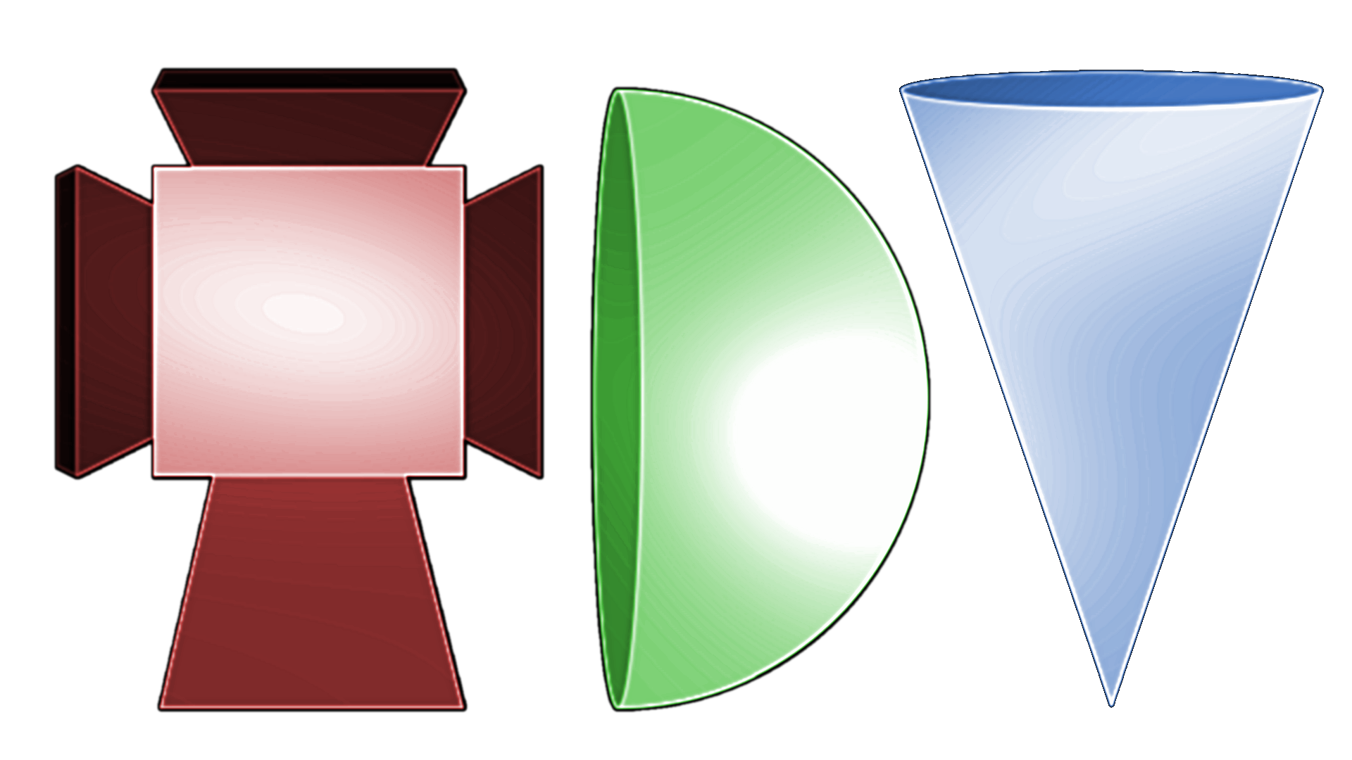

2017

Table of Contents
Revision Notes 2
Introduction 2
Game Analysis 2
Genre 2
Game Elements 3
Game Content 3
Theme 3
Style 3
Game Sequence 3
Players 3
Game Reference 3
Game Technical 3
Game Sales 3
Game Atmosphere 4
Game Play 4
Overall Game States 4
Actions: 5
Options 5
HUD 5
Enemy AI 5
Art 6
Non-pawn actors 6
Inventory 6

Revision Notes

Introduction
Alien robots invade the Earth. Earth releases its own robot to fight them.

The purpose of this project is to design and implement a first-person shooter (FPS) game using the Unreal Engine 4 game engine. This project includes at least one complete level of game with documentation. The level will include a representative sample of the things found in FPS games. The game will be single-player and will be focused on action.

Game Analysis

Genre

Action, first person 3D, shooter

Game Elements

Shooting, action, secrets, science-fiction

Game Content

Realism

Theme

One hero against a hoard of attackers

Style

Realism

Game Sequence

simulation

Players

1

Game Reference
Duke Nukem 3D

Game Technical
Single player, PC-based, 3D with 2D GUI systems, Unreal Engine 4

Game Sales
Free, MIT License

Game Atmosphere

Insert sketches here.

Game Play
Use mouse/keyboard to explore level, kill (or evade) enemy robots without being killed, and find the level exit to continue to the next level. On the way, pickups for health, armor, weapons, and ammunition, as well as optional secret areas to explore.

The first level is a train station: Robot Dynamite took a train to The Old City where the first wave of killer robots landed.

Player movement abilities include running, lunging, jumping (double-tap for higher jump), crouching.

Player starts with one weapon but can reload or get new weapons from pickups. Weapon switches automatically if pickup is “better” weapon or automatically to best available weapon when current weapon is out of ammo. This feature can be turned off in settings.

Player starts with full health and armor. Hits reduce health, inversely related to the amount of armor, while also reducing armor. Pickups restore health or armor. Super-pickups put health or armor above the normal maximum.

Player can change the difficulty of the next level (or first level if just starting) between easy, normal, hard, impossible. This affects pickups and enemies, as well as the extent that enemies and pickups respawn.

On death, the player restarts the level (future development: save point) with the ammo/health/armor/weapons that were available at the start of that level just played. This is equivalent to save checkpoints being the starts of levels.

New levels are unlocked as prior ones are completed. This persists between game runs

Overall Game States

Splash screen → Main Menu → Quit | Options | New Game | previously unlocked level

new game | previously unlocked level→ choose difficulty → Game

Game → Options | Next Level | Die

Actions:
Look/aim: mouse
Fire: left mouse button
Move forward: right mouse button
strafe: WASD
Jump: spacebar
Crouch: C
Lunge: V
Options menu: O or ESC
Change weapon: 1-9 or mouse wheel
Select from inventory: [ and ]
Use from inventory: ENTER (ENTER also stops using if continuous, like jetpack)
Use/Push/Do something: E or F (e.g. open doors)

Optional: Tab: show map

Options

Controls: change controls, mouse sensitivity, invert y axis of mouse
Difficulty: change difficulty of next level loaded (including this level if you die first)
Volume: music and sfx
Resume (game or main menu == title screen)
Return to title screen (if in game)
Exit

HUD
Shows health, armor, current weapon ammo, ammo for each weapon in inventory, current item of inventory

Enemy AI
Patrol between waypoints
Wander randomly
Chase player if detected (sight, hearing, was shot at)
Go to suspected location of player
Flee player if health is low
Attack player if in range

Art
Buildings, walls, floors, ceilings, stairs.
train tracks, bridges, roads, fences
monuments and artifactrs
trash cans, trash
posters, etc.

Non-pawn actors
Elevators
Escalators (maybe)
Doors: swing doors, sliding doors (doom style and elevator style), revolving doors
Movement components: spin, fall, incremental transform (e.g. elevator with multiple floors)
Teleporters
Conveyer belt
Secret area
Level exit
Mirror (maybe)

Inventory
Jetpack
Speed
SCUBA
Night Vision
Flashlight
keycards

