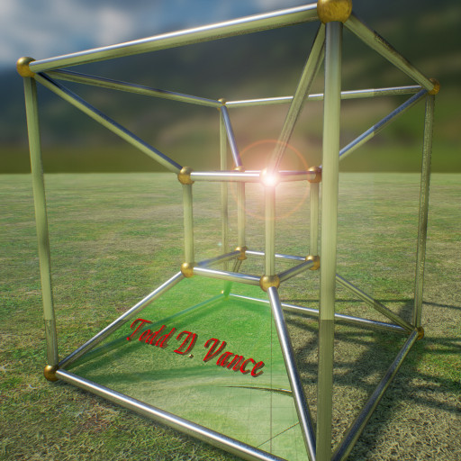

Sling David
Game Design Document Version 0.2
Be David and smash the structures built by Goliath of Gath
© 2016 Todd D. Vance
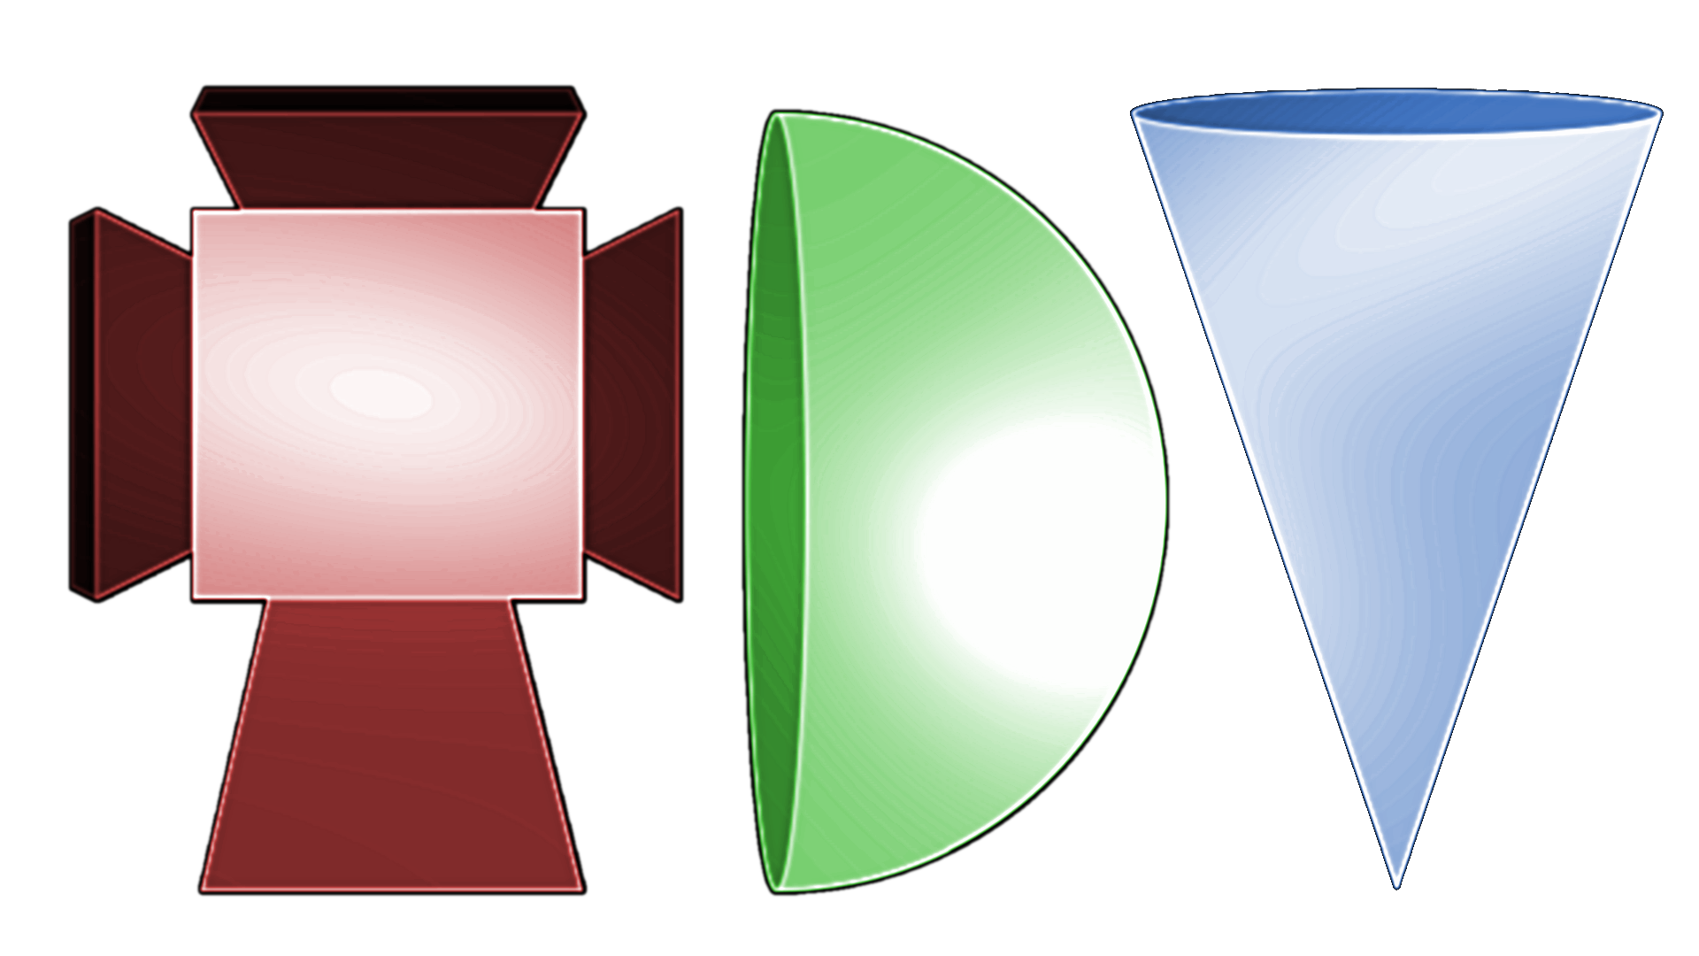
Permission is hereby granted, free of charge, to any person obtaining a copy of this software and associated documentation files (the "Software"), to deal in the Software without restriction, including without limitation the rights to use, copy, modify, merge, publish, distribute, sublicense, and/or sell copies of the Software, and to permit persons to whom the Software is furnished to do so, subject to the following conditions:
The above copyright notice and this permission notice shall be included in all copies or substantial portions of the Software.
THE SOFTWARE IS PROVIDED "AS IS", WITHOUT WARRANTY OF ANY KIND, EXPRESS OR IMPLIED, INCLUDING BUT NOT LIMITED TO THE WARRANTIES OF MERCHANTABILITY, FITNESS FOR A PARTICULAR PURPOSE AND NONINFRINGEMENT. IN NO EVENT SHALL THE AUTHORS OR COPYRIGHT HOLDERS BE LIABLE FOR ANY CLAIM, DAMAGES OR OTHER LIABILITY, WHETHER IN AN ACTION OF CONTRACT, TORT OR OTHERWISE, ARISING FROM, OUT OF OR IN CONNECTION WITH THE SOFTWARE OR THE USE OR OTHER DEALINGS IN THE SOFTWARE.

Table of Contents
1 Game Concept 2
2 Rules and Mechanics 3
2.1 Summary 3
2.2 Game States 3
2.2.1 Splash Screen 3
2.2.2 Progress Map 3
2.2.3 Options Menu 4
2.2.4 Start Level 4
2.2.5 Empty Sling 4
2.2.6 Get A Rock 4
2.2.7 Sling With Rock 5
2.2.8 Sling Spinning 5
2.2.9 Rock Deployed 5
2.2.10 End Level 5
2.2.11 Lose Level 6
2.2.12 New Page 6
3 Asset Requirements 6
4 Monetization 6
5 Concept Art 7
5.1 Prototype screenshot 7

Game Concept
This is the author’s first Unity3d game that is not a clone of a classic. It may share similarities with a very popular game, but the principal mechanic is quite different.
Emulate Boy David (who would later become King David) and try to match his skills with the sling. Drag the sling with the mouse (or touchscreen) repeatedly to build angular momentum and release to send the stone flying toward various structures and attempt to destroy them.

Rules and Mechanics

Summary
The sling transfers drag velocity to rotational energy of the stone. When the stone is circling at the desired speed, and when it reaches the right place in the circle, release and let the stone fly. The stone, if aimed properly, smashes into structures made of blocks of various types, bonus smash-ups (like pickups, but you smash them instead), and enemies. You are given a fixed number of rocks to use, and must destroy all the enemies to continue to the next level. Points are scored for damage dealt and destruction of items. More points are given for destroying an object with fewer separate colisions.

Game States

Splash Screen
- Lasts 2.5 seconds, then goes to last saved position in Progress Map
- Shows company logo
- Shows game title
- Plays short intro music

Progress Map
- If first level on the next page was just unlocked, unlock a new page and go to New Page state before doing the rest
- A graph of progression through game levels
- Locked levels are grayed out
- Current level is highlighted, and is usually the last unlocked level
- User can select any unlocked level, or go forward/backward to other pages of the progress map (if any have been unlocked yet).
- Each level shows highest score attained on that level, with some indication of how that compares to par levels.
- Last score attained and which level it was on is displayed on the page
- Selecting a level goes to Start Level for that level
- buttons for various options menus, pressing them goes to an appropriate options state
  - Options Menu button, the “cog” or settings button goes to Options Menu state.

Options Menu
Allowed actions are are:
    - Set music volume
    - Set sound effects volume
    - Return to Progress Map state

Start Level
- Load appropriate level scene
- Show score (initially 0) and highest score attained for this level, as well as par rating
- Optional animation of level
- Disable the End Level button
- After time required for animation, etc., go to Empty Sling state

Empty Sling
- Show the sling and the current inventory of rocks
- After a short delay (1.5 seconds), go to Get A Rock state

Get A Rock
- If no enemies remaining, enable End Level button
- If no rocks remaining, enable End Level button.
- If there are rocks remaining, remove first rock from inventory and add it to sling
- Pressing End Level, if enabled, goes to End Level state
- If sling has rock, go to Sling With Rock state

Sling With Rock
- If sling is dragged, go to Sling Spinning state
- If End Level button is enabled and pressed, go to End Level state

Sling Spinning
- While sling is dragged, increase angular momentum of rock, otherwise decrease angular momentum
- When drag is released, go to Rock Deployed state
- If drag is released and speed is too slow, treat as a “cancel” and return to Sling With Rock state

Rock Deployed
- Deploy the rock
- Go to Empty Sling state
- See Rock Physics section for how the rock behaves in the level
- Enable RestartLevel button

End Level
- If enemies remain, go to Lose Level state
- Show bonus points for remaining rocks (in inventory and in sling)
  - 5000 bonus for first rock, multiply by 2 for each additional remaining rock
- Show animations for new high score attained and new par level attained
- Unlock next level if not already unlocked
- Set next level as “current level”
- Go to Progress Map state

Lose Level
- Show Lose Level animation
- This level is still “current level”
- Go to Progress Map state

New Page
- May show animation for new page
- Show new page, first level of page, which is unlocked, is current level
- Return to Progress Map state

Asset Requirements
- Rocks to throw
- Blocks to break
- Enemies to kill
- SmashUp bonus items to destroy
- Background art
- Hand-crafted levels
- Animations for cutscenes, etc.
- Progress map pages
- Indicators of varous types (bonus score, par levels, etc)

Monetization
None yet.

Concept Art

Prototype screenshot
