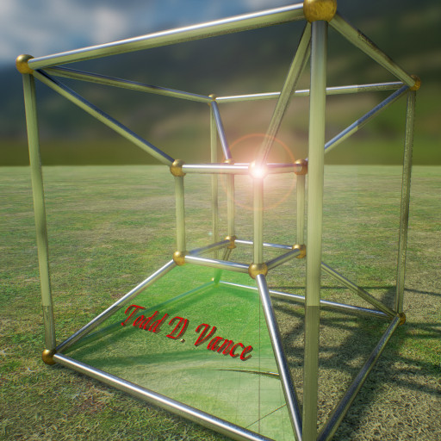

Sling Smash
Game Design Document Version 0.9
Be David and smash the structures built by Goliath
© 2016 Todd D. Vance
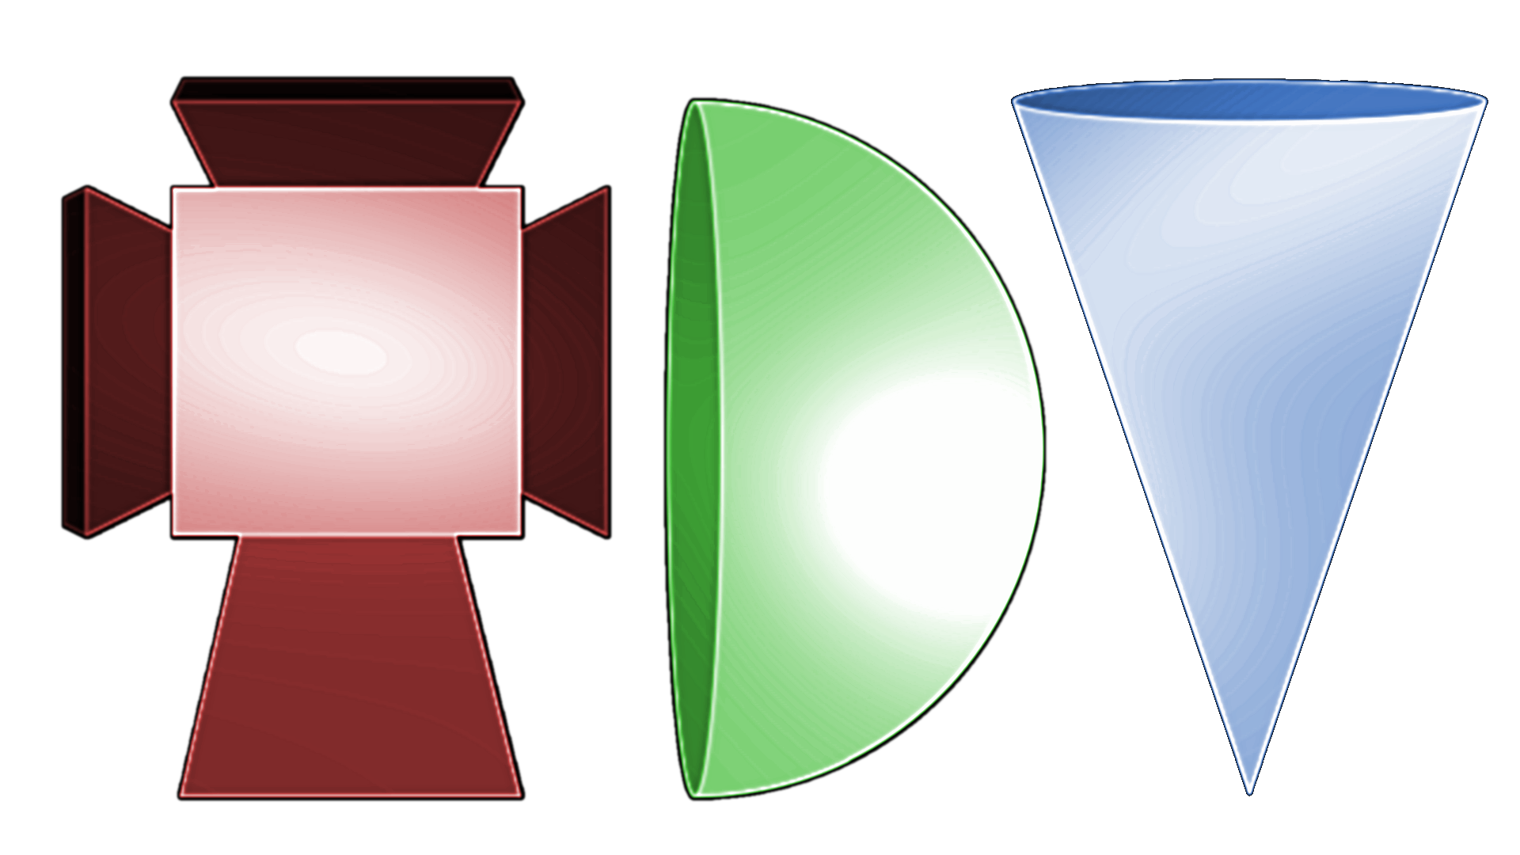
Permission is hereby granted, free of charge, to any person obtaining a copy of this software and associated documentation files (the "Software"), to deal in the Software without restriction, including without limitation the rights to use, copy, modify, merge, publish, distribute, sublicense, and/or sell copies of the Software, and to permit persons to whom the Software is furnished to do so, subject to the following conditions:
The above copyright notice and this permission notice shall be included in all copies or substantial portions of the Software.
THE SOFTWARE IS PROVIDED "AS IS", WITHOUT WARRANTY OF ANY KIND, EXPRESS OR IMPLIED, INCLUDING BUT NOT LIMITED TO THE WARRANTIES OF MERCHANTABILITY, FITNESS FOR A PARTICULAR PURPOSE AND NONINFRINGEMENT. IN NO EVENT SHALL THE AUTHORS OR COPYRIGHT HOLDERS BE LIABLE FOR ANY CLAIM, DAMAGES OR OTHER LIABILITY, WHETHER IN AN ACTION OF CONTRACT, TORT OR OTHERWISE, ARISING FROM, OUT OF OR IN CONNECTION WITH THE SOFTWARE OR THE USE OR OTHER DEALINGS IN THE SOFTWARE.

Table of Contents
1 Game Concept 2
2 Rules and Mechanics 2
3 Asset Requirements 3
4 Monetization 3
5 Concept Art 4
5.1 Prototype screenshot 4

Game Concept
This is the author’s first Unity3d game that is not a clone of a classic. It may share similarities with a very popular game, but the principal mechanic is quite different.
Emulate Boy David (who would later become King David) and try to match his skills with the sling. Drag the sling with the mouse (or touchscreen) repeatedly to build angular momentum and release to send the stone flying toward various structures and attempt to destroy them.

Rules and Mechanics
The slick transfers drag velocity to rotational energy of the stone. When the stone is circling at the desired speed, and when it reaches the right place in the circle, release and let the stone fly. The stone, if aimed properly, smashes into structures made of blocks of various types, bonus smash-ups (like pickups, but you smash them instead), and enemies. You are given a fixed number of rocks to use, and must destroy all the enemies to continue to the next level. Points are scored for damage dealt and destruction of items. More points are given for destroying an object with fewer separate colisions.

Asset Requirements
Stones of various types, blocks of various types, enemies of various types, smash-ups of various types, background art, levels built by hand. (need a way to ensure stability, for example a grid system for accurate placement)

Monetization
None yet.

Concept Art

Prototype screenshot
