Computer-aided Detection Of Pneumonia Using Deep Learning Techniques

by

Thomas Woodward
WOO17664646

A Dissertation Presented in Partial Fulfillment
of the Requirements for the Degree
of Bsc (Hons) Computer Science

School of Computer Science

University of Lincoln
CONTENTS

ABSTRACT i
OBJECTIVES ii
LITERATURE REVIEW iii, iv
TOOLS AND METHODOLOGY v, vi
DESIGN, DEVELOPMENT AND EVALUATION vii
Data analysis and augmentation vii, viii, ix
The Neural Network x, xi, xii, xiii

MODEL PERFORMANCE AND CONCLUSION xiv, xv

REFLECTIVE ANALYSIS xvi

REFERENCES xvii, xviii
ABSTRACT
Pneumonia is swelling (inflammation) of the tissue in one or both of the lungs. It’s usually caused by bacterial or viral infections such as COVID-19 (Bell and Knipe, 2020), this can lead to fatal complications such as Pleurisy or Septicemia (nhs.uk, 2019). Pneumonia is one of the greatest contributors to childhood mortality and morbidity in the world, especially in resource-poor regions (Duke T, 2005). Accurate and fast detection of pneumonia in children is paramount to the case survival rate. Automation of the diagnosis process will reduce human error and deliver reliable healthcare to resource scarce areas. Evaluated is a fast machine learning model that can accurately diagnose pneumonia using only chest x-rays. This model is cheap to train, fast to run, has low memory requirements and requires no specialized hardware or GPUs to use. Due to the size of this model, it may successfully be deployed on old computers as commonly found in the developing world. The conclusions drawn in this study are as follows: machine learning models to accomplish non-trivial tasks need not be excessively large or expensive. While successful in accurately diagnosing pneumonia, the accuracy may not be statistically relevant in a diagnostic or healthcare setting depending on the prior probability of a subject having pneumonia.
OBJECTIVES
The objectives which were planned prior to development are listed below to suggest how the project is structured.

- A suitable data-set was be sourced or built. The data-set must have enough images of normal/Pneumonia inflamed lungs. The data-set should be of a good quality and ideally should have been verified by trained Physicians. The data-set may also be artificially inflated using image processing techniques.

- A suitable model must be selected. After this, the architecture of the model needs to be defined.

- Appropriate software must be identified to develop the project. This includes, the programming language, Integrated Development Environment, compiler, libraries, etc.

- The software must then be integrated into a build-system and moved to a Git repository so changes can be properly tracked.

- The previously selected model then needs to be developed.

- After the model has been developed, the data-set will be split up into a training and testing set. It must be trained with images from the training data-set.

- The model must then be tested using the test data-set. The images will be passed through the model and compared with the “ground truth” to see whether or not the model works. Ideally the model will be “good enough” for use in a medical environment.
LITERATURE REVIEW
Research has shown that Pneumonia accounts for a substantial proportion of deaths worldwide. Reading deeper into this, a number of studies have found that Pneumonia is often misdiagnosed or unfortunately not diagnosed at all. This literature review explains the reasoning behind the project.
“Antibiotic Timing and Errors in Diagnosing Pneumonia” by James A. Welker, DO; Michelle Huston, MD; Jack D. McCue (Welker, Huston and McCue, 2008) is an American paper published in 2008. The paper states that a “Time to first antibiotic dose (TFAD) of less than 4 hours has been made a core quality control measure in hospitals”. The study concludes that reduction in the required TFAD from 8 to 4 hours reduces the accuracy by which Emergency Department Physicians diagnose Pneumonia. These results complement the rationale of the project. If the chest X-rays were automatically scanned by a fully trained neural network the Physicians would have swift access to accurate results. This would decrease the TFAD.
The next relevant piece of literature consulted was “Deep Learning for Medical Image Processing: Overview, Challenges and Future” (Razzak, Naz and Zaib, 2017) by Muhammad Imran Razzak, Saeeda Naz and Ahmad Zaib. This paper discusses the challenges of using deep learning techniques for medical image processing. The paper compares different architectures of Deep learning models which helped me conclude which one was optimal for this project. The paper concludes by mentioning the “tremendous performance of Deep learning” but recognizes that a drawback could be the “unavailability of large, annotated datasets”, therefore I will need to ensure that the dataset I acquire is labeled and is large enough to train the model without effecting the performance of the algorithm.
The next two pieces of literature examined were “Radiology of bacterial pneumonia” (Vilar, Domingo and Cogollos, 2004) by José Vilar, Maria Luisa Domingo and Jonathan Cogollos and “Imaging of community-acquired pneumonia” (Nambu et al., 2014) by Atsushi Nambu, Katsura Ozawa, Noriko Kobayashi, Masao Tago. Both of these studies analyze how chest radiography is used to identify Pneumonia. Although not all of the information is important to me in these studies, the papers have taught me how to detect and characterize different types of Pneumonia from chest x-rays. The features used to classify Pneumonia in these papers are the same features that the neural network needs to learn to be successful.

“An estimated nearly 1.2 million children younger than 5 years died in 2011 from pneumonia. Most of these deaths occurred in developing countries where access to care is limited and interventions that have improved care in developed countries are scarce.” as noted by (Izadnegahdar, Cohen, Klugman and Qazi, 2013). This research addresses the challenges of diagnosing and treating Pneumonia in the developing world and recognizes that care is limited in developing countries and interventions that have improved care in these countries are scarce. The goal of this project is to improve the level of care in these countries, the artefact will require no specialized hardware or GPUs meaning it can easily be trained and used on low cost computers as commonly found in the developing world. If properly trained, this model will red-flag Pneumonia positive chest radio-graphs which will quicken the diagnosis and decrease the overall mortality rate. A similar study exists here (Adegbola and Obaro, 2000), this study provides further reasoning for such a software to exist, stating that “Pneumonia is the leading cause of the infection-attributable mortality in this age-group, accounting for >2 million of the deaths. These deaths are potentially preventable if appropriate clinical and laboratory tools are in place to facilitate early detection of the pneumonia”.
Another paper I read was “Classification of Malaria Infected Cells Using Deep Convolutional Neural Networks” (Pan, Dong and Wu, 2018) by W. David Pan, Yuhang Dong and Dongsheng Wu. This paper is not related to Pneumonia, but it is still relevant to Computer-aided diagnosis. The study aims to classify Malaria-infected cells from images and they use the same class of deep neural networks that I am planning to use. The model was capable of achieving very high classification accuracy for automated diagnosis using a CNN, which is promising.
TOOLS AND METHODOLOGY
Since the project is completed alone, the benefits of a software development methodology won’t be as apparent, but it is still necessary for the reasons explained below. Firstly, without proper focus and objectives (as shown in page ii), I could quickly lose track. A secondary benefit of a methodology is that it helps to schedule and plan the project, since the project is time constrained.
The product itself is a machine learning model, this means there is no need for a GUI or other unrelated features, the product can and is fully controlled using a command-line interface. Further addition of these components (if required) may be done at a later time.
The development process was broken up into several small chunks which are defined in the following section, this method of working was inspired by the UNIX philosophy, which emphasizes building simple, clear, modular and extensible code to ensure that the software can be easily maintained and repurposed (Raymond, 2003). The UNIX philosophy also boils down to one law, the “Keep It Simple Stupid (KISS)” principle (Milicchio, 2020).
A project methodology must be chosen that allows for flexibility and freedom during the development process. This immediately rules out the use of plan-based methodologies and instead suggests that a more ‘organic’ approach to solving the problem should be utilized.
The project methodology should also allow me to keep a working build to demonstrate to my project supervisor or others who may be interested. After reading the advantages in the book Fundamentals of information systems (Stair and Reynolds, 2015), combined with the information specified above, the agile methodology was used to organize the development process.
Initially when choosing a programming language the choices were narrowed down to C++ and Python. According to a survey of over two-thousand machine learning developers (Voskoglou, 2020), Python is by far the most popular language for machine learning. However, at the time I was already using Python for the “Machine Learning” module on my course, so I wanted to use something different. C++ is always a great choice as it has a speed advantage, this is because Python is interpreted whilst C++ is compiled. To add to this, Python is a lot more of a “memory hog” than C++, this is especially important as this program should run on computers with low-grade specifications which are more likely to be found in the developing world. Both languages have a plethora of libraries available that would “get the job done”, so this was not a concern. Taking the information from this paragraph into account, C++ was used.
CMake was used to control the software compilation process. CMake was the obvious choice, it is the industry standard for building C++ programs. A lot of libraries use it (including the library used in this project), it works on all platforms.
“tiny-dnn” is a C++ library that is small and easy to integrate. It is suitable for deep learning on limited computational resources, making it ideal for this project. For simplicity (KISS) and project development speed, I decided to use this header-only library with no build system requirements. The library doesn’t utilize the GPU, but it is still relatively fast, with 98.8% accuracy on MNIST in 13 minutes of training on a Core i7-3520M (tiny-dnn/tiny-dnn, 2020).
Git was used to track changes in the source code during the development phase. The main advantage of using Git is the branching capabilities, every time a new feature is added a branch was made which was later merged into master, this meant I could maintain a working version in the master branch.
Imagemagick was used to augment the data-set. Imagemagick is free software used to edit or convert images, it provides all the image transformation methods needed and works with a variety of image formats. The main benefit of Imagemagick is how the commands can be ran from a terminal, this means simple Bash scripts can be wrote to quickly prepare the entire data-set.
DESIGN, DEVELOPMENT AND EVALUATION
NOTE: The Project Demonstration can be viewed here
Data analysis and augmentation
A suitable data-set has been identified and is accessible here (a shell script exists in the project directory to automatically download this data-set). The data-set consists of 5,863 X-ray images and is split into 2 categories (Pneumonia/Normal). These chest X-ray images were selected from patients aged 1 to 5 years old from Guangzhou Women and Children’s Medical Center, China. All unreadable or low quality scans were removed from the data-set. The data-set was cleared for training an AI after the diagnoses for the images were performed by three expert Physicians. Some examples from the data-set can be seen in the figures below.
In Figure 2 (Pneumonia positive), the lungs have a more cloudy appearance than Figure 1 (normal x-rays), this is what the neural network will hopefully pick up on. To increase the amount and the diversity of data, the images were augmented. The images were randomly rotated and scaled. This was accomplished using ImageMagick.
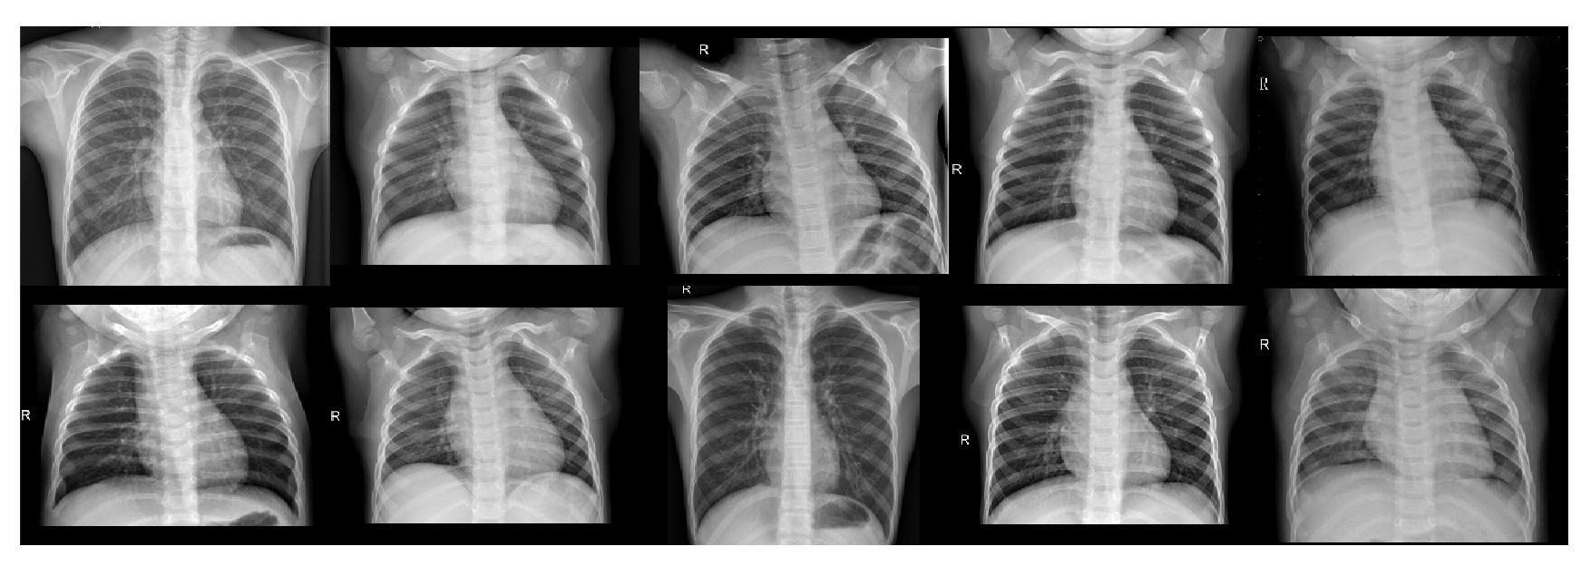Figure 1: Examples of normal chest radio-graphs
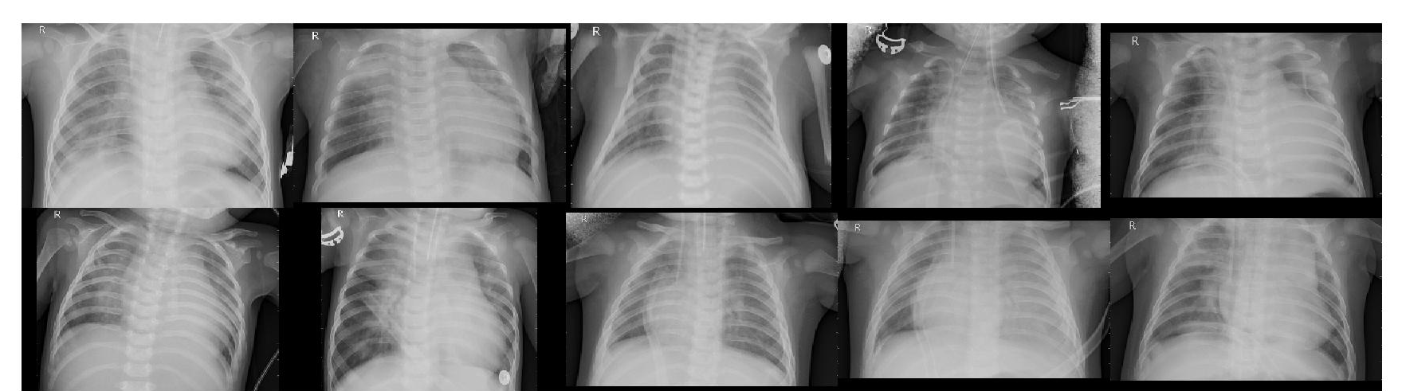Figure 2: Examples of pneumonia infected chest radio-graphs
The above script first extracts the data-set, finds the images, after this the images are randomly rotated and scaled to a smaller size. For each image, 6 images are produced. The images are then converted to a PGM file (the images are already greyscale) so they can be easily fed into the program. All images are then stored inside the “prepped_dataset” directory. This process is repeated for the test data-set.
Script 1: Shell script to extract and augment the data-set
#!/bin/bash
# This preps the dataset AND launches the program

if [[ -d CellData ]]; then
echo "ZhangLabData.zip already extracted (skipping)"
else
unzip ZhangLabData.zip
fi

# remove prepped dataset if exists
rm -rf ./prepped_dataset/ 2> /dev/null

mkdir prepped_dataset

# find all training jpegs
find ./CellData/chest_xray/train -type f -print0 | egrep -z -i "jpeg$" | sort -z -R | \
while read -r -d $'\0' file; do
basename="$( basename "$file" ".jpeg" )"

for copy in {1..6}; do
# generate random rotation angle/scale factor
rot="$( echo "scale=2 ; $RANDOM / 32767 * 20 - 10" | bc )"
scl="$( echo "scale=2 ; $RANDOM / 32767 * 50 + 250" | bc )"

new_filename="$basename-$copy.pgm"

# copy file
printf "convert \"$file\" -background black -rotate \"$rot\" -scale \"$scl\" \"./prepped_dataset/$new_filename\" && printf \".\"\x00"
done
done | xargs -0 -L1 -P8 sh -c

#xargs -0 -L1 bash -c echo

echo -e "\ndone!"
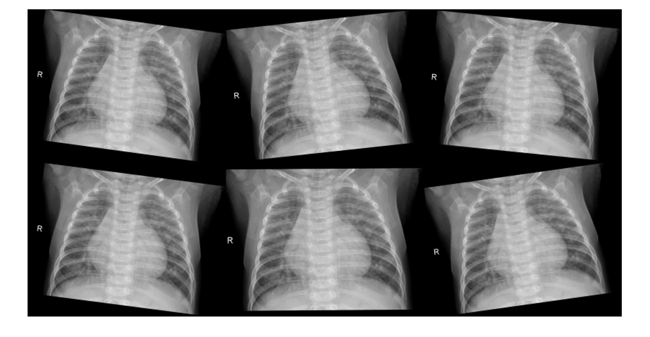Figure 3: An image augmented 6 times using random rotation/scale values

The Neural Network
For this classification task a Convolutional Neural Network (CNN) was implemented. The architecture of the network can be observed in Figure 4.
The network consists of a number of layer types: Convolutional, Pooling, and Fully-connected. The first layer is the input layer (depth of 1) that holds the raw pixel values of the chest x-ray image. In the convolutional layer, a small filter is convolved across the image with a stride of one, the dot product of the matrix and kernel is calculated, resulting in a feature map. The max pooling layer is then used to down sample the output, this layer helps to reduce computation and thus aids efficiency (Convolutional Neural Network, 2020). Finally, the fully-connected layers take the output from the feature map and determine which features correlate to the class (pneumonia or normal chest radiograph).
Input image
(chest x-ray)
Conv layer
FC
layer
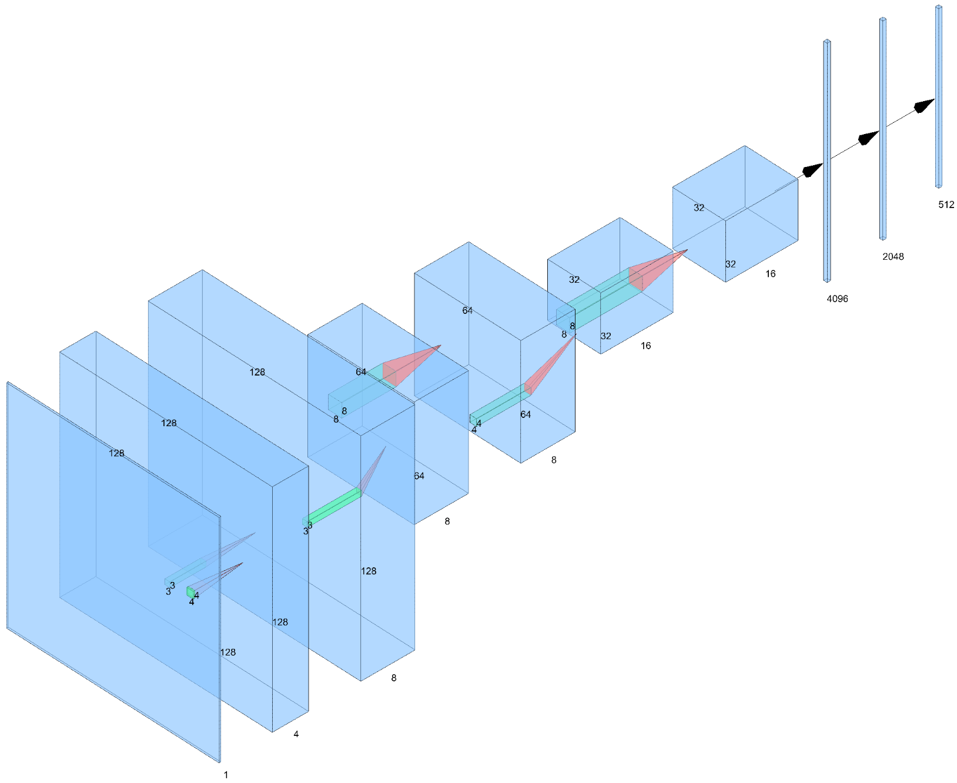Figure 4: Network architecture
Conv layer
Conv layer
Conv layer
Conv layer
Conv layer
FC
layer
FC
layer
Pooling layer
Pooling layer
Pooling layer

A novel method has been used to train the neural network. Ten 128×128 sub-regions are randomly extracted from the x-ray image, these sub-regions are then tested for pneumonia.
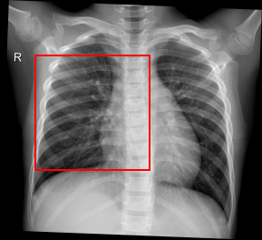Figure 5: A 128x128 sub-region on a resized chest x-ray from the data-set
As the images are scaled to all have the same relative size. That is: preserving the aspect ratio, the width will be roughly twice the size of sub-region. This means that the sub-regions will always contain at least some parts of the lung which contain the features required for the neural network to learn.
There are two code files. “main.cpp” is the source file where the network architecture is defined, the functions that enable testing and training of the network are also stored in this file. The second file is a header file “image.h” which contains functions to load the image and to get random sub-regions from the image for use with the network.
Script 2: Code snippet from main.cpp
// go over all files
for( auto f : filenames ) {
// determine if file label
bool has_pneumonia = regex_search( f, regex("VIRUS|BACTERIA") );

try {
// load file
gsimage_t image = gsimage_t::load(f);

// loop through 10 random subregions to get a somewhat accurate picture
for( uint64_t i = 0; i < 10; i++ ) {
const auto subregion = image.get_random_subregion( 128, 128 );

// set up the input (and desired output for analysis)
const vector<vec_t> ins = { subregion };
const vector<vec_t> outs = { { (has_pneumonia?0.f:1.f),
(has_pneumonia?1.f:0.f) } };

// run the network
const auto o = net.predict( subregion );

// calculate loss
float l = abs(o.at(0)-outs.at(0).at(0))
+ abs(o.at(1)-outs.at(0).at(1));

// what does the network predict?
bool prediction = o.at(0) < o.at(1);

// was the prediction correct?
if( has_pneumonia == prediction )
correct++;

count++;

}
} catch( std::runtime_error &e ) {
// ignore this
}
}

cout << "total: " << ((double)correct)/count*100 << "% accurate "
<< "(" << correct << "/" << count << ")" << endl;
Script 2 shows the process used to test the network. For all images, ten random sub-regions are looped through, these sub-regions are then checked for Pneumonia by running the network, this is repeated for all images in the test set.
Script 3: Shell script to train the network
Script 4: Shell script to test the trained network using a single image
#!/bin/bash

if (( $# != 1 )); then
echo "error: How many images do you want per program run?"
echo "usage: $0 100"
echo " $0 200"
exit 1
fi

# train the network:
find prepped_dataset -type f -print0 | sort -z -R | xargs -0 -L "$1" ./main train

#!/bin/bash

if (( $# != 1 )); then
echo "error: what image do you want to test for?"
exit 1
fi

# determine random preprocessing parameters
rot="$( echo "scale=2 ; $RANDOM / 32767 * 20 - 10" | bc )"
scl="$( echo "scale=2 ; $RANDOM / 32767 * 50 + 250" | bc )"

# convert the image to pgm and do some random preprocessing
convert "$1" -background black -scale "$scl" -rotate "$rot" ./tmp.pgm

# test it
./main test ./tmp.pgm 10

# remove image
rm tmp.pgm

As seen in Script 3 and 4, shell scripts are used to train and test the network. The input image must be preprocessed before they are suitable for testing, this is why the images are rotated and scaled in Script 4.
The full source code can be seen in the Appendices which have been uploaded separately.
MODEL PERFORMANCE AND CONCLUSION
We will analyze the models performance in two ways:
- Computational performance
- Statistical performance
Computational performance
Since the developing world has dated hardware compared to the West, any machine learning software targeted towards it must consider the restrictive hardware environment the software will be exposed to and must not require special hardware. Many deep learning softwares require CUDA and are not concerned with performance on dated hardware as they value features over quality, stability and dated hardware support. Unable to run on dated hardware may result in significantly little adoption of diagnostic software tools like this new model.
Statistical performance
Four performance metrics were used to measure the effectiveness of the model. These are:

Respectively, TP, FP, TN and FN represent the number of True Positive, False Positive, True Negative and False Negative readings. Therefore TP is the amount of Pneumonia positive x-rays that are correctly labeled as Pneumonia positive by the model, whilst FP is the proportion of normal x-rays which are incorrectly labeled by the model. Similarly, TN is the amount of normal x-rays which are correctly labeled as normal, whilst FN is the amount of pneumonia positive x-rays which are mislabeled by the model.
Table 1: Confusion matrix
 | True Positive | True Negative
Predicted Positive | 0.98 | 0.16
Predicted Negative | 0.02 | 0.84

The ineffectiveness of a test's probability is easily demonstrated by the following thought experiment:
Using a test with a FP>0 on verified negative samples will ensure that any positives reported by the test are false positives. In this case the probability of a reported positive being truly positive is 0. While this is obvious, the following is less clear: If you replace one sample in the population with one that's truly positive and blindly repeat the experiment, what is the probability a positively tested sample is truly positive?
Demonstrated is the importance of prior probability of the population to the information yielded by the test.
The solution to this thought experiment lies in Bayes' theorem:
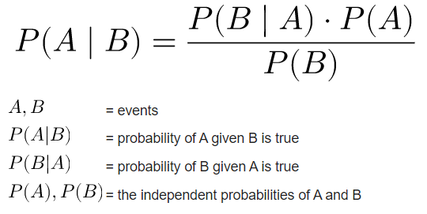
Introduced in this work was a simple yet effective CNN which can only be trained using only the CPU, the model works using a unique computationally efficient sub-region approach as described previously in this document. From the confusion matrix above, it is evident that the model, whilst accurately predicting Pneumonia, may not be medically significant on its own. This is because the “false positive” performance metric is too high at 0.16. Therefore the model should be used only by trained professionals and in conjunction with other tests. The model should be used as a tool to automatically highlight suspicious X-rays as it has a true positive reading of 0.98, but should definitely not be used as a sole diagnostic tool. Perhaps more training or more sub-regions would improve the false positive reading.
REFLECTIVE ANALYSIS
Overall, the project went well. The model successfully recognizes Pneumonia in the majority of most cases (98%) however the figures are not perfect. As mentioned before the TN is suspiciously high (0.16), meaning normal x-rays are quite likely to be misdiagnosed as Pneumonia affected. However, I think this is acceptable as the images radio-graphs would be checked by a medical professional anyway.
Putting this aside, the project has been a great learning experience for me, until now I have never worked on a big project like this to completion, this combined with the successful outcome of the project has given me a lot more confidence in my abilities.
In hindsight there are some things I would have done differently, I would’ve worked more consistently on the project throughout the academic year, this combined with regular supervisor meetings would’ve resulted in an easier time and possibly a better overall product. In addition to this, the library used (tiny_dnn) had some limitations. The tiny_dnn library is lesser known, the project is orphaned, but the code exists on Github and is usable. The documentation is lacking, I ran into a few problems during development which would’ve easily been solved if the documentation was up to scratch. The library also has certain code issues, the function overloads for the built in “predict” and “train” methods are dangerous. To resolve this, if I was given more time, it would’ve been wise to fork the repository to iron out these issues or use another more recent library such as TensorFlow or OpenNN.
If I had more time, I would’ve liked to output a heat-map of the input chest radiograph to show where the Pneumonia is in the lungs. This would’ve made the program a lot more complex but it would’ve been an impressive and, more importantly, a useful feature.
REFERENCES
- Bell, D. and Knipe, H., 2020. COVID-19 | Radiology Reference Article | Radiopaedia.Org. [online] Radiopaedia.org. Available at: <https://radiopaedia.org/articles/covid-19-3> [Accessed 9 April 2020].
- nhs.uk. 2019. Pneumonia. [online] Available at: <https://www.nhs.uk/conditions/pneumonia/> [Accessed 9 April 2020].
- Duke T, Neonatal pneumonia in developing countries Archives of Disease in Childhood – Fetal and Neonatal Edition 2005;90:F211-FF219. Available at: <https://fn.bmj.com/content/90/3/F211> [Accessed 4 April 2020].
- Welker, J., Huston, M. and McCue, J. (2008). Antibiotic Timing and Errors in Diagnosing Pneumonia. Arch Intern Med, [online] 168(4), pp.351-356. Available at: https://jamanetwork.com/journals/jamainternalmedicin e/article-abstract/413982 [Accessed 29 March 2020].
- Razzak, M., Naz S. and Zaib A. (2017). Deep Learning for Medical Image Processing: Overview, Challenges and Future. Available at: https://arxiv.org/ftp/arxiv/papers/1704/1704.06825.pdf [Accessed 30 March 2019].
- Vilar, J., Domingo, M. and Cogollos, J. (2004). Radiology of bacterial pneumonia. European Journal of Radiology. [online] Available at: https://www.sciencedirect.com/science/article/abs/pii/S0720048X04000907 [Accessed 8 Apr. 2019].
- Izadnegahdar, R., Cohen, A., Klugman, K. and Qazi, S., 2013. Childhood Pneumonia In Developing Countries. [online] Available at: <https://www.sciencedirect.com/science/article/abs/pii/S2213260013700754> [Accessed 23 April 2020].
- Adegbola, R. and Obaro, S., 2000. Diagnosis of childhood pneumonia in the tropics. Annals of Tropical Medicine & Parasitology, 94(3).
- W. David Pan, Yuhang Dong and Dongsheng Wu (September 19th 2018). Classification of MalariaInfected Cells Using Deep Convolutional Neural Networks, Machine Learning - Advanced Techniques and Emerging Applications, Hamed Farhadi, IntechOpen, DOI: 10.5772/intechopen.72426. Available from: https://www.intechopen.com/books/machine-learningadvanced-techniques-and-emerging-applications/ classification-of-malaria-infected-cells-using-deepconvolutional-neural-networks [Accessed 3 April. 2020].
- Raymond, E., 2003. Basics Of The Unix Philosophy. [online] Homepage.cs.uri.edu. Available at: <https://homepage.cs.uri.edu/~thenry/resources/unix_art/ch01s06.html> [Accessed 16 April 2020].
- Milicchio, F., 2020. THE UNIX KISS: A CASE STUDY. [online] Dept. Computer Science and Engineering, University Roma Tre. Available at: <https://arxiv.org/vc/cs/papers/0701/0701021v1.pdf> [Accessed 17 April 2020].
- Voskoglou, C., 2020. What Is The Best Programming Language For Machine Learning?. [online] Medium. Available at: <https://towardsdatascience.com/what-is-the-best-programming-language-for-machine-learning-a745c156d6b7> [Accessed 19 April 2020].
- GitHub. 2020. Tiny-Dnn/Tiny-Dnn. [online] Available at: <https://github.com/tiny-dnn/tiny-dnn/blob/master/README.md#Features> [Accessed 20 April 2020].
- Medium. 2020. Convolutional Neural Network. [online] Available at: <https://towardsdatascience.com/convolutional-neural-network-17fb77e76c05> [Accessed 20 April 2020].

