**Copado Deployer v22.27 Release Notes**

Copado Deployer v22.27 brings some updates on Source Format Pipelines including the ability to block promotions for user stories where tests are in progress or have failed.

**User Stories Can't Be Promoted If Tests Are In Progress or Have Failed**

* **Promotion Blocking:** This release enforces stricter quality control by preventing the promotion of user stories where tests are either in progress or have failed. The block applies to:
  + Tests initiated within the user story.
  + Tests run during the execution of a quality gate, especially when the quality gate rule condition specifies "User Story".

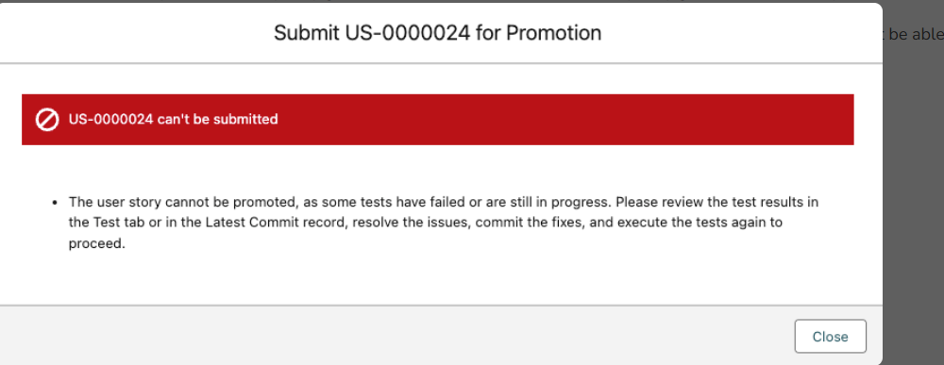**Resolution Steps:**

* + Wait for all tests to complete and pass before attempting promotion.
  + If tests fail, issues must be resolved, changes committed, and tests rerun successfully before proceeding with the promotion.

**Exception Handling:**

* In certain scenarios, where immediate promotion is necessary (e.g., critical updates), you can override this restriction by creating a system property named IgnoreTestStatusForPromotion and setting its value to true. This allows promotions even if tests haven't passed.
* **Caution:** This override is generally not recommended, especially for development environments, as it may lead to promoting code with unresolved issues. It’s advisable to review test results thoroughly before promotion.

**Dashboard Updates:**

* You can enhance your testing dashboard to display the number of pending or failed tests using the User Story: Pending Tests field, providing better visibility into test statuses.

**2. View the Promotion Branch on the Promotion Record Page**

* A new View in Git field is introduced, which allows users to directly navigate from the promotion record to the associated promotion branch in Git. This feature becomes available when a merge process is initiated, and a promotion branch is created, streamlining the process of tracking and managing promotion branches.

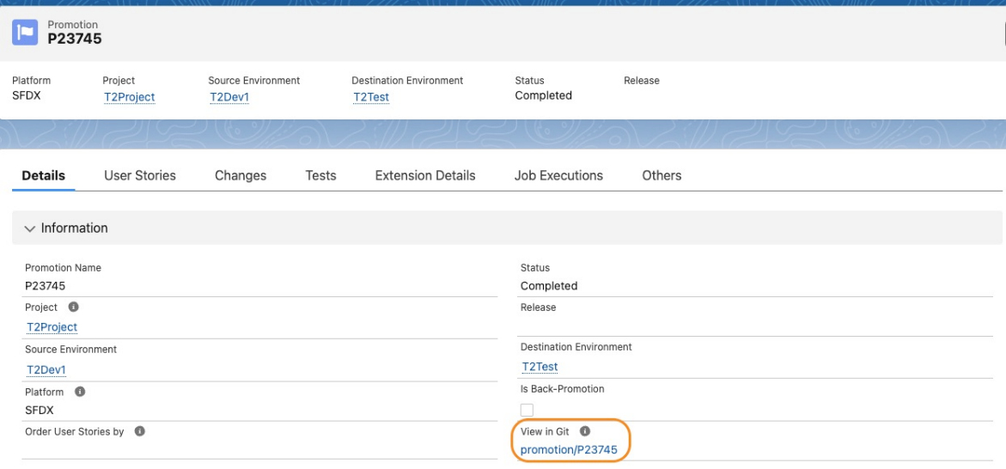

**3. Creating a New Source Format Pipeline**

* To create a new Source Format Pipeline in this release, you must first activate the **PackageDistribution** picklist value in the Copado Actions picklist value set. This is a prerequisite step and involves:
  + Navigating to Setup in your Salesforce org.
  + Searching for Picklist Value Sets and selecting the Copado Actions picklist value set.
  + Activating the **PackageDistribution** value from the Inactive Values section and saving the changes.

