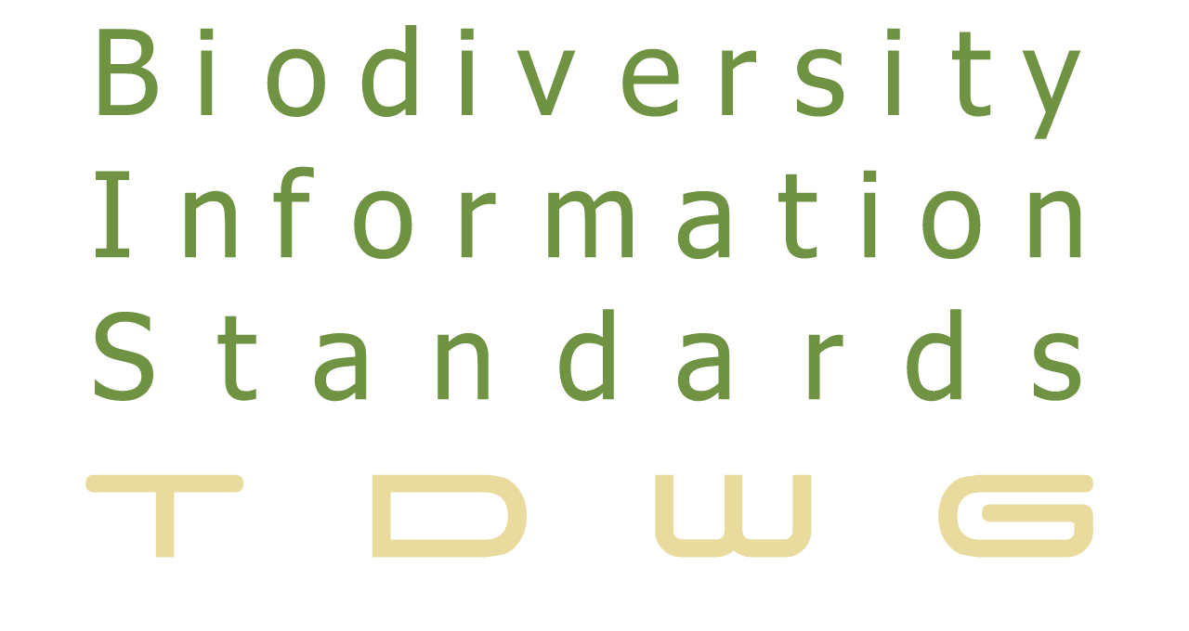 | Standards for the Exchange  of Biodiversity Data  http://www.tdwg.org

<Natural Collections Description>
Primer

Summary
Natural Collections Description (NCD) is a data standard for describing collections of natural history materials at the collection level; one NCD record describes one entire collection.
NCD is a lightweight resource description standard specific to natural history. NCD is between general resource discovery standards such as Dublin Core (DC) and rich collection description standards such as the Encoded Archival Description (EAD). It will be possible to extract a Dublin Core record from an NCD record for use with general resource discovery systems. It is also possible to use an NCD record as the seed for a richer collection description.
The NCD standard covers any type of natural history collection, such as specimens, original artwork, archives, observations, library materials, datasets, photographs or mixed collections such as those that result from expeditions and voyages of discovery. NCD primarily holds information about collections of objects, but can also be used to describe organisations (collections of collections) and networks (collections of organisations). There are many existing sources of information about biodiversity organisations, but they are all in different formats. NCD could be used to form a directory for organisations using LSIDs based on existing identifiers, such as the CODENS used in Index Herbariorum.
The Interest Group is developing NCD for use with RDF to ensure that it integrates with TDWG’s common development architecture

2. Motivation and Rationale
The Group is developing and supporting a data standard, called Natural Collections Description (NCD) for describing entire collections of natural history materials. For example, collection description records contain information about the collection, access and usage of the collection and where to get more detailed information.

There are valuable collections that have no information stored in databases. Many do not have a presence on the Internet. Collections without a web presence are easily overlooked by researchers because they are so reliant on the Web. A brief descriptive record as defined by the NCD standard can act as the “business card” for a collection, providing enough information to identify and locate it. The standard enables the aggregation of collections descriptions from many sources and facilitates resource discovery.
Three main areas are served by collection-level description records:
- Resource discovery, providing a descriptive overview of each collection
- Establishment of relationships between collections in several locations
- As an aid for collections management processes
A component of the NCD standard will be used as the “business card” of organisations in the area of natural history and biodiversity research. NCD records will allow an organisation to be identified from its code. NCD will also provide information on any other relevant codes.

NCD brings together work on collections descriptions being carried out for the European Union Framework VI programme SYNTHESYS with the work performed by RAVNS under the auspices of RLG.

A standard for describing natural history collections fits well with the suite of data standards being developed on behalf of the Global Biodiversity Information Facility (GBIF) by the Biodiversity Information Standards (TDWG). Funding has come from GBIF, the Smithsonian Institution and from the Gordon & Betty Moore Foundation.

3. Description
Collection descriptions are electronic records that document the holdings of organisations as groups of items. Such descriptions complement the more traditional item-level records describing a single specimen or a library book. Each collection record describes one entire collection, including information on the extent and purpose of the collection, conditions of access and use and who to contact for more information.
A collection is loosely defined as any group of things that have something in common. That "something in common" can be defined by the basic questions that users ask when accessing collections - who, what, where and when. Examples of collections include:
- items that were collected or made by a particular person
- items that have the same format, such as art on paper
- items that came from the same place
- specimens that belong to the same taxonomic group
- all specimens collected on a research voyage
In natural history museums, for example, the best known collections are the specimens, the library and the archives. Exhibitions, paintings and sculptures are also collections. The electronic equivalents include datasets and databases (which are collections of item-level records) and the thematic sections of Web-sites.
Three main areas are served by collection-level description records:
- Resource discovery, providing a descriptive overview of each collection
- Establishment of relationships between collections in several locations
- As an aid for collections management processes
SPEED
Collections of natural history material can be large. Consequently detailed item-level descriptions often take a long time to generate As a insurance policy, a collection-level record can ensure that knowledge about a collection can be rapidly be revealed.
CROSS-DOMAIN RESOURCE DISCOVERY
Relating collections that are in museums, libraries, archives and other organisations (cross-domain resources) is a priority for many governments. By adopting the same standard for collections in each domain, it is possible to search across all collections, regardless of domain or location,
RE-UNITING SCATTERED COLLECTIONS
"Virtual collections" are another way to link resources. Some organisations divide collections between departments for curatorial purposes. Researchers would need to contact each department individually to assess the complete collection. Similarly, some collections have been dispersed throughout several organisations. These collections may be re-united in a virtual sense, using collection descriptions for each component.
POINTER TO ITEM-LEVEL DETAIL
A collection description record can be created for a collection whether the items in that collection have their own records in a database, or not. Where a database containing item-level details exists, a link can be provided to that database to provide more detail. If the collection does not have an item-level database, producing a collection description reduces the chances of that collection being overlooked by researchers using the Web for resource discovery.
TOOL TO HELP WITH COLLECTIONS MANAGEMENT
Collection descriptions enable a broad perspective. A collection description could serve a variety of additional purposes for any organisation:
- A collections inventory is helpful in protecting against both loss of data and loss of collections and thus serves as a form of audit control and security against unauthorised disposal.
- It can help with the assessment of the strengths and gaps in the organisation as a whole, so that finding collaboration partners that have either the same or complementary strengths is simplified.
- It can help to identify which areas should be a priority for development in strategic plans and to establish priorities for item-level cataloguing.
- By recording conservation concerns, the priorities for conservation / preservation treatment can be established. Collections cannot be protected if it is not known that they exist.
EARLY WARNING OF TECHNOLOGICAL OBSOLESCENCE
Collection descriptions can serve to prevent loss of data that is in a physical form or data in a format that is nearing technological obsolescence. Creating collection descriptions for datasets that includes format information will help to act as an early warning so that data can be transferred to a current format. Data then becomes part of a digital preservation programme, rather than a digital archaeology project.
REPOSITORY FOR ADDITIONAL INFORMATION
Collection description records act as a convenient place to store information volunteered by visitors.
MULTIPLE USE OF DATA
Re-use of data is important. Collection description records can be created from existing resources and published finding aids. Once collection level data exists it can used for internal projects such as labelling exhibits or for including to produce exhibit labels external initiatives such as merging data from several sources to provide regional coverage of biodiversity collections. An example is the BioCASE project.
If collection level descriptions are produced, there is a risk that the item –level descriptions may not get done. However, if a collection has no description it is not discoverable.
The NCD class diagram is shown here:
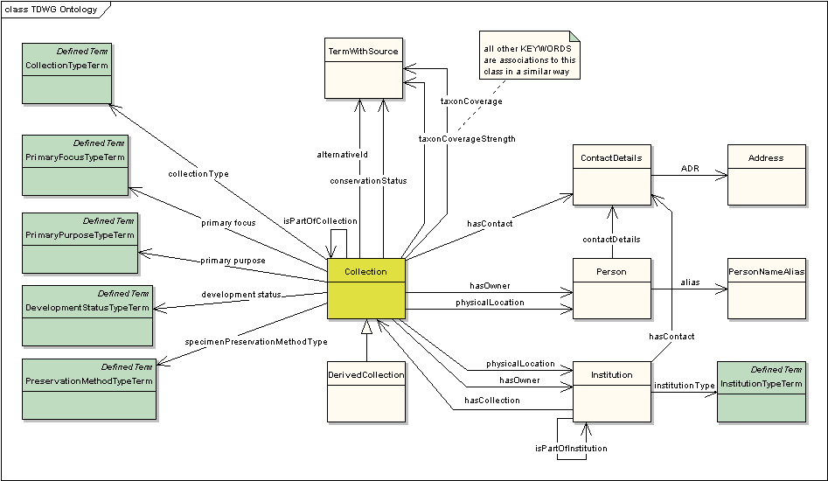

4. Implementation

To implement this standard, consult the NCD User Guide. NCD files may be found at http://rs.tdwg.org/ncd/ and the RDF version may be found at: http://rs.tdwg.org/ontology/voc/Collection.rdf (Note: Use View | Source to see the actual RDF).

- What steps would the reader need to take to implement of this standard?
- A demonstration of the use of the standard must be included
- Identify demonstrations, test implementations or validations that may be useful

5. Further Information
- The NCD Website is at: http://www.tdwg.org/activities/ncd/
- To join the mailing list see: http://lists.tdwg.org/mailman/listinfo/tdwg-ncd
- Discussion and documents are on the Wiki: http://wiki.tdwg.org/twiki/bin/view/NCD/WebHome.

6. Glossary
SYNTHESYS:
RAVNS: Resources Available in Natural Science
RLG: RLG Programs is part of OCLC’s Programs and Research division.
OCLC: Founded in 1967, OCLC Online Computer Library Center is a nonprofit, membership, computer library service and research organization dedicated to the public purposes of furthering access to the world's information and reducing information costs.
CODENS:
Dublin Core: The Dublin Core metadata element set is a standard for cross-domain information resource description.
EAD: Encoded Archival Description is a standard for encoding archival finding aids using Extensible Markup Language (XML).

All technical terms, acronyms and abbreviations used in the text must be included in the glossary. It should not be assumed that the reader is familiar with any of them. If need be the text on the TDWG glossary pages should be copied so that this is a stand alone document. All terms not on the TDWG Glossary must be submitted to web@tdwg.org for inclusion in the TDWG Glossary.

