Natural Collections Descriptions (NCD)

USER GUIDE

Draft in progress May 2006

Contents
- Introduction to the NCD data standard
- Group-level structure diagrams
- Element notes and mappings

Part 1: Introduction to the NCD data standard

What is NCD?
Natural Collections Descriptions (NCD) is an emerging data standard for describing collections of natural history materials at the collection level - in other words, one NCD record describes one entire collection.

It is intended primarily as a lightweight resource description standard that is specific to natural history and lies between general resource discovery standards such as Dublin Core (DC) and rich collection description standards such as the Encoded Archival Description (EAD). However, it should be possible to extract a Dublin Core record from an NCD record for use with general resource discovery systems or, going in the other direction, to use an NCD record as the seed for a much richer collection description as and when time allows.

NCD is intended to cover any type of natural history collection, such as specimens, original artwork, archives, observations, library materials, datasets, photographs or mixed collections such as those that result from expeditions and voyages of discovery.

What are collections descriptions?
Collection descriptions are electronic records that document the holdings of an organisation as groups of items, which complement the more traditional item-level records such as are produced for a single specimen or a library book.

Each record describes one entire collection, including information on the extent and purpose of the collection, conditions of access and use and who to contact for more information.

What is a collection?
A collection can be loosely defined as any group of things that have something in common. That "something in common" can be defined by the basic questions that users ask when accessing collections - who, what, where and when.

Examples include:
- items that were collected or made by a particular person
- items that have the same format, such as art on paper
- items that came from the same place
- specimens that belong to the same taxonomic group

In natural history museums, for example, the best known collections are the
specimens, the library materials and the archives. However, the exhibitions are also collections, as are the paintings and sculptures throughout the galleries.

The electronic equivalents include datasets (which are collections of item-level records) and the thematic sections of Websites.

What are the uses of collection descriptions?
CLD records serve three main areas:

- Resource discovery, providing a descriptive overview of each collection
- Establishing relationships between resources that are in several locations
- An aid for some of the collections management processes

1. SPEED
Collections of natural history material are often very large. The vast number of individual items means that it will take a very long time before every item has its very own database record. It is much faster to record collection details for entire collections so that the full extent of the richness of the collections can be revealed much earlier.

It is also useful to hold the details that are common to the whole collection once, rather than being repeated with the record for each item.

2. CROSS-DOMAIN RESOURCE DISCOVERY
The concept of cross-domain resources, that is relating collections that are in museums, libraries, archives and other organisations, is currently quite high on the agenda of many governments. By adopting the same standard for collections in each of these (and other) domains, it becomes possible to search across all collections, be they in a single organisation or in several organisations throughout a region or even internationally.

3. RE-UNITING SCATTERED COLLECTIONS
Another way to link resources is by creating "virtual collections". Some organisations divide collections between departments for curatorial purposes.

Researchers would need to contact each department individually to assess such a collection as a whole. Similarly, some collections have been dispersed throughout several organisations. These collections may be re-united in a virtual sense, using collection descriptions for each component.

4. POINTER TO ITEM-LEVEL DETAIL
Collection descriptions are verbose, and therefore complement the rows of raw data that are produced by databases.

A collection description record can be created for a collection whether the items in that collection have their own records in a database, or not. Where a database does exist, a link can be provided to that database, so that the "purposeful enquirer" can get much more detail, should they wish.

If the collection does not have an item-level database, producing a collection description reduces the chances of that collection being overlooked by researchers using the Web for resource discovery purposes.

5. TOOL TO HELP WITH COLLECTIONS MANAGEMENT
Collection descriptions allow you to stand back and take a look at the wider landscape. For an organisation, a completed collection inventory could serve a variety of additional purposes:
- A collections inventory is helpful in protecting against both loss of data and loss of collections and thus serves as a form of audit control and security against unauthorised disposal.
- It can help with the assessment of the strengths and gaps in the organisation as a whole, so that finding collaboration partners that have either the same or complementary strengths becomes easier.
- It can also help to identify which areas should be a priority for development in strategic plans and to establish priorities for item-level cataloguing.
- By recording conservation concerns the priorities for conservation / preservation treatment can be established. Collections cannot be protected if it is not known that they exist.

6. EARLY WARNING OF TECHNOLOGICAL OBSOLESCENCE
Collection descriptions can serve to prevent loss of data that is in a physical or data format that is on the point of technological obsolescence.

Creating collection descriptions for datasets that includes format information that can be matched against records in data format registries, such as PRONOM, will help to act as an early warning of impending obsolescence. Plans can then be drawn up to transfer the data to a current format. It then becomes part of a digital preservation programme, rather than a digital archaeology project.

7. REPOSITORY FOR ADDITIONAL INFORMATION
Collection description records act as a convenient place to store information volunteered by visitors.

8. MULTIPLE USE OF DATA
Re-purposing data is seen as a very important element. Collection description records can be created from existing resources and published finding aids.

Conversely, data recorded in the collection description records can be used to produce exhibit labels.

The data can also be provided to external initiatives, some of which wish to merge data from several sources to provide regional coverage of biodiversity collections.

How has NCD evolved and who is involved?
The first major effort in standardising collection-level description began with a European Union Framework V project known as BioCASE - the Biodiversity Collections Access Service for Europe. This project ran from November 2001 until early 2005. Further details may be found at http://www.biocase.org

An RLG working group of mainly North American natural history librarians and archivists known as RAVNS (Resources AVailable in Natural Sciences) has generalised the BioCASE metadata standard from dealing only with specimen collections to a standard that covers any type of natural history collection.

RAVNS includes representatives from the following institutions:
- American Museum of Natural History
- Missouri Botanical Garden
- Museum of Comparative Zoology, Harvard University
- National Museum of Natural History, Smithsonian Institution
- Natural History Museum, London
- New York Botanical Garden
- Peabody Museum of Natural History, Yale University

NCD brings together work on collections descriptions being carried out for the European Union Framework VI programme SYNTHESYS with the work performed by RAVNS under the auspices of RLG.

The Taxonomic Databases Working Group (TDWG) believe that a standard for describing natural history collections would fit well with the suite of data standards being developed on behalf of the Global Biodiversity Information Facility (GBIF). The NCD 2006 Workshop at the Smithsonian Institution was part-funded by them from the grant provided by the Gordon & Betty Moore Foundation.

What is the timetable?
It is intended to create a test implementation of the standard in late 2006 resulting in a stable version of the NCD standard by March 2007, so that it can be submitted as a Proposed TDWG Standard at that time. If that is achieved, NCD will be voted on at the October 2007 TDWG meeting.

Part 2: Group-level structure diagrams

The NCD data standard comprises 66 elements (of which only 7 are required) in seven groups, arranged as in diagram 1. This section of the user guide provides a structure diagram for each of the seven groups.

Legend
- Solid line box around a data element indicates a required element
- Dotted line box indicates an optional element
- Stacked box indicates a repeatable element
- Plus sign indicates further level(s) of data

DIAGRAM 1: Top Level

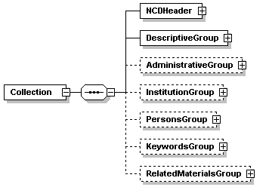

DIAGRAM 2: NCD Header

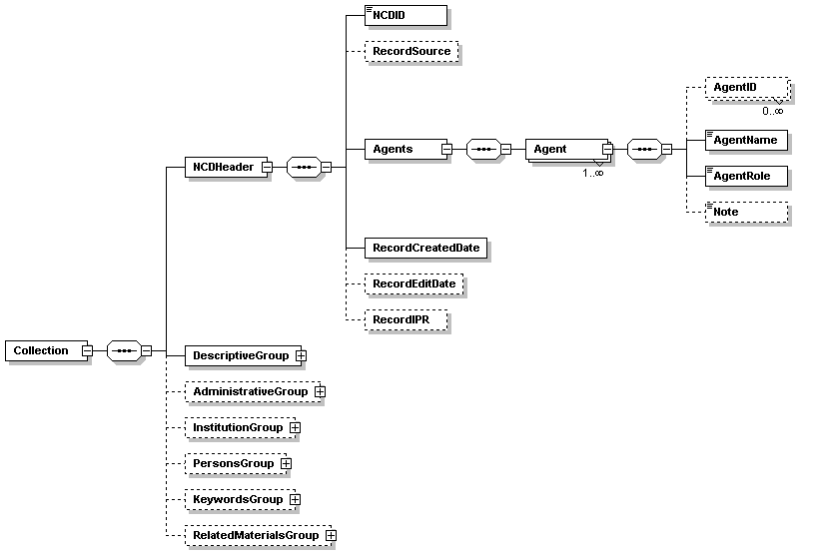

The NCD Header is based on the METS header and is intended to provide information about the record itself, rather than about a collection. This group contains four of the seven required elements.

Each record must have a unique identifier, the name and role of the agent (person or organisation) that produced the record and the record’s creation date.

Optional elements include the source of the record, if it has been harvested from a system rather than being created directly, along with the date of the last edit and an IPR statement, if that is specific to the record.

More than one agent may be associated with the record, for example a different person than the creator may edit the record. Each agent may provide one or more unique identifiers so that further details about them may be determined from other systems if they exist.

Finally, an element is provided that an agent may use to provide a note, for example to provide explanatory information about a correction to the original record.

DIAGRAM 3: Descriptive Group

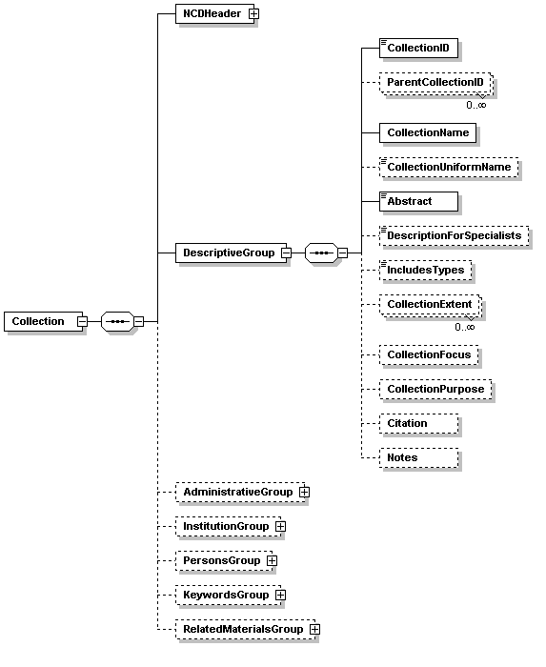

The Descriptive Group is the main part of the record and contains the remaining three required elements – the “Collection identifier”, “Collection name” and the “Abstract” - a plain text description of the collection itself.

Two elements are provided for describing a collection. The “Abstract” is required and intended to hold a description in plain language. This may be supplemented by the “Description for specialists” which may contain terminology that would be understood by a specialist, but not necessarily by a non-specialist.
A collection may be identified as being part of a larger collection through the use of the “Parent collection ID” element, of which there can be more than one.

The “Collection Name” will often be in the form “The X collection of Y” and will be in the language of the holding country. An attribute indicates the language of the text. The “Collection uniform name” may be used to provide an English-language translation of the collection name, to aid retrieval.

The “Includes types” element is a flag to indicate that collection includes type specimens, which have special significance to researchers in natural history.

The three elements “Collection extent”, “Collection focus” and “Collection purpose” provide an opportunity to make comparisons between collections.

Extent is an estimate of the size of the collection, with attributes to indicate the number of objects and unit of measure (e.g. skins / 12 / small cupboards), which may be repeated as necessary.

Focus will contain a keyword or phrase to indicate primary focus of collection, examples being: regional / personal archive / taxonomic / expedition / bibliographic / original artwork / other

Purpose will also contain a keyword, this one to indicate primary purpose of collection. Examples are: research / education / exhibition / other

The “Citation” element can contain a preferred citation to the collection, particularly where sponsors may wish to have an agreed form of words that mentions their name.

Finally, the “Notes” element is a free-text area that can contain anything that does not fit elsewhere.

DIAGRAM 4: Administrative Group

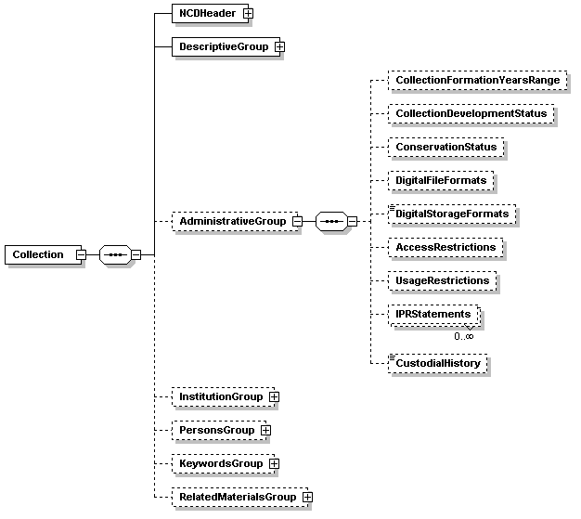

The Administrative Group holds elements that are concerned with selected collections management aspects, including rights and restrictions information, along with some historical and conservation aspects.

Two elements that are specific for digital collections are included. These for use in conjunction with external format registries, such as PRONOM, so that advice on format migration can be sought.

DIAGRAM 5: Institution Group

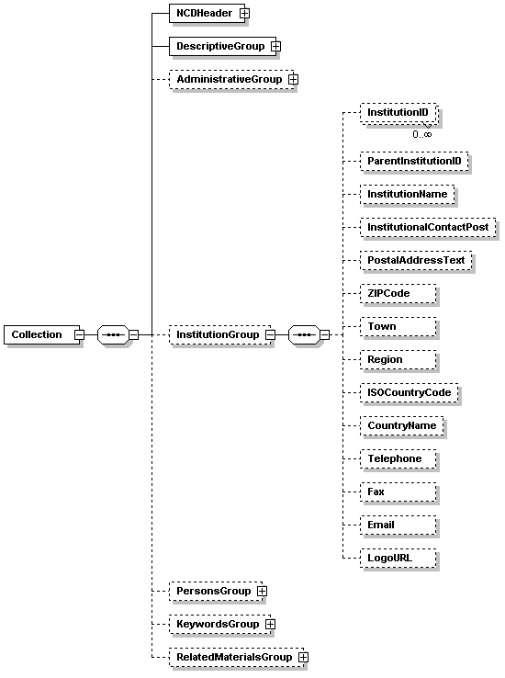

The Institution Group contains the contact details for the holding institution. The institution itself may be known through several identifiers, particularly if it have collections from several domains and these may be recorded here. The institution may also be identified as part of a larger institution through the “Parent Institution identifier” element.

For a more specific contact within the institution, the title of a contact post may be given. This is used in preference to a personal name since the person occupying a post usually changes more frequently than the title.

DIAGRAM 6: Persons Group

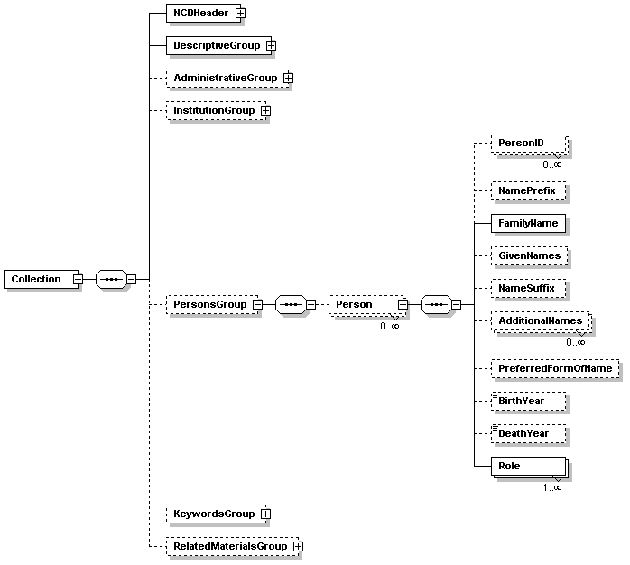

The Persons Group holds comparatively minimal detail about persons who are, or have been, associated with the collection in the way identified in the “Role” element.

Two elements are mandatory if applicable – that is, if there is a person known to be associated with the collection, then at minimum that person’s “Family name” and “Role” must be recorded.

Once again, multiple identifiers may be recorded so that further details about a person may be retrieved from, for example, a biographical database by noting the source database or system and the identifier for the record of that person.

DIAGRAM 7: Keywords Group

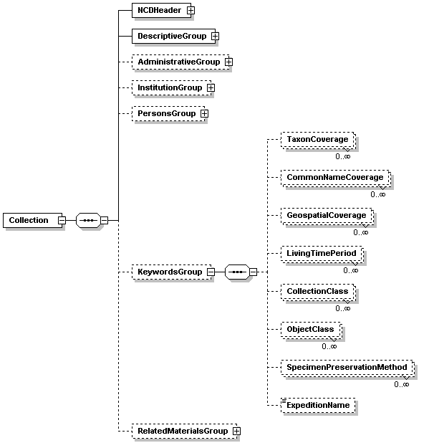

The Keywords Group hold additional terms which may be indexed as an aid to retrieval. All are repeatable (with the exception of “Expedition name”) so that each instance of an element contains only one keyword.

Each element also has attributes that may be used to indicate that the keyword has been drawn from a published terminology source, which aids consistency. In most of the elements, an attribute also indicates that the keyword represents a special strength of the collection and another attribute indicates the language of the keyword.

The “Collection class” provides one or more keywords to describe the domain of the collection as a whole, such as living, preserved, digital or archive. The “Object class” can record the types of objects within the collection, such as photographs, skulls, digitised images or microscope slides.

DIAGRAM 8: Related Materials Group

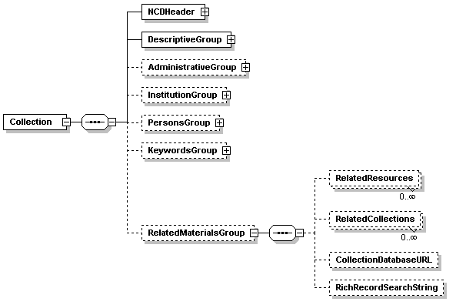

The Related Materials Group encourages linkages with relevant material that is available elsewhere.

“Related resources” is a repeatable element indicating resources, such as printed catalogues, Websites etc.

“Related collections” is a repeatable element holding the identifier for, or short description of, related collections. This may be useful in the records for components of a large collection that has been dispersed.

“Collections databaseURL” records the URL of a database that is available over the Web that contains item-level records for each item in the collection.

“Rich record search string” holds the search string that will return the record of a richer description of this collection, for example an EAD record in an archive database.

Part 3: Element notes and mappings
LEGEND:
Greyed out line = Container Group
Asterisk = Required element

NCD V0.34
Elements | Attributes |  | DC V.1.1 | EAD 2002

NCDHeader
NCDID* |  |  | Identifier | <eadheader><eadid>
RecordSource |  |  | Source
RecordCreatedDate* |  |  | Publisher | <eadheader><filedesc><publicationstmt><date>
RecordEditDate |  |  | Publisher | <eadheader><filedesc><publicationstmt><date>
RecordIPR |  |  | Rights | <eadheader><filedesc><notestmt> ??legalstatus??
Agents
Agent
AgentID |  |  | Publisher | <eadheader><filedesc><publicationstmt><publisher>
AgentID | Source
AgentName* |  |  | Publisher | <eadheader><filedesc><publicationstmt><publisher>
AgentRole* |  |  | Publisher | <eadheader><filedesc><publicationstmt><publisher>
Note |  |  |  | <eadheader><filedesc><notestmt>

DescriptiveGroup
CollectionID * |  |  | Identifier | <ead><archdesc><did><unitid>
CollectionID * | Source
ParentCollectionID |  |  | Relation | <ead><archdesc><did><unitid>
ParentCollectionID | Source
CollectionName * |  |  | Title | <ead><archdesc><did><unititle>
CollectionName * | Language
CollectionUniformName |  |  | Title | <ead><archdesc><controlaccess><title>
Abstract* |  |  | Description | <ead><archdesc><did><abstract>
Abstract* | Language
DescriptionForSpecialists |  |  | Description | <ead><archdesc><did><abstract>  or  <ead><archdesc><scopecontent>
DescriptionForSpecialists | Language
IncludesTypes |  |  | Description | <ead><archdesc><did><abstract>
CollectionExtent |  |  | Description | <ead><archdesc><did><physdesc><extent>
CollectionExtent | Number
CollectionExtent | UnitOfMeasure
CollectionFocus |  |  | Description | <ead><archdesc><did><abstract>
CollectionPurpose |  |  | Description | <ead><archdesc><did><abstract>
Citation |  |  | Description | <ead><archdesc><prefercite>
Notes |  |  | Description | <ead><archdesc><note>

AdministrativeGroup
CollectionFormationYearsRange |  |  | Date | <ead><archdesc><did><unitdate type="inclusive">
CollectionDevelopmentStatus |  |  | Description | <ead><archdesc><did><note>
 |  | Date
ConservationStatus |  |  | Description | <ead><archdesc><did><note>?or <ead><archdesc><processinfo>?
ConservationStatus | Source
ConservationStatus | Date
DigitalFileFormats |  |  | Format | <ead><archdesc><did><note>
DigitalStorageFormats |  |  | Format | <ead><archdesc><did><note>
AccessRestrictions |  |  | Rights | <ead><archdesc><accessrestrict>
UsageRestrictions |  |  | Rights | <ead><archdesc><userestrict>
IPRStatements |  |  | Rights | <ead><archdesc><did><note>
CustodialHistory |  |  | Publisher | <ead><archdesc><custodhist>
InstitutionGroup
InstitutionID |  |  | Publisher | <ead><archdesc><did><repository>?
InstitutionID | Source
ParentInstitutionID |  |  | Publisher | <ead><archdesc><did><repository>?
ParentInstitutionID | Source
InstitutionName |  |  | Publisher | <ead><archdesc><did><repository><corpname>
InstitutionalContactPost |  |  | Publisher | <ead><archdesc><did><repository><persname>?
PostalAddressText |  |  | Publisher | <ead><archdesc><did><repository><address>
ZIPCode |  |  | Publisher | <ead><archdesc><did><repository><address>
Town |  |  | Publisher | <ead><archdesc><did><repository><address>
Region |  |  | Publisher | <ead><archdesc><did><repository><address>
ISOCountryCode |  |  | Publisher | <ead><archdesc><did><repository><address>
CountryName |  |  | Publisher | <ead><archdesc><did><repository><address>
Telephone |  |  | Publisher | <ead><archdesc><did><repository><address>
Fax |  |  | Publisher | <ead><archdesc><did><repository><address>
Email |  |  | Publisher | <ead><archdesc><did><repository><address>
LogoURL |  |  | Publisher | <ead><archdesc><did><repository><address>

PersonsGroup
PersonID |  |  | Creator/Contibutor/Publisher
PersonID | Source
NamePrefix |  |  | Creator/Contibutor/Publisher
FamilyName |  |  | Creator/Contibutor/Publisher
GivenNames |  |  | Creator/Contibutor/Publisher
NameSuffix |  |  | Creator/Contibutor/Publisher
AdditionalNames |  |  | Creator/Contibutor/Publisher
PreferredFormOfName |  |  | Creator/Contibutor/Publisher
BirthYear |  |  | Creator/Contibutor/Publisher
DeathYear |  |  | Creator/Contibutor/Publisher
Role |  |  | Creator/Contibutor/Publisher

KeywordsGroup
TaxonCoverage |  |  | Subject | <ead><archdesc><controlaccess><subject>
TaxonCoverage | Source
TaxonCoverage | IDinSource
TaxonCoverage | Strength
CommonNameCoverage |  |  | Subject | <ead><archdesc><controlaccess><subject>
CommonNameCoverage | Source
CommonNameCoverage | IDinSource
CommonNameCoverage | Strength
CommonNameCoverage | Language
GeospatialCoverage |  |  | Coverage | <ead><archdesc><controlaccess><subject>
GeospatialCoverage | Source
GeospatialCoverage | IDinSource
GeospatialCoverage | Strength
GeospatialCoverage | Language
LivingTimePeriod |  |  | Coverage | <ead><archdesc><controlaccess><subject>
LivingTimePeriod | Source
LivingTimePeriod | IDinSource
LivingTimePeriod | Strength
CollectionClass |  |  | Subject | <ead><archdesc><controlaccess><subject>
CollectionClass | Source
CollectionClass | IDinSource
CollectionClass | Strength
CollectionClass | Language
ObjectClass |  |  | Subject | <ead><archdesc><controlaccess><subject>
ObjectClass | Source
ObjectClass | IDinSource
ObjectClass | Strength
SpecimenPreservationMethod |  |  | Subject | <ead><archdesc><controlaccess><subject>
SpecimenPreservationMethod | Source
SpecimenPreservationMethod | IDinSource
ExpeditionName |  |  | Subject | <ead><archdesc><controlaccess><subject>
RelatedMaterialsGroup
RelatedResources |  |  | Relation | <ead><archdesc><relatedmaterial>
RelatedCollections |  |  | Relation | <ead><archdesc><relatedmaterial>
CollectionDatabaseURL |  |  | Relation | <ead><archdesc><relatedmaterial><dao>
RichRecordSearchString |  |  | Relation | <ead><archdesc><relatedmaterial><dao>

