Membership and Funding

Summary
This document is a summary of the nature, advantages and costs associated with ‘membership’ of standards development organisations that could be considered most similar to TDWG. All organisations except IETF had a range of different types of memberships tailored to different audiences with different requirements and different subscription rates. Subscriptions varied from zero (IETF) to over US$250,000 (OGC: in kind contributions).

All information was taken from the organisations public web sites on or before May 23, 2006.

Table of Contents
Membership and Funding 1
Summary 1
Table of Contents 2
Global Grid Forum 3
Individual Membership 3
Organisational Membership 5
IETF 6
2.9 Where Do I Fit In? (from the IETF Tao) 6
2.9.1 IS Managers 6
2.9.2 Network Operators and ISPs 6
2.9.3 Networking Hardware and Software Vendors 6
2.9.4 Academics 7
2.9.5 Computer Trade Press 7
OASIS 7
Membership 7
Fees 7
OGC 11
Membership Benefits 11
Strategic Members (US$250,000+) 12
Principal Plus Members (US$100,000+) 12
Principal Members (US$55,000) 12
Technical Committee Members (US$11,000) 12
Associate Members (US$500-4,400) 12
Membership Fees 13
W3C 14
Who Can Join W3C 14
Membership Benefits 14
Membership Fees 15
WS-I 19
Membership Benefits 19
Contributing Membership 19
How to Join as a Contributing Member 20
Associate Membership 20
How to Join as an Associate Member 20
Advocates Program 20
How to become an Advocate 21
Adopters Program 21
How to become an Adopter 21

Global Grid Forum
http://www.ggf.org/Members/ggf_members_become.php

Individuals and organizations who choose to become GGF members expect the following benefits:
- INFLUENCE … On GGF Directions & Priorities
- RECOGNITION… As a Leader Driving Grid Adoption
- INSIGHT… On Grid Standards & Best Practices.

Last year, over 50 organization members from both research and industry supported GGF annually with technical and financial involvement. These financial contributions comprised nearly 85% of GGF’s operating income and allowed GGF to continue its leadership role in the advancement of grid technologies worldwide.

In 2006, GGF is launching an integrated membership program that will allow GGF to achieve the following goals:
- Identify and measure GGF’s organizational and individual constituency
- Offer recognition to both organizations and individuals involved in the work of GGF
- Provide benefits to GGF’s core participants
- Identify and reward group members who actively contribute to the work of GGF.

Individual Membership
US$1,000 annually
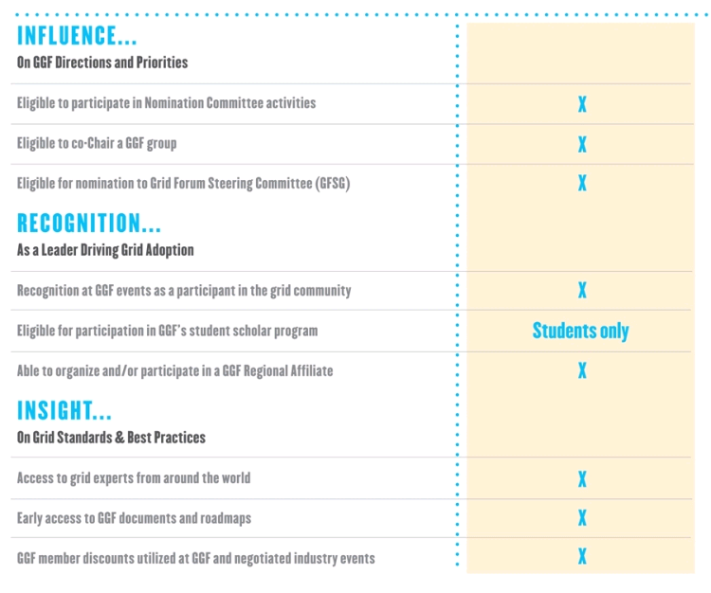

Organisational Membership
US$3,000-50,000
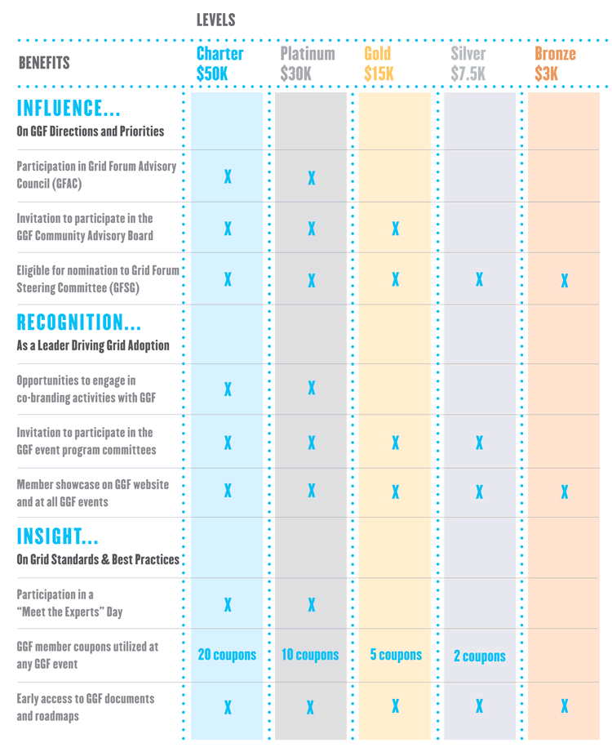

IETF
http://www.ietf.org/overview.html

“The Internet Engineering Task Force (IETF) is a large open international community of network designers, operators, vendors, and researchers concerned with the evolution of the Internet architecture and the smooth operation of the Internet. It is open to any interested individual. The IETF Mission Statement is documented in RFC 3935.

Membership costs nothing.

2.9 Where Do I Fit In? (from the IETF Tao)
The IETF is different things to different people. There are many people who have been very active in the IETF who have never attended an IETF meeting. You should not feel obligated to come to an IETF meeting just to get a feel for the IETF. The following guidelines (based on stereotypes of people in various industries) might help you decide whether you actually want to come and, if so, what might be the best use of your time at your first meeting.

2.9.1 IS Managers
As discussed throughout this document, an IETF meeting is nothing like any trade show you have attended. IETF meetings are singularly bad places to go if your intention is to find out what will be hot in the Internet industry next year. You can safely assume that going to Working Group meetings will confuse you more than it will help you understand what is happening, or will be happening, in the industry.
This is not to say that no one from industry should go to IETF meetings. As an IS manager, you might want to consider sending specific people who are responsible for technologies that are under development in the IETF. As these people read the current Internet Drafts and the traffic on the relevant Working Group lists, they will get a sense of whether or not their presence would be worthwhile for your company or for the Working Groups.

2.9.2 Network Operators and ISPs
Running a network is hard enough without having to grapple with new protocols or new versions of the protocols with which you are already dealing. If you work for the type of network that is always using the very latest hardware and software, and you are following the relevant Working Groups in your copious free time, you might find attending the IETF meeting valuable. The closer you are to the bleeding edge of networking, particularly in the areas of routing and switching, the more likely it is that you will be able to learn and contribute at an IETF meeting.

2.9.3 Networking Hardware and Software Vendors
The image of the IETF being mostly ivory tower academics may have been true in the past, but the jobs of typical attendees are now in industry. In most areas of the IETF, employees of vendors are the ones writing the protocols and leading the Working Groups, so it's completely appropriate for vendors to attend. If you create Internet hardware or software, and no one from your company has ever attended an IETF meeting, it behooves you to come to a meeting if for no other reason than to tell the others how relevant the meeting was or was not to your business.
This is not to say that companies should close up shop during IETF meeting weeks so everyone can go to the meeting. Marketing folks, even technical marketing folks, are usually safe in staying away from the IETF as long as some of the technical people from the company are at the meeting. Similarly, it isn't required, or likely useful, for everyone from a technical department to go, particularly if they are not all reading the Internet Drafts and following the Working Group mailing lists. Many companies have just a few designated meeting attendees who are chosen for their ability to do complete and useful trip reports.

2.9.4 Academics
IETF meetings are often excellent places for computer science folk to find out what is happening in the way of soon-to-be-deployed protocols. Professors and grad students (and sometimes overachieving undergrads) who are doing research in networking or communications can get a wealth of information by following Working Groups in their specific fields of interest. Wandering into different Working Group meetings can have the same effect as going to symposia and seminars in your department.

2.9.5 Computer Trade Press
If you're a member of the press and are considering attending IETF, we've prepared a special section of the Tao just for you -- please see Section 8.2.

OASIS

Membership
“OASIS membership secures your place in an international standards development community of solution providers, user organizations, industry groups, government agencies, academic institutions, and unaffiliated individuals in more than 100 countries around the world. By joining OASIS, you become part of the solution and ensure your views are represented in the development, convergence and adoption of e-business standards.”

Fees

 | Foundational Sponsor | Sponsor | Contributor | Individual
Annual Fee (US$) | 45,000 | 13,500 | 5,750 - 1,000 | 250
Participation
Participate in any and all OASIS TCs
Involve an unlimited number of employees in OASIS TCs
Initiate new OASIS TCs to address specific needs
Chair a TC (subject to TC vote)
Access members-only website
Vote on Committee Specifications
Vote on OASIS Standards
Consortium Governance
Serve on OASIS Board of Directors and Technical Advisory Board
Nominate candidates for OASIS Board of Directors and Technical Advisory Board
Vote on OASIS Board of Directors and Technical Advisory Board
Promotion
Use OASIS Member logo
Speak on behalf of an OASIS TC at conferences
Participate in OASIS InterOps
Host OASIS Open Standards Days
Receive link from OASIS member list to your homepage
Receive placement of your logo on OASIS home page
Receive recognition in OASIS press releases
Submit quotes for OASIS press releases
Receive automatic inclusion of your press releases on XML.org homepage
OASIS executive quote for company press releases (upon request)
Promote your conference presentations on OASIS work on OASIS Events Calendar
Receive recognition and linked logo placement on your choice of one site:  •Cover Pages  •XML.org  •OASIS CGML Open Member  Section  •OASIS DCML Member Section  •OASIS LegalXML Member  Section  •OASIS PKI Member Section  •OASIS UDDI Member Section  •OASIS Japanese site translation  •ebxml.org |  | •
Receive recognition as sponsor of OASIS Symposium and OASIS Forum annual events |  | •
Briefings
Schedule private briefings with OASIS executives to align your strategies and Committee participation
Schedule private briefings with OASIS Info Channel editors on your products or services
Discounts/Passes
Receive one free registration for OASIS Symposium and for OASIS Forum
Receive discounts for OASIS Symposium and OASIS Forum
Receive discounts for many events and training classes
• Available for an additional fee

OGC
http://www.opengeospatial.org/about/?page=levels

Membership Benefits
“Market growth based on interoperability benefits both technology users and providers, and OGC members are at the forefront. Through OGC, technology users are able to maximize the value of past and future investments in geoprocessing systems and data. They:

- Develop architectures and procurement plans for systems that enable them to share and reuse data, thus decreasing costs (avoiding redundant data collection), getting more or better information, and increasing the value of data holdings. Vastly improved inter-organizational data sharing is a key benefit.
- Position their organizations to: choose the best tool for the job, optimize work flows, and reduce technology and procurement risk (i.e., avoid being locked in to one vendor or an unsatisfactory solution).
- Enable more of their people with less training to benefit from using geospatial data in more applications: That is, they leverage their investments in software and data.
- Get to know, evaluate, and begin working with interoperable technologies in "real life" testbed and prototyping settings, at low cost, often with partner organizations.
- Influence interface design, avoiding the wait for strictly vendor-side developments that then need to be further customized to fully suit requirements.
- Gain alignment with the "center" that executives and investors regard as essential. OGC's link with ISO TC/211 and other standards groups ensures that an organization's modernization puts them in the technology mainstream.

In OGC, technology providers:
- Position themselves to take advantage of opportunities for commerce in interoperable products, discovering early through testbeds and pilot projects what's possible and what's needed in market sectors. and making product development decisions based on known user requirements.
- Share costs of developing interoperability technologies, hastening time-to-market and extending the profit period in their product life cycles.
- Influence the content, timing and scope of standards.
- Provide niche solutions that build on other vendors' offerings.
- Form relationships with user organizations, globally.
- Link to the international geospatial standards community. Key organizations represented in TC/211 and the Chairman of ISO TC/211 participate in OGC.
- Have a forum to discuss industry issues and solve shared problems.

Data suppliers and integrators, who may be both technology providers and technology users, benefit as described above, and they:
- Can make data offerings discoverable, accessible and usable on the Web.
- Easily partner with more than one GIS platform provider, through one set of interfaces, thus broadening the range of their offering.
- Learn to provide "interface management" services to their customers.

See http://portal.opengeospatial.org/files/?artifact_id=7376 for “Join OGC benefits”

Strategic Members (US$250,000+)
In addition to maintaining Principal Membership, Strategic Members provide significant resources to support OGC objectives in the form of funding to program initiatives and Full-Time Equivalent staff resources inserted into the OGC process, of total value in excess of US$250,000 per year. Strategic Members are able to focus the use of their resources in specific OGC programs and leadership roles, subject to OGC management approval. Strategic Members are also provided a forum, the Strategic Member Advisory Committee, in which to make recommendations regarding strategic business opportunities to the OGC Board of Directors and to the OGC Planning Committee. Strategic Membership is reviewed and subject to approval by the OGC Board of Directors.

Principal Plus Members (US$100,000+)
In addition to maintaining Principal Membership, Principal-Plus Members provide an FTE staff resource, for a minimum 6-month commitment during a membership year, or mutually agreed in-kind resources (hardware, software, network, or other relevant support), valued at US$100,000 per membership year over and above Principal Membership fee. Principal-Plus Members are accorded the opportunity to focus the application of their resources in mutually agreed, specific areas of OGC programs. Principal-Plus Membership is subject to the review and approval of OGC management.

Principal Members (US$55,000)
Principal Members have complete authority over the specification release and adoption process through their voting rights in the Planning Committee (PC). It is by PC vote that OpenGIS® Specifications are approved and released by the Consortium. PC Members participate in planning and management of the Consortium's technology development process, evaluate and provide guidance on market direction and Consortium focus, possess Technical Committee voting rights, have approval authority for OGC policies and procedures, and vote to elect members of the OGC Board of Directors.

Technical Committee Members (US$11,000)
Technical Committee Members participate and vote in the OGC Technical Committee (TC). TC members may submit draft standards for consideration by the membership. The TC consists of the technical representatives of all OGC member organizations and is charged to define, document, approve, and maintain OGC standards that enable interoperability of geospatial data and services. TC members may represent their organizations in any working groups or subcommittees of the TC, and may sponsor and/or participate in OGC Interoperability Initiatives.

Associate Members (US$500-4,400)
Associate Members are granted non-voting membership in the TC and have access to all written and electronic TC communication. Associate Members may participate in working groups and subcommittees of the TC, as well as in OGC Interoperability Initiatives. Commercial enterprises; national, state, provincial, and local government agencies; and university administrative units may become Associate Members.

Membership Fees
Membership Level | On Or After 1 January 2006
Strategic Member | Call for Process & Terms
Principal-Plus Member | Contact OGC for Process & Terms
Principal Member | US$ 55,000
Technical Committee Member | US$ 11,000
Associate Member: Commercial / National Government Organization. Government-National includes organizations representing national-level interests, such as a country that is a member of the European Union, the United States, etc | US$ 4,400
Associate Member: Small Company ( <US$500,000 annual gross revenue). Associate Small Company Member applicants must provide documentation that their annual gross revenue is less than US$ 2,000,000. | US$ 2,200
Associate Member: Government-Sub national (e.g., province, state Government-Subnational includes province- or state-level organizations, e.g., a province of Canada, a state of the United States, a province or state of a country that is a member of the European Union, etc ) | US$ 1,100
Associate Member: Research Institute / Not for Profit Institute. Research Institute / Not For Profit - An independent not-for-profit organization legally recognized in its nation of registration. | US$ 1,100
Associate Member: Government-Local (e.g., county, municipality. Government-Local includes town-, municipal- or county-level organizations. ) | US$ 500
Associate Member: University / Research Center. University / Research Center - Accredited universities and research centers that are funded and managed by a accredited university | US$ 500

W3C
http://www.w3.org/Consortium/join

Who Can Join W3C
“W3C Membership is available to all organizations. If your organization is investing significant resources into Web technologies — either by developing Web-based products, using Web technologies as an enabling medium for your work, conducting research on the Web, and/or developing products based on W3C specifications — then your organization should be a W3C Member. Adoption of W3C standards and reliance of global commerce and information exchange upon these standards continue to grow. Those who participate in our work have a unique opportunity to shape W3C standards and to leverage them to create new markets, expand existing markets, and participate directly in the revolution that continues to change the way the world works.

Please note that W3C does not have a class of Membership tailored to or priced for individuals. Individuals and organizations can also help support W3C operations through financial contributions and donations of goods.

Membership Benefits
Take a leadership role
- Exercise technical influence over standards through participation in Working Groups, review of standards in development, implementations, and contribution of use cases;
- Provide strategic direction for the Web's future through your seat on the W3C Advisory Committee and through participation in W3C's meetings;
- Extend your international outreach through W3C media activities such as W3C press releases and accompanying Member testimonials, generally published in multiple languages to a world audience;

Promote your image as innovator
- Introduce new ideas through W3C Workshops, the W3C Incubator Activity, and Member Submissions, complementary means available to W3C Members for building interest in new work within W3C;
- Gain public recognition of your organization's contributions through your display of the W3C Member logo and also through the prominent display of your organization's logo and testimonial on the W3C home page, viewed by a quarter million visitors each day on average;
- Ensure that Web standards can be implemented royalty-free. The goal of W3C's unique Patent Policy is to assure that Web Standards (W3C Recommendations) can be implemented on a Royalty-Free (RF) basis. As explained in the Business Benefits of the W3C Patent Policy, royalty-free Web standards allow organizations to gain revenue from their technology investments;

Gain early insight into market trends
- Track development of emerging technologies, markets, and priorities through Member-only news services, discussion forums, face-to-face meetings, Workshops and the process for starting new work at W3C;
- Implement a standard ahead of the market while participating in the Working Group that authors it. A close association between the implementers and the Working Group affords numerous benefits, including access to the expertise of the entire group, improvements to the quality and deployment of the standard, and marketing power;
- Help to coordinate technology development, for example at W3C's annual Technical Plenary, an opportunity to hear about the industry's current technical challenges and directions, and to help forge solutions.

Membership Fees
Organizations with Headquarters in Europe, the Middle East, and Africa (EUR)
Organization Type in HIC Country | Annual Fee for Memberships Starting 2006-04-01
For-profit organization that has annual gross revenue, as measured by the most recent audited statement, of greater than or equal to 204,000,000 EUR. | 65,000 EUR
For-profit organization that has annual gross revenue, as measured by the most recent audited statement, of greater than or equal to 51,000,000 EUR and less than 204,000,000 EUR. | 26,000 EUR
All other organizations, including not-profit organizations and government agencies. | 6,500 EUR
Organization Type in UMC Country
For-profit organization that has annual gross revenue, as measured by the most recent audited statement, of greater than or equal to 204,000,000 EUR. | 65,000 EUR
For-profit organization that has annual gross revenue, as measured by the most recent audited statement, of greater than or equal to 51,000,000 EUR and less than 204,000,000 EUR. | 26,000 EUR
For-profit organization that has annual gross revenue, as measured by the most recent audited statement, of greater than or equal to 30,600,000 EUR and less than 51,000,000 EUR. | 6,500 EUR
All other organizations, including not-profit organizations and government agencies. | 3,900 EUR
Organization Type in LMC Country
For-profit organization that has annual gross revenue, as measured by the most recent audited statement, of greater than or equal to 204,000,000 EUR. | 65,000 EUR
For-profit organization that has annual gross revenue, as measured by the most recent audited statement, of greater than or equal to 51,000,000 EUR and less than 204,000,000 EUR. | 26,000 EUR
For-profit organization that has annual gross revenue, as measured by the most recent audited statement, of greater than or equal to 15,300,000 EUR and less than 51,000,000 EUR. | 6,500 EUR
All other organizations, including not-profit organizations and government agencies. | 1,950 EUR
Organization Type in LIC Country
For-profit organization that has annual gross revenue, as measured by the most recent audited statement, of greater than or equal to 204,000,000 EUR. | 65,000 EUR
For-profit organization that has annual gross revenue, as measured by the most recent audited statement, of greater than or equal to 51,000,000 EUR and less than 204,000,000 EUR. | 26,000 EUR
For-profit organization that has annual gross revenue, as measured by the most recent audited statement, of greater than or equal to 7,650,000 EUR and less than 51,000,000 EUR. | 6,500 EUR
All other organizations, including not-profit organizations and government agencies. | 975 EUR
Organizations with Headquarters in Japan or Korea
Organization Type in HIC Country | Annual Fee for Memberships Starting 2006-04-01
For-profit organization that has annual gross revenue, as measured by the most recent audited statement, of greater than or equal to 23,000,000,000 JPY. | 7,300,000 JPY
For-profit organization that has annual gross revenue, as measured by the most recent audited statement, of greater than or equal to 5,750,000,000 JPY and less than 23,000,000,000 JPY. | 2,920,000 JPY
All other organizations, including not-profit organizations and government agencies. | 730,000 JPY
Organization Type in UMC Country
For-profit organization that has annual gross revenue, as measured by the most recent audited statement, of greater than or equal to 23,000,000,000 JPY. | 7,300,000 JPY
For-profit organization that has annual gross revenue, as measured by the most recent audited statement, of greater than or equal to 5,750,000,000 JPY and less than 23,000,000,000 JPY. | 2,920,000 JPY
For-profit organization that has annual gross revenue, as measured by the most recent audited statement, of greater than or equal to 3,450,000,000 JPY and less than 5,750,000,000 JPY. | 730,000 JPY
All other organizations, including not-profit organizations and government agencies. | 438,000 JPY
Organization Type in LMC Country
For-profit organization that has annual gross revenue, as measured by the most recent audited statement, of greater than or equal to 23,000,000,000 JPY. | 7,300,000 JPY
For-profit organization that has annual gross revenue, as measured by the most recent audited statement, of greater than or equal to 5,750,000,000 JPY and less than 23,000,000,000 JPY. | 2,920,000 JPY
For-profit organization that has annual gross revenue, as measured by the most recent audited statement, of greater than or equal to 1,725,000,000 JPY and less than 5,750,000,000 JPY. | 730,000 JPY
All other organizations, including not-profit organizations and government agencies. | 219,000 JPY
Organization Type in LIC Country
For-profit organization that has annual gross revenue, as measured by the most recent audited statement, of greater than or equal to 23,000,000,000 JPY. | 7,300,000 JPY
For-profit organization that has annual gross revenue, as measured by the most recent audited statement, of greater than or equal to 5,750,000,000 JPY and less than 23,000,000,000 JPY. | 2,920,000 JPY
For-profit organization that has annual gross revenue, as measured by the most recent audited statement, of greater than or equal to 862,500,000 JPY and less than 5,750,000,000 JPY. | 730,000 JPY
All other organizations, including not-profit organizations and government agencies. | 109,500 JPY
Organizations with Headquarters in All Other Countries
Organization Type in HIC Country | Annual Fee for Memberships Starting 2006-04-01
For-profit organization that has annual gross revenue, as measured by the most recent audited statement, of greater than or equal to 200,000,000 USD. | 63,500 USD
For-profit organization that has annual gross revenue, as measured by the most recent audited statement, of greater than or equal to 50,000,000 USD and less than 200,000,000 USD. | 25,400 USD
All other organizations, including not-profit organizations and government agencies. | 6,350 USD
Organization Type in UMC Country
For-profit organization that has annual gross revenue, as measured by the most recent audited statement, of greater than or equal to 200,000,000 USD. | 63,500 USD
For-profit organization that has annual gross revenue, as measured by the most recent audited statement, of greater than or equal to 50,000,000 USD and less than 200,000,000 USD. | 25,400 USD
For-profit organization that has annual gross revenue, as measured by the most recent audited statement, of greater than or equal to 30,000,000 USD and less than 50,000,000 USD. | 6,350 USD
All other organizations, including not-profit organizations and government agencies. | 3,810 USD
Organization Type in LMC Country
For-profit organization that has annual gross revenue, as measured by the most recent audited statement, of greater than or equal to 200,000,000 USD. | 63,500 USD
For-profit organization that has annual gross revenue, as measured by the most recent audited statement, of greater than or equal to 50,000,000 USD and less than 200,000,000 USD. | 25,400 USD
For-profit organization that has annual gross revenue, as measured by the most recent audited statement, of greater than or equal to 15,000,000 USD and less than 50,000,000 USD. | 6,350 USD
All other organizations, including not-profit organizations and government agencies. | 1,905 USD
Organization Type in LIC Country
For-profit organization that has annual gross revenue, as measured by the most recent audited statement, of greater than or equal to 200,000,000 USD. | 63,500 USD
For-profit organization that has annual gross revenue, as measured by the most recent audited statement, of greater than or equal to 50,000,000 USD and less than 200,000,000 USD. | 25,400 USD
For-profit organization that has annual gross revenue, as measured by the most recent audited statement, of greater than or equal to 7,500,000 USD and less than 50,000,000 USD. | 6,350 USD
All other organizations, including not-profit organizations and government agencies. | 953 USD

WS-I
http://www.ws-i.org/join/membership.aspx

Approximately 130 member organizations
- 70% vendors, 30% end-user organizations
- Strong non-U.S. membership, including very influential Japan SIG

Membership is open to any company or organization interested in contributing to Web services interoperability. Current members include:
- Software and hardware vendors that sell Web services products
- Companies that are building or deploying Web services within their organizations and/or with their trading partners
- Standards development organizations that want to ensure their work is available to the widest possible audiences

Membership Benefits
- To influence the WS-I agenda by submitting real-world interoperability requirements to the organization’s working groups
- To influence industry direction by participating in the development of interoperability guidelines
- To complete products and/or projects sooner by having early access to WS-I deliverables
- To create favorable publicity through WS-I membership and, potentially, speaking opportunities
- To collaborate and network with other influential industry leaders

Contributing Membership
Contributing members receive many benefits from their memberships:
- Help drive the WS-I agenda by contributing real-world interoperability issues to the organization’s working groups
- Participate in working groups, committees and special interest groups
- Attend WS-I Community Meetings (held three times per year)
- Vote on WS-I materials and deliverables and in WS-I elections
- Access deliverables while they are in development, before general distribution
- Access and redistribute materials developed by WS-I
- Are listed in the WS-I community directory, with links to their companies’ Web sites
- Use the WS-I logos
- Access resources on the WS-I members-only Web site
- Are eligible for election to leadership positions, such as working group chairs, open committee chairs and the board of directors
- May have real-world case studies demonstrating the value of WS-I profiles promoted by the organization
- May join WS-I speakers’ bureau to promote WS-I at industry conferences and events
- Receive a subscription to WS-I newsletter, WS-Insider

How to Join as a Contributing Member
To join WS-I, please complete the following steps:
- Step 1: Use this link to Register and download the membership documents.
- Step 2: Review, sign and return the membership documents to:
Membership Coordinator
Web Services Interoperability Organization
401 Edgewater Place, Suite 600
Wakefield, MA 01880 USA
- Step 3: Receive executed membership agreement from WS-I
- Step 4: Send annual dues payment of $3,000 USD

Associate Membership
As a standards integrator for Web services interoperability, it is important for WS-I to collaborate with the standards development organizations (SDOs) that operate in the Web services arena. The Associate membership category is offered by invitation only, at no charge, exclusively to SDOs, and offers many benefits. In particular, our Associate Members:
- Help drive the WS-I agenda by contributing real-world interoperability issues to the organization’s working groups
- Participate in working groups, committees and special interest groups
- Attend WS-I Community Meetings (held three times per year)
- Access deliverables while they are in development, before general distribution
- Access and redistribute materials developed by WS-I
- Are listed in the WS-I community directory, with links to their organizations' Web sites
- Use the WS-I logos
- Access resources on the WS-I members-only Web site
- Receive a subscription to WS-I newsletter, WS-Insider

How to Join as an Associate Member
Associate membership is by invitation only to qualifying SDOs. If your SDO is interested in becoming an Associate Member, please contact the WS-I Membership Coordinator at membership@ws-i.org with the following:
- Organization name and brief description
- Primary contact name
- Telephone
- E-Mail Address
The WS-I Board will review your request. If it determines that an invitation is appropriate, you will receive an Associate membership kit with instructions.

Advocates Program
As an Advocate, a company shows its support for the mission of WS-I and the business and technical value of the WS-I deliverables, without the expense or time commitment of a formal membership. WS-I encourages Advocates to promote the use of WS-I deliverables within their industries and with their customers and partners.
The Advocates program has many benefits. In particular, WS-I Advocates:
- Are listed in the WS-I community directory, with links to their companies’ Web sites
- Use the WS-I Advocate Logo
- Receive subscriptions to the WS-I newsletter, WS-Insider

How to become an Advocate
To register for the Advocate program, please fill out this registration form.

Adopters Program
Participating as an Adopter allows a company to use and re-distribute WSI materials without becoming a member or paying a membership fee. Joining the Adopters program has many benefits. In particular, Adopters:
- Access and redistribute materials developed by WS-I
- Are listed in the WS-I community directory, with links to their companies’ Web sites
- Use the WS-I logos
- Receive subscriptions to the WS-I newsletter, WS-Insider

How to become an Adopter
  - Download the Adopter Agreement
  - Review, sign and return the Adopter agreement to:
Membership Coordinator
Web Services Interoperability Organization
401 Edgewater Place, Suite 600, Wakefield, MA 01889 USA
  - Receive executed agreement from WS-I

