 | International Union for  Biological Sciences  Taxonomic Databases Working Group  http://www.tdwg.org

Evaluation of Technology for the TDWG Website
Version 2 – 10 Jan 2006

Index
1. Introduction 2
2. Content Management Systems (CMS) Evaluations 2
2.1. Typo3 CMS (Recommended Package) 3
2.2. Other Systems Evaluated (Which Failed to Fulfill Requirements) 10
2.3. Summary of CMS Evaluation 13
3. Wiki Systems Evaluations 14
3.1. Summary of Wiki Evaluations 15
4. Mailing List Manager Evaluations 16
4.1. Evaluation Criteria 16
4.2. Evaluation 16
4.3. Mailing List Manager Software Evaluation Summary 17
4.4. Mailing List Manager Recommendation for TDWG 18
5. Integration of Component Software Packages 19

Introduction
This document evaluates software packages that meet the specifications required for the new TDWG website described in details on the companion document – TDWG Website Requirements – (version 15 of 10-Jan-2006):
- The system must administer and serve TDWG standards and their related information (metadata) via the World Wide Web;
- The system must provide collaborative tools to support subgroup operations.
- The system must be easily managed remotely by several different administrators and content managers.
- The system must provide an environment for publishing TDWG related information that can evolve with the organization.
- The system must meet a number of general website requirements, such as compliance to web standards, search engine friendliness, performance, and security.
As the result of this evaluation we recommend the use of an integrated solution using Typo3 Content Management System, TWiki and Mailman Mailing List Manager.
To keep this document as concise as possible we have limited the detailed evaluation to only those systems that currently are capable of meeting the specific TDWG website requirements. We briefly discuss aspects and limitations that make other popular packages inappropriate for the TDWG environment.

Content Management Systems (CMS) Evaluations
Modern web based Content Management Systems (CMS) provide the basic infrastructure necessary to implement a dynamic, database-backed website. CMS provide convenient features that allow users to author web pages remotely without requiring technical knowledge of HTML coding or programming.
We restricted the evaluation to those CMS which are
- based on the most popular web application platform currently in use: Linux Operating System, Apache Web Server, MySQL Database Management Server and one of Python, Perl or PHP web scripting languages, in short: LAMP.
- popular, stable, mature, and which have a wide user base, development support, and hosting services.
- distributed under an open source license.
The main reasons for these requirements are:
- Open source technologies provide a range of cost-effective and increasingly robust alternatives to commercial software;
- Their inexpensive (or inexistent) distribution fees provide more flexibility for TDWG, especially in cases of financial instability;
- Popular web application platforms confer a great deal of mobility to the website, in case it needs to be moved to one host to another or even moved to a hired web hosting service. That is a very important feature given that TDWG website has historically been hosted by different institutions in a voluntary basis.
- They match the TDWG general philosophy of open sharing of knowledge.
Although we focused on the LAMP web platform, we considered it an advantage if the system runs also on the Windows Operating System.
Based on the above descriptions, we selected Typo3, Mambo, Drupal, eZ Publish, and Plone/Zope for evaluation. We used the following criteria to evaluate those packages:
- Usability: Is it easy to learn and remember, efficient, visually pleasing and fun to use.
- Suitability: How appropriate the CMS is to implement the TDWG website, considering its specific requirements.
- Separation of Contents and Presentation: How well the CMS separates actual content from HTML tags used for layout and rendering the content. The more effective this separation the more valuable the content becomes.
- Content Migration: How easy it is to migrate content from one CMS to another.
- Access Control: Fine grained access control is required for remote management of content by administrators, group conveners and secretaries.
- Conformance to Web and Accessibility Standards: It is important to ensure that TDWG website can be visited and provide useful information to the broadest range of users possible.
- Performance: How fast the CMS is in rendering and delivering web pages to client web browsers. This is related to database design and query optimization, and caching strategies.
- Documentation and Source Code: Quality and quantity of documentation describing software design, implementation, and usage.
Since all CMS packages selected for evaluation have large user communities and very active developer bases, are very stable, mature, and extensible, we did not include those criteria in this evaluation.

Typo3 CMS (Recommended Package)
Typo3 is a free, open source web based content management system written in PHP and based on the MySQL database. It is used to publish enterprise intranets and websites on the Internet. Typo3 offers one of the most flexible and extensible frameworks among all tested CMS, presenting an advanced yet highly usable set of ready-made user interfaces.
After evaluating Typo3, we consider it to be the most suitable package for implementing the new TDWG website for the following reasons.

Usability
Typo3 uses a natural and intuitive model to organize website pages and content. Typo3 models websites as a series of pages that are linked together hierarchically. Its administration user interface consistently shows the website page hierarchy using a tree browser panel, like the one shown in Figure 1.
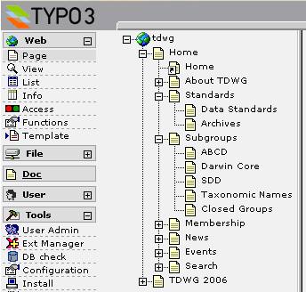
Figure 1 – Sample website page hierarchy in Typo3.
The benefits of such a model seem obvious, but few CMS use it to organize website structure internally. In our evaluation, we found that only Typo3, Midgard and eZ Publish are successful in presenting this model to users. Other popular CMS such as Mambo and Drupal use completely different models to organize websites internally, which we believe are not as intuitive as the page based model.
In Typo3, each page contains a number of content items, called “content elements”. These elements come in a variety of types, from plain text and text with figures to multi-media and customized content presented by third-party plug-ins.
For example, Figure 2 shows the homepage of a sample website which contains 3 content elements: an introductory text entitled “Welcome to TDWG”, followed by the news plug-in that displays latest news items on the homepage, and a list of TDWG subgroups displayed by a custom TDWG plug-in. The concept of content elements improves content re-use and makes it easier to rearrange items across pages.
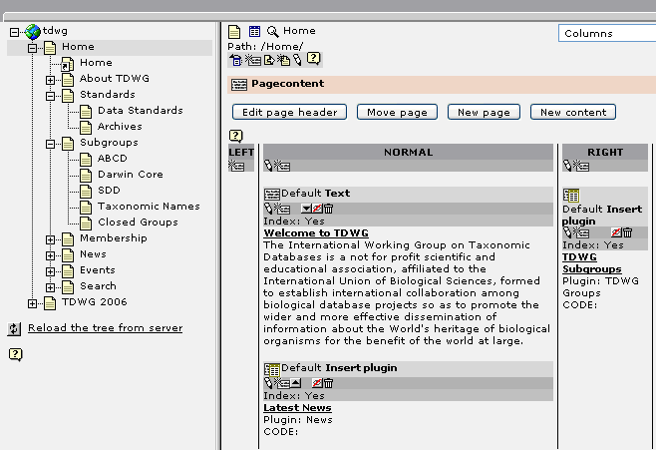
Figure 2 – Content elements in a Typo3 web page.
Figure 3 shows the same page rendered in a web browser. Notice that the menu on the left-hand side is dynamically generated from the website page hierarchy. New pages added under the homepage would be automatically added to the menu on the rendered page, allowing the administrator to easily modify the website structure as needed.
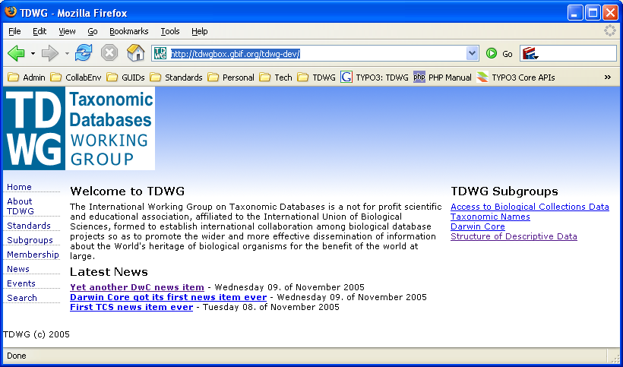
Figure 3 – Corresponding Typo3 web page rendered on a web browser.
Other usability features of Typo3 include:
- Context sensitive inline help (Figure 4) that the user can bring up by clicking the question mark icon next to each field in any web form;
- Context (right-click) menus with context sensitive options;
- Tool tips in all icons and buttons. A tool tip is a short description of button function that is displayed when user leaves the mouse cursor over it for a short while.
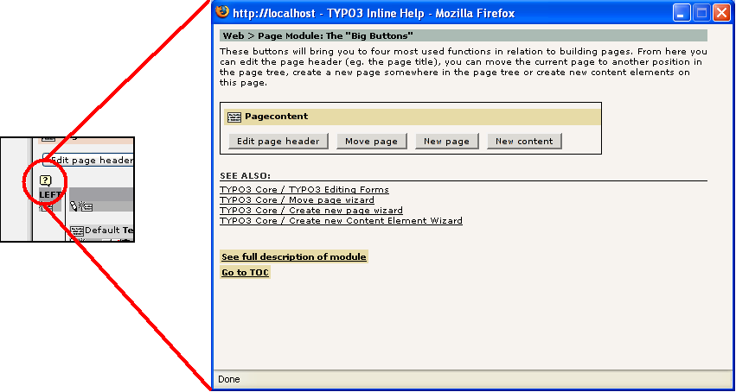
Figure 4 - Context sensitive inline help

Separation of Presentation and Content
An important aspect of a CMS is how effectively it separates content from presentation. If the content and presentation are well separated, it is trivial to re-brand the entire website or sections of it whenever needed, without the having to rewrite its contents. On this criterion, most of the CMS evaluated (including Typo3) performed very well.
Figure 5 shows the web design selection panel which allows administrators to select different website templates for a web page and its sub-pages as well as the arrangement of their contents (single, two, three column content display).
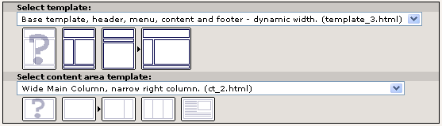
Figure 5 – Web design selection panel.
Figure 6 shows the same page rendered using different templates. Second (upper-right) and third (bottom) templates present a vertical menu on the left-hand side, while the first (upper-left) present a single-level horizontal menu and a path menu right above it. The second and third templates are fixed-width while the first stretches using all available window space (variable-width template).
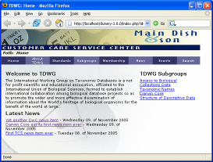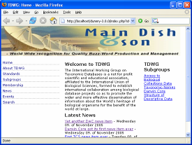
Figure 6 – Same page content rendered using three different web templates.

New web designs can be added at any time and become available for use in any website section as soon as they are uploaded.

Content Migration
The choice of a popular web application platform (such as LAMP) simplifies the migration of the website from one server to another or even to a hosting service.
TDWG might face a situation where its website contents need to be migrated to another CMS or custom built system. In that case, the new website must provide mechanisms to migrate contents from one website to the new system.
Content migration in popular CMS is usually accomplished by exporting contents directly from the database via scripts. For that reason, it is important that the CMS provides a clean and well organized database design. Typo3 meets that requirement.
Typo3 is unique in that it exports contents using XML format. The exported package includes all content: pages, page hierarchy, page contents, links between pages, various text and image files, website configuration, users, and database records. Once the target system is known, and assuming that both source (in this case Typo3) and the target system are conceptually compatible, developers can create migration scripts that read XML data from the Typo3 exported website and populate the new CMS database tables and set up configuration accordingly.
During the migration process, however, one should pay special attention to whether the exported XML contains HTML tags or other proprietary tags, to which the target system might be allergic. Typo3 does allow proprietary tags (such as Typo3 <LINK> link tags) and regular HTML tags to be present inside page content.

Access Control
Most CMS evaluated do not provide the appropriate access control required for the new TDWG website. The requirements state that group conveners and secretaries must be able to edit and update information about their subgroups and related standards, but it must be possible to lock some of this information against change without approval of an oversight body in TDWG.
Typo3 provides the required access control schema by providing access control both at page and database field levels. Figure 7 shows the form used by an administrator to manage a standard metadata record, while Figure 8 shows the equivalent form that is available to the group convener, with restricted set of fields. The same situation applies to group metadata information.
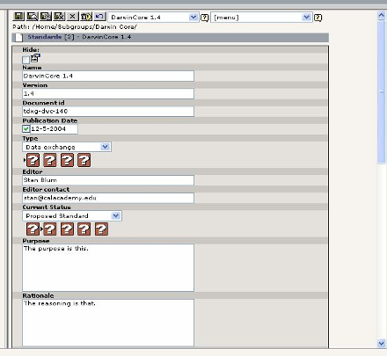
Figure 7 – Form used by an administrator to manage a standard metadata record.
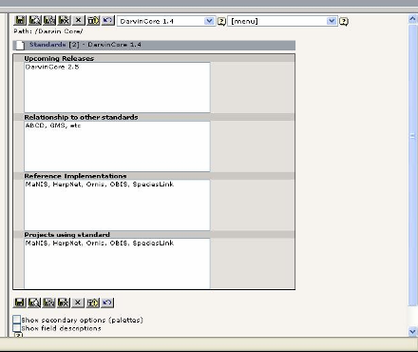
Figure 8 – Form used by the group convener to manage a standard metadata record. Notice that conveners can edit fewer fields than administrators.

Documentation and Source Code
There is excellent documentation for Typo3 end users and administrators, including introduction guides, installation manuals, user guides, and technical descriptions of Application Programming Interface (API).
The highlight is the series of excellent tutorials that teach users and developers how to build Typo3 websites step by step and how to master advanced features such as template design and extension development. The only area where Typo3 seems to lack documentation is in some of its extensions.
Typo3 source code documentation appears complete and appropriate. All modules contain inline documentation in JavaDoc format. Those comments are later compiled into API reference guides.
Typo3 developers have also established a strict coding standard to ensure high quality of coding, source code readability, and consistency of coding between modules. This standard is applied throughout main Typo3 components and it is also used to guide other developers when coding Typo3 extensions.

Web Standards, Accessibility
All Typo3 content elements are generated in XHTML compliant code allowing the creation of website following accessibility standards, with complete UTF-8 support. The template engine can be programmed to generate more modern CSS based table-less web designs. Web standards compliance is not however present in all Typo3 extensions.

Performance
Typo3 is fast. The main reasons for its good performance are:
- It features a powerful caching engine that stores rendered pages and content elements. The cached contents are then used to serve subsequent requests to the same page. Its fine grained caching strategy which caches the output of individual content elements allows pages with mixed dynamic and static content to be rendered efficiently.
- Its clean database design and optimized SQL queries make efficient use of the database server.
- It uses HTTP/1.1 cache-control headers to optimize caching of pages on client web browsers and proxy servers.
- It supports the use of several different PHP accelerators.

Extensibility
Typo3 can be extended to meet specific requirements through the development of additional modules called extensions. The following are potential examples of Typo3 extensions that may be developed to fulfill TDWG Website requirements:
- Data entry and submission of charters for new subgroups.
- Submission of new standards and requests to move standards along the TDWG standards track.
- Automated tools to validate whether submitted standards documents conform to guidelines and format.

Other Systems Evaluated (Which Failed to Fulfill Requirements)

Custom Software
A CMS can generate a new Web site far quicker than can be generated by other means. A custom built software solution would have to provide a set of features that are already provided by Typo3 and other CMS, such as basic security, database access, separation of contents and presentation and search engine friendliness.
A custom built solution would require higher on-going maintenance costs because it would not have many of the benefits of popular open source CMS, such as: security for a large user base, and support in case a security treat is found, frequent releases and active developments by a large base of developers

Mambo
Mambo is one of the most popular open source CMS currently available. Mambo has a very large user community and an active developer base. However, Mambo’s development community has been involved in conflicts between the main supporting organization and original Mambo developers.
The Mambo CMS was considered unsuitable for the following reasons:
- Mambo does not use an intuitive model to organize websites. Instead of using the concept of pages, like Typo3, it uses menus and links. That is, the content of a page is defined by the content items that are linked to the corresponding menu item. For that reason, it is impossible to see what content will be displayed on a particular web page before it is properly linked and published. This property has is a significant drawback on usability because users are unable to preview the pages they are working on. This forces Mambo users to think about their website structure in a non-intuitive manner.
- Current versions of Mambo have a static hierarchy forcing content to be divided into exactly three levels: sections, categories and content. This requirement seems overly restrictive and considerably degrades system usability.
- Access control is inappropriate. Permissions are given to a few hard-coded user groups and these do not provide sufficient flexibility to fulfill TDWG website requirements.

Drupal
Drupal is also a very popular free, open source CMS. However it does not appear suitable for several reasons:
- Drupal also uses a model based on menus and links (as used in Mambo) instead of pages (like Typo3).
- Many Drupal features emphasize content creation by users at large, a feature which may not be very useful to TDWG users. For that reason, Drupal seems to be more suitable to manage weblog or forum-based websites, i.e., websites in which content is highly volatile and is mainly composed by a continuous flow of articles and contents contributed by the user community.
- Drupal default access control is inappropriate to implement TDWG requirements because it does not offer the appropriate level of granularity. There is an add-on that provides finer grain access control, but it is not convenient and intuitive to use.

eZ Publish
Although eZ Publish uses the concepts of pages and display website contents in terms of a hierarchy of pages, its administration user interface is not as intuitive as the one offered by Typo3.
Another problem with eZ Publish is that it had very poor performance during the testing. We acknowledge however that we did not perform strictly comparable performance tests between the various CMS packages tested. Information gathered on the Internet also presents evidence that indicates database query statements are under-optimized in several core eZ Publish modules.

Plone
Zope/Plone CMS is not recommended because it uses a proprietary object-oriented database system, which makes it very hard to extract or manipulate database items directly, or even export contents using custom scripts.

Macromedia Contribute
Macromedia Contribute (http://www.macromedia.com/software/contribute/) is an easy-to-use client-side tool that allows web developers to upload content to a website without disrupting its graphical design, layout and server-side programming code.
Although it provides a powerful user interface for remote content contribution, it does not fulfill TDWG website requirements for two main reasons: i) it does not support dynamic database-based websites; and ii) it is individually licensed, forcing each contributor to purchase his or her own license or for TDWG to purchase and distribute licenses.
See more detailed review of Macromedia Contribute at http://www.sitepoint.com/article/review-macromedia-contribute.

Summary of CMS Evaluation

 | Typo3 | Mambo | Drupal | eZ Publish | Plone
Version | 3.8.1 | 4.5.2 | 3.6.3 | 3.7.0 | 2.x
Licence and Cost | Free - GPL | Free - GPL | Free - GPL | Free - GPL | Free - GPL
Application Platform | W/LAMP | W/LAMP | W/LAMP | W/LAMP | W/LAMP (uses proprietary object oriented database)
Programming Language | PHP | PHP | PHP | PHP | Python
Usability | Good | Fair | Fair | Good | Fair
Suitability | Good | Poor | Poor | Good | Poor
Access Control | Fine grained | Predefined set of permissions for groups | Predefined set of permissions for groups (can be extended) | Fine grained | Fine grained (but complex)
Separation of Content and Presentation | Good (most flexible template engine) | Good | Good | Good | Fair
Content Migration | SQL scripts  XML export | SQL scripts | SQL scripts | SQL scripts | Difficult
Content Reuse | Yes | Limited | Limited | Yes | Yes
XHTML | Yes | Yes | Yes | Yes | Yes
WAI | Yes (free add-on) | Limited | Limited | Yes | Yes
UTF-8 | Yes | No | Yes | Yes | Yes
Performance | Good | Good | Good | Fair | Good

Wiki Systems Evaluations
Wiki systems support a more flexible and less constraining web publishing environment than CMS. Wikis provide areas where members can publish free-form content regarding their group activities.
Wiki Systems are more homogeneous than CMS, providing little difference in the features they provide. We evaluated TWiki, MoinMoin, WikiMedia, and ZWiki.
We found that TWiki, MoinMoin, or MediaWiki were suitable systems that could be used by TDWG. All of these products provide the main features required by the TDWG collaboration environment:
- Software license and cost: All tested wikis are free and distributed under General Public License (GPL), a common open source license that is suitable for TDWG needs.
- Web application platform: All three wikis are implemented in a very broad application platform, running at least on Linux and Windows operating systems, Apache web server and PHP, Perl or Python scripting languages.
- Ease of use: All three wikis provide appropriate navigation schemes and editing capabilities. Both MoinMoin and TWiki employ markup languages that are easy to learn and write, yet are very flexible. MediaWiki, on the other hand uses a more complex markup language.
- Clean presentation: All three wikis present their pages using nice graphical design and layout in the standard installation. All of the systems support customization of web design using templates, skins and cascading stylesheets.
- Performance: All three wikis have satisfactory performance. MediaWiki, the wiki used by WikiPedia, has the best scalability among all tested wikis. Any of the wiki systems reviewed would be appropriate for TDWG, given that TDWG has a low demand by the number of pages and users.
- Versioning: All tested wikis provide satisfactory versioning control, allowing unlimited number of revisions per page, diffs between any revision, and undo feature to restore any of the stored revisions as the latest revision of a page.
- Security and spam protection: All tested wikis have appropriate strategies to handle security threats, including a clear strategy to identify, receive notifications about, handle, and disseminate information about security threats.
- Broad user base and development community: All wikis tested have large user communities and high development activity.
We recommend the use of TWiki because it provides the best mechanism for separating subgroup wiki pages from one another. In TWiki, pages can be grouped together into collections called “webs”. Each web is separated from each other both visually, through the use of templates, and logically via navigation. Using separate TWiki webs is a simple and natural way of keeping TDWG subgroup wiki pages logically separate, while allowing cross-references between them.
We found ZWiki inappropriate for use by TDWG because:
- It uses Zope, a specialized object-oriented database, which makes it very difficult for administrators to inspect page contents;
- Markup language is not easy to learn and use, requiring a great deal of work to get desired results, especially regarding text layout.

Summary of Wiki Evaluations

Criteria / Wiki | TWiki | MoinMoin | MediaWiki | ZWiki
Web Server | Apache or IIS | Apache or IIS | Apache or IIS | Zope Application Server
Data Storage | Flat file | Flat file | MySQL | Zope Object-Oriented Database
Programming Language | Perl | Python | PHP | Python
Ease of Use | Yes | Yes | Yes | Markup language is not friendly
Presentation | Good | Good | Good | Good
Performance | Good | Good | Good | Good
Versioning | Appropriate | Appropriate | Appropriate | Appropriate
Security | Fair | Fair | Fair | Fair
User Base and Development Activity | Large
License | GPL
Cost | Free
Operating System | Linux/Windows

Mailing List Manager Evaluations
Mailing lists have long been the main means of communications for most TDWG subgroups. The same is true for most of the other standards development organizations we reviewed. Over the years, TDWG subgroups have used a wide variety of mailing list server software from a number of different institutions, adding significant heterogeneity and overhead to subgroup operations. To correct that, the new TDWG collaboration infrastructure will provide mailing list services to all groups.
Initial estimates suggest that TDWG might use from 20 to 50 lists, with an average of 50 to 200 subscribers, with low to medium activity ranging from a few messages a week to many messages a day. TDWG might also have a few announcements lists with higher number of subscribers (about 500) and much lower activity (a few messages a month).

Evaluation Criteria
We used the following criteria to evaluate the most appropriate Mailing List Manager (MLM) software for TDWG:
- Software Platform: What operating system the list manager runs on, and what other software packages it requires. This is an important factor that defines the mobility of TDWG website and collaboration infrastructure as a whole.
- Software License: Given TDWG funding capabilities, we gave preference to open source, free software over commercial alternatives.
- Performance: Ability to handle lists of considerable size and activity, compatible with expected TDWG demands.
- Ease of Use and Maintenance: How easy it is for list members to perform basic functions using the package, such as subscribing, unsubscribing, posting messages, changing configuration options, searching archives. For administrators, how easy it is to manage the lists.
- User Community, Support and Development Activity: Size of current user community and developer base contributing to software development.

Evaluation
Based on the criteria above, we considered L-Soft ListServ, GNU Mailman, Majordomo, ListProc, and SmartList. All of those are free, open source packages, except for ListServ, a commercial package.

L-Soft ListServ
ListServ is a capable commercial Mailing List Manager that was one of the first packages developed for both Unix/Linux and Windows platforms. Nowadays, ListServ is probably one of the fastest and most scalable mailing list managers on the market. It is known to serve lists with more than a million subscribers.
ListServ presents all features a major mailing list manager must offer, such as: administrative and user web interfaces, automated subscription management and searchable web archives. It provides all features a major mailing list manager must offer, such as web interfaces for members and administrators, automated subscription management, searchable web archives and email bounce checks. ListServ, however, presents a somewhat old-fashioned web interface.
ListServ has reasonable development activity, compatible with commercial software packages. There are no signs of slowdown or possible discontinuity of development or support in the near future.
ListServ’s main drawback is its high cost. A licensing scheme appropriate for TDWG would cost at least USD 2,500 (one-time fee) and USD 1,000 per year for support and software upgrades. That cost may be prohibitive given TDWG funding capabilities.
The only available ListServ hosting service is provided by L-Soft itself. Their setup and monthly fees are very high.

GNU Mailman
Mailman is a popular free, open source, UNIX based Mailing List Manager. It is fast and scalable, although not as much as ListServ. The largest Mailman-managed lists are known to have about 150,000 members.
Mailman provides an easy to use web interface for members and administrators, automated subscription management, searchable web archives and email bounce checks.
Mailman is currently used by a variety of large websites, SourceForge being the largest Mailman-hosted mailing list currently in operation with several thousand lists.
Mailman has an active development base. Software packages are released frequently. Development goals and future plans are clear and transparent. Mailman has comprehensive and very high quality documentation.
There are many inexpensive Mailman hosting services available, at around US$ 3 per list per month. Those services can be used if TDWG decides not to manage mailing lists internally.

Majordomo, ListProc and SmartList
Majordomo, ListProc and SmartList are other relatively popular Unix-based Mailing List Managers. They were all considered inappropriate for TDWG because they all presented a considerable reduction in popularity and a commensurate decrease in development activity in the last 4 or 5 years. Such factors might indicate compromised level of support needed for ongoing maintenance of the service.

Mailing List Manager Software Evaluation Summary

 | Evaluation Criteria
Packages | Software Platform | Software Cost and License | Performance and Scalability | Ease of Use | User and Development Community
L-Soft Listserv | Linux and Windows | ~ US$ 3,500 (first year)  ~ US$ 1,000 (yearly) | Best | Good | Good
GNU Mailman | UNIX/Linux | Free and open source | Good | Good | Good
Majordomo | UNIX/Linux | Free and open source | Poor | - | Poor
SmartList | UNIX/Linux | Free and open source | - | - | Poor
ListProc | UNIX/Linux | Free and open source | - | - | Poor

Mailing List Manager Recommendation for TDWG
Although ListServ seems to be superior at least in performance in comparison to Mailman, the difference is not worth the significant additional cost. Mailman performance is more than sufficient to fulfill TDWG requirements. We therefore recommend that TDWG uses GNU Mailman as its Mailing List Management package.

Integration of Component Software Packages
All three recommended systems (Typo3 CMS, TWiki and Mailman) will be integrated into a single solution to form the new TDWG Website.
Both Typo3 CMS front-end (i.e. the public website, not the back-end administration user interface) and TWiki will be branded and linked to appear as a single entity. They will both share the same graphical design and templates.
Mailman, however, will not be integrated via branding (except for TDWG logos) because its implementation tightly couples functionality and presentation. That makes it impossible to customize look and feel or graphical design. Mailman developers have plans to decouple those components in future releases.
Integration of Mailman to the rest of the Website will simply consist of hypertext links from web and wiki pages.

Evaluation based on a slightly outdated release.
Latest release dates from January 2000. Updates and fixes provided since then are all based on file patches on a voluntary basis. Developer community deems current source code as dead. Some developers are working on new version does not seem promising.
Latest release dates from September 2001. Maintainers have abandoned the project. Fixes are provided as patch files by volunteers.
Latest release dates from February 2002. Long-term supporting institution, the Corporation for Research and Education Networking (CREN), has been dissolved in 2003. Software package is now being developed under SourceForge.

