Taxonomic Concept Schema
Complementary Documentation for Draft Standard

The schema was developed by the TDWG Name Standard Committee as a collaborative project funded by GBIF and SEEK at Napier University. Full documentation and contact information as well as a platform for discussion can be found at:

http://tdwg.napier.ac.uk/

1 Overwiew 2
2 Definition of terms and their relation to Schema Elements 2
2.1 Data set 2
2.2 (Taxonomic) concept 2
2.3 Relationships between Taxonomic Concepts 4
2.4 Publication 8
2.5 Author 8
2.6 Name 8
2.7 Specimen 8
3 Appendix 9
3.1 List of Parties consulted 9
3.2 Additional Material 9
3.3 Glossary of terms 9
3.4 Conventions (technical) 10
3.4.1 Design 10
3.4.2 Element Names 11
3.4.3 References 11
3.4.4 Documentation 11
3.4.5 Included XSD 11
3.5 Use of fields for different publication types 11
3.6 Type Definitions 12
3.6.1 Type Definitions: (based on ICBN, Chapter II, Section 2, Article 9) 12
3.6.2 Type Definitions: (based on International Code of Zoological Nomenclature (ICZN) 4th Edn.) 13
3.6.3 Codes of Nomenclature 14

Overwiew

This documentation should be read in conjunction with the Taxonomic Concept (Transfer) Schema (TCS) as submitted to TDWG for consideration as a standard. The version of the schema is v0.70.

This is the second ‘official’ version after v0.50 presented at the eScience Workshop in May 2004 in Edinburgh. We have taken on board the comments received there and either incorporated changes to accommodate requirements or discussed how the additionally requested information can be stored with the current structure.

The major change is the incorporation of a top-level structure called Assertions that is used to store relationships between Taxonomic Concepts as declared/established by Taxonomists who are not the authors of either of these concepts. Furthermore the definition of what a concept is has been widened and new types were introduced.

Here is a list of the main changes:
- Key ref instead of ID-REF
- ReferenceType refined to allow explicit notation of GUID reference
- Author added to Publication.
- Renaming of various fields to clarify their meaning
- Expanded enumeration list for concept types and relationships
- AccordingToType and RelationshipType separated out for re-use
- Status attribute for names

Definition of terms and their relation to Schema Elements

The terms listed here are to complement the inline documentation of the XSD file and give an indication under what circumstances the particular element is going to be used.

Data set
(also data source) – taxonomic data (e.g. a revision of a taxonomic group or a database of taxonomic names) that is transformed to conform to the Taxonomic Concept (Transfer) Schema. Depending on the kind of data, interpretation will be necessary to extract concepts.
Information about the (source) data set is stored in the MetaData element.

(Taxonomic) concept
Concepts arise from the classification of a group(s) of organisms by a person (taxonomist) at a certain time. They are given a name by the person, typically following the rules of nomenclature. The concept can be defined in many ways; by the organisms or other concepts which circumscribe it, one of which being its type (specimen); by reference to other concepts or by a set of characters which differentiate it from other concepts. Depending on the data source only a subset of the information might be available.

In short: a concept is composed of a name and some kind of definition.

The vagueness of this definition is intentional and reflected in the design of the TaxonConcept element, where only the name is compulsory (to give some sort of handle, to communicate about the concept) and all possible elements that can contribute to the definition of the concepts are optional. There are two possibilities why such elements would be missing: either the author did not use them in his definition or the data source that was used as the basis for the transfer didn’t include the information. It might not be known for a particular data source which possibility applies.

A TaxonConcept can be designated as one of five concept types (below) via its type attribute. In addition it can be recorded as 'empty' for TaxonConcepts that hold no information other than a reference to an external concept record via a GUID. It should be noted that type is optional because often it cannot be determined from the data source.

Original | The first representation/original publication of a taxon concept/name use. In other words: concepts where a new name has been created. The definition of the taxon concept will be variable depending on where and when it was published. These concepts act as the foundation on which current taxonomic concepts are based.
Revision | A concept definition presented as part of a taxonomic revision. Usually the results of a re-classification (e.g. combining or splitting) of existing concepts where a previously used name is redefined in some way.
Incomplete | An incomplete record of a concept. This should be used if it is known (or suspected) that not all information about the concept is contained in the data source.
Aggregate | A collection of TaxonConcepts grouped together under a name of utility by a user/author. It needs to include links to all of the TaxonConcepts it covers explicitly stated.
Nomenclatural | A concept holding purely nomenclatural information, any relationships held will be to similar nomenclatural concepts. It (implicitly) covers all concepts that ever used the particular name. A special case of this is a vernacular concept.
Empty | No contents other than its ID (a GUID), which is to be used as a reference to an external TaxonConcept record.

The Schema does not prescribe which composite elements of a Taxon Concept must be represented for each of the given Taxon Concept types, rather it is envisaged that this would be determined by the business rules of applications that use and parse data exchanged via a TCS validated document.

The allowed components for each of the types might be as follows

Concept Components | Original  Concept | Revision  Concept | Incomplete  Concept | Aggregate  Concept | Nomenclatural  Concept
Name | + | + | + | + | +
AccordingTo | + | + | ? | + | -
Kingdom | ? | ? | ? | ? | ?
Rank | ? | ? | ? | ? | ?
Relationships to Concepts | ? | ? | ? | + | ?
Specimen Circumscription | ? | ? | ? | - | - (1)
Character Circumscription | ? | ? | ? | ? | -

+ Required; ? Optional; - Disallowed

(1) Nomenclatural Concepts might have type specimens recorded

Relationships between Taxonomic Concepts

Relationship (also Taxonomic Concept Relationship, Synonymy) – describes the documented association between two concepts as seen by the author of one of the two OR by a third party. Therefore the relationship can be considered as a directed link.

In the TCS the definition of a TaxonConcept can include Relationships to other taxon concepts, these are determined by the author of the concept. However we can also have relationships between two existing taxon concepts which we call Assertions. Such Assertions are not part of the definition of a Taxon Concept and are often made by a third party.

A provisional list of the possible types of relationships (for relationships defined in the Taxon Concept and Assertions) is presented below, together with a brief descriptive definition. Most of the relationships that are not inherently bi-directional are represented by a pair of unidirectional relationships.

The various relationships can be grouped according to which variety of Taxon Concept that they may apply to (refer to separate discussion of TaxonConcept types). The group of set operations can only be asserted between full Taxon Concepts (i.e. it is not possible to express these opinions about concepts that are purely nomenclatural). Such relations will provide the richest means of relating concepts between separate taxonomic hierarchies, and as such can be classified as 'Horizontal Relationships'. Parent Child (i.e. Vertical) relationships apply within a taxonomic hierarchy or classification, and may relate full Taxon Concepts or Nomenclatural Concepts. The majority of Relationships are Nomenclatural, and express the various 'traditional' relationships of taxonomy. All concepts are required to possess names, and can therefore be related by nomenclatural relationships.

SET OPERATIONS BETWEEN CONCEPTS

is congruent to | The extent of Concept 1 is (essentially) identical to Concept 2
is not congruent to | The extent of Concept 1 is not identical to Concept 2
includes | Concept 2 is a subset of Concept 1
does not include | Concept 2 is not a subset of Concept 1
excludes | Concept 1 does not overlap or include Concept 2
is included in | Concept 1 is a subset of Concept 2
is not included in | Concept 1 is not a subset of Concept 2
overlaps | Concepts 1 and 2 share members/children in common
does not overlap | Concepts 1 and 2 have no members/children in common
HIERARCHICAL RELATIONSHIPS BETWEEN CONCEPTS OR NAME CONCEPTS
is child of | Concept 1 is a member of lower taxonomic rank of Concept 2
is parent of | Taxon Concept 1 includes Concept 2 as a lower-ranked member.
NOMENCLATURAL RELATIONSHIPS (BETWEEN NAMES OF CONCEPTS

is type of | Concept 1 is the nominal taxon that is the name-bearing type member of Concept 2.
has type | Concept 2 is the nominal taxon that is the name-bearing type member of Concept 1.
is basionym for | The name for Concept 2 is provided by Concept 1, by the rules of priority
has basionym | The name for Concept 1 is provided by Concept 2, by the rules of priority
is vernacular for | The name of Concept 1 is a common usage name for Concept 2
has vernacular | The name of Concept 2 is a common usage name for Concept 1
is conserved against | An exception to the rules of nomenclature allows the name of Concept 1 to be maintained in preference to that of Concept 2
has conserved name | An exception to the rules of nomenclature allows the name of Concept 2 to be maintained in preference to that of Concept 1
has conserved type | An exception to the rules of nomenclature allows Concept 2 to be retained as the taxonomic type of Concept 1
is conserved type of | An exception to the rules of nomenclature allows Concept 1 to be retained as the taxonomic type of Concept 2
is heterotypic synonym of | The name applied to Concept 1 is an alternative name for Concept 2, and derives from a different type
is homotypic synonym of | The name applied to Concept 1 is an alternative name for Concept 2, and derives from the same type
is later homonym of | The name for Concept 1 is the same as that of the earlier Concept 2, but the concepts are not related
has later homonym | The name for Concept 2 is the same as that of the earlier Concept 1, but the concepts are not related
is treated as later homonym of | The name for Concept 1 is the same as that of Concept 2 and treated as of junior precedence, but the concepts are not related
has homonym treated as later | The name for Concept 2 is the same as that of Concept 1 and treated as of junior precedence, but the concepts are not related
is lectotypification of | Concept 1 has been selected as the lectotype of Concept 2 (in the absence of a holotype)
has lectotypification | Concept 2 has been selected as the lectotype of Concept 1 (in the absence of a holotype)
is neotypification of | Concept 1 has been selected as the neotype for Concept 2
has neotypification | Concept 2 has been selected as the neotype for Concept 1
is orthographic variant of | The name of Concept 1 is variant spelling of that of Concept 2
is misapplied name for | The name given for Concept 1 is misapplied, the correct name being that of Concept 2
has misapplied name | The name given for Concept 2 has been misapplied to Concept 1
is nomen novum for | The name of Concept 1 is established expressly to replace the established name of Concept 2 (retaining the name-bearing type)
has nomen novum | The name of Concept 2 is established expressly to replace the established name of Concept 1 (retaining the name-bearing type)
is not a synonym of | The name of Concept 1 is not an alternative name for Concept 2
is partial synonym of | The name applied to Concept 1 can be applied to some of the taxonomic concepts represented in Concept 2
is pro parte synonym of | The name applied to Concept 1 is a partial synonym (q.v) of Concept 2, generally not involving the type
is recombination of | The name for Concept 1 is a new combination of a generic name with the previously established species-group name in Concept 2.
has recombination | The name for Concept 2 is a new combination of a generic name with the previously established species-group name in Concept 1
is rejected in favour of | The name of Concept 1 is set aside in favour of the name of Concept 2
has rejected name | The name of Concept 2 is set aside in favour of the name of Concept 1
is rejected type of | Concept 1 is set aside as the type of Concept 2
has rejected type | Concept 2 is set aside as the type of Concept 1
is replaced synonym for | The name for Concept 1 has been replaced by the alternative name given for Concept 2
has replaced synonym | The name for Concept 2 has been replaced by the alternative name given for Concept 1
is synonym of | The name applied to Concept 1 is an alternative name for that applied to Concept 2
is validation of | The name for Concept 1 is the correct name for Concept 2 under the rules of the nomenclatural codes
has validation | The name for Concept 2 is the correct name for Concept 1 under the rules of the nomenclatural codes
is epitypification of | Concept 1 is designated the epitype for Concept 2
has epitypification | Concept 2 is designated the epitype for Concept 1
is anamorph of | Concept 1 is the asexual or mitotic reproductive stage in a pleomorphic life cycle in which Concept 2 is the teleomorph or meiotic reproductive stage
is teleomorph of | Concept 1 is the teleomorph or meiotic reproductive stage in a pleomorphic life cycle in which Concept 2 is the asexual or mitotic reproductive stage
HYBRIDIZATION RELATIONSHIPS

is second parent of | Concept 1 is genetic parent (2) of Concept 2 (a Hybrid)
is female parent of | Concept 1 is genetic mother of Concept 2 (a Hybrid)
is first parent of | Concept 1 is genetic parent (1) of Concept 2 (a Hybrid)
is male parent of | Concept 1 is genetic father of Concept 2 (a Hybrid)
is hybrid parent of | Concept 1 is genetic parent of Concept 2 (a Hybrid)
is hybrid child of | Concept 2 is a genetic parent of Concept 1 (a Hybrid)
GENERAL

doubtful | Uncertain relationship between Concepts 1 and 2
CONSIDERED BUT NOT USED

is taxonomically included in | equivalent to 'included in'?
have common elements | equivalent to 'overlaps'?
sanctioning (only fungi) | Unsure of use - does it refer to use of 'ex' Author?
is later validation of | equivalent to 'is validation of'?
is contradiction | Unsure of use
same citation as | Unsure of relevance to concept definitions
earlier publication of | Unsure of relevance to concept definitions
later publication of | Unsure of relevance to concept definitions
isonym of | Unsure of meaning
correction of | Unsure of relevance to concept definitions
corrected by | Unsure of relevance to concept definitions

Publication
The publication is the document where the author’s opinion is recorded. Historically this would be a paper publication such as a journal article/monograph but databases are being used increasingly. There has been a lot of discussion about the adoption of a common format for publications for all TDWG schemata. We are much in favour of such a format, but not in a position to make a decision. Until then the basic format as introduced in the strawman schema is used which is based on the Endnote format. This has the advantage of being simple and compact. An explanation on how the different fields are used is provided in the appendix.

Author
(also Author Team) – person or group of people who publish taxonomic concepts. In addition to taxonomist/biologists this can include owners of taxonomic databases such as ITIS if the data stored there underwent taxonomic modification and interpretation (revision) and is not just a record of other authors concepts. (Authority should not be used because of its ambiguity)

Name
A name is a textual label for a concept. It can be
scientific – follows the rules of nomenclature and can be broken down into components
non-scientific – ad-hoc label, vernacular or any other type of identifier

Specimen

In the TaxonConceptSchema a Taxon Concept can be circumscribed by a (set of) Vouchers, which are records of specimen objects. A voucher consists of two parts, the Institution or Repository, where it is stored and a local Identifier of the actual Specimen. It is anticipated to use records from ABCD or DiGR here, provided they can be accessed by a GUID.

Some of the specimen might be designated types for a concept. A type attribute can optionally be recorded for each voucher in the circumscription, to detail whether the specimen is a 'type specimen' for the given Taxon Concept, and the nature of the type according to the rules of nomenclature.

15 enumerated type of types are given here, representing the types controlled in the botanical and zoological codes of nomenclature (see appendices below).

epitype
holotype
isotype
lectotype
neotype
non-type
paratype
syntype
isosyntype
hapantotype
paralectotype
paratype
syntype
type
name-bearing type

Appendix

List of Parties consulted
- VegBank and Taxonomer groups Santa Barbara, 22-25th January 2004
- Berlin Model group, Berlin 26-27th Feb 2004
- GBIF, Copenhagen 16-17th Feb 2004
- Nomencurator, London 29th Mar 2004
- Species 2000, London 30th Mar 2004
- ITIS, Edinburgh 9th May 2004
- IPNI, London 9th Jun 2004

Other valuable input was received on the Wiki page by

Additional Material
Wiki/Website for schema related discussion
http://tdwg.napier.ac.uk/

Previous versions of the TCS Schema:
http://cvs.ecoinformatics.org/cvs/cvsweb.cgi/seek/projects/taxon/schemas/seek_napier.xsd?only_with_tag=EdinburghMeeting (pre march’04)
http://www.soc.napier.ac.uk/tdwg/index.php?pagename=TheSchema (post march’04)

Case studies: conversion of existing databases to schema conformant XML
(actual data only available at request because of copyright issues):
http://tdwg.napier.ac.uk/data-sets/

Notes from meetings with taxonomic data user groups
(various formats; incomplete):
http://tdwg.napier.ac.uk/notes/

Glossary of terms
Here various taxonomic (or somehow related) terms and their definitions (from various sources) are listed. This reflects our understanding of their meaning if there are multiple meanings associated with them.

- authorship - author's name and date of publication are typically given after the scientific name. If a name is later changed (e.g., moved to a new genus), The original author is given in parentheses. Anonymous publication is invalid as of 1950, but was accepted before then.
- autonym - when an author names a new subspecies or variety, the species is given the same new rank, based on the original type of the species and duplicating the epithet, e.g., when Pinus nigra ssp. larico was designated, Pinus nigra ssp. nigra came into being.
- basionym - specific or infraspecific name which has priority over other names later given to the same plant by different authors.
- binomial - genus name is one word. A species name is the genus plus a second word. Subspecies have a trinomial name. A subgenus is occasionally given in parentheses after the genus, thus:
- Bison (Bison) bison bison (Linne, 1758) Skinner & Kaisen, 1947
- component – parts of a string that still have a meaning.
- description - after 1930, new names must come with a description (or reference to one) telling what the name means.
- element – used in the XML sense; a node in the document tree.
- homonym - scientific name given two or more times to plants of the same taxonomic rank but which are quite distinct from each other. In botanical nomenclature, the authors are given in taxonomic monographs, and if a name is changed, both the original author (in parentheses) and the revising author are named.
- original data source – where the data stored in the transfer schema is coming from; typically a database, but can also be a piece of literature.
- synonym – any one of two or more names used for the same taxon rank; a rejected name due to misapplication or difference in taxonomic judgment.
- tautonym - illegitimate binomial in which the genus and species are the same word, such as Amoracia armoracia, later changed to Armoracia rusticana.
- taxon - taxonomic group; A group of organisms at any level of the taxonomic hierarchy. The major taxa are the species and genus and the higher taxa, including the family, order, class, phylum, and kingdom.
- type specimen - descriptions should refer to an actual specimen, available for examination in a museum or other collection. There are complicated rules for determining the type if the original is lost or if there was no type specimen with the original description.

Conventions (technical)

This section lists all conventions used in designing the Napier SEEK transfer schema.

Design
- The schema is designed to store about taxonomic concepts, assertions (relationships), specimen (vouchers) and publications. This is reflected in the three top-level elements.
- If a collection of items is stored, the individual items are encapsulated in a container element that takes the name of the individual item plus the letter ‘s’ to indicate plural (e.g. <Items>). Container elements are mandatory but can be empty.
- If an item is typically used as the concatenation of individual components, the schema provides a way to store the full text string as <FullItem> (mandatory) and broken down list of components as <ItemAtomised> (optional). The <ItemAtomised> can also contain information that is not part of <FullItem>.

Element Names
- Names of elements are written in lower case with an initial uppercase letter and (in the case of composite names) uppercase letters at the start of every component.
- Underscores (_) are not used.
- Attributes are all lower case (composite name are not used).

References
- If an element is not specified in place, but rather references a location either in the same file or at a globally accessible location, the element is stored as an empty element either with a ref attribute containing a local ID (LUID) or a gref attribute containing a global ID (GUID). As a result of comments received in Edinburgh, the reference Element doesn’t carry the same name as the target.
- LUIDs are typically the identifiers from the original data source

Documentation
- Every element defined in the schema has an associated <xs:annotation> tag, containing annotations and documentation.
- Inside the <xs:annotation> tag a compulsory <xs:documentation> tag contains text describing the purpose of the element. This should be a single, concise sentence that doesn’t contain any reasoning or discussion.
- If an element has attributes it is good form to use [A] in the documentation as they are often overlooked.

Included XSD
- Parts of the schema that are taken (nearly) verbatim from other sources are contained in a separate file and included via the <xs:include> tag as a single file.
- The filename indicates the source: SourceContents.XSD.
- The original XSD is left untouched as far as possible.
- Modifications are documented inside and additional <xs:annotation><xs:documentation> tag

Use of fields for different publication types
(As used by EndNote 7 ;taken from Richard Pyle’s Taxonomer paper)

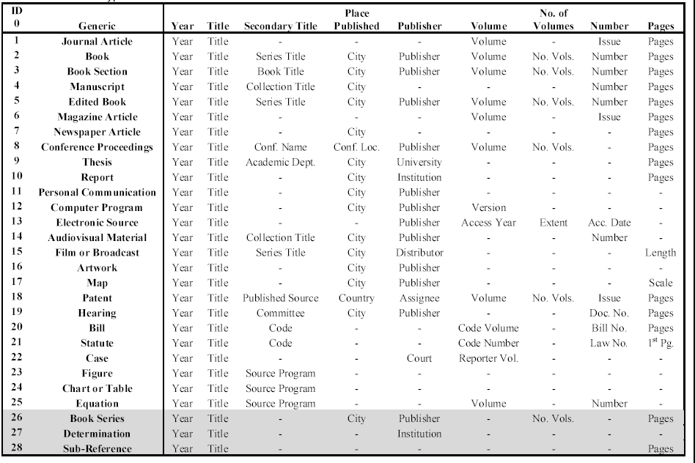
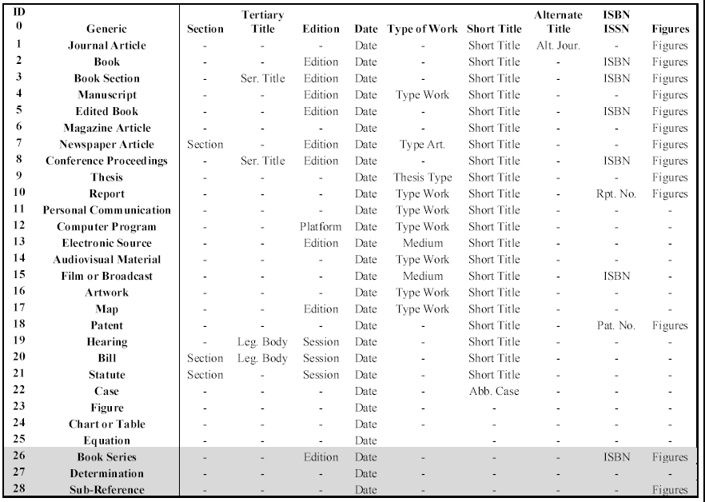

Type Definitions

Type Definitions: (based on ICBN, Chapter II, Section 2, Article 9)

Included in TDWG TCS
- epitype: "a specimen or illustration selected to serve as an interpretative type when the holotype, lectotype, or previously designated neotype, or all original material associated with a validly published name, is demonstrably ambiguous and cannot be critically identified for purposes of the precise application of the name of a taxon." The holotype, lectotype, or neotype that the epitype supports must be explicitly cited when the epitype is designated.
- holotype: the one specimen or illustration used by the author, or designated by the author as the nomenclatural type.
- isotype: any duplicate specimen of the holotype.
- lectotype: a specimen or illustration designated as the type when no holotype was indicated at the time of publication. If possible, the lectotype should be selected from the syntypes or original material.
- neotype: a specimen or illustration selected as the type when all of the material on which the name of the taxon was based is missing.
- non-types: specimens which are erroneously labelled as types should be annotated as, "Not a Type."
- paratype: a specimen cited in the protologue that is neither the holotype, isotype, nor one of the syntypes. These are often listed as representative specimens in the original description.
- syntype: any one of two or more specimens cited in the protologue when no holotype was designated, or any one of two or more specimens simultaneously designated as types in the original description. Monographers are urged to select a lectotype from among the syntypes whenever possible.
- isosyntype: a duplicate specimen of a syntype.
Not in the Code, but in common usage (Not in TDWG TCS)
  - isolectotype: any duplicate specimen of the lectotype.
  - isoneotype: any duplicate specimen of the neotype.

Type Definitions: (based on International Code of Zoological Nomenclature (ICZN) 4th Edn.)
Included in TDWG TCS

- hapantotype: One or more preparations consisting of directly related individuals representing distinct stages in the life cycle, which together form the name-bearing type in an extant species of protistan. A hapantotype, while a series of individuals, is a holotype that must not be restricted by lectotype selection; however, if a hapantotype is found to contain individuals of more than one species, components may be excluded until it contains individuals of only one species.
- holotype: The single specimen (except in the case of a hapantotype, q.v.) designated or otherwise fixed as the name-bearing type of a nominal species or subspecies when the nominal taxon is established.
- lectotype: A syntype designated as the single name-bearing type specimen subsequent to the establishment of a nominal species or subspecies.
- neotype: The single specimen designated as the name-bearing type of a nominal species or subspecies when there is a need to define the nominal taxon objectively and no name-bearing type is believed to be extant. If stability and universality are threatened, because an existing name-bearing type is either taxonomically inadequate or not in accord with the prevailing usage of a name, the Commission may use its plenary power to set aside that type and designate a neotype.
- paralectotype: Each specimen of a former syntype series remaining after the designation of a lectotype.
- paratype: Each specimen of a type series other than the holotype.
- syntype: Each specimen of a type series from which neither a holotype nor a lectotype has been designated. The syntypes collectively constitute the name-bearing type.
- type: A term used alone, or forming part of a compound term, to denote a particular kind of specimen or taxon.
- name-bearing type: The type genus, type species, holotype, lectotype, series of syntypes (which together constitute the name-bearing type) or neotype that provides the objective standard of reference whereby the application of the name of a nominal taxon can be determined.

Not in the Code, but in common usage (Not in TDWG TCS)

- allotype: A term, not regulated by the Code, for a designated specimen of opposite sex to the holotype.
- cotype: A term not recognized by the Code, formerly used for either syntype or paratype, but that should not now be used in zoological nomenclature.
- genotype: A term not recognized by the Code, formerly used for type species, but that should not now be used in zoological nomenclature.
- topotype: A term, not regulated by the Code, for a specimen originating from the type locality of the species or subspecies to which it is thought to belong, whether or not the specimen is part of the type series.

Codes of Nomenclature
- International Code of Botanical Nomenclature: Saint Louis Code in English (published by the IAPT - International Association for Plant Taxonomy)
- International Code of Nomenclature of Bacteria. The International Committee on Systematics of Prokaryotes (ICSP) (www.the-icsp.org). Unfortunately, the Bacteriological Code (1990 Revision) is not available on the Internet!
- International Code of Zoological Nomenclature (ICZN), also non available on the Internet www.iczn.org
- International Code of Virus Classification and Nomenclature (published by the ICTV - International Committee on Taxonomy of Viruses).
- BioCode (the) - Draft BioCode 1997
- PhyloCode

