Veg-X names architecture

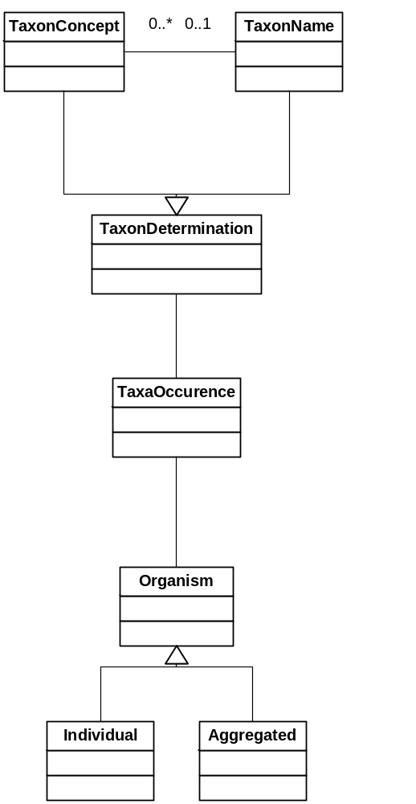

TaxonName

A published nomenclatural unit of any rank (order, family, genus, species, subspecies, etc.). This is a formal taxonomic name published under codes. Each name is of type tcs:scientificName and may be referenced in taxonDetermination allowing a name usage concept (author name) to be determined or asserted as a specific published nomenclatural name. tcs:scientificName:citation is contained in the literature container. Note this is not the same as a taxonomic name, i.e. these are not taxa, which are defined by a taxonConcept.

Relationships:

May have zero or more taxon concept records
Name may be referred to by zero or more assertion records

TaxonConcept

Representation of a Taxon Concept. Various types of concept can be represented, including a reference to the GUID of an existing Concept. Each taxon concept follows tcs:taxonConcept and may be referenced in taxonDetermination allowing a name usage concept (author name) to be determined or asserted as a specific published taxonomic name/concept. It is recommended that the relationships between concepts be a child pointing to its parent.

Relationships:

May have zero or one taxon name record
May be referred to by zero or more assertion records

TaxonNameUsage -> (TaxonOccurence above)

A taxon name string occurring within the dataset. This is a usage concept defined by the dataset author which may follow, or be according, to an additional third party. It may be further related to a published name (taxon name, tcs:TaxonName) and or taxonomic name (taxon concept, tcs:TaxonConcept) by using the authorName assertedNameID attribute or alternatively relate the name to a published name (taxon name) and or taxonomic name (taxon concept) in taxonDetermination.

Relationships:

May have zero or one taxon name record
May be have zero or more determination records

TaxonDetermination

A specific relationship or assertion between two name concepts which are not part of the original definition of either of these concepts; possibly by a third party. Within vegX this typically allows for an author usage concept, i.e. a name string used by the author in this dataset, to be linked to either a published nomenclatural name (taxon name) or a specific taxa treatment (taxon concept), according to a third party. Similar to a tcs: TaxonRelationshipAssertion. An identification applying one or more TaxonConcepts or taxon names to an IndividualOrganismObservation or AggregateTaxonObservation by a Party. May be used to add additional taxon determinations or annotations by users of the dataset beyond the original author.

Relationships:

One or more assertions (either a taxon name or taxon concept) records
Must have one TaxonOccurence (TaxonNameUsage) record

