Dirichlet:

Grid Size | Error
1/8 | 0.0281737
1/16 | 0.00664675
1/32 | 0.00161231
1/64 | 0.000396936
1/128 | 0.0000984684
1/256 | 0.0000245215

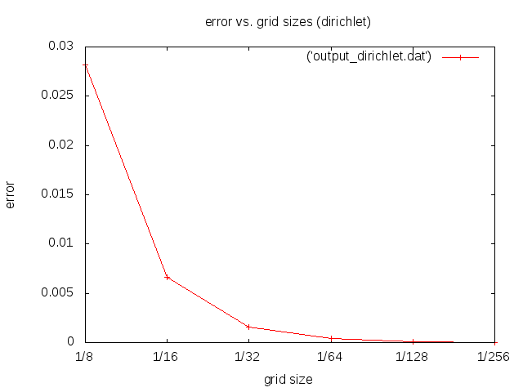
Description of measurement:

For every plot we are using the error after 20 Iterations.
As we thought the error gets smaller using finer grid sizes.

Neumann:

Grid Sizes | Error
1/8 | 0.0285806
1/16 | 0.0134054
1/32 | 0.00777938
1/64 | 0.00527653
1/128 | 0.00340702
1/256 | 0.00199494

